III. Technical Content

Table of Contents

Section | Page Number(s)
1. Technical Approach and Justification
2. Statement of Work
3. Project Schedule and Milestones
4. Management Approach
5. Personnel Qualifications
6. Current Pending Project and Proposal Submissions
7. Relevant Experience
8. Attachments (Addendums, Exhibits, Figures, Resumes, etc.)

1. Technical Approach and Justification:

The major portion of the proposal should consist of a clear description of the technical approach being proposed. This discussion should provide the technical foundation/justification for pursuing this particular approach/direction and why one could expect it to enable the objectives of the proposal to be met. This section should include the concise technical approach in its entirety.

Include for Basic Research, if it applies.
• Future Naval Relevance (where applicable): A description of potential Naval
relevance and contributions of the effort to the agency’s specific mission.

For Applied Research and Advanced Technology Development, if it applies.
• Operational Naval Concept (where applicable): A description of the project
objectives, the concept of operation for the new capabilities to be delivered, and
the expected operational performance improvements.
• Operational Utility Assessment Plan (where applicable): A plan for
demonstrating and evaluating the operational effectiveness of the Offeror’s
proposed products or processes in field experiments and/or tests in a simulated
environment.

2. Statement of Work: The Statement of Work (SOW) should clearly detail the scope and objectives of the effort. If options are included, separate sections should be included to address what work will occur in the base and each option.

It is anticipated that the proposed SOW will be incorporated as an attachment to the resultant award instrument. The SOW without restrictive markings is your company’s affirmation that the SOW is non-proprietary and releasable in response to Freedom of Information Act (FOIA) requests.

At a minimum, the format and content of the Statement of Work should contain the following information.

TITLE OF PROGRAM/SERVICES AND/OR SUPPLIES

1.0 Background. The background section should, in general terms, describe the overall program or the goal the contractor is attempting to accomplish. This section shall also include any previous research or accomplishments that form the basis or the beginning point of the work effort to be performed under the statement of work.

2.0 Scope/Objective. This section should describe, in general terms, the work effort that will be performed by the contractor.

3.0 Requirements. This section should describe each task(s) the contractor must perform. The requirements section should describe each task using complete sentences, active voice, and mandatory terms (“the contractor shall” or “the contractor will”). The task(s) should be arranged systematically and logically so that both parties (contractor and government) understand the desired effort. In addition, all task(s) should be listed in chronological order. The task(s) should be explained in clear and understandable terms. Include any industry specific standards that need to be adhered to in fulfilling the SOW.
NOTE: Numbering of tasks 3.1, 3.2, 3.3, etc.

4.0 Deliverables. The work effort defined in the task(s) should result in a deliverable product (monthly progress report, quarterly progress reports, final technical report). In this section the deliverables should be defined.

3. Project Schedule and Milestones: Attach a POA&M that sets forth planned actions and critical milestones. 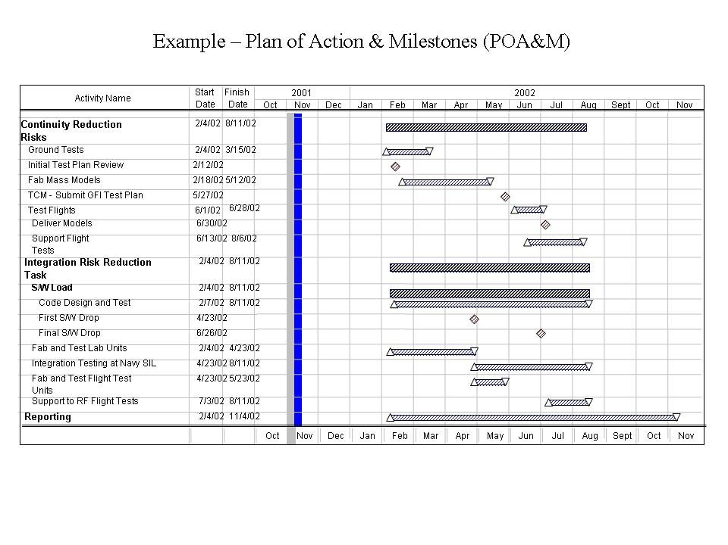

4. Management Approach:

1.0 Discuss the overall approach of the management of this effort, such as brief discussions of the total organization; use of personnel; project/function/subcontractor/consultants relationships; government research interfaces; and planning, scheduling and control practice.

2.0 Identify which personnel and subcontractors/consultants (if any) will be involved.

5. Personnel Qualifications:

1.0 Discuss the qualifications of the proposed Principal Investigator and any other key personnel.

2.0 Include resumes for the Principal Investigator and other key personnel and full curricula vitae for Principal Investigators and consultants. The resumes and curricula vitae shall be attached to this document and will not count toward the page limitations.

6. Pending Proposal Submissions:

1.0 Have you submitted any related or complementary pending proposal submissions, including subsequent funding, to other sources (e.g. ONR, Federal, State, local or foreign government agencies, public or private foundations, industrial or other commercial organizations?

If so to whom?

7. Relevant Experience: A description of the Offeror's Government contracts (both prime and major subcontracts) received during the past three (3) years, which are similar in nature to the effort being proposed. Include contract number and the name, phone number and email address of the technical point of contact. If necessary, add additional rows.

a. Description of Effort
b. Name of Awarding Agency
c. Contract Number
d. Technical POC
e. Phone Number
f. Email
g. Period of Performance (inclusive of options) (i.e. 01 Jan 11 – 31 DEC 13)
h. Total Award Amount (including options)
i. Contract Type (FFP, CPFF, etc.)
j. Have any options been exercised?
If not, why?

8. List of Attachments: Provide a list of all attachments to this document including addendums, figures, exhibits, resumes etc.

