**Media Delivery Network Simulator**

**Massive, parallel, real-time distribution of data**

The largest minority of traffic traversing the Internet today is video, in various shapes and sizes; combined, all media forms have a peak time majority of network traffic. The amount of media traffic is only set to increase, as more and more people choose IP as their delivery method of choice. The natural question, therefore, is whether we are transferring that traffic in a good manner, or if we can do better.

In order to answer the question of how to transfer the traffic well, we must first create the traffic. As experimenting on customer networks is very costly, and current models for traffic simulation assume traditional loads, creating a simulator will create a distinct opportunity to experiment with different algorithms and attempt to find how to better transfer media.

The goal of this project is to build a “life sized” simulation of internet-based media distribution, with a flexible framework that will allow tinkering, experimentation and evolution. The simulator will then collect different metrics from each node in the overlay network and reports them to a master node that manages the simulation. These will help researchers to validate the design of a media delivery network based on metrics collected from the simulator.

The simulator is implemented as an extensible framework at application layer where we have a master node, a web client and several different type of nodes running in different node containers. The master node will be responsible for controlling entire simulation and reporting metrics to the web client.

Each node is simulating a different functionality performed in a media delivery network. Source Node is used to generate data (and metadata), Processing node is used to simulate additional processing being done (like ad-insertion) on the generated data. Relay nodes are used to simulate the proxy behavior and Sink nodes are used to simulate the clients requesting data streams.

Web Client is used to take different work configurations as input from the user and display the current

status of the network along with important metrics like packet loss, transfer rate and latency. The work configuration specifies how many nodes are there in the simulation, how are they related, where they are hosted and what data they are sending/requesting for. The nodes and links periodically report metrics to the master which is then displayed in an user friendly way to the user in a web client interface.

For more details please refer the github link for the project <https://github.com/cmusv-sc/Practicum2014-Ericsson-Media>

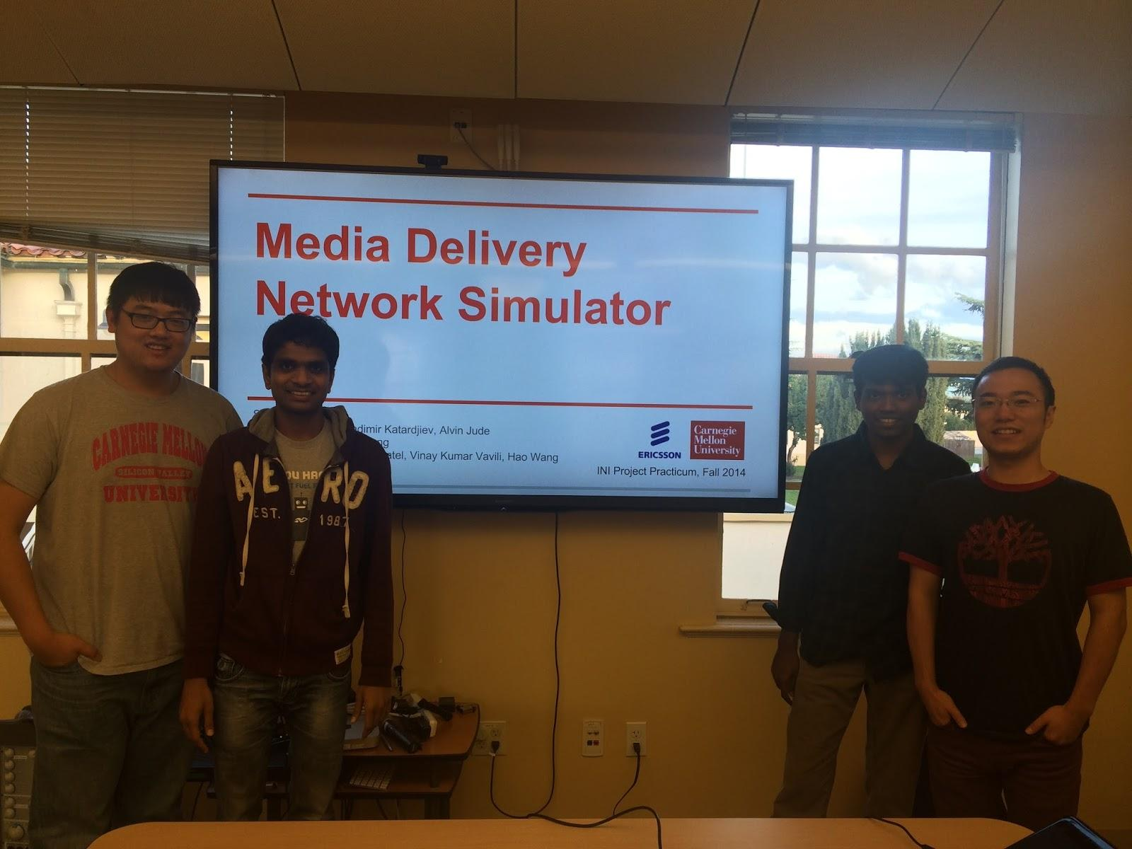

Team Members (from left to right)

Geng(Jeremy) Fu , Jigar Patel, Vinay Kumar Vavili, Hao Wang