**Test Suite**

We will register two accounts in our system and test the functionalities.

|  |  |  |
| --- | --- | --- |
|  | Email | Password |
| User 1 | [bob@gmail.com](mailto:bob@gmail.com) | 123456 |
| User 2 | [jeff@gmail.com](mailto:jeff@gmail.com) | 123456 |

1. Register a user using the account info User 1.

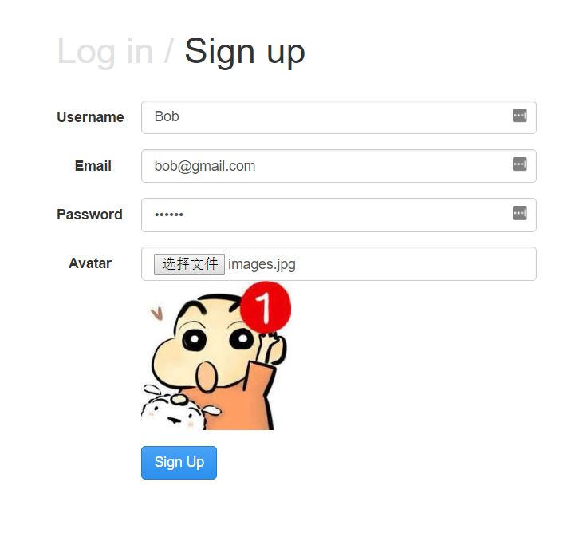

1. Sign in with the email you just registered. Our system will redirect to the home page.

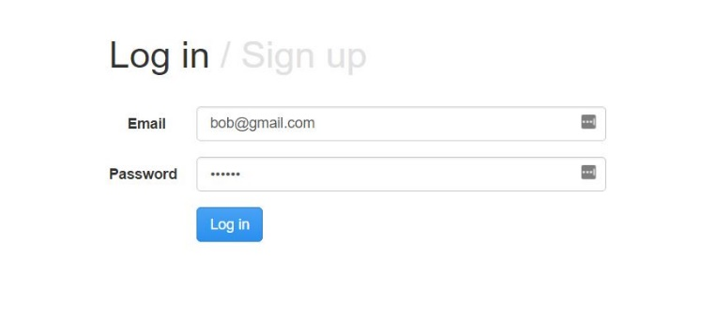

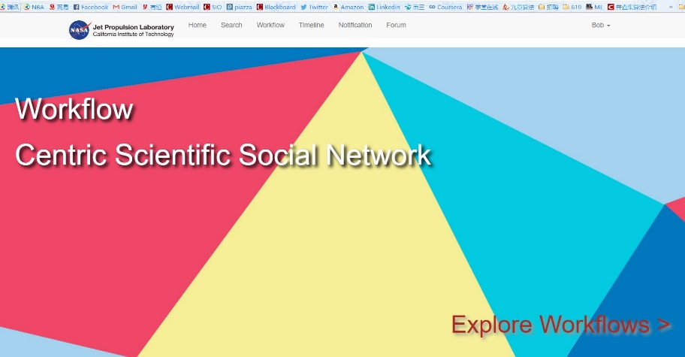

1. Enter the **Form**. In the form page, we can find there is an existing workflow called Mouse Microarray Analysis

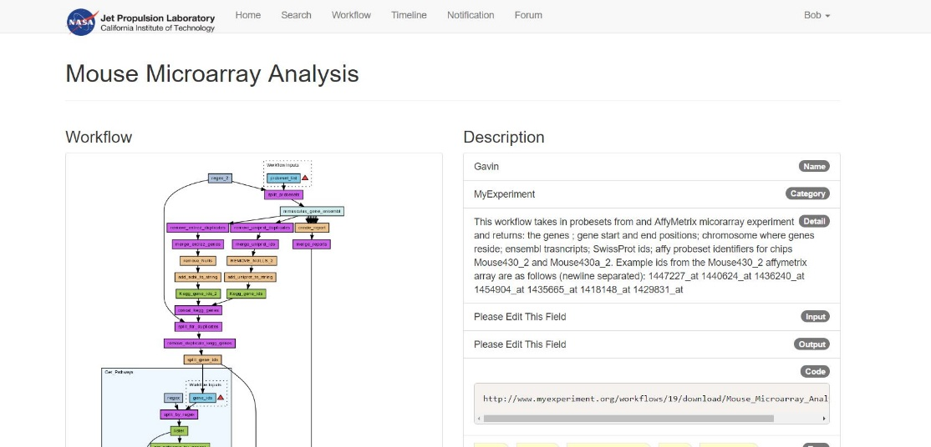

1. Test the **Search** function.

Enter the **Search** service page. Search for the Mouse Microarray Analysis workflow using keyword “Microarray” in the searching box. Choose Workflow as the searching category.

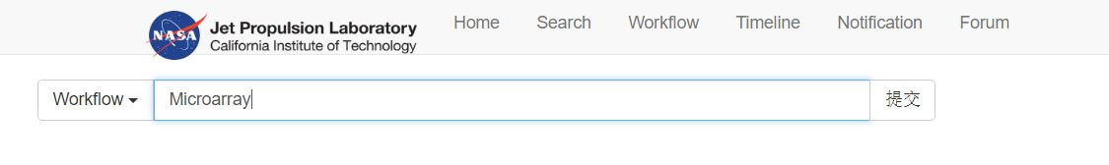

We can find the result later.

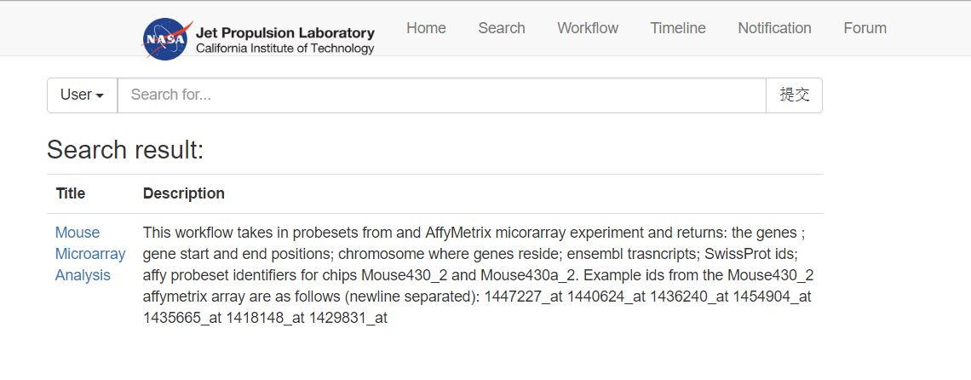

1. Test the **Workflow** service

We can create a new Workflow in the Workflow service page. Enter the page and type in all the necessary information as shown below.

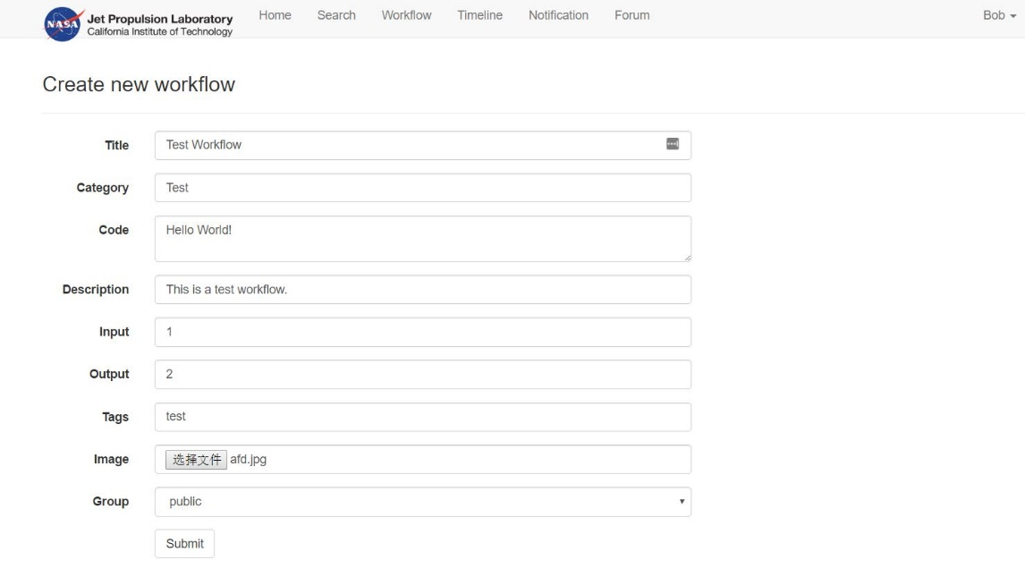

After creating the new workflow successfully, we could see the new workflow in the form.

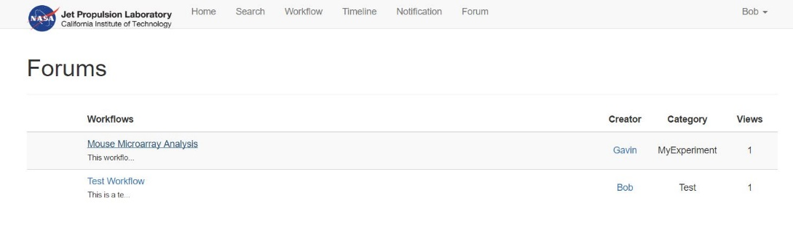

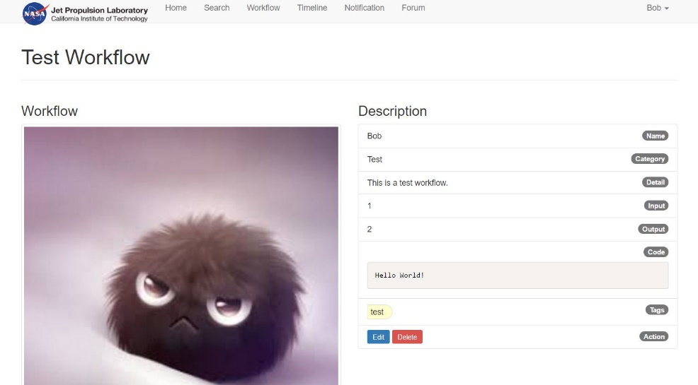

1. We can also see the recent activities via the **Timeline** servce page

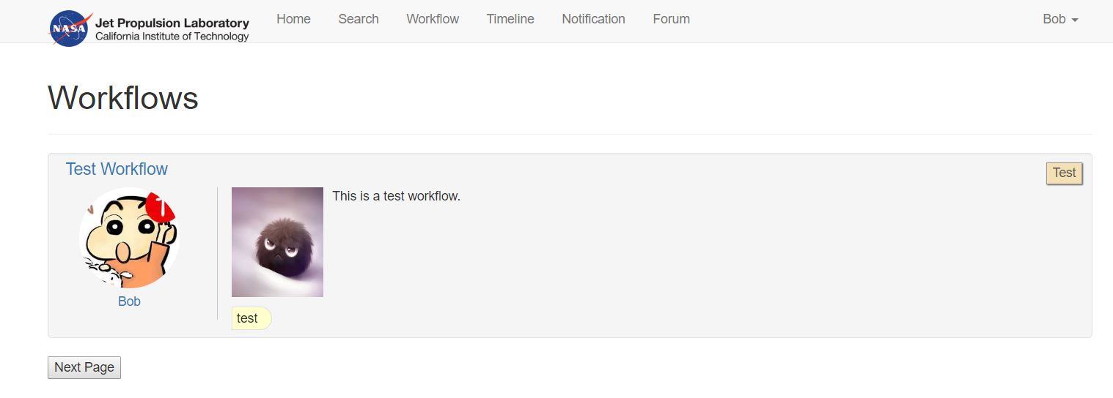

1. Test the **Create Group** function.

Click on the username at the top-right corner. Choose “Create Group” in the menu.

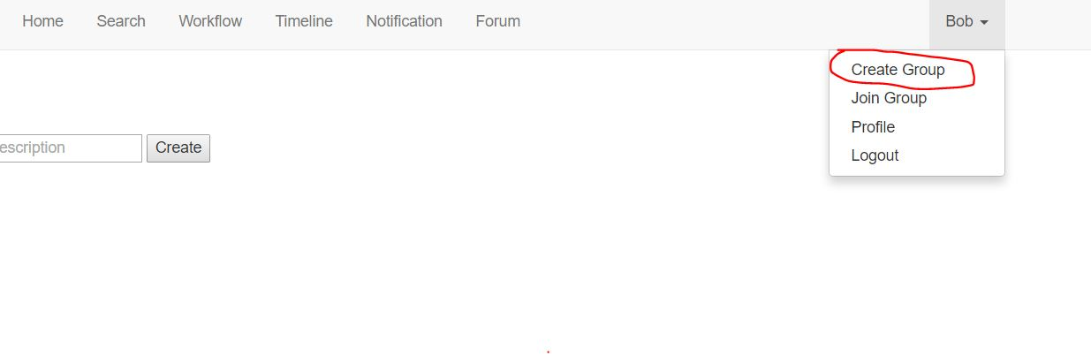

In the Create Group page, enter group name and the description of the group.

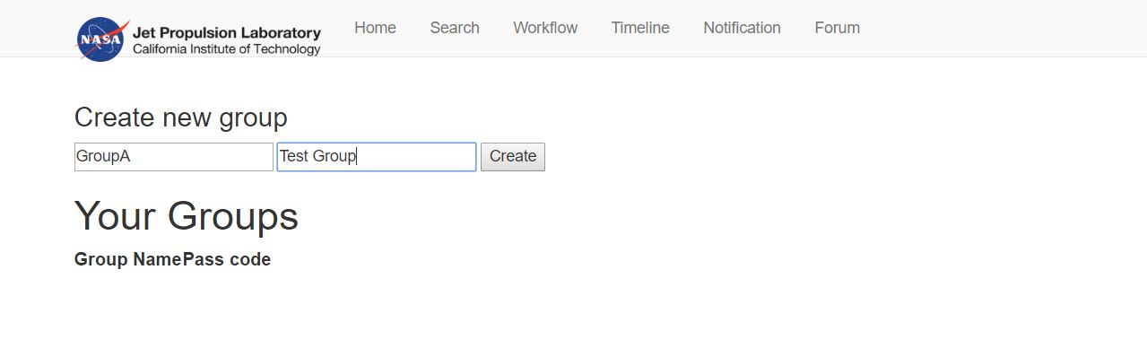

Few seconds later, we can find the new group is created successfully.

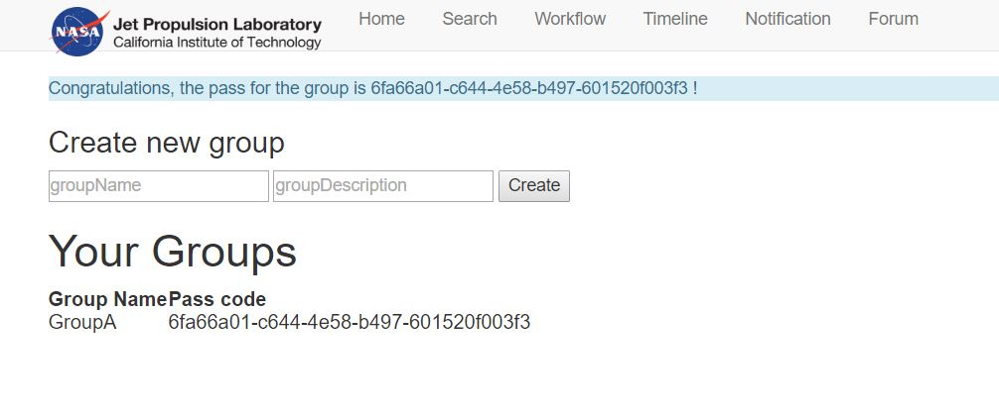

1. Create a new user and test the functions for social network.

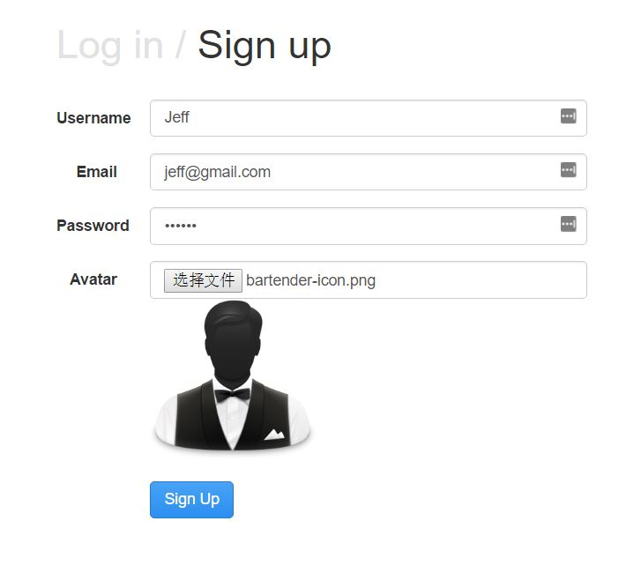

Click on the username at the top-right corner of the page and choose the **Profile** page. Now we can see the profile of Jeff.

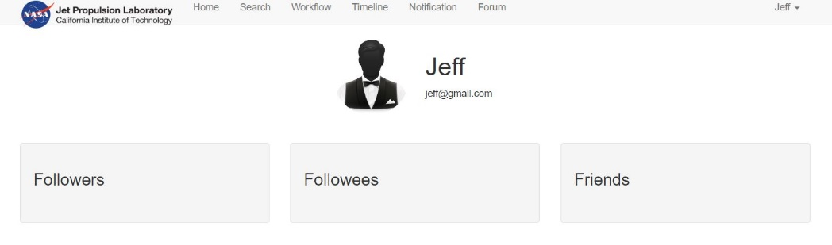

1. Follow Bob.

Enter the **Form** page and click on the username **Bob**.

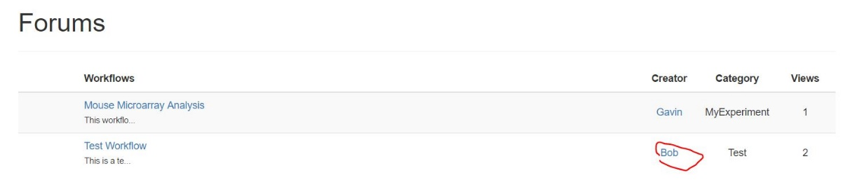

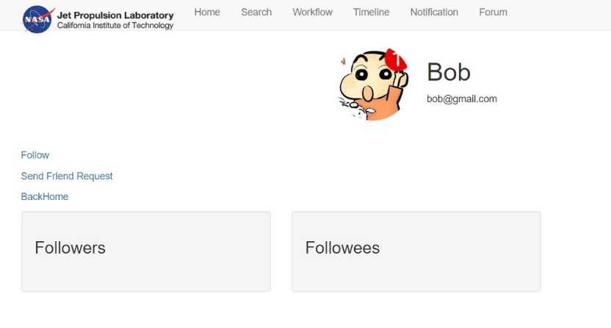

You can see Bob has a new follower.

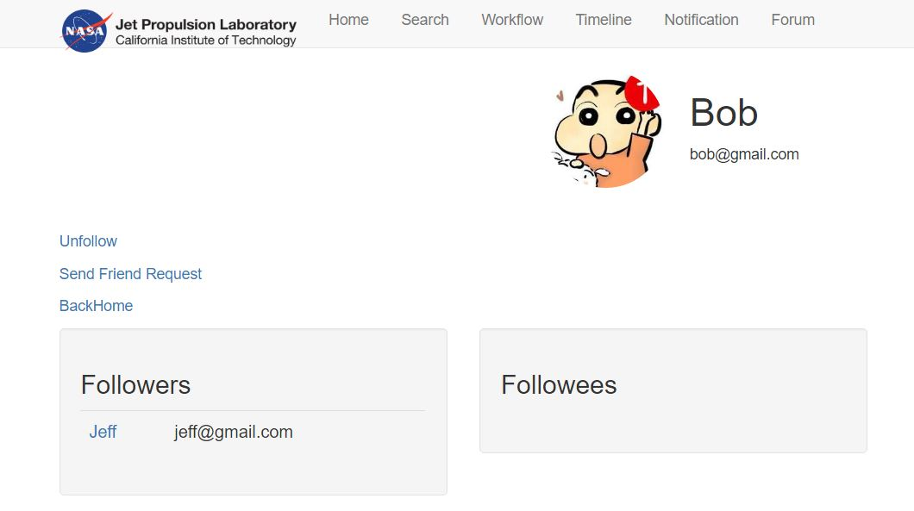

In Jeff’s personal profile, we find he has followed Bob.

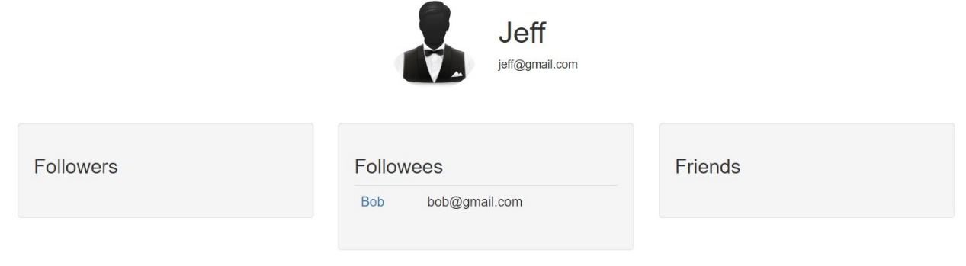

1. Join a group.

Click “Join Group” in the top-right menu. Enter the pass code of the group that we just created in user Bob, and then click “Join”.

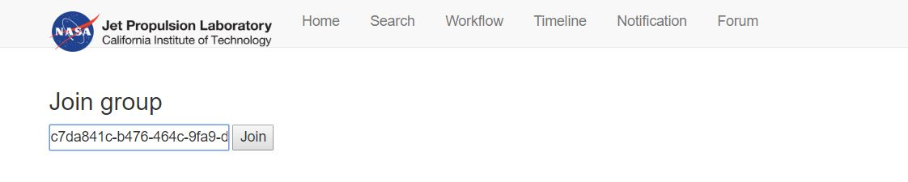

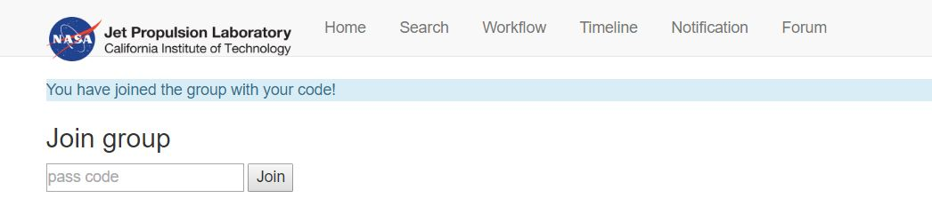

1. Test **Suggestions** and **Comment**.

Enter the Form service page and choose the Mouse Microarray Analysis workflow.

Type in your suggestions in the Suggestion box.

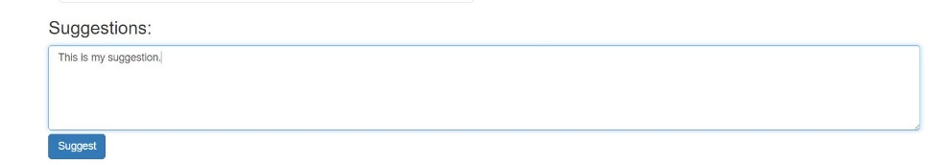

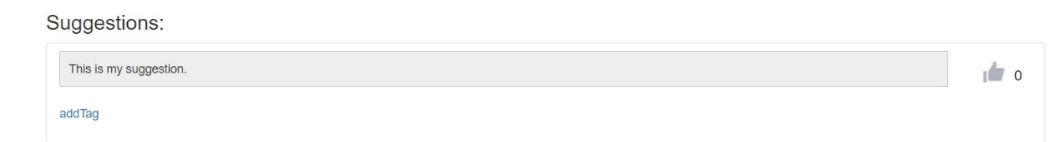

You can also add a tag for this suggestion.

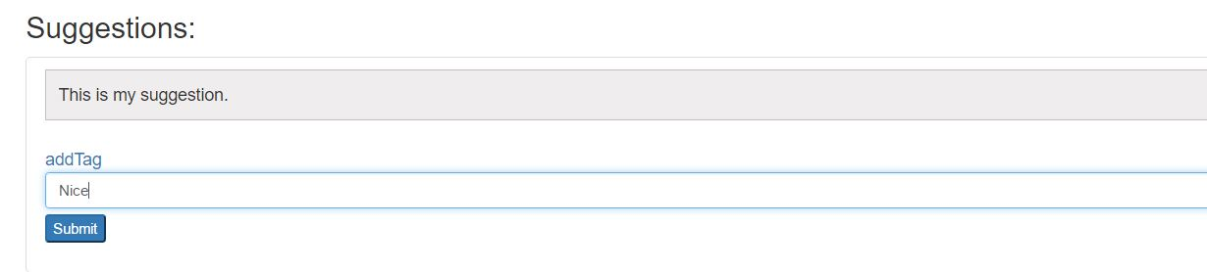

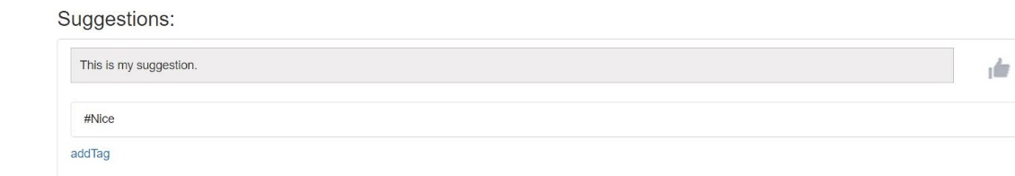

You could add a comment in the Comment box and then reply this comment.

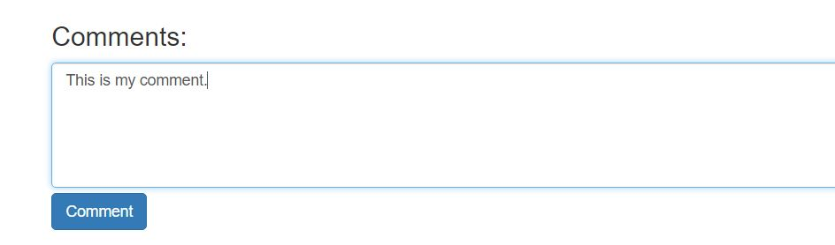

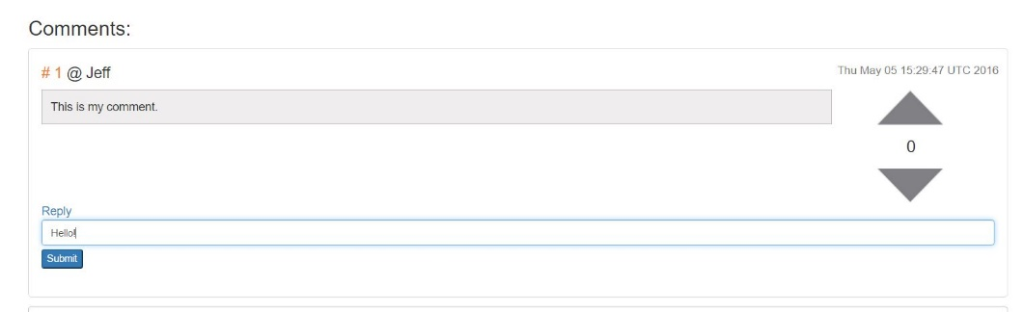

Reply the comment.

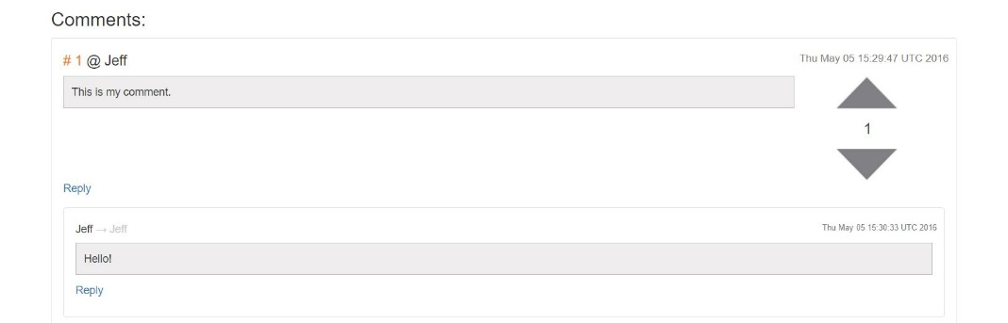

Finally, you could click the Arrow on the right to endorse this comment.

