***Access Information***

1.First type localhost:9234

2.Sign-up page

Username: TEST

Email: TEST@GMAIL.COM

Password: 12345

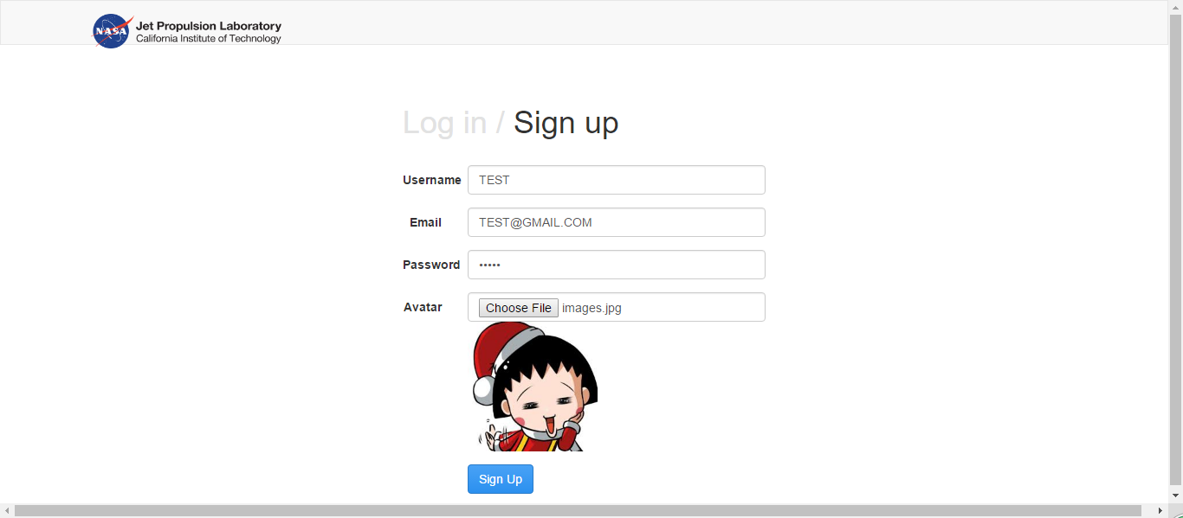

3.Registered successfully

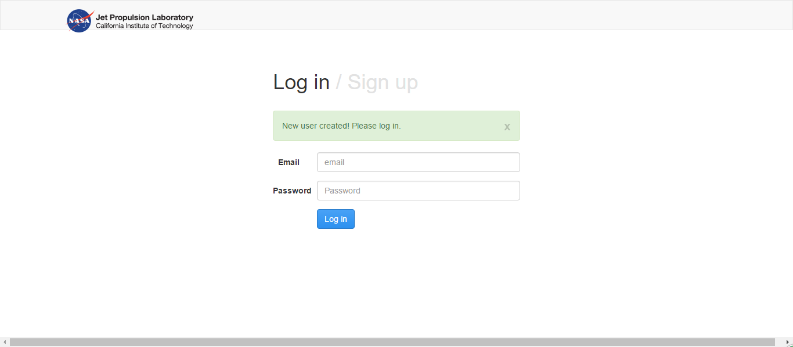

4.Login :

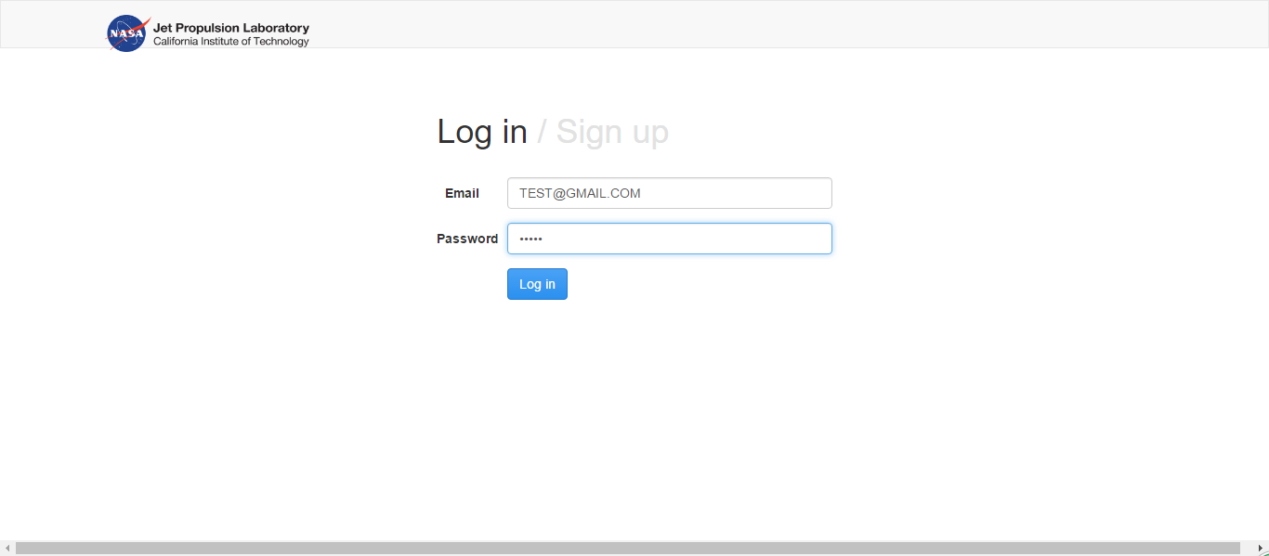

Successfully login the website:

