**Download and Installation**

Step 1: Download and install Docker and Virtual box.

Step 2: Open Virtalbox client. Select `**default**` VM and Click on **Settings** to enter the settings dialog.

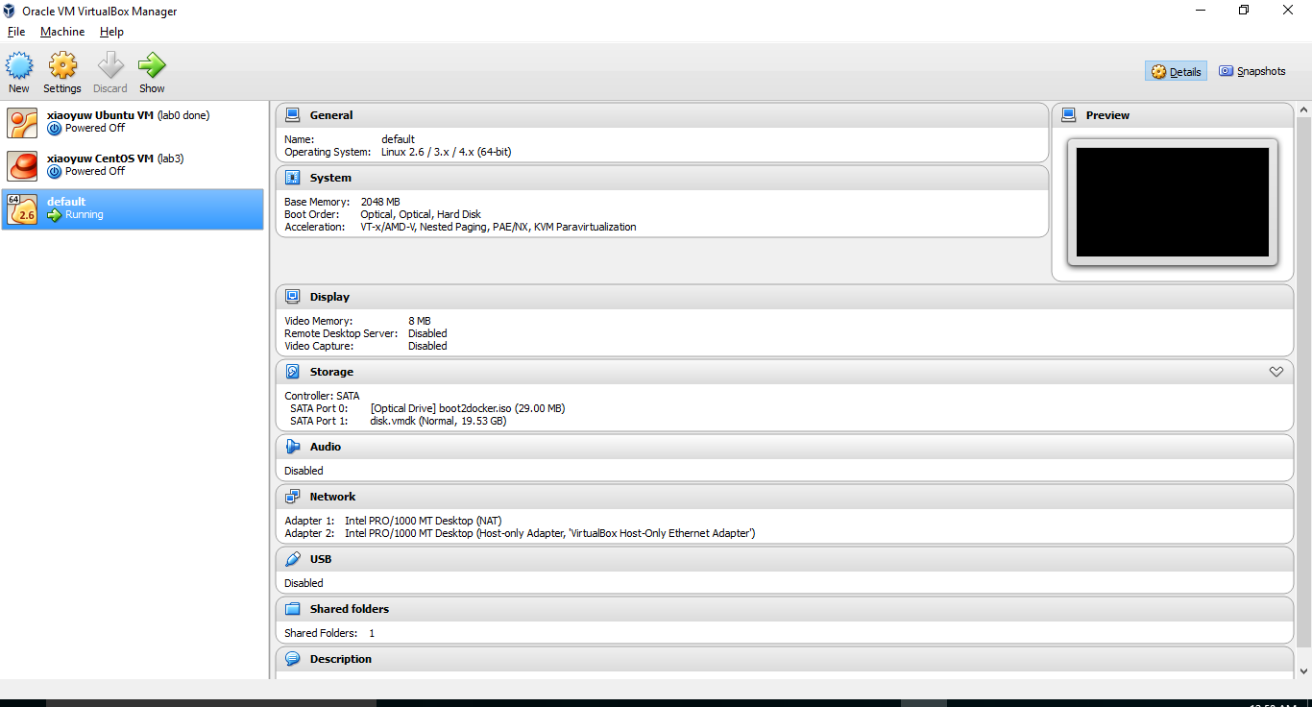 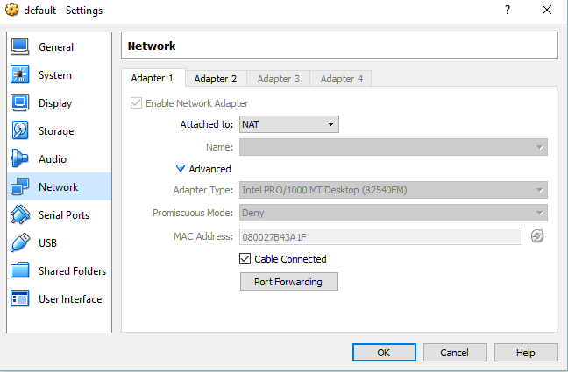

Step 3: Click **Port Forwarding** and set up the port mapping. 9234 : 9001

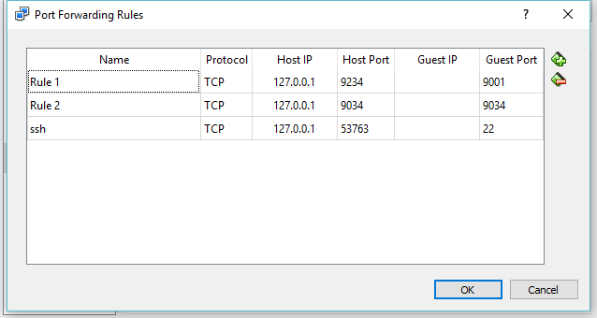

Step 4: Open Docker QuickStart terminal. Enter commands to start Docker container.

docker run -it -p 9001:9000 -v /c/Users/wxy/653:/home/Spring2016/Dev cmusvsc/apachecmda:1.1

It also maps the folder in host machine to the folder Dev in Docker machine.

Step 5: Copy ApacheCMDA-Frontend and ApacheCMDA-Backend to the folder Dev. Since it is mapped to a folder in the host machine, the same contents should also appear in the host machine.

Step 6: Download and install Sublime.

Step7: Select File -> Open Folder and locate the folder in host machine. Then the project should be loaded into the sublime editor. We can do code implementation in it.

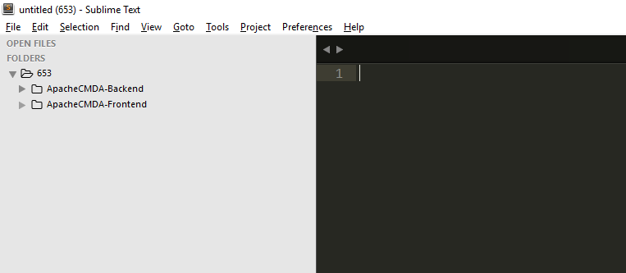

Step 8: Start Frontend.

cd /home/Spring2016/Dev/ApacheCMDA-Frontend

./activator “run 9000”

Step 9: Start Backend. Open another terminal. End type commands:

docker exec -it `docker ps -q` /bin/bash

service mysql start

cd /home/Spring2016/Dev/ApacheCMDA-Backend

./activator "run 9034"

Finally, both the Frontend and backend are built and you can test and modify your code in Sublime editor and test it in the browser by typing: <http://localhost:9234>.