**Tutorial**

We have provided a tutorial for how to test this project. First, ensure that you have successfully installed Docker and related software.

1) Load the provided image which has already configured the environment for this project. In addition, mount the front-end server directory into a directory into Docker. An example is given as follows:

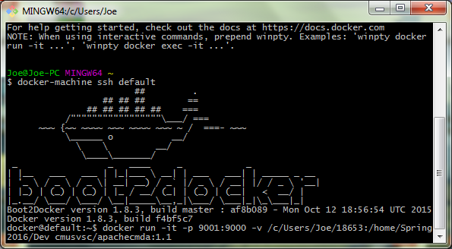

2) Change the directory in the Docker image to the directory mapped to the front-end directory in local machine. An example is given as follows:

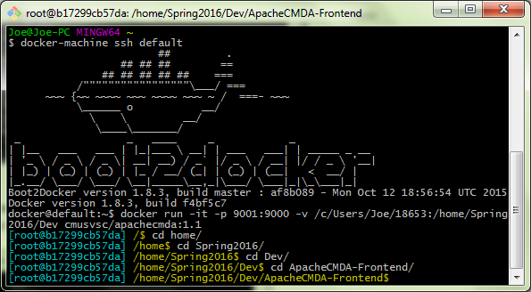

3) Start front-end server with the command: ./activator run ‘’9000”, and an example is given as follows:

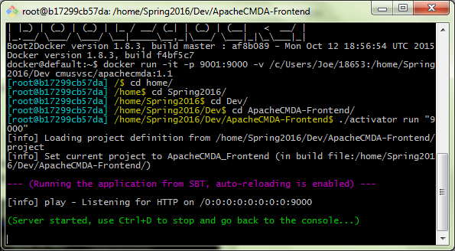

4) Open another docker terminal and input the command “docker exec -it `docker ps -q` /bin/bash”, an example is given as follows:

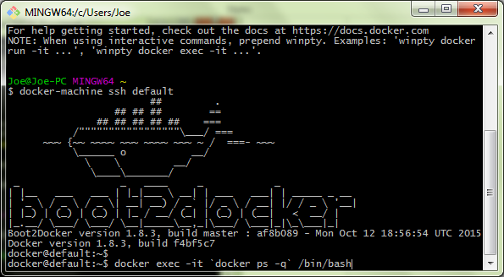

5) Start the mysql service and start the back-end server at port 9034 with the command: ./activator “run 9034”. An example is given as follows:

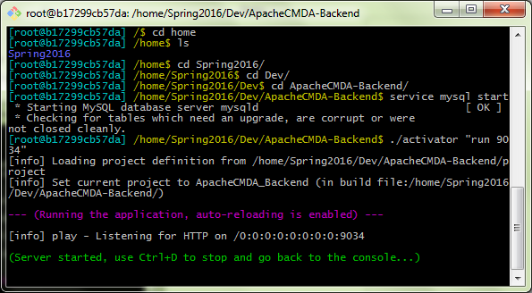

6) Test the web application at a browser and the URL is <http://localhost:9234/>, and the following is an example:

