## Step by Step Instruction

**Prerequisite**: Docker & Virtualbox are correctly installed (both by docker installation package)

1. Start **Docker Quick Start Terminal** and wait until VM is started

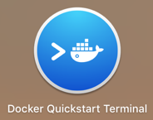

2. Set up port forwarding

1. Open **Virtualbox** client; Select `**default**` VM and Click on **Settings** to enter the settings dialog.

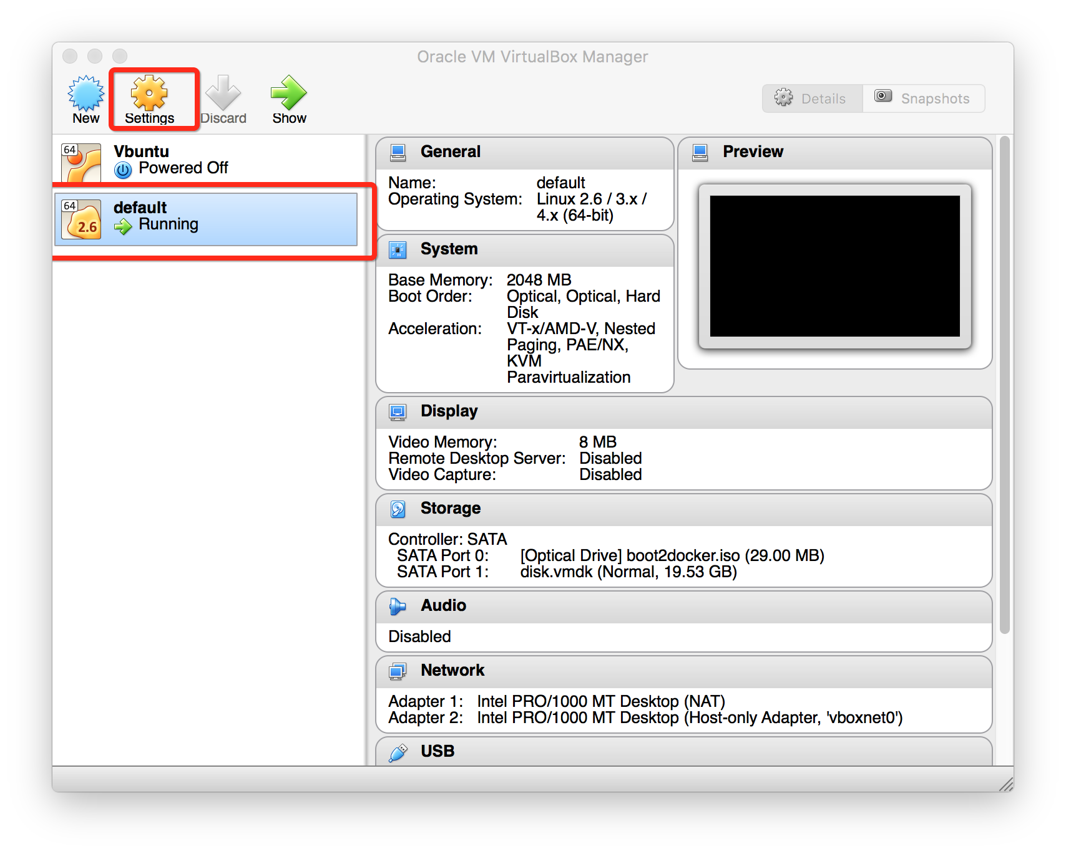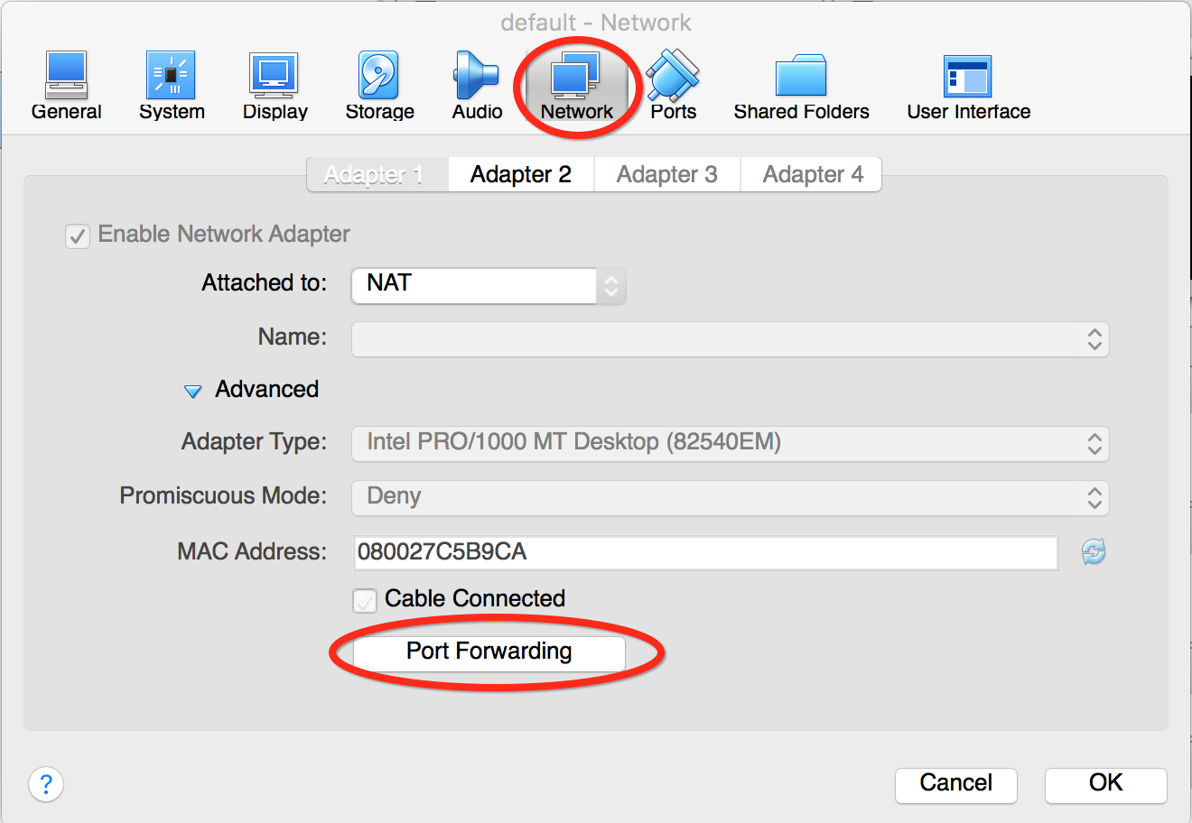

1. Navigate to **Network** tab and click on **Port Forwarding** button
2. Add a new rule with port number **A** and **B** (explain later)

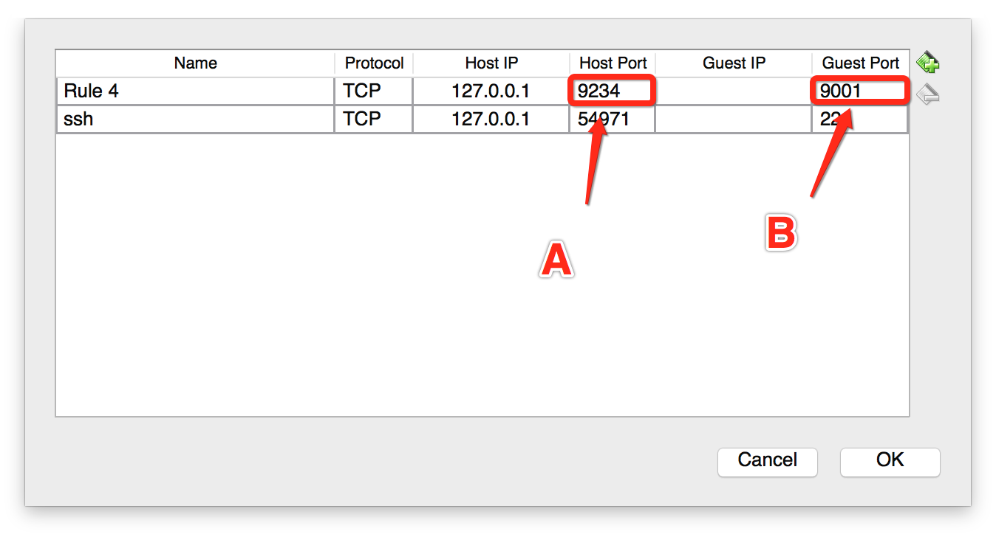

1. Click **OK** buttons on both dialogs and go back to Terminal

3. Run Application

1. Enter commands to start docker container (the first time run will take long because it’s going to download the image automatically)

$ docker run -it -p 9001:9000 cmusvsc/apachecmda:1.1

# Assume 9001=C, 9000=D (explain later)

1. Commands to run Front-end

$ cd /home/Spring2016/ApacheCMDA-Frontend

$ ./activator run # this is equivalent to /activator “run 9000”

1. Keep current terminal open and start another **New** Docker Terminal using the same tool as step 1
2. Enter command in **New Terminal** to log into the running docker container

$ docker exec -it `docker ps -q` /bin/bash

1. Start MySql

# service mysql start

1. Start backend application at port 9034

# cd /home/Spring2016/ApacheCMDA-Backend

# ./activator “run 9034”

4. Test with browser on your local machine with URL http://localhost:9234

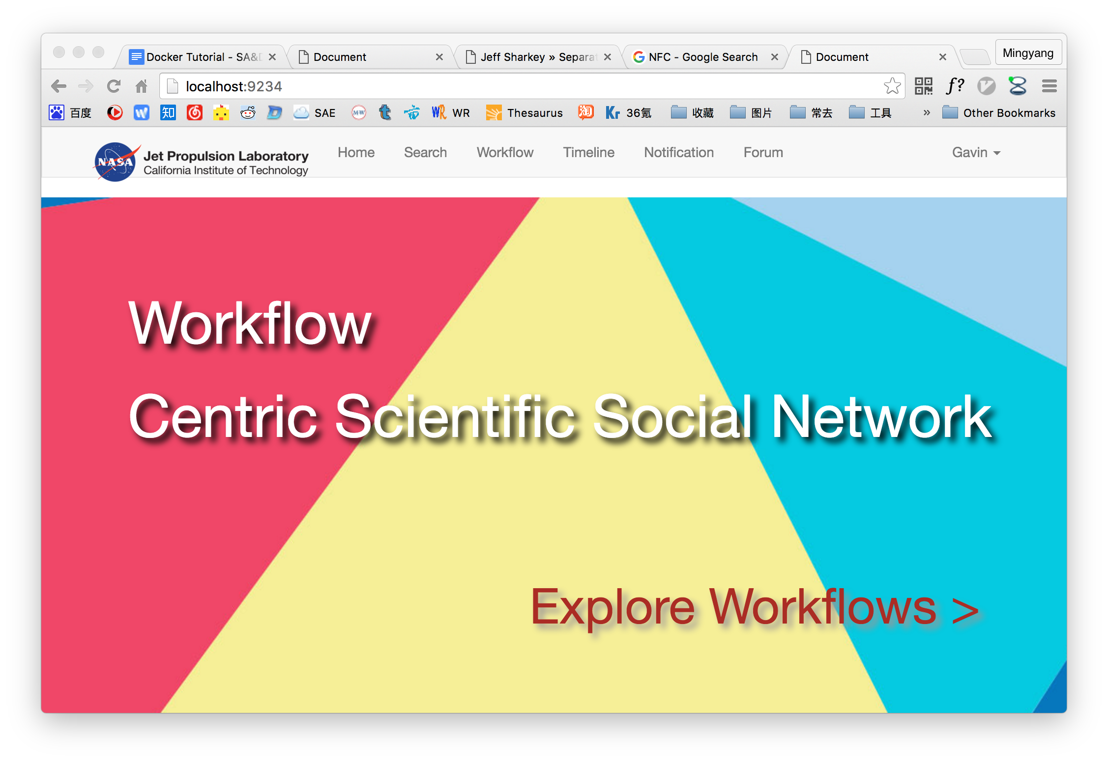

Port Forwarding Explanation

Remember the port numbers we have? A, B, C and D (A=9234, B=9001, C=9001, D=9000)

**A** is the host port number where you can access the application

**B** is the forwarding target on the Virtual Machine

**C** is the forwarding source on Virtual Machine

**D** is the target on Docker Container.

So, we can access the application at **A** on **local browser**, **B** must equals to **C**, and the Front-end application on Docker container should be running at **D**.

The backend application must run at 9034 because front-end program communicate with backend at this port number

Shared Folder

Using shared folder is a convenient way to develop with docker. You can put your code on local machine and map the folder to docker container. Then you can edit the code locally and run it in docker environment. Please check out the folder sharing option in the **docker run** commands below.

## Commonly Used Commands

Initial Steps

<https://docs.docker.com/mac/>

Reset the Default Virtual Machine

$ docker-machine rm default  
$ docker-machine create --driver virtualbox default

Set Port Mapping in Virtual Box:

Default Virtual Machine

->Settings

->Network

->Adapter1

->Port Forwarding

->9234-9001

Start Docker Image and Application

$ docker run -it -p 9001:9000 cmusvsc/apachecmda:1.1

$ service mysql start

$ cd /home/Spring2016/ApacheCMDA-Frontend/

$ ./activator run

$ cd /home/Spring2016/ApacheCMDA-Backend/

$ ./activator “run 9000”

TMUX

$ sudo apt-get install tmux

$ tmux

$ Ctrl+B C

$ Ctrl+B P

$ exit

Folder Mapping

$ docker run -it -p 9001:9000

-v ~/localFolder:/sharedFolder cmusvsc/apachecmda:1.1