**Tutorials**

1. Make sure you have installed Docker correctly.
2. Open Oracle VirtualBox and select the “default” VM. Choose the Settings manu.
3. Choose the Network submenu and edit the Port Forwarding configuration.

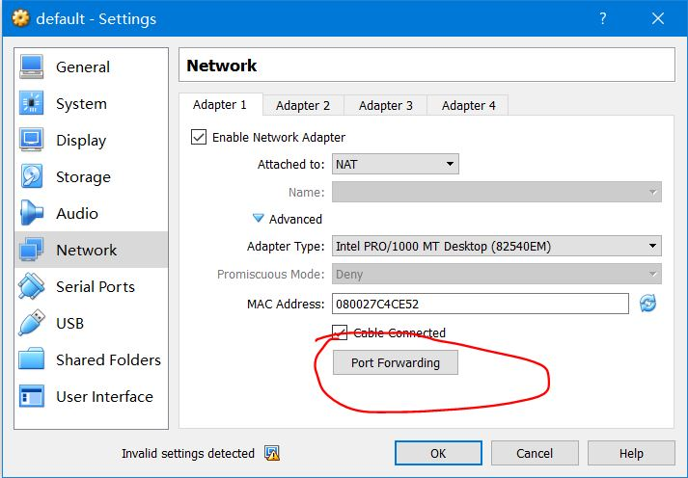

1. Set up port forwarding from guest port 9234 to host port 9234

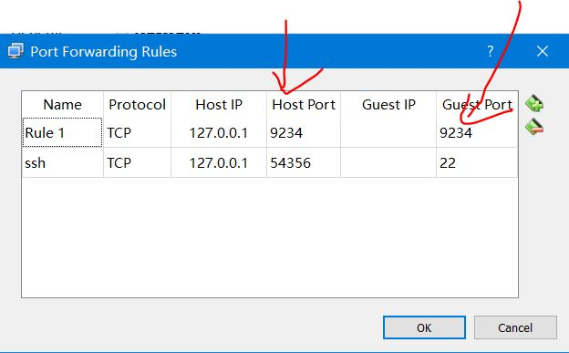

1. Create a development directory in your local machine and put the project under the directory, e.g., C:\Users\GitHub\Final\SOC-Fall-2015-Team1

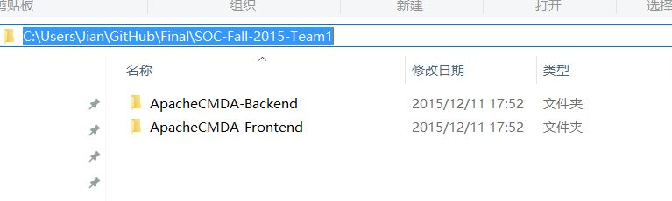

1. Open Docker Terminal and mount the local directory to the container by

docker run -it -p 9234:9000 -v /c/Users/GitHub/Final:/home/SOC-Fall-2015/Dev cmusvsc/apachecmda:1.0

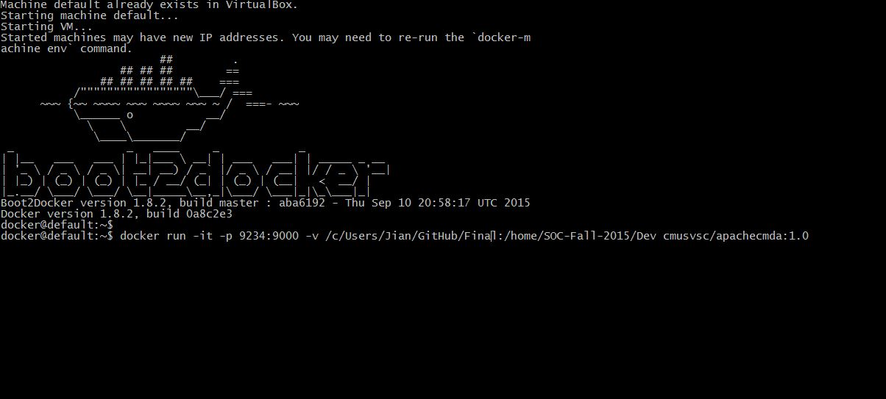

1. Change the current directory to the backend directory ApacheCMDA-Backend

cd /home/SOC-Fall-2015/Dev/SOC-Fall-2015-Team1/ApacheCMDA-Backend

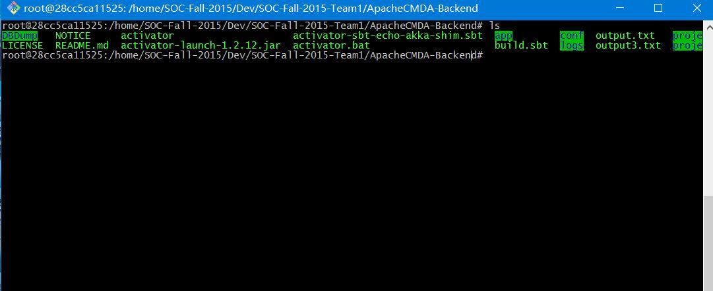

1. Run the MySQL database.

sudo service mysql start

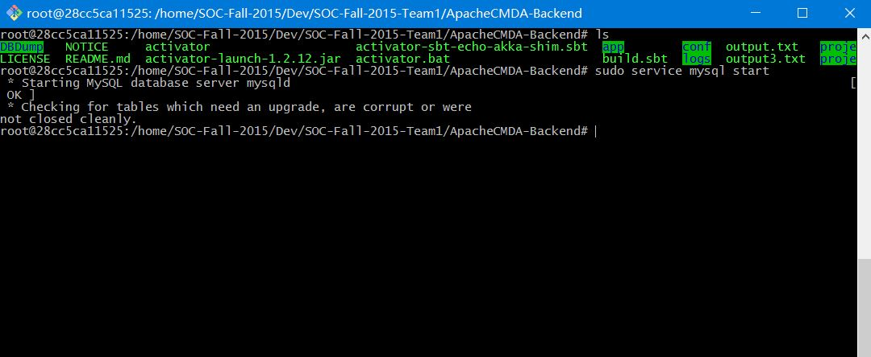

1. Create a Screen Session to start the backend.

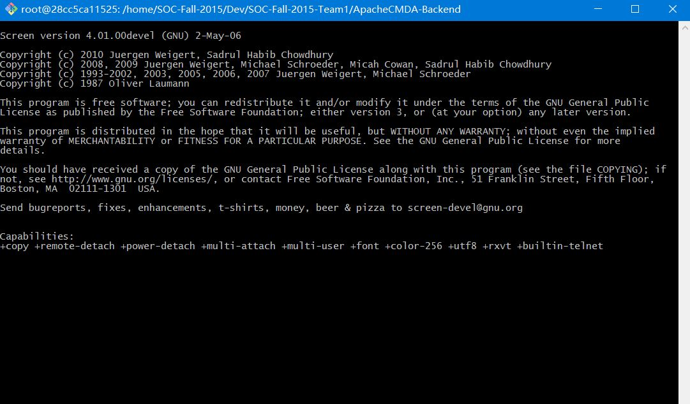

1. Start the backend server with port number 9034, then detach the session

./activator "run 9034"

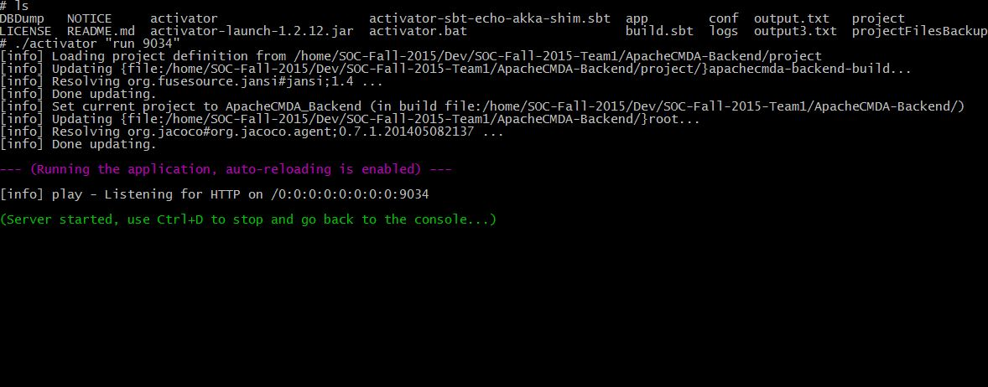

1. Detach the session by: CTRL + A + D
2. Go to the Frontend directory

cd /home/SOC-Fall-2015/Dev/SOC-Fall-2015-Team1/ApacheCMDA-Frontend

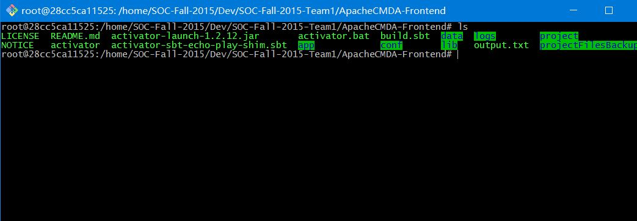

1. Run the frontend server: ./activator run

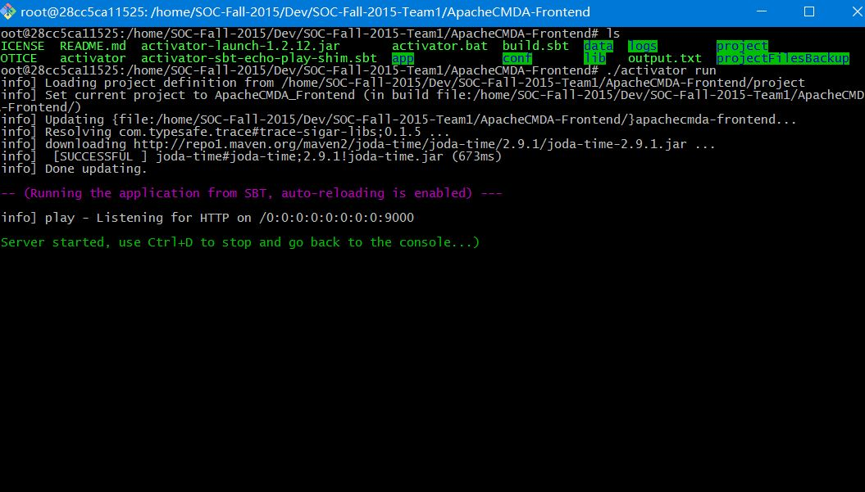

1. Open the URL below using your host’s browser:

<http://localhost:9234/>

1. Click on the Login button on the top right corner of the web page. You will be redirected to the Sign In page. If you have not signed up for our system, choose Sign Up a new account.

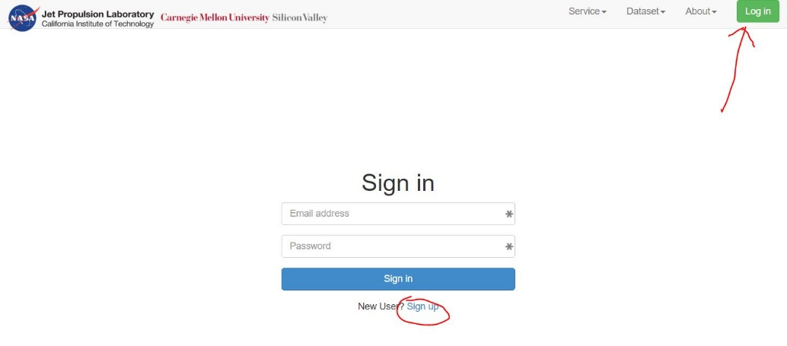

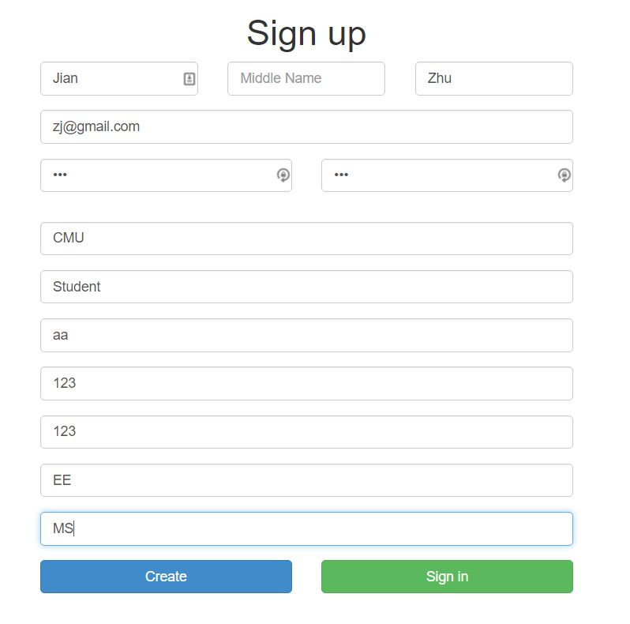

1. You will need to use the email and password you just registered to sign in our system. After signing in the system, you will be redirected to the home page of our climate service management system. Now You can choose the function from the menu in the header of the web page.

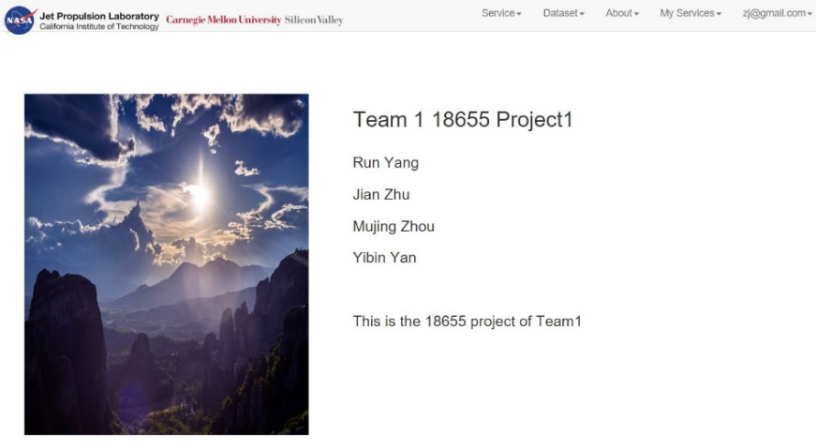

1. In the header of main page, you can click on “Service” to view the menu.

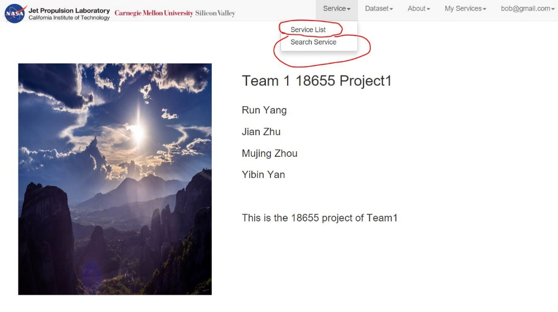

1. Choose Service List, and you will be redirected to our new service list page.

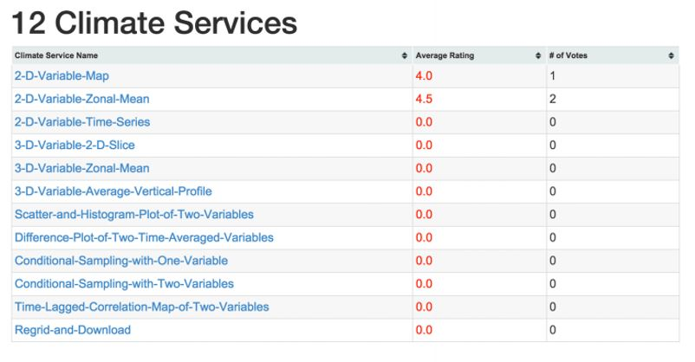

1. Choose one of the services, you can go to the individual service page.

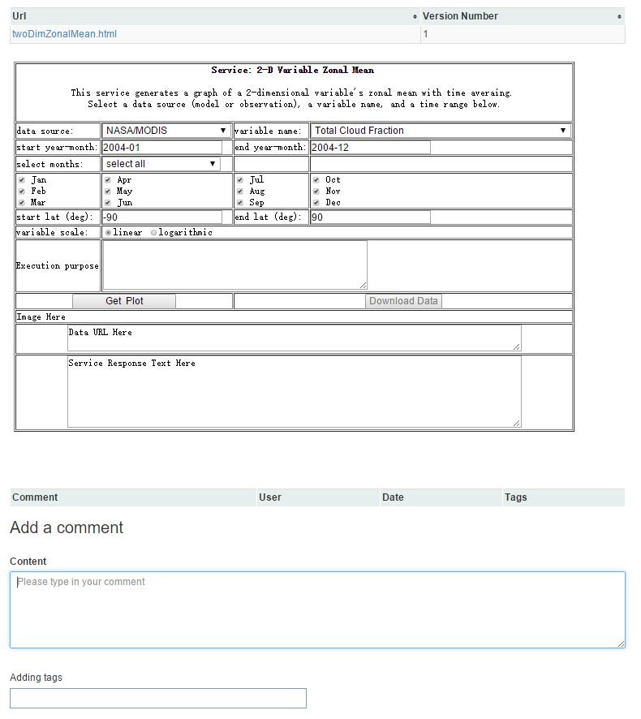

1. You can comment, tag, mention a service with #, mention a user with @.

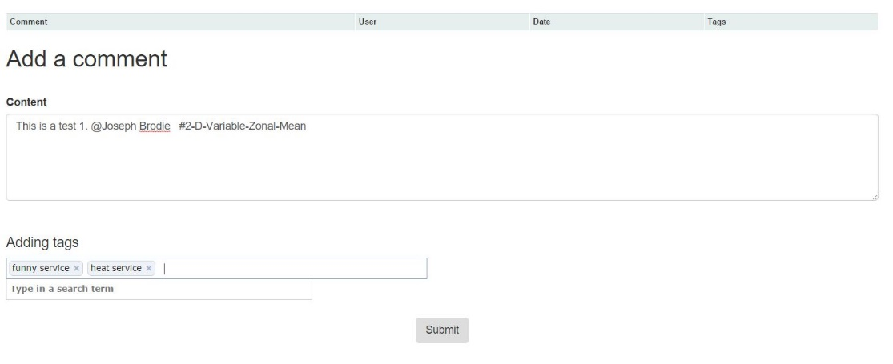

1. You can also rate and like a service.



1. Choose the “Search Service” in the header menu. You can search the key word.

