**Test Suite**

We will register two accounts in our system and test the functionalities.

|  |  |  |
| --- | --- | --- |
|  | Email | Password |
| User 1 | [bob@gmail.com](mailto:bob@gmail.com) | 123 |
| User 2 | [jeff@gmail.com](mailto:jeff@gmail.com) | 123 |

1. Register a user using the account info User 1.

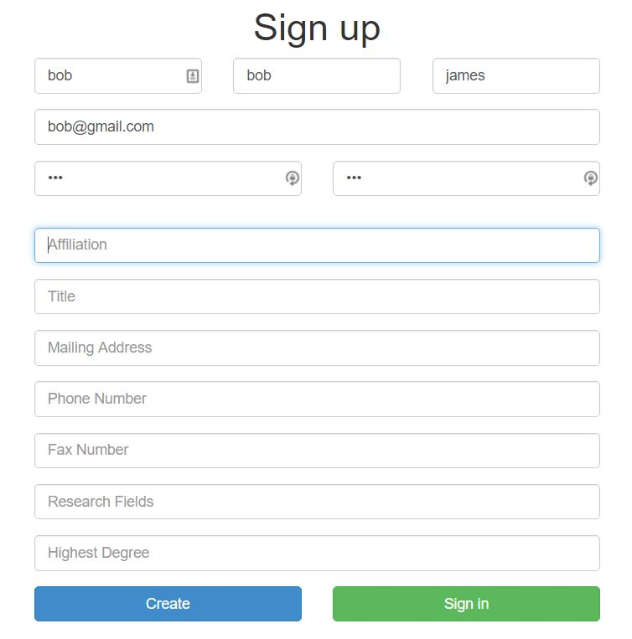

1. Sign in with the email you just registered. Our system will redirect to the home page.

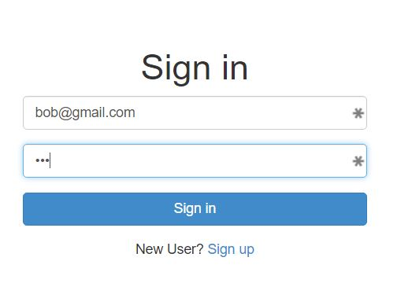

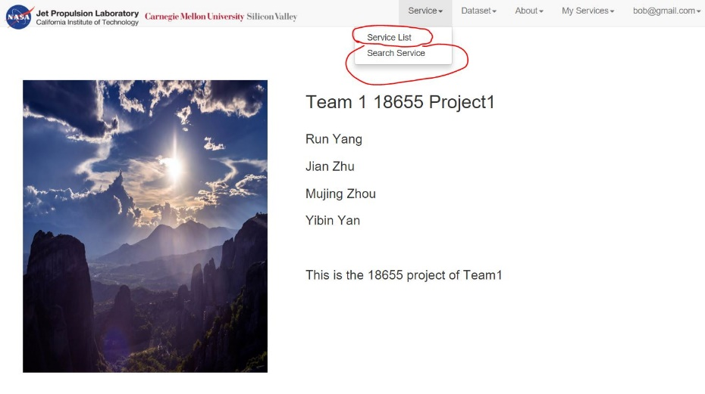

1. Test the keyword search function. Choose the “Search Service” in the header menu. Search the key word “2-D”. Three climate service containing “2-D” in their names will be returned as the results.

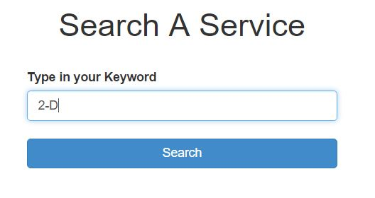

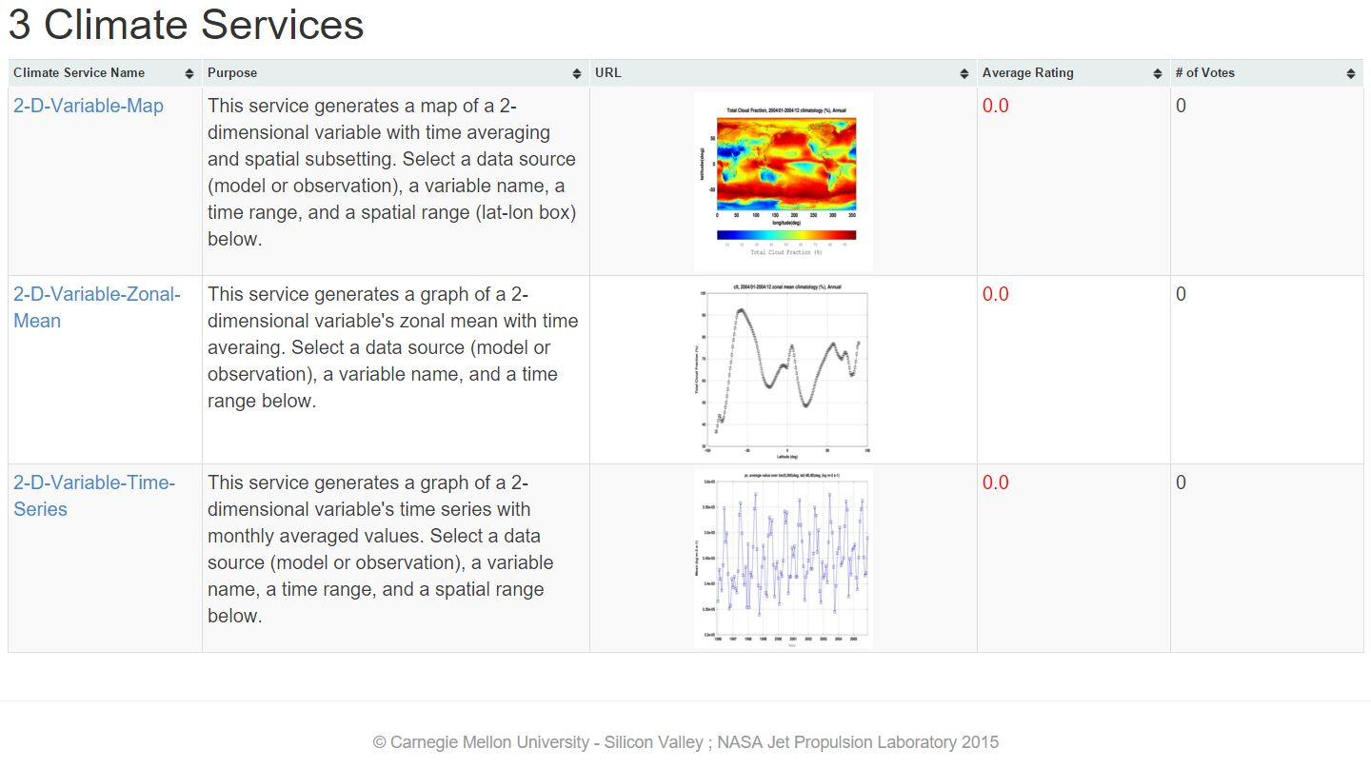

1. A glimpse of individual service page and version control.

Enter the “2-D-Variable-Map” service page. You will see the page as below.

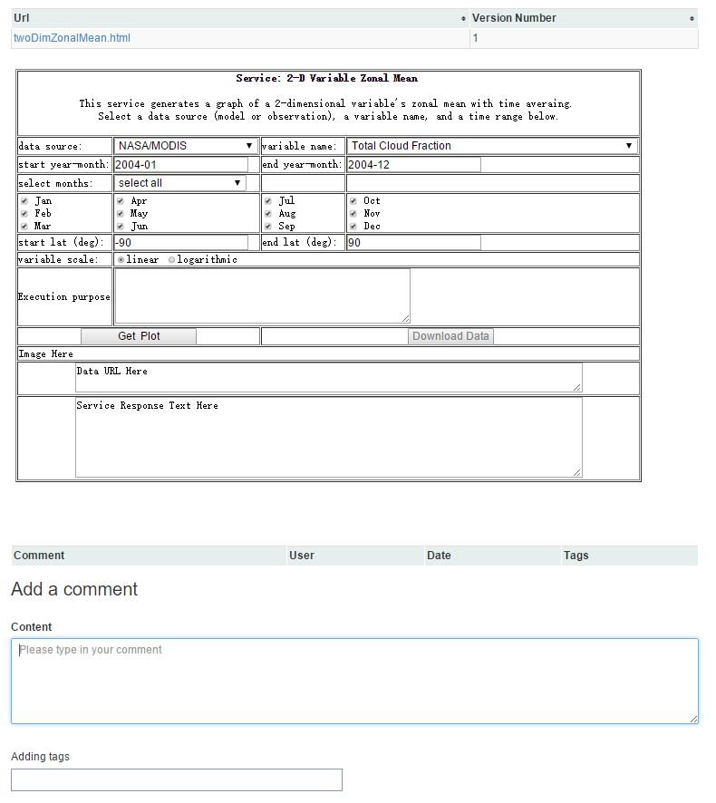

1. Test the comment, hashtag, @ and tag these four functionalities.

Choose the “Service List” in the header menu and enter the individual service page of “2-D-Variable-Map”. Type in “This is a test 1.” in the comment box. Mention Joseph Brodie and 2-D-Variable-Zonal-Mean service using @ and # respectively. Add funny service and heat service these two tags in the tag area.

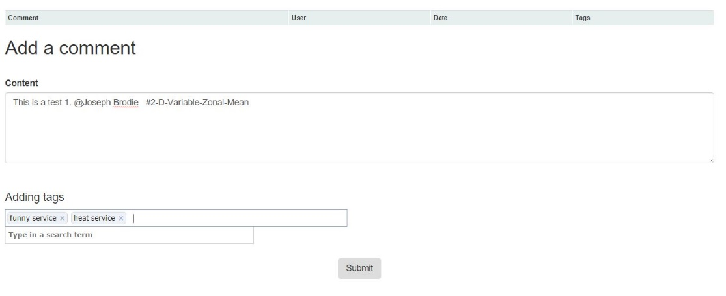

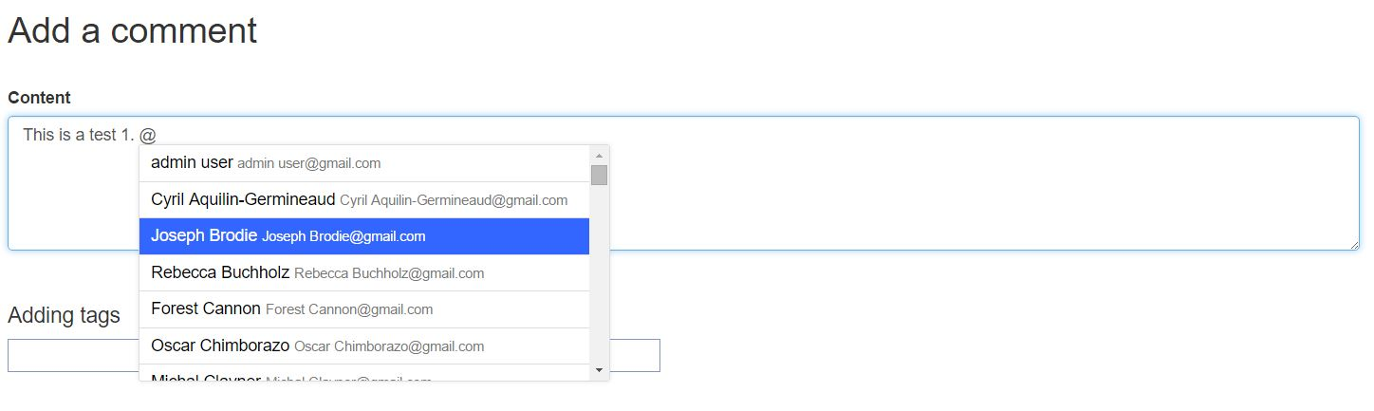

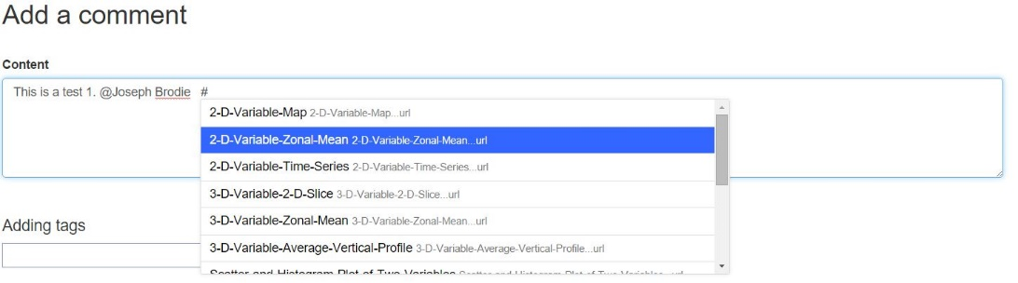

Submit the page and reenter the “2-D-Variable-Map” service page. You will see the results as the screenshots below.

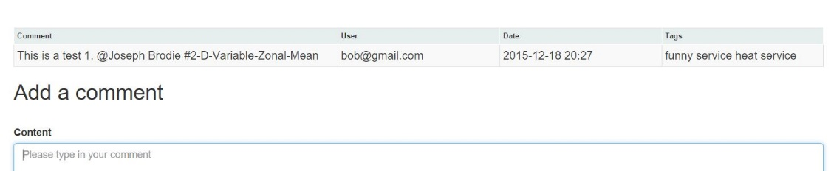

1. Test the rating functionality.

Choose the service “2-D-Variable-Map”. Rate 4 stars and like it.

Choose the service “2-D-Variable-Zonal-Mean”. Rate 5 stars and like it.

Choose the service “2-D-Variable-Time-Series”. Rate 5 stars and like it.

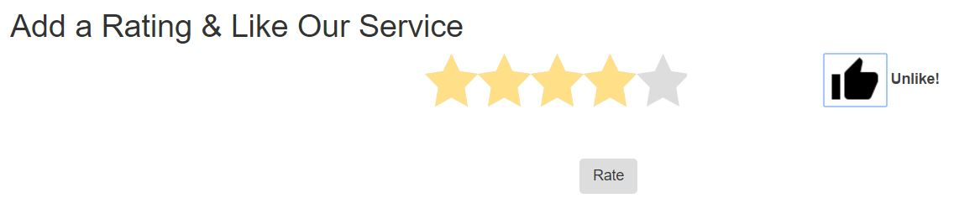

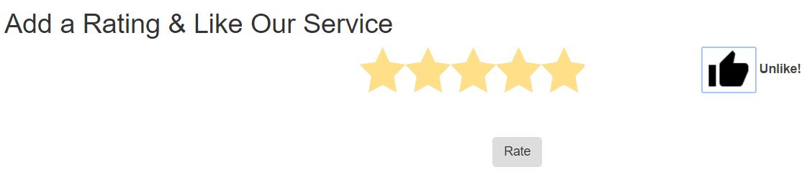

As a result, in the Service List page, you will see the results as the screenshot below.

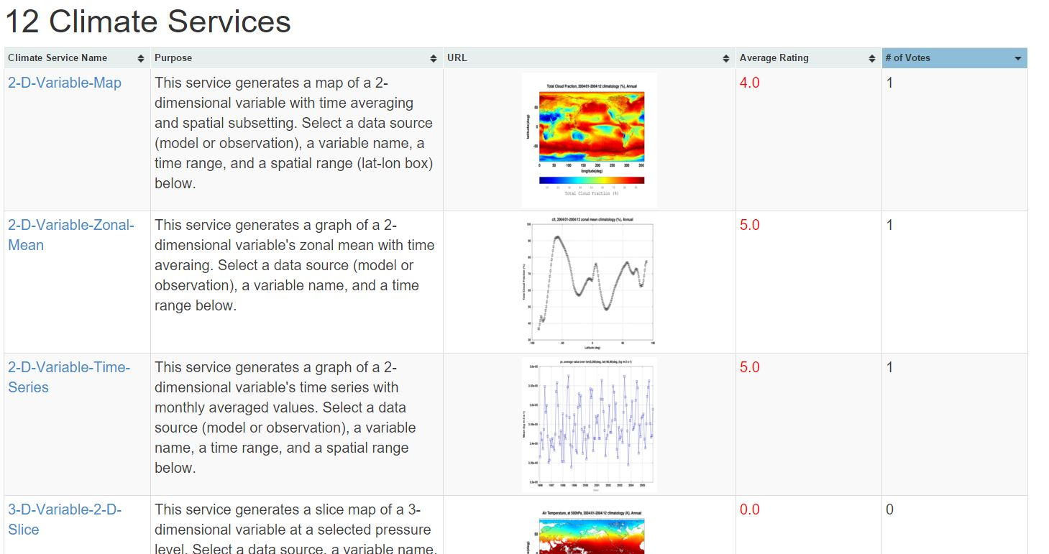

1. Test the Like and Recommendation functionality.

Log out the system and use the User 2 info to register for a new user.

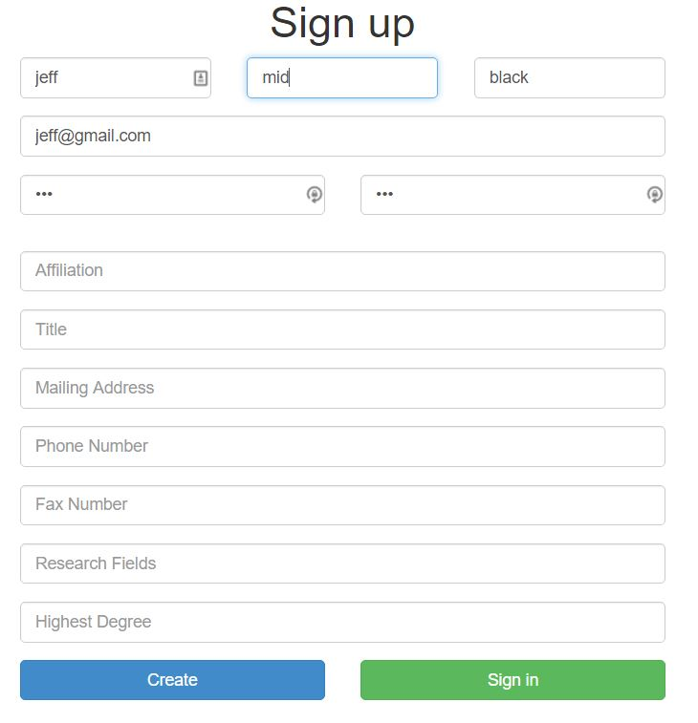

Enter the “2-D-Variable-Zonal-Mean” service page. Rate it for 4 stars and like it.

In the Service List page, you will see the following results.

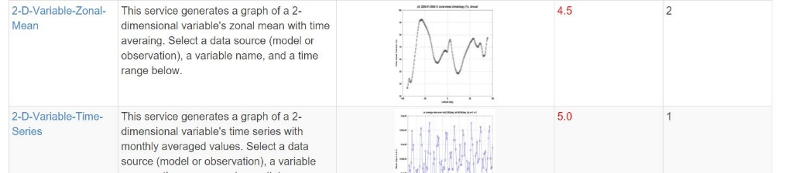

Re-enter the “2-D-Variable-Zonal-Mean” service page. In the recommendation area, you will see the following recommendation results.

