**Design Documents**

We used Play framework, JQuery, CSS, Bootstrap, spring framework and hibernate in this project.

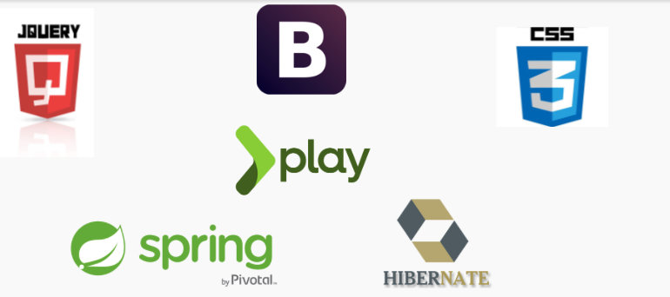

**Frontend**

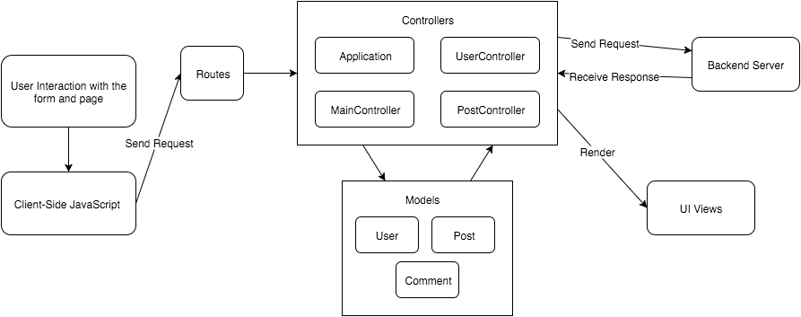

For the frontend, the flow image above is an overall design flow for the front-end part, which follows MVC design principle.

When user start to interact with the page or go the certain page and the client-side JavaScript will handle the user input and change the views correspondingly to give user feedback about his/her input. Meanwhile, the JavaScript also sends ajax requests to the front-end controllers. The routes defines the mappings from these request locations to controllers. These controllers will use the models that we designed to manipulate data and interact with back-end via sending HTTP requests and receiving response, mostly Json data. Based on the response and data that return from backend, controllers will parser the data and populate the views with the corresponding data using Scala template engine.

In addition to Play framework, we use jQuery to manipulate DOM element and sending ajax request, use Bootstrap and CSS3 to style the views and user interface. For the location feature, we also use Google Map APIs and HTML5 methods to get the latitude, longitude and location.

**Backend**

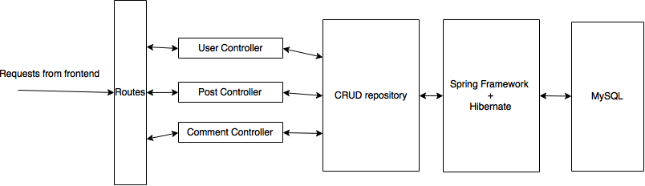

For the backend part, our design is that the HTTP requests from the frontend will be routed by the play framework to the corresponding controller, in our case, the controllers are user controller, post controller and the comment controller. The controllers uses the CRUD repository to perform CRUD operations on the models (user, post and comment). THe CRUD repositories use spring framework and hibernate to interact with MySQL to persist the changes.

The reasons for this design is that we can leverage the advantages of play framework, spring framework and hibernate. By using these frameworks, we could mainly focus on the logic of the changes on the models, instead of how to realize the tedious database and server operations. The routing can be completed by play framework, which can associate the incoming requests to the corresponding method in the controller. The controller can use the CRUD repository to perform operation on the model and let the spring and hibernate framework to translate the changes to the database.