# Tutorial

1. In the login page, login if you already have an account or register one if you don’t.

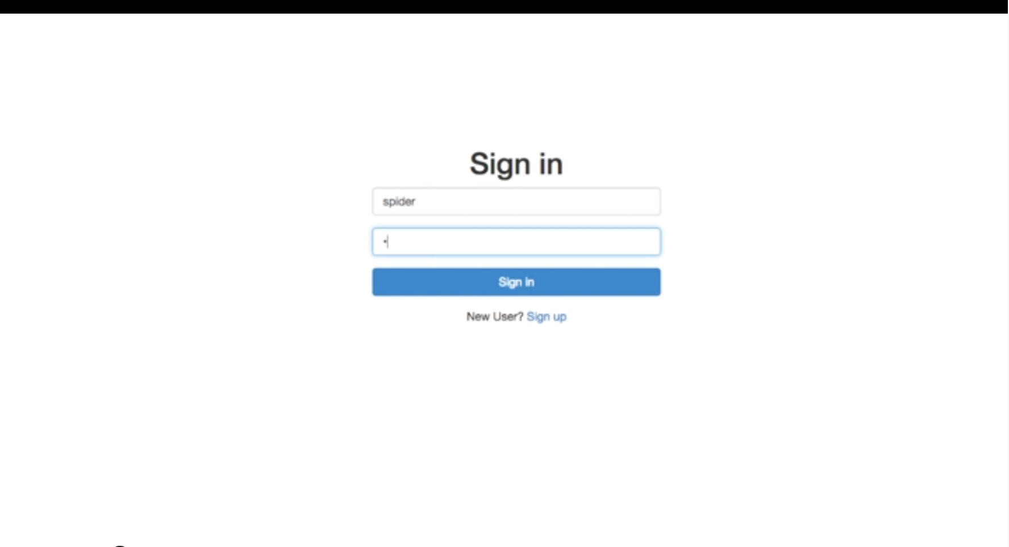

Register an account

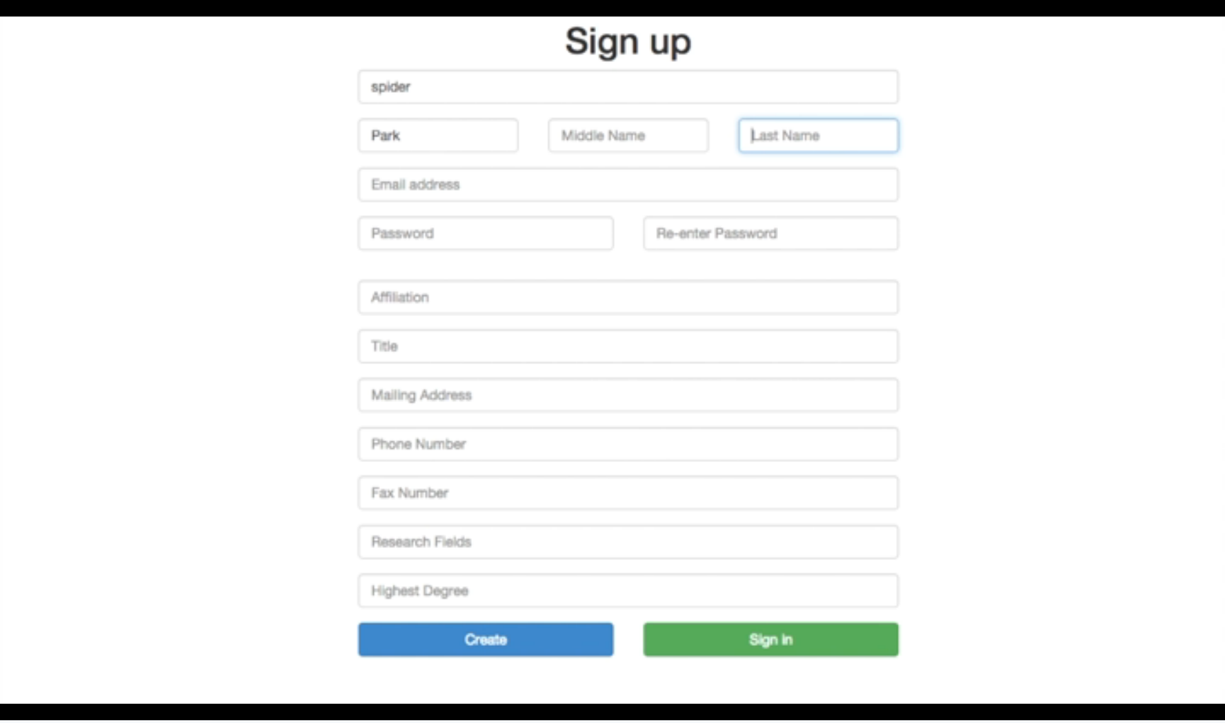

2. Once log into the site, you are automatically located to home page. You can choose to change your profile logo by clicking on the camera button on the left side.

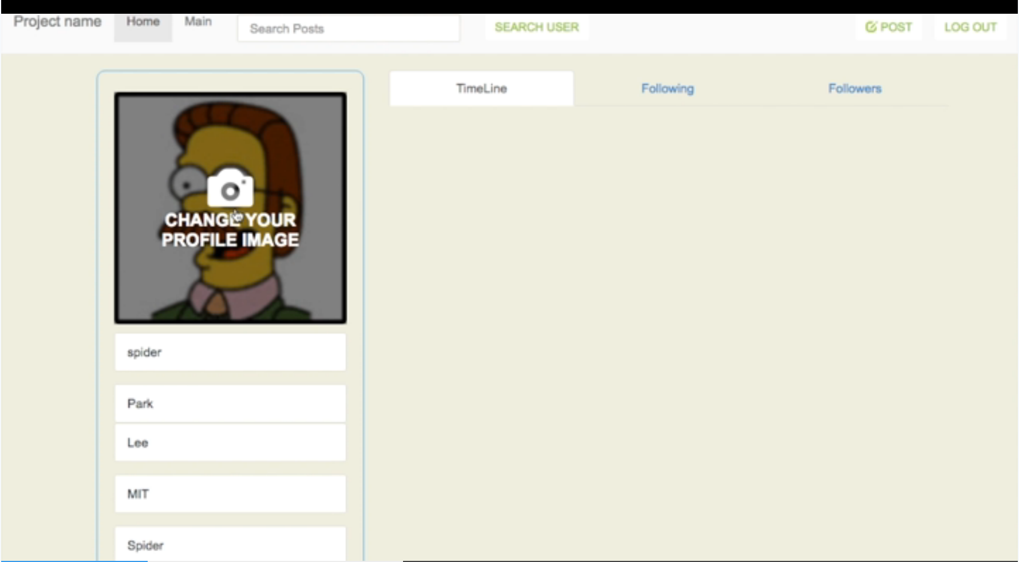

3. In the home page, you can view all of the posts that are posted by either you or people you follow. You can also check people you follow and people following you.

# 

You can leave a comment or like other people’s posts.

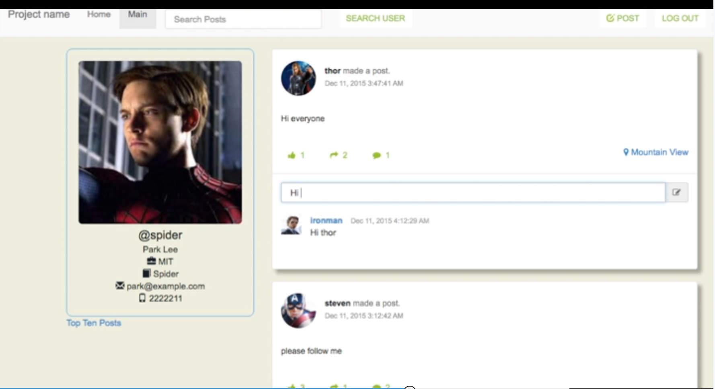

4. You can also switch to main tab, where you can view all posts from all users who registered in this site.

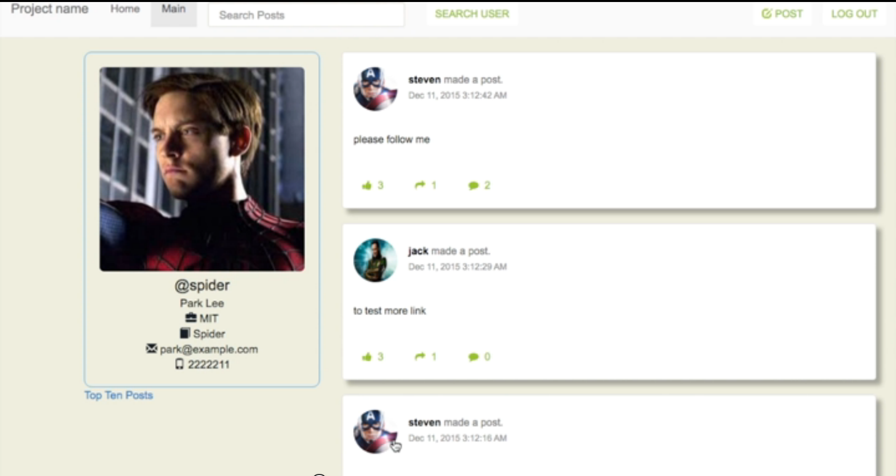

5. In the navigation bar, you can also do search. There are two different kinds of search. One is the Fuzzy search, another is the advanced search.

In fuzzy search, you can just search people based on their name.

# 

In advanced search, you can search based on first name, last name, email and affiliation, which enables user to find results more accurate.

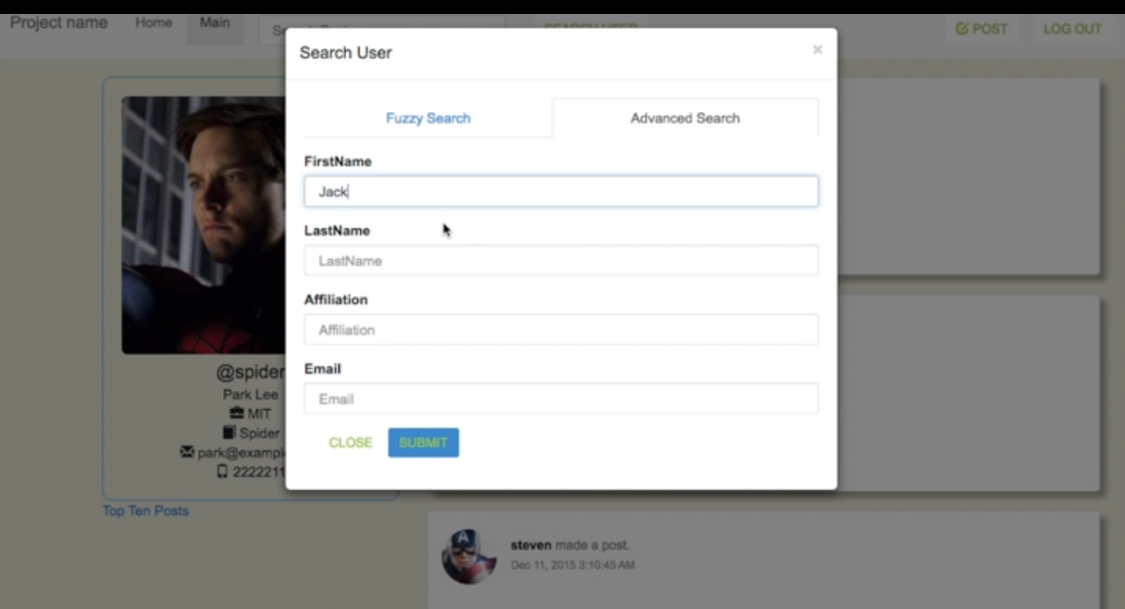

6. Of course you can publish your own post. In the navigation bar, click on new post and you will be navigated to a input box.

You can write down some text in the input box. If you choose to expose your location, you can click on get location button. If you want your post to be a private one, you can toggle on the private button. Then you can choose to post it out or just cancel it.

# 

7. You can also view the top ten posts on this site by clicking the link under the profile pane in main page.

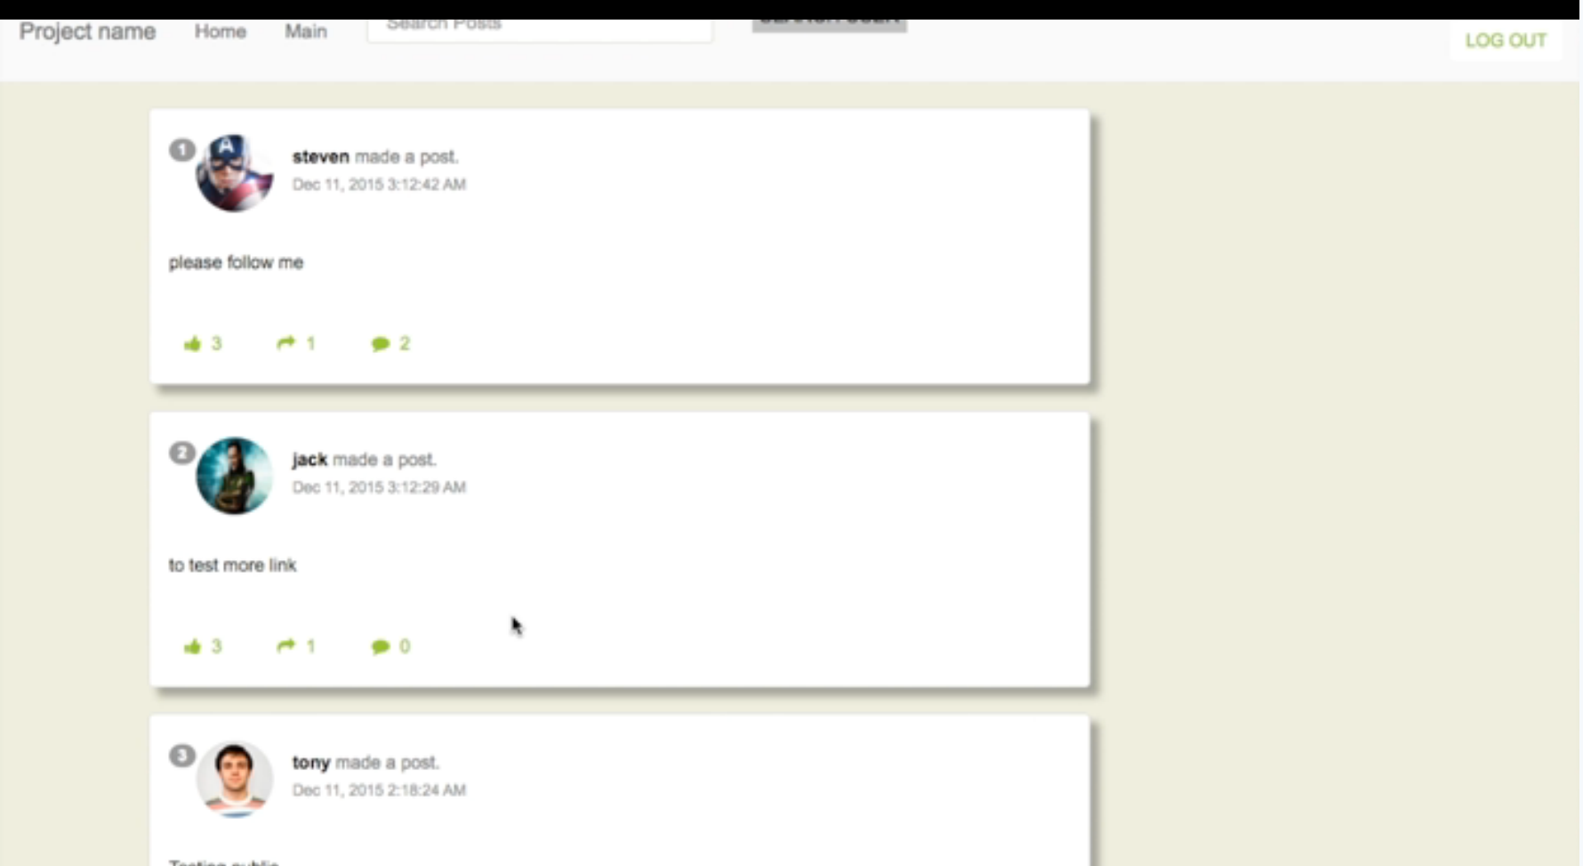

8. Finally, you can add a layer to your profile page to support France. Just click on the support France button under the profile pane in your home page. You can remove it by clicking on remove layer button if you don’t want the layer anymore.

