API Frontend

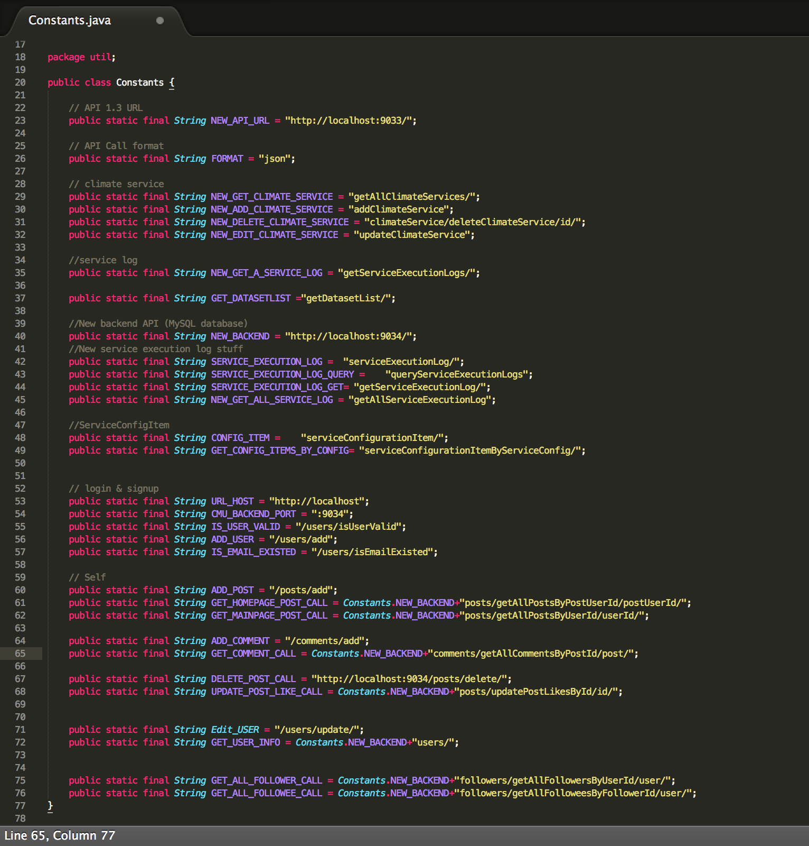

API Routes

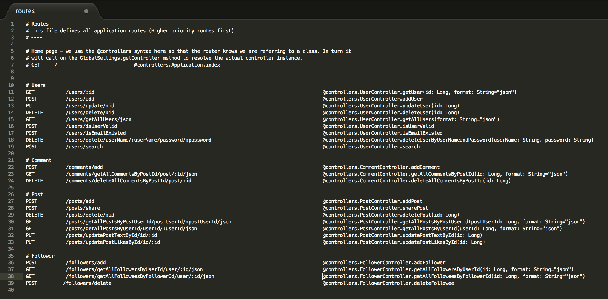

**API Example:**

Get the id of the user:

get:

parameters:

- name: id

description: id of the user.

type: long integer

not null: true

responses:

'200'

description: Successful response indicating that we have received the requested id of a certain user