TASK_2

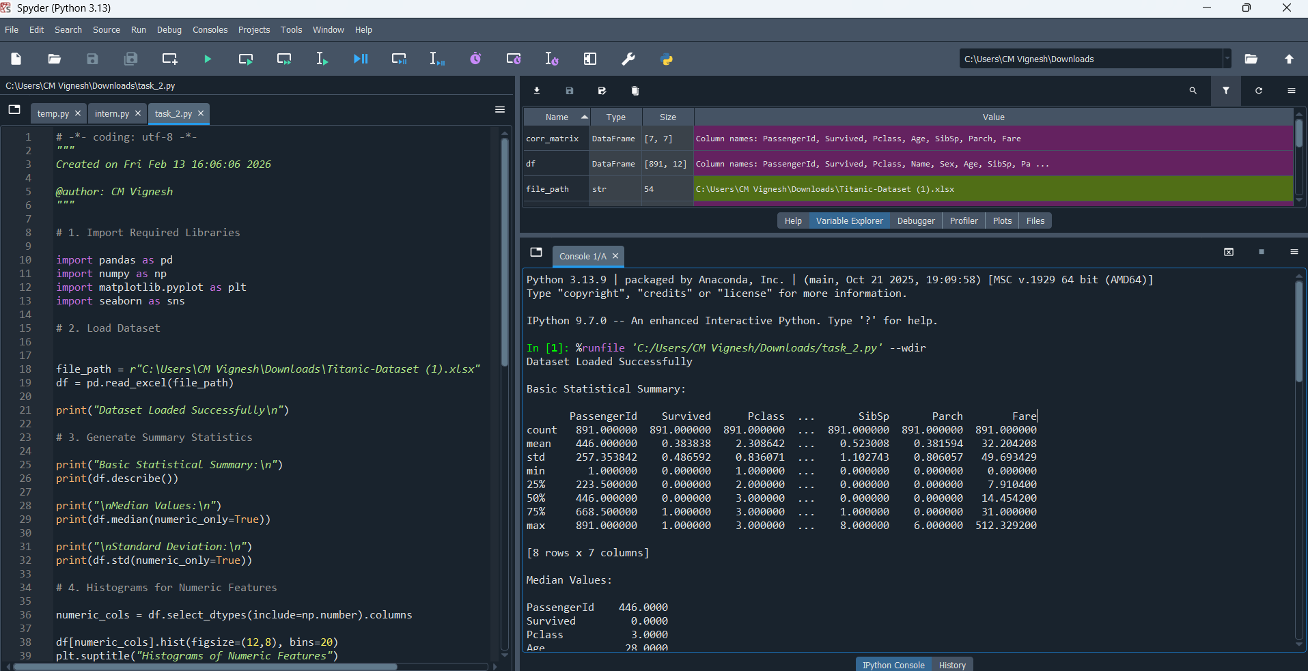
The above screenshot shows about the given querries code and its respective output

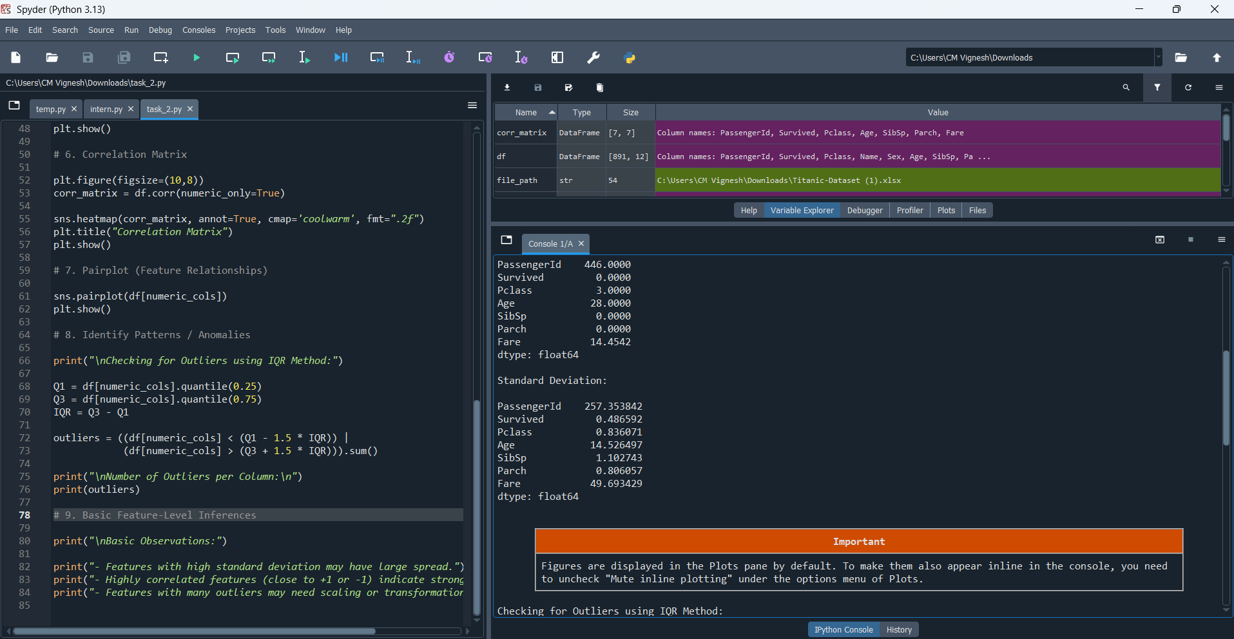

* Dataset loading
* Statistical analysis
* Data visualization
* Correlation analysis
* Outlier detection
* Basic feature insights
These are the work done by this querries

