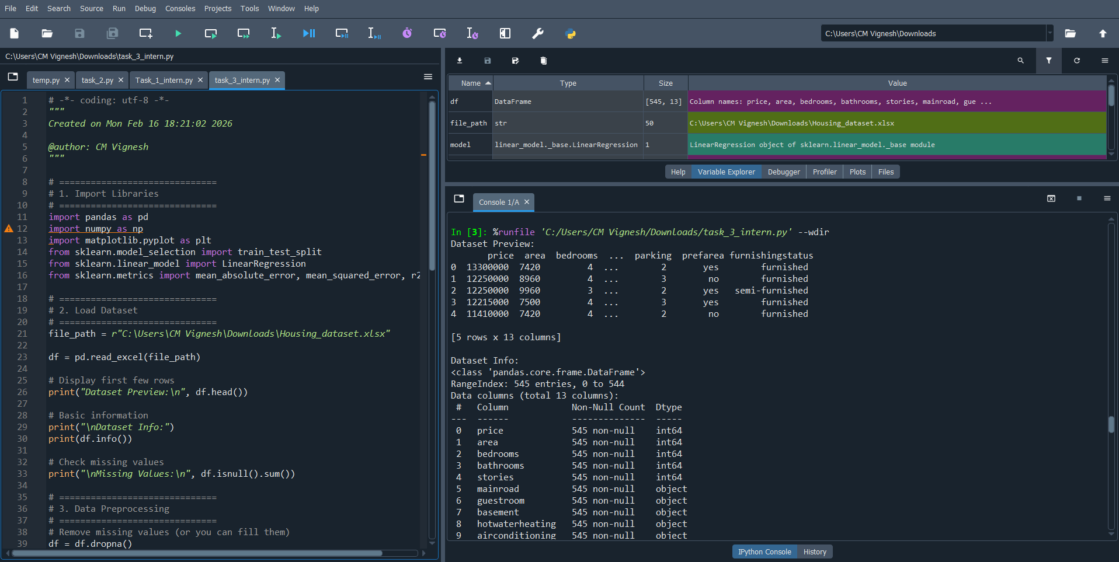

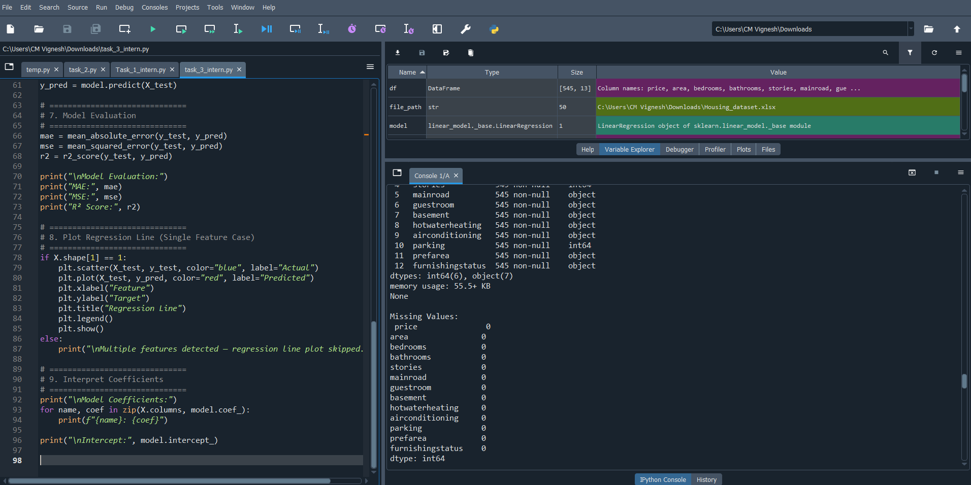

*The above screenshot explains about the given 5 querries of task 3
•* X (features / independent variables) → input data
• *y (target / dependent variable) → output to predict.
• Splits data into:
- Training data (80%) → used to learn model
- Testing data (20%) → used to evaluate model
• Done using train_test_split().
• Creates model using LinearRegression().
• Trains model using .fit(X_train, y_train).
Quiet summary about the above code and its respective output.

