TASK_5 INTERNSHIP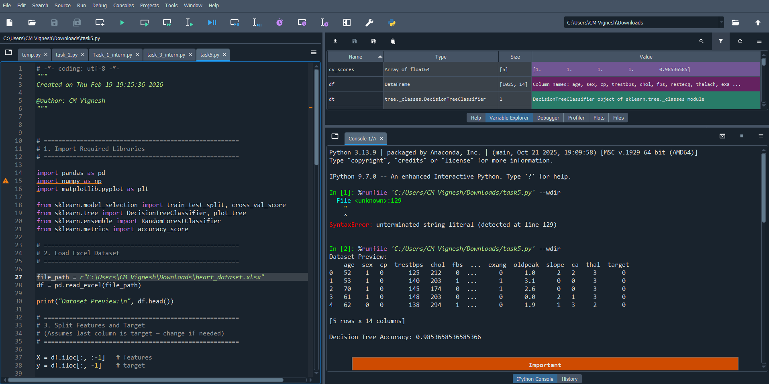

* Explanation
* pandas
- Used for loading and handling dataset.
- Reads Excel file into DataFrame.
* numpy
- Used for numerical operations.
* matplotlib.pyplot
- Used for visualization (decision tree, feature importance).
* train_test_split
- Splits dataset into training and testing data.
* DecisionTreeClassifier
- Machine learning algorithm for classification.
* plot_tree
- Used to visualize decision tree.
* RandomForestClassifier
- Ensemble learning algorithm (multiple trees).
* accuracy_score
- Measures prediction accuracy.
* cross_val_score
- Performs cross-validation evaluation.

* Purpose
Splits data into training and testing sets.
* Explanation
Parameter | Meaning
test_size=0.2 | 20% data for testing
random_state=42 | Same result every run
* Why Needed?
- Training data → learn model
- Testing data → evaluate model

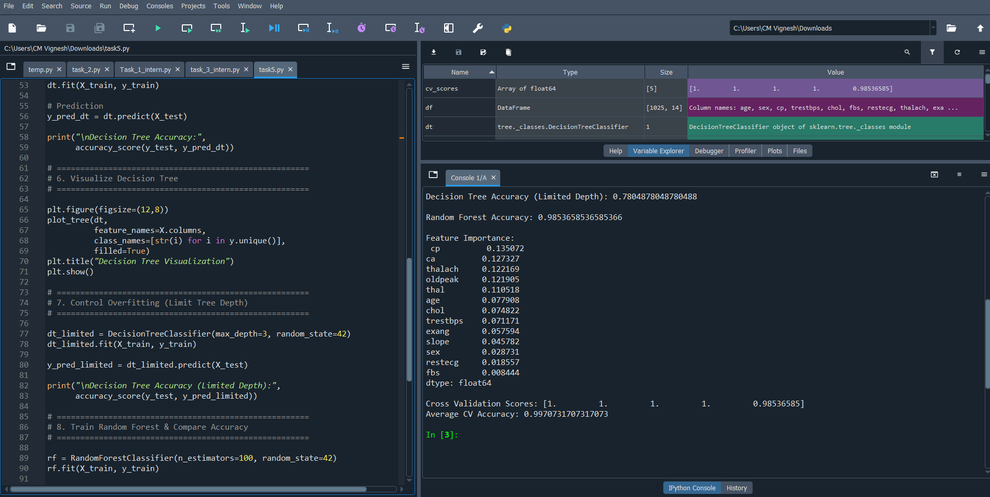
Purpose
Shows tree structure graphically.
What You See
- Decision rules
- Feature names
- Class labels
- Data splits
Benefit
- Easy interpretation.
- Understand model logic.

Control Overfitting Using Tree Depth
dt_limited = DecisionTreeClassifier(max_depth=3)
What is Overfitting?
When model learns training data too well and performs poorly on new data.
Solution
Limit tree complexity.
max_depth=3
- Tree can grow only 3 levels.
- Reduces overfitting.
- Improves generalization.
Comparison
- Deep tree → high training accuracy but poor testing accuracy.
- Limited tree → balanced performance.

Train Random Forest
rf = RandomForestClassifier(n_estimators=100)
rf.fit(X_train, y_train)
What is Random Forest?
- Collection of multiple decision trees.
- Uses voting mechanism.
Why Better?
- Reduces overfitting.
- More accurate.
- Stable predictions.
n_estimators=100
- Creates 100 trees.

Compare Accuracy
accuracy_score(y_test, y_pred_rf)
*( Purpose
Compare performance:
- Decision Tree vs Random Forest.
* Expected Result
Random Forest accuracy > Decision Tree accuracy
Because ensemble learning improves prediction.

Feature Importance
importance = rf.feature_importances_
* Purpose
Finds most important features affecting prediction.
* Meaning
Higher value → more influence.
Example output:
age 0.35
chol 0.25
cp 0.18
* Why Useful?
- Feature selection
- Model interpretation
- Understanding dataset

Cross-Validation
cv_scores = cross_val_score(rf, X, y, cv=5)
* Purpose
Evaluates model reliability.
* How It Works
- Splits data into 5 parts.
- Trains and tests multiple times.
- Returns average performance.
* Advantage
- More reliable than single train-test split.
- Reduces bias.
Example output:
[0.82 0.85 0.80 0.83 0.84]
Average CV Accuracy = 0.83

* Overall Workflow
Load dataset
↓
Split features & target
↓
Train Decision Tree
↓
Control overfitting
↓
Train Random Forest
↓
Compare accuracy
↓
Find important features
↓
Evaluate using cross-validation
This is an explaination about todays querries .

