# ShopBridgeAPI

Shopbridge API is created in ASP.Net Core.

DATABASE is MSSQL, Dapper ORM used for connecting API and SQL Server.

Implemented Swagger For API testing

# Steps of Creating API

1. Creating API project under ASP.NET Core

2. Installed and Initiated Dapper ORM

3. Write Separate Controller and Method

4. Implementation of Swagger UI

# Implementation Of API

1. Find the Project and change Database connection in appsetting.json

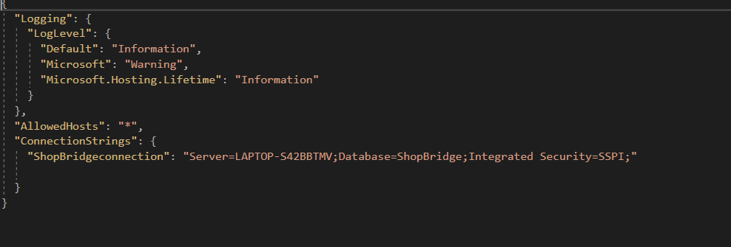

Change ShopBridgeConnection according to your Database connection.

# ShopBridge API (Swagger UI)

