**ShopBridge Application**

Abstract: -

ShopBridge Application is developed for managing inventory functions. Application has two-part UI and API. API id developed on ASP.NET core and Dapper ORM. ASP.NET MVC is used for developing Front-end UI.

Technology Used: -

Front-End Framework: -

1. ASP.NET MVC
2. .Net Framework 4.7.2
3. HTML, CSS, Bootstrap for Design work
4. AJAX, Json, JavaScript, jQuery: - For All API calling

API

1. ASP.NET Core 3.1
2. Dapper – For connecting Database.
3. Database – MSSQL (SP used for CRUD operations)
4. API Home

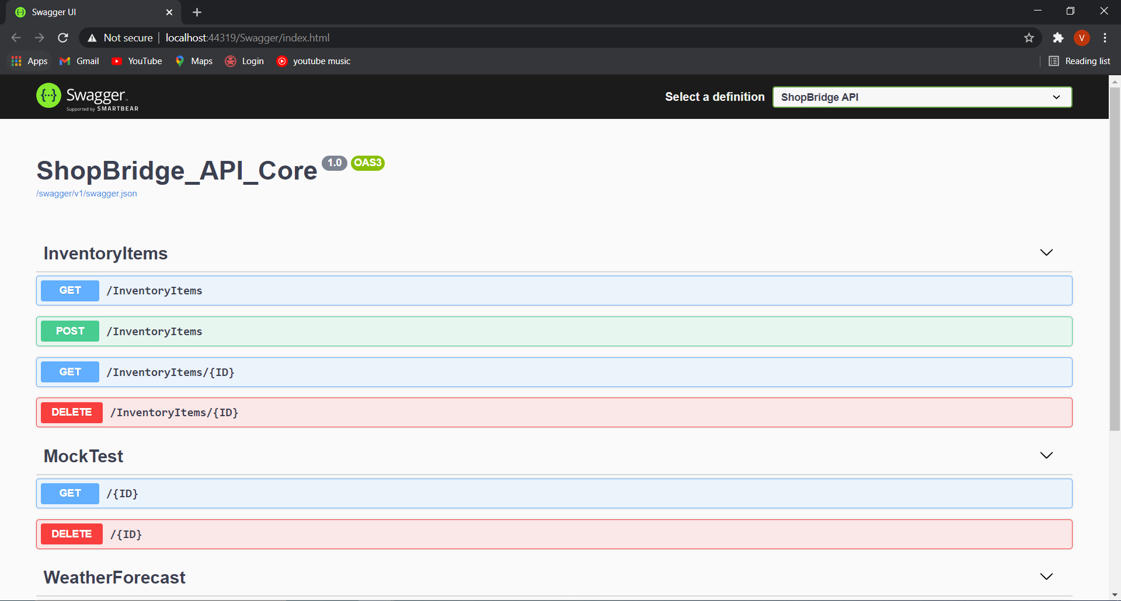

1. Application Home

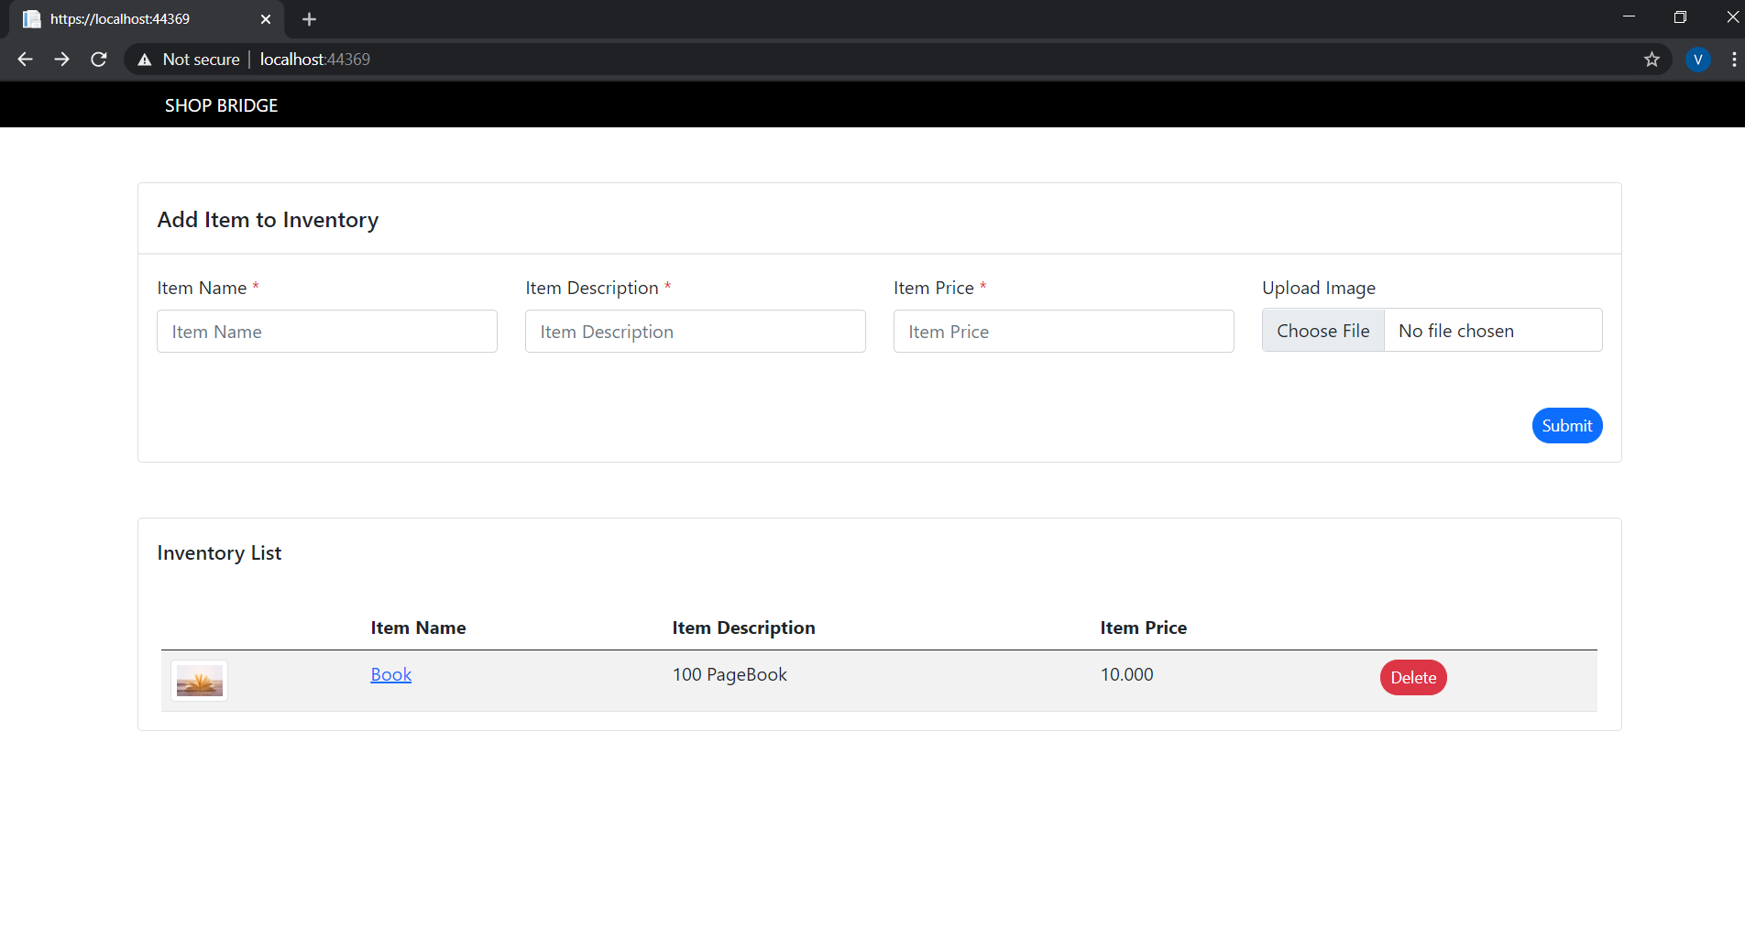

Click to Open Details page for specific Item.

Inventory Item List

For Deleting Item

Adding Items to inventory List

1. Adding item to Inventory list.

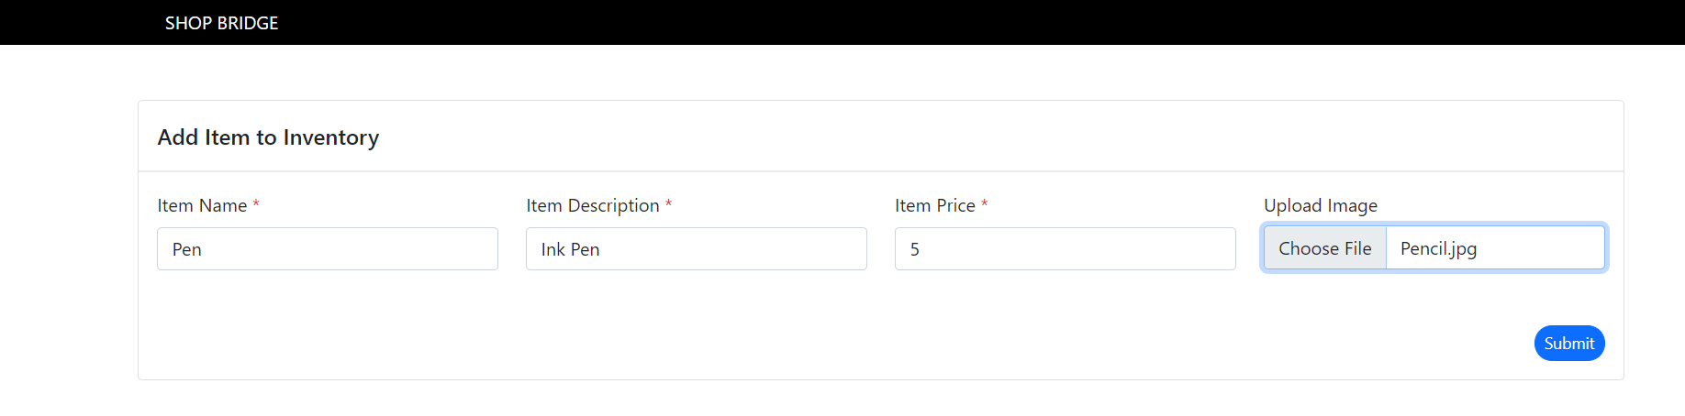

* Enter All fields and attach Photo (optional)
* Click “Submit” button for saving.
* Added item will show in grid instantly.

After saving.

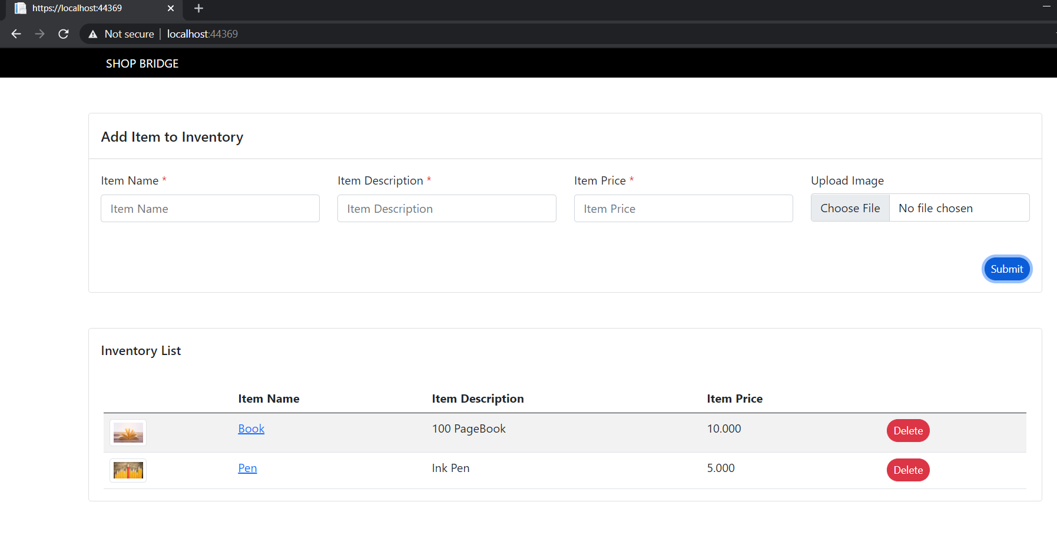

1. Deleting Inventory item

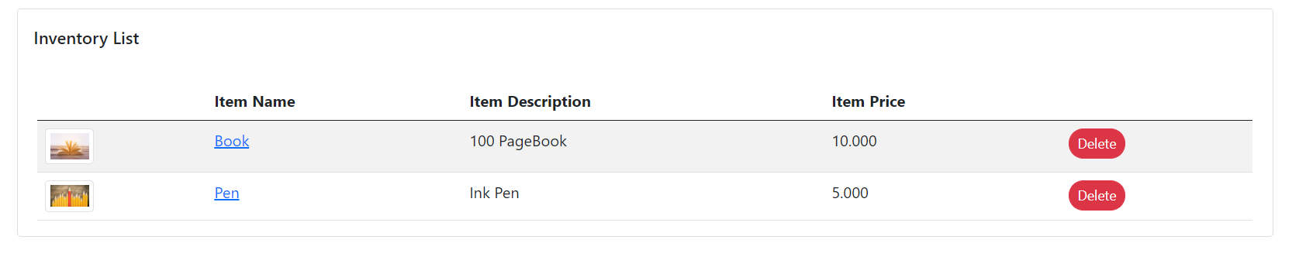

* Click on “Delete” Button for deleting inventory item.

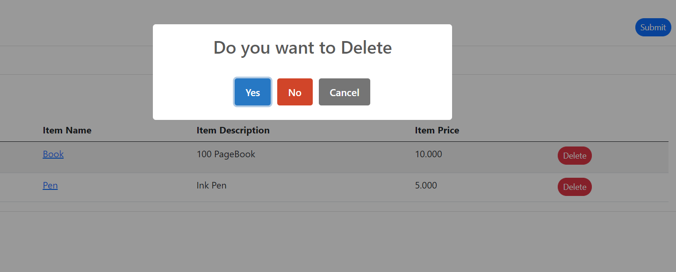

* Click “Yes” button for Confirming.

After Deleting

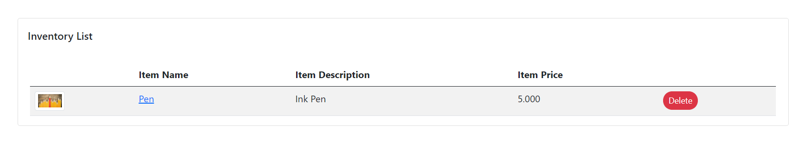 Deleted items will remove from Grid instatntly.

1. Item Details Page

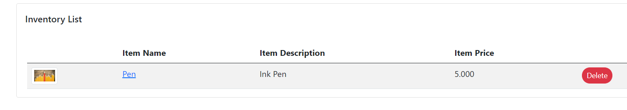

* Click on Item Name which is hyperlinked.
* Page will redirect to new page and will show the Details of item

Item Details Page



Implementation :-

1. Find Database Shopbridge.bak file and Restore.
2. Open API application and change Database connection in appsetting.json in API
3. Run API and Copy the API URL
4. Open Frond-end application and change ApiUrl parameter in both Index.cshtml and ItemDetails.cshtml.

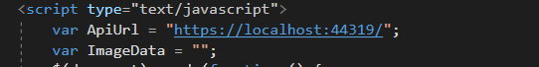

For time being I given ApiUrl insidethe page , we can also give ApiUrl in webconfig for globaly accessing .

1. Run frond-end Application

Important Note :- may be you will face CORS issue if API and UI Application in different domain , then please disable the security of browser and Continue again.

Tracking Developement :

1. Database and API Creation 🡪 45 Minutes
2. Front-End Application Creation,API calling and binding Data 🡪 1 hour
3. Styling, Adding validation and Sweet alerts 🡪 1.5 hour
4. For API test case 🡪 30 minutes (I tried to write API unit test case in Xunit Tool . But I couldn’t able to complete)