eDiValo Seedlings Natural Regeneration

## Setup and data structuring

Loads libraries, sets up custom theme for ggplot, and reads in data (code not printed)

## Total seedlings count

Summary for plotting total and richness (code not printed)

Summary for analyzing total and richness (code not printed)

### Total seedling count plot

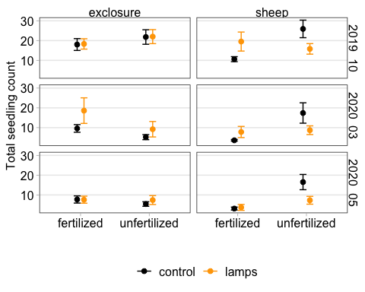

### Total seedling analysis

#### With time

|  |  |  |  |
| --- | --- | --- | --- |
| **Characteristic** | **Beta** | **95% CI** | **p-value** |
| grazing | -5.8 | -12, 0.48 | 0.073 |
| nutrient | 2.1 | -4.2, 8.4 | 0.5 |
| light | 3.3 | -2.5, 9.1 | 0.3 |
| month |  |  |  |
| 2019_10 |  |  |  |
| 2020_03 | -8.2 | -12, -4.2 | <0.001 |
| 2020_05 | -12 | -16, -7.7 | <0.001 |
| 2020_06 | -17 | -21, -13 | <0.001 |
| grazing * nutrient | 12 | 3.5, 20 | 0.007 |
| grazing * light | 0.23 | -7.8, 8.2 | >0.9 |
| grazing * month |  |  |  |
| sheep * 2020_03 | 0.80 | -3.1, 4.7 | 0.7 |
| sheep * 2020_05 | 2.7 | -1.2, 6.6 | 0.2 |
| sheep * 2020_06 | 3.6 | -0.33, 7.5 | 0.074 |
| nutrient * light | -1.9 | -9.9, 6.1 | 0.6 |
| nutrient * month |  |  |  |
| unfertilized * 2020_03 | -4.5 | -8.5, -0.62 | 0.024 |
| unfertilized * 2020_05 | -1.1 | -5.1, 2.8 | 0.6 |
| unfertilized * 2020_06 | -2.3 | -6.2, 1.6 | 0.3 |
| light * month |  |  |  |
| lamps * 2020_03 | 2.2 | -1.8, 6.1 | 0.3 |
| lamps * 2020_05 | -1.6 | -5.6, 2.3 | 0.4 |
| lamps * 2020_06 | 0.46 | -3.5, 4.4 | 0.8 |
| grazing * nutrient * light | -9.1 | -21, 2.6 | 0.13 |

Looking at October and March time points as 1. separate models or 2. a combined sum. I think we can make the argument that if we do it this way we won’t need time series analyses since we expect Oct seedlings to have died or grown by March, mostly not resampling the same individuals. But there are other approaches to this that use the time series angle.

#### Fall only

|  |  |  |  |
| --- | --- | --- | --- |
| **Characteristic** | **Beta** | **95% CI** | **p-value** |
| grazing | -7.4 | -16, 1.6 | 0.11 |
| nutrient | 3.8 | -5.2, 13 | 0.4 |
| light | 0.30 | -8.7, 9.3 | >0.9 |
| grazing * nutrient | 11 | -1.3, 24 | 0.082 |
| grazing * light | 8.6 | -4.2, 21 | 0.2 |
| nutrient * light | -0.10 | -13, 13 | >0.9 |
| grazing * nutrient * light | -19 | -37, -0.87 | 0.044 |

#### Spring only

|  |  |  |  |
| --- | --- | --- | --- |
| **Characteristic** | **Beta** | **95% CI** | **p-value** |
| grazing | -6.0 | -15, 3.4 | 0.2 |
| nutrient | -4.4 | -14, 5.0 | 0.4 |
| light | 9.0 | -0.38, 18 | 0.065 |
| grazing * nutrient | 18 | 4.9, 31 | 0.009 |
| grazing * light | -4.8 | -18, 8.5 | 0.5 |
| nutrient * light | -5.0 | -18, 8.3 | 0.5 |
| grazing * nutrient * light | -7.9 | -27, 11 | 0.4 |

#### Both combined

|  |  |  |  |
| --- | --- | --- | --- |
| **Characteristic** | **Beta** | **95% CI** | **p-value** |
| grazing | -11 | -26, 3.6 | 0.14 |
| nutrient | 2.4 | -13, 18 | 0.8 |
| light | 8.5 | -6.5, 23 | 0.3 |
| grazing * nutrient | 28 | 6.0, 49 | 0.015 |
| grazing * light | 3.5 | -18, 25 | 0.7 |
| nutrient * light | -4.3 | -26, 17 | 0.7 |
| grazing * nutrient * light | -26 | -57, 4.2 | 0.095 |

## Seedling richness

### Seedling richness plot

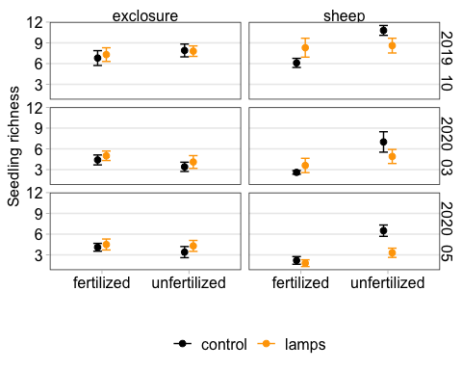

### Seedling richness analysis

#### With time

|  |  |  |  |
| --- | --- | --- | --- |
| **Characteristic** | **Beta** | **95% CI** | **p-value** |
| grazing | -0.53 | -2.2, 1.1 | 0.5 |
| nutrient | 0.32 | -1.4, 2.0 | 0.7 |
| light | 0.44 | -1.2, 2.0 | 0.6 |
| month |  |  |  |
| 2019_10 |  |  |  |
| 2020_03 | -2.9 | -4.2, -1.6 | <0.001 |
| 2020_05 | -2.9 | -4.1, -1.6 | <0.001 |
| 2020_06 | -6.0 | -7.3, -4.8 | <0.001 |
| grazing * nutrient | 4.0 | 1.9, 6.1 | <0.001 |
| grazing * light | 0.48 | -1.6, 2.5 | 0.6 |
| grazing * month |  |  |  |
| sheep * 2020_03 | -0.70 | -2.0, 0.57 | 0.3 |
| sheep * 2020_05 | -1.6 | -2.9, -0.35 | 0.013 |
| sheep * 2020_06 | -0.50 | -1.8, 0.77 | 0.4 |
| nutrient * light | 0.08 | -2.0, 2.1 | >0.9 |
| nutrient * month |  |  |  |
| unfertilized * 2020_03 | -0.70 | -2.0, 0.57 | 0.3 |
| unfertilized * 2020_05 | -0.43 | -1.7, 0.85 | 0.5 |
| unfertilized * 2020_06 | -0.70 | -2.0, 0.57 | 0.3 |
| light * month |  |  |  |
| lamps * 2020_03 | 0.00 | -1.3, 1.3 | >0.9 |
| lamps * 2020_05 | -0.62 | -1.9, 0.65 | 0.3 |
| lamps * 2020_06 | 0.15 | -1.1, 1.4 | 0.8 |
| grazing * nutrient * light | -2.8 | -5.8, 0.15 | 0.066 |

#### Fall only

|  |  |  |  |
| --- | --- | --- | --- |
| **Characteristic** | **log(IRR)** | **95% CI** | **p-value** |
| grazing | -0.11 | -0.45, 0.24 | 0.5 |
| nutrient | 0.15 | -0.17, 0.47 | 0.4 |
| light | 0.07 | -0.26, 0.40 | 0.7 |
| grazing * nutrient | 0.42 | -0.03, 0.87 | 0.067 |
| grazing * light | 0.24 | -0.23, 0.70 | 0.3 |
| nutrient * light | -0.08 | -0.54, 0.37 | 0.7 |
| grazing * nutrient * light | -0.45 | -1.1, 0.18 | 0.2 |

#### Spring only

|  |  |  |  |
| --- | --- | --- | --- |
| **Characteristic** | **log(IRR)** | **95% CI** | **p-value** |
| grazing | -0.53 | -1.0, -0.04 | 0.033 |
| nutrient | -0.26 | -0.70, 0.19 | 0.3 |
| light | 0.13 | -0.28, 0.53 | 0.5 |
| grazing * nutrient | 1.2 | 0.62, 1.9 | <0.001 |
| grazing * light | 0.20 | -0.45, 0.84 | 0.5 |
| nutrient * light | 0.06 | -0.55, 0.67 | 0.8 |
| grazing * nutrient * light | -0.74 | -1.6, 0.13 | 0.094 |

#### Both combined

|  |  |  |  |
| --- | --- | --- | --- |
| **Characteristic** | **log(IRR)** | **95% CI** | **p-value** |
| grazing | -0.23 | -0.51, 0.05 | 0.11 |
| nutrient | 0.11 | -0.15, 0.37 | 0.4 |
| light | 0.09 | -0.16, 0.35 | 0.5 |
| grazing * nutrient | 0.68 | 0.32, 1.0 | <0.001 |
| grazing * light | 0.22 | -0.16, 0.60 | 0.3 |
| nutrient * light | -0.04 | -0.40, 0.32 | 0.8 |
| grazing * nutrient * light | -0.55 | -1.1, -0.04 | 0.034 |

#### April/May

|  |  |  |  |
| --- | --- | --- | --- |
| **Characteristic** | **log(IRR)** | **95% CI** | **p-value** |
| grazing | -0.62 | -1.1, -0.11 | 0.018 |
| nutrient | -0.19 | -0.64, 0.27 | 0.4 |
| light | 0.09 | -0.33, 0.52 | 0.7 |
| grazing * nutrient | 1.3 | 0.61, 1.9 | <0.001 |
| grazing * light | -0.29 | -1.0, 0.46 | 0.4 |
| nutrient * light | 0.14 | -0.47, 0.76 | 0.7 |
| grazing * nutrient * light | -0.62 | -1.6, 0.35 | 0.2 |