edivalo-seedlings-toothpicks

## Setup and data structuring

Loads libraries, sets up custom theme for ggplot, and reads in data (code not printed)

## Visualization plots

### All species through time

Taking a first look at our data, just the abundance counts of the six species through time. Months are listed on the right side (2-February to 7-July). Seedling abundance was generally highest in March-April-May, and the most common species were Plantago lanceolata and Dianthus. 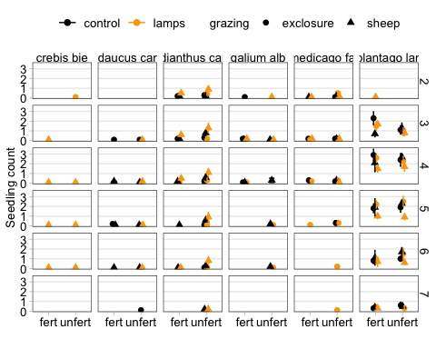

Now zooming in on just the most common species to see how they may be responding to treatments.

### April abundance of Plantago

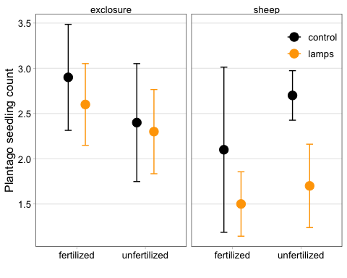

### April abundance of Dianthus

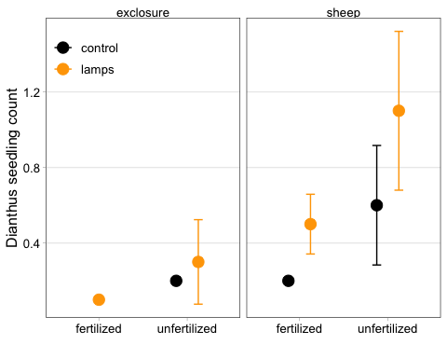

## Next steps

Separately analyzing emergence and survival (rather than just abundance) for all species. Incorporating trait data.