edivalo-seedlings-trait-demo

## Correlations between trait variables

Simple correlation plot: 1. root bm, shoot bm, and total bm are strongly correlated, will probably use the total bm 2. sla (first 3 leaves) and sla.2 (first 2 leaves only) are strongly correlated, that’s good, we can just use the first 2 leaves. 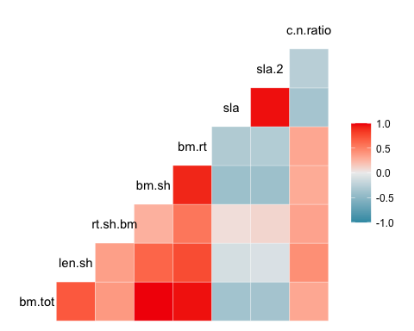

More detailed correlation plot with our smaller set of variables 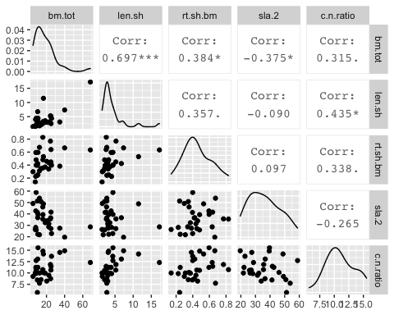

## Trait distributions

Seeing what the distribution of trait relationships are, and where our toothpick-marked seedlings fall in this space (these species are labled in red)

Total biomass and root-shoot biomass ratio 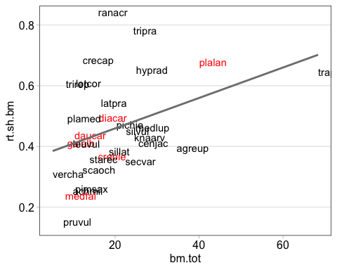

SLA and C:N 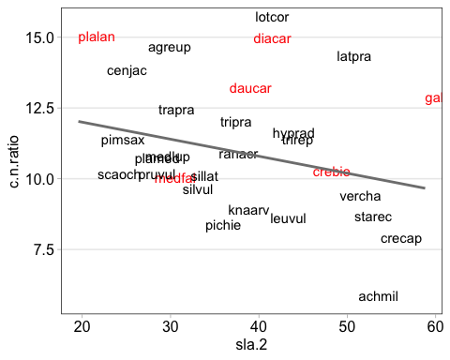

Total biomass and shoot length–these are pretty strongly correlated (R^2 of almost 0.7), I think it will probably be best to not include shoot length in the analyses 