vRig User Guide

  - January 2017
  - Version 1.00

NanAlCon, Ltd.

Copyright and third-party information as required

Document Revisions

Date | Version Number | Document Changes
01/12/2017 | 0.1 | Initial Draft

Table of Contents
1 Introduction 7
1.1 Scope and Purpose 7
1.2 Overview 7
2 General Description 7
2.1 Simulation Engine 7
2.2 The Drilling Cycle 9
3 Installation 12
3.1 Minimum Requirements 12
3.2 SQL Database Installation 12
3.3 vRig Application Installation 15
4 Quick Start Description 19
4.1 The Drilling Panel 19
4.2 Well Settings and Configurations 28
4.2.1 The General Tab 29
4.2.2 The Calibration Tab 33
4.2.3 The Well Plan Tab 34
4.2.4 The Survey Tab 36
4.2.5 The BHA Tab 37
4.2.6 The Formation Tab 41
4.2.7 Pipe Tab 45
4.2.8 New Well Tab 46
4.2.9 Deleting a Well 47
4.3 Control Panel 47
4.4 Visualization 48
4.4.1 Map View 48
4.4.2 Plane View 49
4.4.3 3D WellPath 51
4.5 Evaluation 53
4.6 Utilities 54
4.6.1 KickOff Point Calculator 55
4.6.2 Database Backup and Restore 57
4.6.3 Reset A Well 57

Introduction

Scope and Purpose
vRig is a Drilling Rig Simulation. It’s focus is on Directional Drilling Control and Formation Evaluation. The Simulation allows definitions of multiple wells, including a Well Plan, and Surveys for the section of well that may already have been drilled. There are reusable items which can be configured and shared across multiple wells, including Pipe Sets, BHAs and Formations.

This guide will provide instructions for installation, configuration and operations of the simulator.

Overview
This software project is intended to provide a Drilling Rig Simulation with focus on:
- Rig Sensors
- Drilling Performance
- Directional Drilling Control
- Formation Evaluation and Interpretation
When completed, the target audience will be:
- Training Environments
- Well Plan Testing
- Drilling Performance Optimization

General Description
The software has a number of components, including:
- A Graphic User Interface
- A Simulation Engine
- A Data Storage system
Each component may be composed of several sub-components.

Simulation Engine
Starting with the Simulation Engine description, this item calculates a series of “responses” to events that occur during the drilling process.
Core responses include “Counts” which would be observed by Rig Sensors during an observation period.
A typical drilling rig would contain various sensors which create electronic signals, either digital or analog, for a parameter which they measure. The electronic signals can be converted to a number representing a count, correlating to the strength of the signal. Typically, signals are sampled and converted at a rate of 20 times per second, or 20 hz.
The sensors are monitoring various drilling rig conditions. These include:
- Hookload – a pressure cell mounted on the deadline cable which deflects and exerts pressure on the cell based upon the tension upon the cable. This represents the total load which is being suspended by the travelling block, including the drill string weight.
- RPM – this is a simple sensor that counts the turning of the rotary table when the rotary is turning the drill pipe.
- Torque – a sensor which measures electric current that is applied to the Rotary drive motor. While rotating, the motor may require more current to turn when there is greater resistance to the turning, such that the drive amperage can infer the amount of torque applied.
- Pump Stroke Counters – simple switch devices that turn on and off with each stroke of the mud pumps. Each pump displaces a known volume per stroke, such that monitoring the stroke counts in a given period of time allows calculation of the mud flow rate.
- Drawworks Encoder – This is a complex sensor which measures the vertical movement of the traveling block. The block is suspended via a multipart cable which passes between the traveling block and the crown. One end of the cable is fixed to the rig floor, as the deadline, and the other end of the cable is spooled around a cable drum in the Drawworks. As the Drawworks turns, cable is spooled in or out, allowing the traveling block to move. A sensor is attached to the axel of the Drawworks drum, and rotates along with the drum. A slotted disk in the sensor then rotates in sync with the drum. A light sensor is separated from a light source, separated by the slotted disk, such that the rotating disk creates light pulses which are the counts, correlating to the drum rotation, which in correlates to the cable motion, which correlates to the block motion.
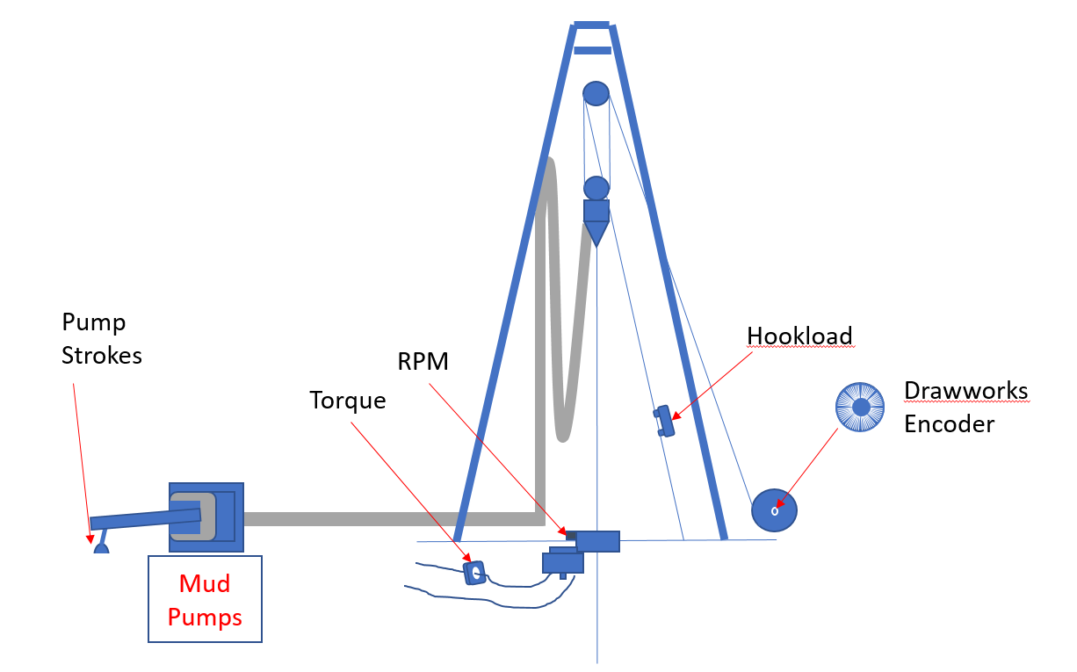

During operation, the simulator engine cycles through a series of loops, corresponding to the sampling interval of 50 milliseconds, or 20hz sampling.
Calculations are performed to adjust items which are being monitored and the number of counts for the sensors are computed. Some of the monitored items are updated, and the looping cycles continue until a threshold is met to move to the next phase of the drilling cycle.
The counts computed will be dependent upon a variety of factors, not the least of which is the phase of the drilling cycle at that point in time.

The Drilling Cycle
The Drilling Cycle is broken into discreet steps needed to drill a single joint of drill pipe. (Note: The description here is for a conventional rig which drills using single joints and a Kelly. Top Drive rigs have a slightly modified sequence). The cycle can be visualized as a chart which tracks the Block height versus Time. Such a chart can be represented like this:
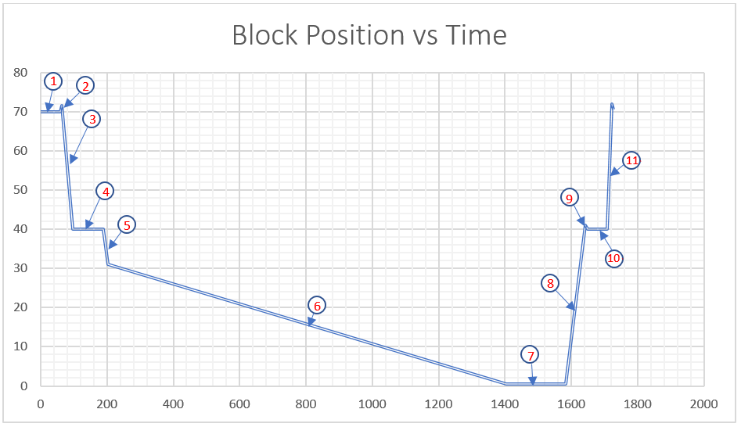
During the drilling of a single joint, there are distinct steps. The performance of the sensors will vary depending upon the step. The trigging event will vary based each step.
- Initial Start – Making a connection at the start of the drilling
  - Block Motion – not moving
  - Hookload – Equals Block Weight
  - Pumps – Off
  - Rotary – Off
  - Triggered by – Time (Initial Connection Time)
- Pickup Out of Slips – Lifting the drill string up high enough to pull the slips
  - Block Motion – move up about 1 foot
  - Hookload – Picks up to total string weight, plus upward drag
  - Pumps – Off
  - Rotary – Off
  - Triggered by – Block travel upwards
- Run In Hole – Move the string down until the Pipe/Kelly joint is at the rig floor
  - Block Motion – Moving downward until Block position is a length of Kelly
  - Hookload – total string weight less drag
  - Pumps – Off
  - Rotary – Off
  - Triggered by – Block Height
- Take Survey
  - Block Motion – Block held still
  - Hookload – total string weight
  - Pumps – initially off, come after a short wait period
  - Rotary – off
  - Triggered by – Time, waiting for “Survey Time”
- Run In/Tag Bottom
  - Block Motion – Moving downward
  - Hookload – total string weight less drag
  - Pumps – On
  - Rotary – Initially off, start up and then continue
  - Triggered by – Continues until Bit Depth reaches last hole depth
- On Bottom Drilling
  - Block Motion – moving downward, based upon ROP (Rate of Penetration) Calculation
  - Hookload – total string weight less drag, less Weight on bit
  - Pumps – On, but controllable by user
  - Rotary – On, but controllable by user, may orient for sliding, etc
  - Triggered by – Continues until Block Height shows Kelly down
- Kelly Down/Circulating
  - Block Motion – Not moving
  - Hookload – total string weight
  - Pumps – On
  - Rotary – On
  - Triggered by - Timer, continues until Time out of “Circulating Time”
- Pull Out of Hole
  - Block Motion – Moving up
  - Hookload – string weight plus drag
  - Pumps – On initially, then cut off
  - Rotary – On initially, then cut off
  - Triggered by – block height travels Kelly length plus enough to set slips (about 1 foot)
- Set Slips
  - Block Motion – downward about 1 foot
  - Hookload – drops to block weight
  - Pumps – off
  - Rotary – off
  - Triggered by – Block motion
- Break Connection
  - Block Motion – no motion
  - Hookload – block weight
  - Pumps – off
  - Rotary – off
  - Triggered by – Timer, time out of “Connection Time”
- Pick Up for next Joint
  - Block Motion –Move up length of next Joint of Pipe (from Talley)
  - Hookload – block weight
  - Pumps – off
  - Rotary – off
  - Triggered by - Block motion achieving target block height
In addition to the sensor counts, the simulator engine will determine the survey values when a survey is taken and will update a survey table.
While on bottom drilling, as the Bit advances each defined sample interval, the engine will calculate the formation measurements that would be seen by evaluation tools, (e.g. Resistivity, Porosity, etc.) from the formation model, and determining the location of the formation sensor within the model. These measurements will be saved into a Logging data table.
Also, as the Bit advances through the formation, each sample interval will calculate a “micro-survey” or the position of the bit, based upon directional drilling inputs (e.g. Sliding orientation etc.) These values are stored in a “Blind Hole” data set. The purpose of this is to accurately provide the survey data needed when the survey point reaches that interval. The survey values will reflect the trajectory changes based upon the directional drilling changes that we made during the simulator operation.

Installation
vRig software requires certain minimum components. There is the software application and a database needed to work with the application.

Minimum Requirements
The Software is designed to run on Microsoft Windows 7 or later. It requires Microsoft .Net Framework 4.5 or higher. If that is not present, an opportunity to install it will be provided during the software installation.
The target machine should have a minimum of 3 Gb of RAM.
The display should be 1024 x768 or higher.
Processor Speed of 2.5 Ghz or higher is recommended.
The appropriate 64 bit version of Windows is preferred.

SQL Database Installation
The database component of vRig is designed to run on the local machine with a light weight SQL component from Microsoft, Microsoft SQL Server 2016 SQLLOCALDB. This provides the run-time processes necessary to connect to the vRig database. This is included in the installation media.
Locate the SQLLOCALDB.MSI file in the installation media.

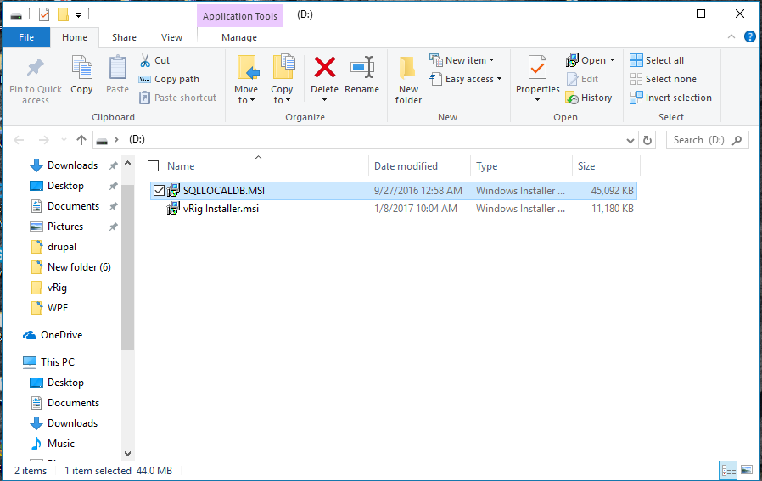
Double click the file to begin installation.
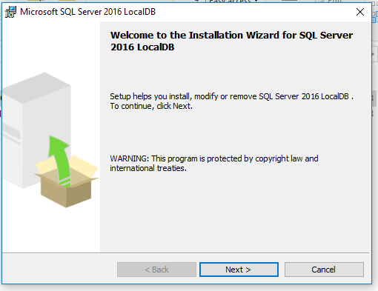

Follow the installation Wizard. Be sure to select the “I accept the terms…” selection, then click “Next”
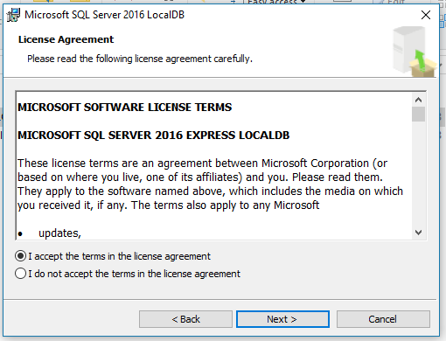
Click “Install”.
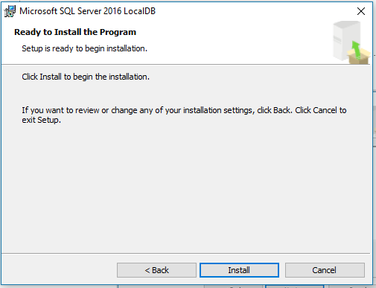

Click “Finish”
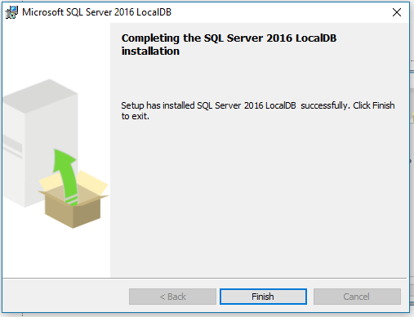
Congratulations! You now have the Microsoft SQLLocalDB component installed!

vRig Application Installation
The main application of vRig installs like most other Microsoft Windows applications. Locate the vRig Installer.msi file located on the installation media.
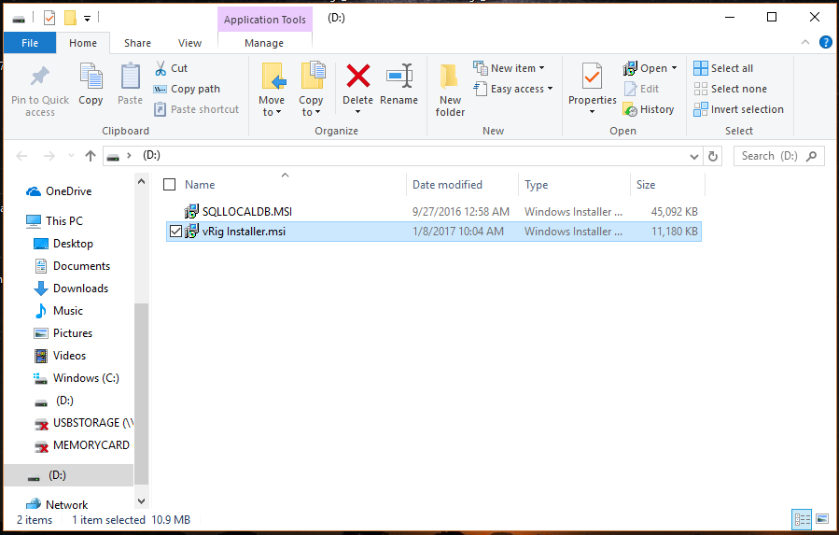
Double click on the file to launch the installer.
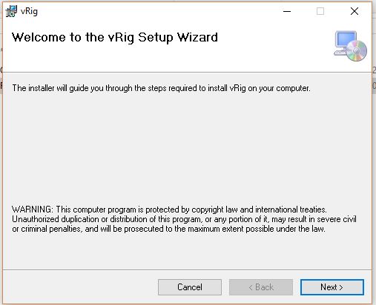
Click Next.
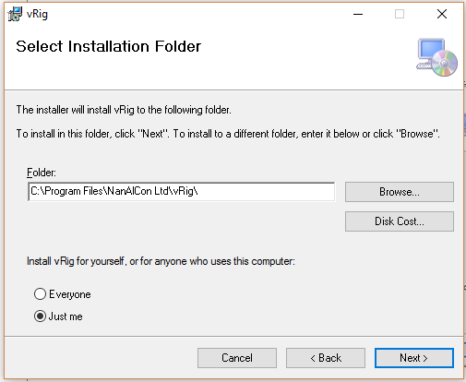
In the Select Installation Folder, select or edit the installation path. By default, the software will be installed in C:\Program Files\NanAlCon Ltd\vRig. This can be edited to any path desired, however it is recommended to accept the default. Also, it is recommended to select “Just Me” rather than Everyone.
NOTE: The vRig data components will be installed in the C:\Users\UserName\ AppData\Roaming directory under a vRigData directory, where “UserName” is the windows account that was used to log in. If multiple users log into the same machine, it is recommended that each user perform this installation to ensure their data file is correctly located.
Click “Next”
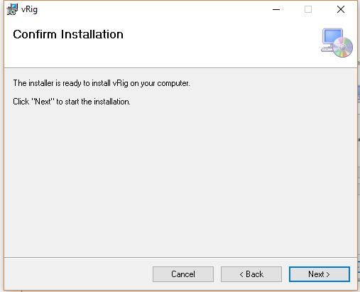
On the Confirm Installation, click next
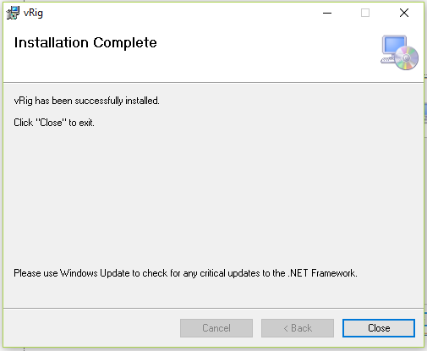
When the installation is complete, click the Close button to close the installer.
You will find a vRig icon has been added to your Desktop, and Start/NanAlCon Ltd/vRig has been added to the Start Menu.
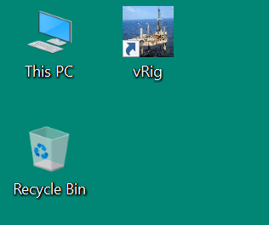

This completes the vRig Installation.

Quick Start Description
After vRig has been installed, the program can be started by double-clicking the desktop icon or by going to the Start > NanAlCon Ltd > vRig Folder and clicking the vRig menu link.
A typical session would be as follows:
- Select the desired Well to be drilled from the Available Well Dropdown List.
- Confirm settings under “Set up > Well Management”
- Run the simulator by clicking the “Start” Switch.
- During different phases of drilling each joint, Drilling Controls become active and may be adjusted to steer the well and impact drilling performance.
- During Drilling, or at the conclusion of running the Simulation, inspect the Well Path based on Surveys compared to the Well Plan via the “Visualization” tools.
- During Drilling, or at the conclusion of running the Simulation, inspect the Formation Log data via the “Formation Evaluation” displays
Let’s examine the Drilling Panel in more detail.

The Drilling Panel
When the program starts, the main window Drilling Panel will appear:
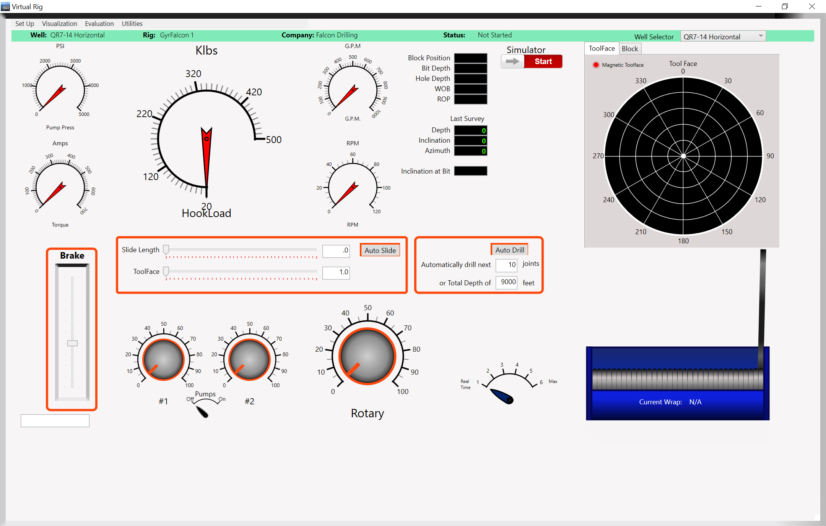
The Panel is broken into several areas.
At the top, there is a menu area:
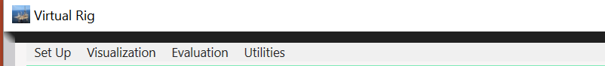
This provides access to functions and features which will be described shortly.
Immediately below the menu is a status bar:
This indicates information about the well which is currently selected. There is a Well Name, Rig Name, Company Name and Simulator Operating status.
Continuing on the status bar, there is a Well Selector
This is a drop down list of all available wells in the simulator, with the current selection showing. To switch the simulator to a different well, click on the drop down list, and select the desired well.
Below the status bar, there is a Rig Display area which includes various gauges and digital displays.
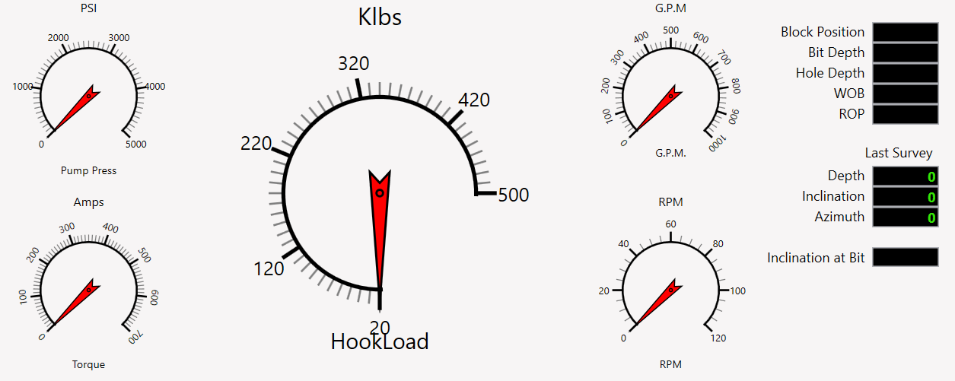
The gauges will act as indicators when the simulator is running, to provide feedback on the status of different drilling parameters.
The gauge displays include:
- Pump Pressure
- Torque
- Hookload
- Flow Rate
- Rotary Speeds
Next to the gauge displays, there are a number of digital displays. These include:
- Block Position – Height of the Block above the rig floor
- Bit Depth – current measured depth of the bit
- Hole Depth – current measured depth of the bottom of the well
- Weight on Bit – the effective weight of the drill string on the bit
- Rate Of Penetration – current rate of drilling new hole
- Last Survey Depth
- Last Survey Inclination
- Last Survey Azimuth
- Inclination at the Bit
Next to the Gauge and Displays a toggle switch allows the Simulator to Start. After making the Well Selections, and verifying the initial settings and configurations, when ready to start the simulator, click this switch.
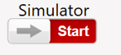
To the Right of the Simulator Start Switch, a tabbed pane provides graphic feedback on some drilling functions.
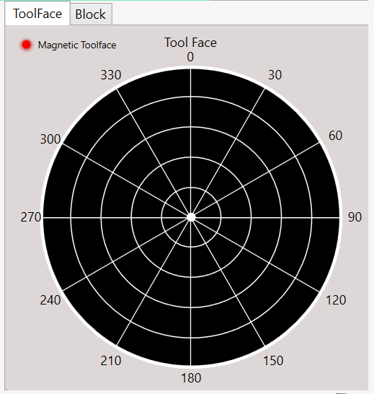
The ToolFace display is a radial display which shows the orientation of the high side of a drilling motor. The Outer ring is the most recent data point, with each inner ring showing an older history point. When using a Steerable Motor with MWD, the tool face points will update based upon the MWD update rates. When rotating, the points will vary, however when sliding, the points will tend to align, showing the orientation of the steering assemble, allowing the directional driller to control the well’s direction.
Clicking on the “Block” tab changes the display to show a depiction of the Derrick with the Block movement based upon the current rig operation.
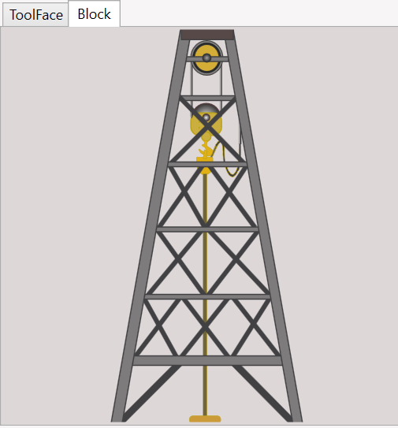
This give you a quick view of how much is left to drill for that Joint.
Directly below the ToolFace and Block views, there is the Drawworks. This is the cable drum which feeds cable in and out to lift or lower the block.
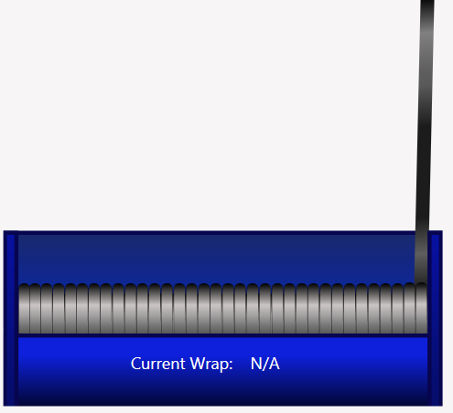

The items described so far have all been different displays of graphics to give the user feedback on the Rig operation. The section below the Gauge displays are the user controls to allow actual operation of the rig.
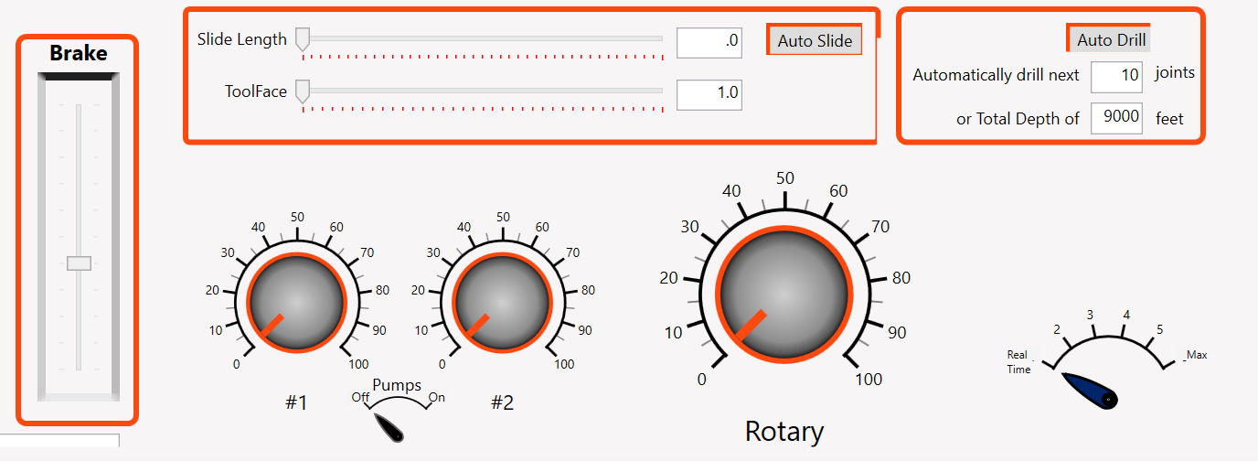
There are several controls that can be used to adjust the drilling operation. You may notice that these have an orange border. When they are active, the borders change to green, indicating that they are active and can be changed.
There are 3 main items for controlling drilling. They are:
- The Brake
- Pumps
- Rotary

The Brake is a simple slider control which you can manipulate to increase or decrease the Hookload, which in turn impacts the Weight on Bit, (WOB), and the Rate of Penetrations (ROP). Generally, increased Weight On Bit increases the drilling speed, however it may also increase pump pressure, and can cause increased Bit Wear.
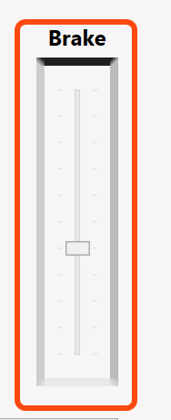
When the simulator is running, the brake only becomes active when on bottom, drilling.
The Pump Controls are a set of adjustable knobs, one for each of 2 pumps.
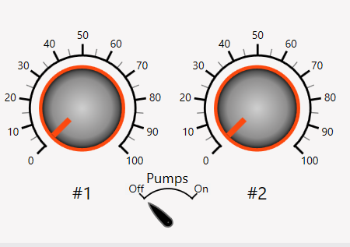
The simulator automatically turns the pumps on when at the point in the drilling cycle where pumps would be needed, and turns them off, when drilling is completed. When active, either or both controls can be adjusted to a desire number of Strokes per Minute. In the settings, a value can be set to define the number of gallons of drilling fluid pumped per stroke. This allows the simulator to calculate the flow rate and pressures as you are drilling.
If using a Positive Displacement Mud Motor, Bit RPM will be calculated based on the flow rate, so that pumping faster increases Bit RPM. When sliding, meaning the Drilling Assembly is oriented to drill in a direction, and the string is not rotating, the Bit RPM can be controlled with the pumps.
The Rotary Control is the knob control which determines how fast the drill string is turning due to rotation of the rotary table.
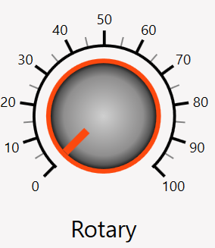
This control becomes active automatically during the drilling phase when the rig needs to rotate. Once on bottom, the Rotary Control can adjust speed. You can also stop rotating by setting the speed to 0. You can manually bump the speed up and back to zero in order to manually adjust the toolface.
In the real world, a driller would need to use the Rotary to adjust the tool face. This can be tedious and time consuming. The simulator has a feature “Auto Slide” which eliminates the need to manually adjust the toolface for each joint.
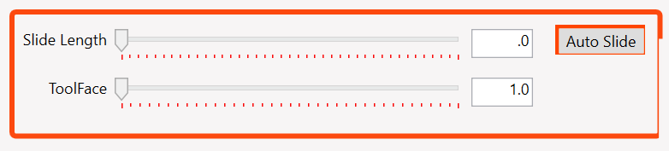
When on bottom drilling, the Auto Slide can be activated by adjusting the slide length up to 200 feet, and setting the desired ToolFace orientation. Clicking the Auto Slide button then activates Auto Slide. The simulator will adjust ToolFace to the desired value, and will continue to slide for the specified length. The Slide Length indicator will automatically update as the hole is drilled showing the remaining length to slide. At any time, while Auto Slide is engaged, the Slide Length and/or ToolFace can be adjusted. If the Slide Length reduces to zero, Auto Slide disengages and the simulator resumes rotating at the speed set by the Rotary Control.
The default drilling scenario when starting the simulator is to drill a single joint of pipe. Before starting the simulator, you may decide that you would like to drill multiple joints. The “Auto Drill” function allows you to set a specific number of Joints, or a maximum depth to drill.
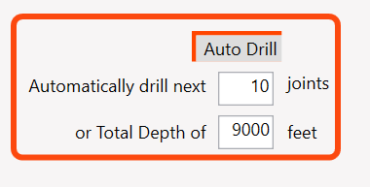
NOTE: Auto Drill will drill the number of Joint, unless the Total Depth is reached. If the Total Depth is not reached before the number of Joints is completed, the Simulation will complete. In order to drill to a Total Depth, ensure that the number of Joints would be large enough the ensure TD is reached.

vRig is designed to simulate actual drilling. This can be a very tedious and time consuming process. For the purpose of simulations, a Time Compression feature has been added.
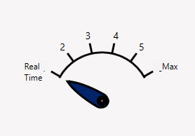
This Time mode selector allows running the simulator a close to real time, or to accelerate time and speed the simulation process. In some cases, such as when setting up to Slide, or figuring out desired drilling parameters or build angles, etc, running in near Real Time mode is preferred. After you have everything set up as desired, you can increase speed to 4, 5, or Max in order to generate the simulated results.
Technical Detail: vRig simulates drilling by calculating readings that would be generated by rig sensors. These sensor measure counts at 20 Hz, or 1 sample every 50 milliseconds. The computation cycle takes ~ 1 millisecond, but this will vary based upon your computer’s performance. Programmed delays are inserted to pause executions to yield Near Real Time, or other timing modes.

Well Settings and Configurations
Well Management is located under the Set Up Menu, and contains the primary inputs for creating and managing wells and the drilling environment.
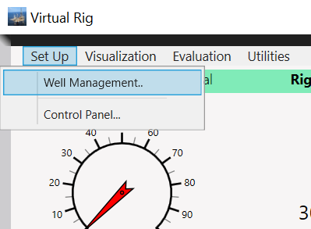
Selecting Well Management Opens a new window, the Well Management Panel.
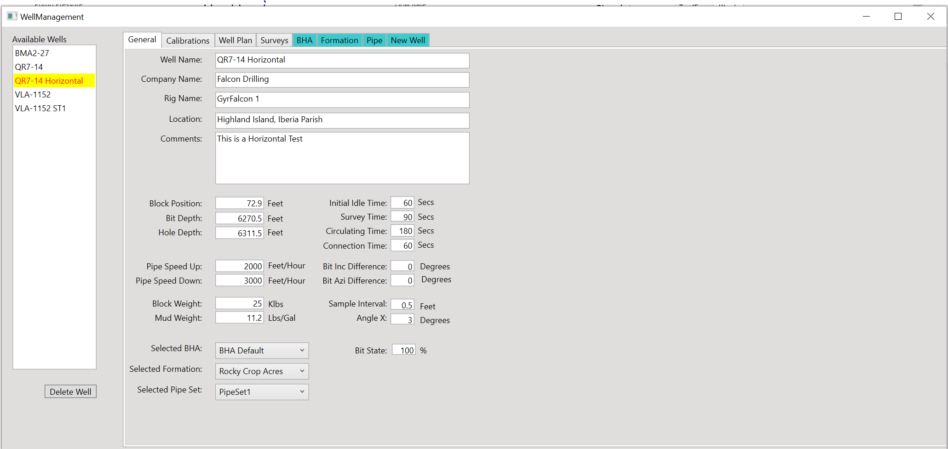
The panel features a listing of all available wells, with the currently selected well highlighted in the list. To work with another well, simply select it in the list.
Note: Selecting the well in the Available Wells List only focuses on that well for editing. To change the well to be drilled, use the Available Wells selector on the Drilling Panel

The panel also contains a number of Tabs. 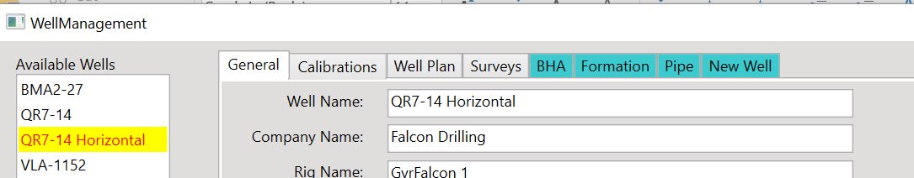

- General Tab- general details about the rig and well
- Calibrations – Values for computing Rig Sensor Counts
- Well Plan – an editor for the Depth, Inclination and Azimuth of points which define the desired well trajectory
- Surveys – an editor for the Depth, Inclination, and Azimuth of the points measured as the simulator drills to define the actual well path
- BHA – an editor to manage Bottom Hole Assemblies
- Formation – an editor to define and manage the formation models which can be drilled
- Pipe – an editor to define and manage sets of drill pipe to be used for drilling
- New Well is an editor to create a new well and add it to the simulator
We will cover each of these in detail. One thing you may note is that some tabs are shaded differently, such as the BHA tab. These tabs represent items which can be created and then selected or shared for various wells. As an example, you may define a Formation Model. Once it is created, it is available and can be assigned to any well. If you wanted, you could drill a vertical well, and then create a side track well using the same formation.

The General Tab
As indicated before, this tab contains general details about the well and Rig.
- Well Name is a label identifier you would like to use to distinguish wells
- Company Name is label to identify the name of the company owning the well
- Rig Name is a label to help identify the well
- Location is a description of where the well is located.
- Comments is a detail to capture a description about the well
- Note: These values are primarily for display and do not influence the simulator performance.

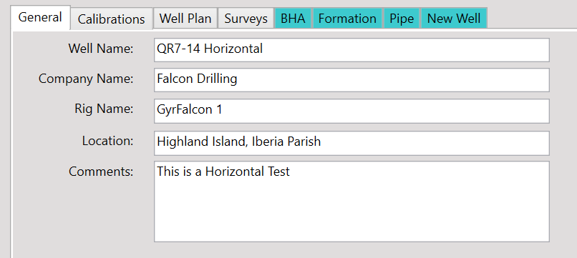
Next are a series of initial settings:
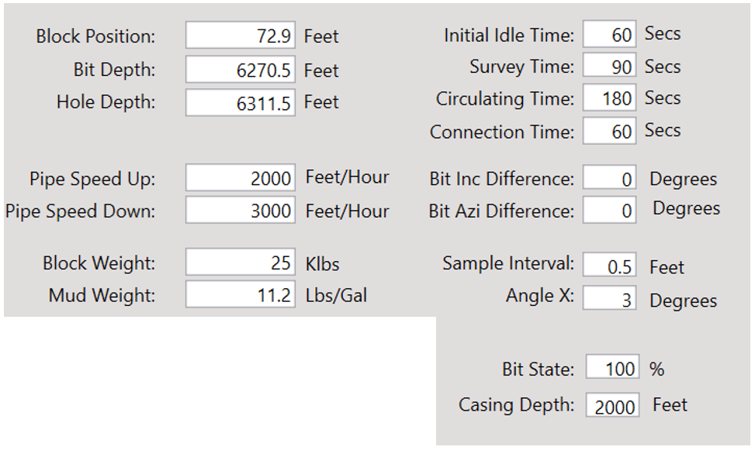
The first 3 values:
- Block Position
- Bit Depth
- Hole Depth
Are values to initialize the the rig at the start of the simulation. Although they can be edited, the simulator will perform calculations at the start of drilling the first joint to auto correct these values as needed based upon the Pipe Set selected, the BHA Selected, and the Last Survey Depth.

The next set of values are:
- Pipe Speed Up
- Pipe Speed Down
- Block Weight
- Mud Weight
Pipe Speeds up and down tell the simulator the maximum speed to move the block when tripping the pipe in or out of the hole. During the normal drilling process, the simulator will start with the pipe in the slips. After a wait period while the connection is made, the pipe is lifed up. The simulator performs an acceleration calculation and starts moving the pipe upward, but does not reach the Pipe Speed Up velocity. After the pipe is up sufficiently to clear the slips, the simulator reverses and moves toward a downward percentage of the pipe down speed, and then slows as it approaches the depth to stop and take a survey.
The Block Weight is a value which is used to help calculate the hookload.
Mud Weight is a value to help calculate the down hole pressure and bouyancy of the drill string. Well trajectory, Casing Depth, and Mud Weight Values are used to calculate the Hookload during operations.
A series of Time values are collected to help the Simulator. There are a series of drilling phases during drilling a single joint which the simulation engine treats as timed events. The Time entries define how long the simulator should make each of these phases.
- Initial Idle Time
- Survey Time
- Circulating Time
- Connection Time
The drilling cycle starts with the making up of a joint. During this phase, the block remains fixed, and the pumps, etc are off. The Initial Idle time default is 60 seconds.
After the Initial idle time completes, the block picks up to remove the slips, then runs into the hole to take a survey. At the survey depth, the block remains still, the pumps start and it takes a period of time for the Survey to be taken and received. This period is the Survey Time, with a default of 90 seconds.
After the Survey, the simulator runs in to tag bottom, drill the length of the joint, and tehn reach “Kelly Down”. At Kelly Down, typically the block would stay down, and the pumps would run to circulate the cuttings up for some period of time. This is the Circulating time, with a default of 3 minutes, or 180 seconds.
After circulating, the drill string will be pulled up until the connection can be broken. This is the Connection time to break the connection, with a default value of 60 seconds.. Finally the block picks up for the next joint. The cycle will then repeat.
At the start of the simulation, the simulator knows a series of values, including the bit depth, hole depth, and the last survey values. The simulator needs to be able to calculate the section of hole which has already been drilled, but not yet surveyed. Sometimes the difference between the last survey depth and the hole depth can be over 100 feet, depending upon the BHA Configuration. If the last section of hole had been drilled as a straight section, it would be easy to just project the last survey inclinations and azimuth to the bottom of the hole. And when moving down to take the next survey, it would be easy to determine the value. As this is not often the real case, 2 values, Bit Inc Diff and Bit Azi Diff are used to define the amount of difference between the last survey and the last bit inclination and azimuth for the section drilled but not yet surveyed. The simulation engine calculates a trajectory for the hole not yet measured (the “Blind” Hole) such that when ready for the next survey, the survey point is determined and the appropriate survey values provided.
Sample Interval defines the change in measured depth of the well for Logging Data samples to be collected. Also, blind hole calculations are also taken so that the well trajectory survey point information will be available when the survey tools reach that depth. The default is set to .5 feet, providing 6 inch resolution of well logs.
Angle X is a value that determines when an MWD tool will switch from a Magnetic source to a Gravity Source. When the well is near vertical, the tool face for orienting and steering is based upon magentic sensor and the value is an aziumth value. When the inclination is sufficient, accelerometer sensors provide a gravity based tool high side reference to all orienting the tool face. Angle X defines the cross over point of inclination where the tool switches from Magnetic to Gravity Toolface, or back.
Bit State is a value which reflects the bit condition, starting with a new bit of 100%. Based upon the amount of drilling and other factors such as Weight on Bit and the formation’s hardness, the bit may degrade which in turn may reduce it’s effectivness and leading to a reduction in the Rate of Penetration, or the rate of cutting new hole.
Casing Depth is the depth of the last casing. In calculating Hookload, a number of factors are taken into account. The Pipe Weight per foot, the amount of pipe, the mud weight, the well bore trajectory, and the amount of casing. When picking up or down, drag forces occur which add to or detract from the hookload. There are different drag coefficients for open hole and cased hole. The Casing Depth is needed as an input for this calculation.
The final items for the General Tab are a set of 3 drop down lists:
- Selected BHA
- Selected Formation
- Selected Pipe Set
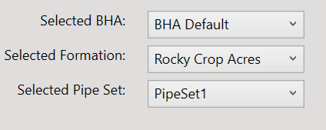
These display the currently selected item which is assigned for use for the current well. Click on the list causes it to expand to show all of the available items of that type. In other tabs we will see selection lists showing the available BHA, Formation, or Pipe Set, which will allow you to select and edit any of these, however assignment of the item to the currently selected well occurs here, on the General Tab.

The Calibration Tab
One feature of the core Simulation Engine design is the calculation of Sensor Counts. In the background, these counts are computed as a potential output that could be injected into a Surface Acquisition system.
Typically, a variety of sensors would take measures. Various calibration gains and offsets may be needed to align sensor count changes with corresponding changes of the physical items being measure by the sensor.
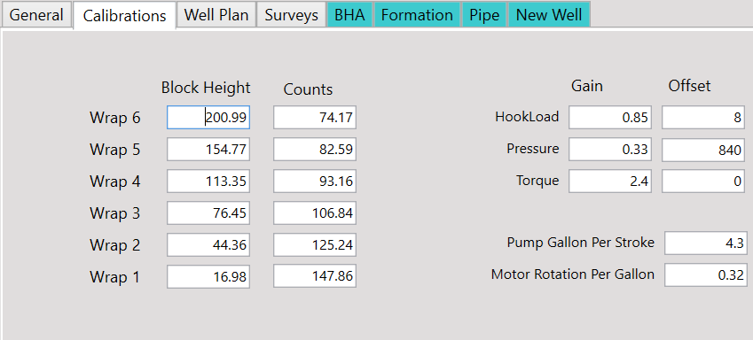
One set of calibrations are for the draw works encoders used to measure block motion. These encoders measure the revolution of the draw works axle, but as the cable hits a flange and “makes a wrap”, the number of counts changes for the amount of block motion, because the cable motion changes as it’s effective diameter changes.
There are Gain and Offset values for Hookload, Pressure and Torque.
There are 2 additional values stored here. The Pump Gallons per Stroke defines the flow volume per pump stroke. As the pump speeds are increases, the flow rate can be properly calculated.
When using a Positive Displacement Mud Motor, the bit rotates as mud is forced through the motor. The Motor Rotation Per Gallon defines the amount of rotation generated by the mud flow. This allows calculation of bit rotation, providing Bit RPM when sliding. While rotating the effective Bit RPM will be the Rotary RPM added to the Bit RPM.

The Well Plan Tab
This tab allows you to manage your well plan. A well plan is the intended or ideal trajectory that you would like to drill. It is composed of a series of coordinate points which are
- Measured Depth
- Inclination
- Azimuth.
The tab displays a table of 3 columns with rows for each depth.
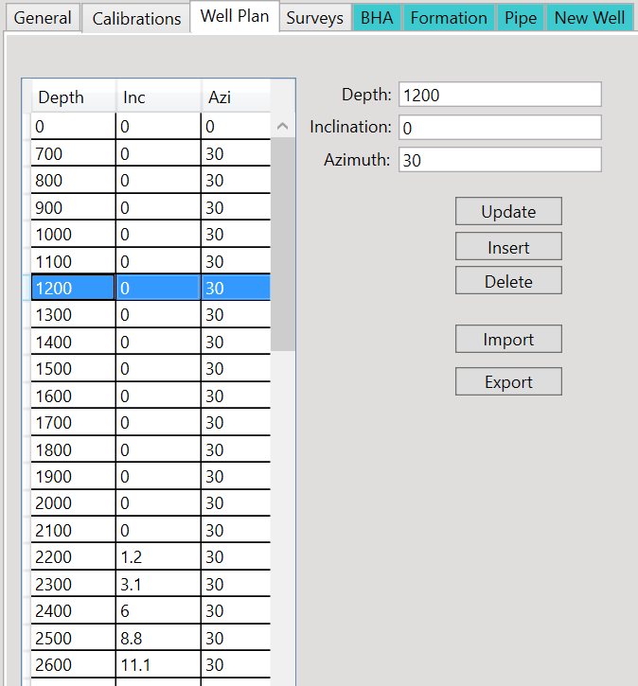
Clicking on a row highlights the row and places the row’s selected values in detailed fields. You can edit these values in the boxes, and when satisfied, you save the changes by clicking the “Update” Button.
If you wanted to add a new row, enter the desired values in the edit boxes, and click the “Insert” button.
If you wish to delete a row, select the row, and click the “Delete” button.
It can be tedious to work in the grid panel making adjustments one at a time. If desired, you can export the Well Plan data by clicking the “Export” button. A pop up window will appear which will allow you to specify where you want to save the file, and what name you would like to give the saved data.
- Note: Data is exported into a simple “comma delimited value” text file. The file should be given a name and a “.csv” extension. CSV files can be opened with text editors, such as Windows Notepad, however they can be easily opened with Microsoft Excel or similar programs. Excel is recommended.
- Note: After editing the file, be sure that the first row of values is not changed. Save the file as a CSV file and it can be imported back into vRig.
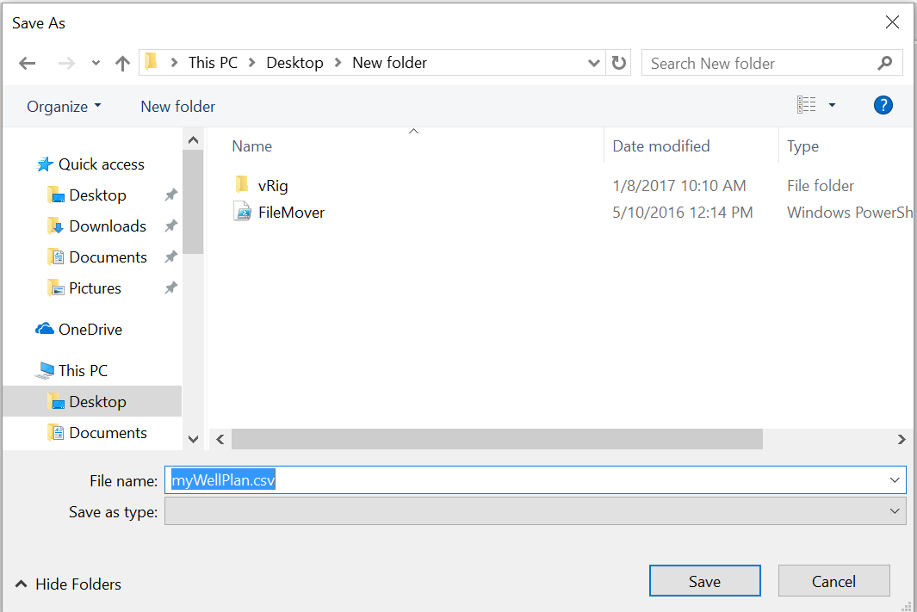
You can export well plans and modify it as desired. When finished, simply import the saved CSV file back into vRig. This will replace the current Well Plan with the data points you have in the CSV file.
You may also export the Well Plan into other software programs or spreadsheets. The csv file export should allow an easy way of accomplishing this.

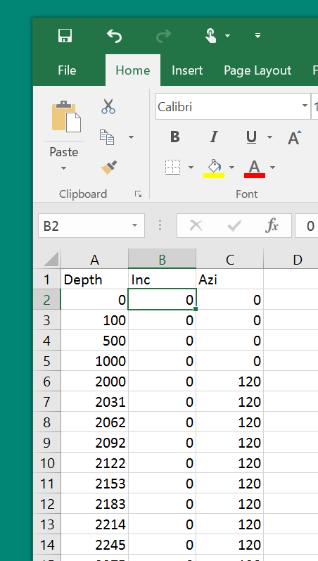
To import the file, simply click the “Import” button and then use the standard windows File management dialog box to locate the desired file, and click “Ok”
You may wish to replicate one well plan into another well. Simply export the well plan, then in select the well in the Available Wells List that is the target, the go to the Well Plan tab, and select import.
If you have an existing well plan from another source, format it to match the export format and it can be imported into vRig.

The Survey Tab
This tab is for managing survey point which have already been taken. This is essentially identical to the Well Plan tab in functionality, differing only in the details which it manages.
Note that although one of the main goals of the simulator is to simulate directional drilling, you don’t need to necessarily start at the surface. You can “pre-drill” a portion of a well to arrive at some depth above a kick off point to expedite the process.
A very important point is that when you start the simulation, it keys off of the deepest survey to determine a variety of parameters. Using the BHA, and the distance behind the bit of the Survey Measure Point, the simulator will set the initial hole depth, and the bit depth at the simulation start. It will also determine the amount of drill pipe is in the hole, and if necessary, adjust a variable “pup joint” of pipe to allow the survey and the pipe in hole and BHA lengths etc to place the top of pipe in the slips and position the block at the correct height for simulation start. The last survey depth is key. Keep that in mind as you decide to edit your surveys.

The BHA Tab
The Bottom Hole Assembly, or BHA is a critical component of directional drilling and formation evaluation services. This is the portion of the Drill String which contains the items near, and including the Bit. The BHA Tab and it’s sub-Tabs allows the driller to select and manage the items that are included within the BHA. This will typically include things like the Bit, a Positive Displacement Motor, any Formation Evaluation tools, and any Measurement While Drilling Tools. Some of these tools contain sensors, at different locations in the tool. It is essential to understand the tools, and their sensors, as the placement of these tools in the BHA will determine the distance behind the bit for each sensor.
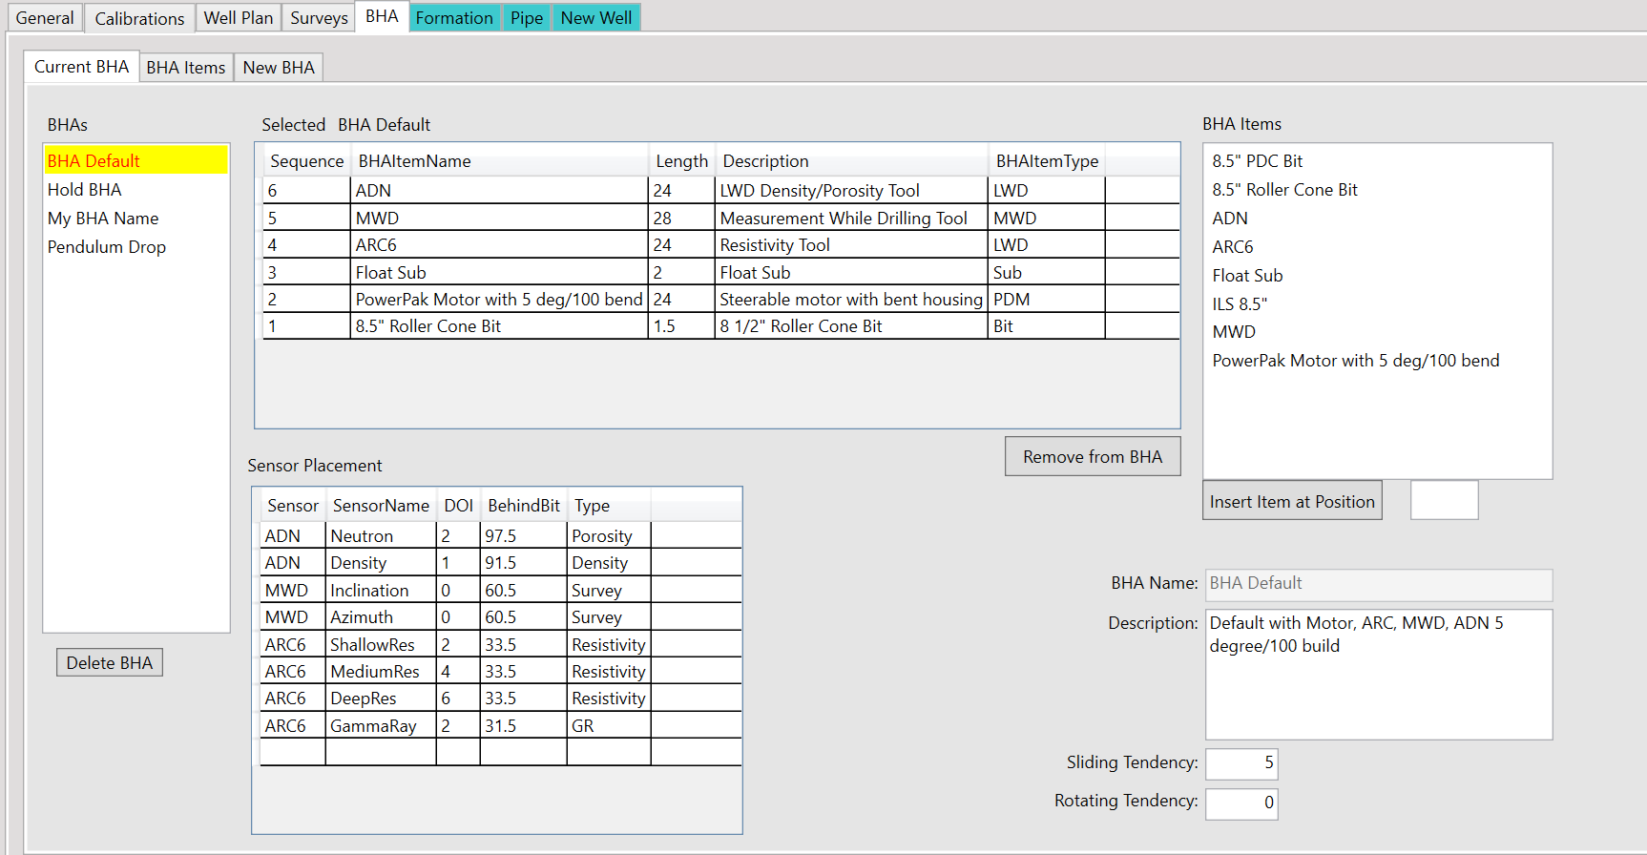
The BHA Tab is composed of 3 sub-Tabs:
- Current BHA
- BHA Items
- New BHA
The Current BHA sub-Tab displays a list of all defined BHAs, with the BHA currently assigned to the selected well being highlighted. If, necessary, you can select and work with one of the other BHAs in order to modify it. On the General Tab, you can then assign that BHA to the selected Well by changing the selection of the Selected BHA dropdown list.
In addition to the Available BHAs, with current selected, the sub-Tab also shows a table of the BHA Items which have been added to the BHA, as well as some of the details, such as the length, description, and position (from bottom) of the items.
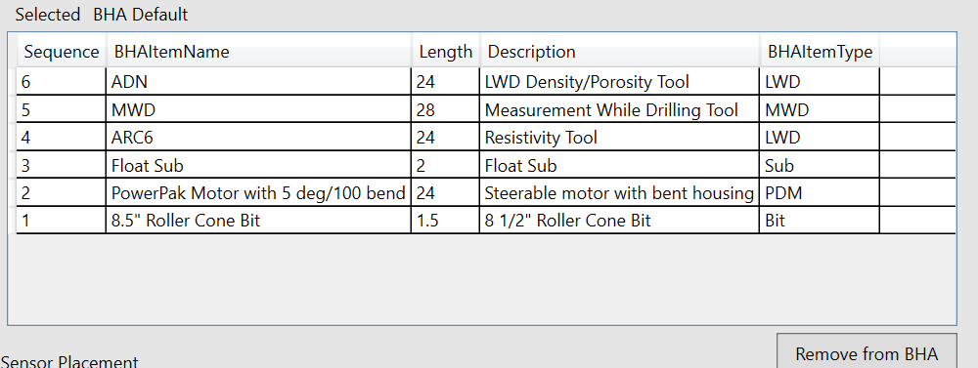
Clicking on a Row in this table will select an item. Clicking on the “Remove from BHA” button will remove that item from the BHA.
To the right of the Detailed Grid is a listing of BHA Items that have been defined for the Simulator.
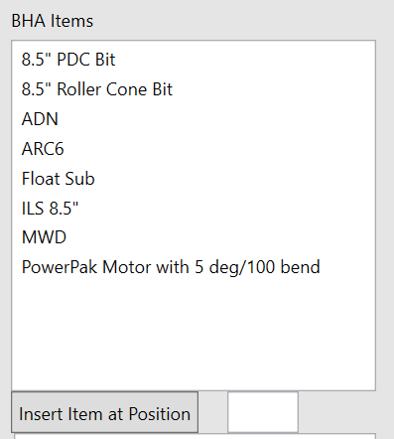
Click to select any item.
Below the list of Available BHA Items, there is a “Insert Item at Position” Button and a text entry box. Enter the position number that you want to insert the selected item, then click the button. The selected item will then be inserted into the BHA at that position. Items at that position or above will automatically adjust to move up in the order.
Below the Item table, a Sensor table displays the list of sensors that are contained within the BHA string, as well as showing details such as the item’s Depth of Investigation, and the distance behind the bit of the sensor’s measure point.
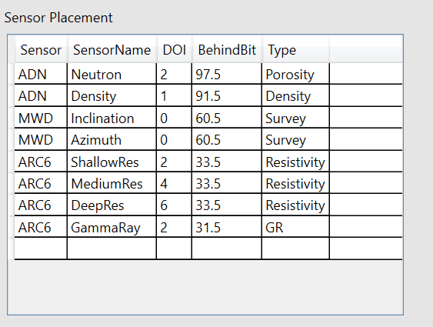
Finally, there are some editable fields to allow the editing of the BHA Name, a description, and building tendencies while both sliding and rotating.
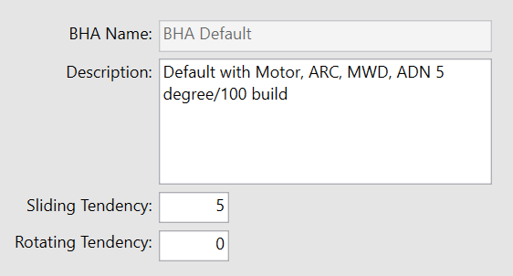
- Note: The BHA Default BHA does not allow it’s name to be changed. All others can be edited.
The Sliding Tendency defines the maximum sliding build that the BHA can achieve while sliding. This value only is used for BHAs which have a Positive Displacement Motor.

The BHA Items sub-Tab allows the management of the items to be used within a BHA.
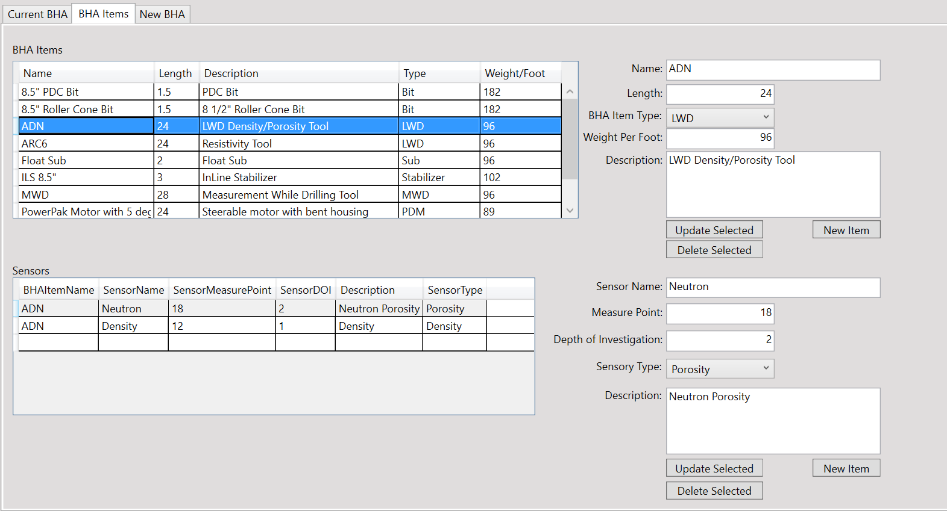
There are 2 tables and 2 sets of edit fields and buttons on this sub-Tab.

The BHA Items table is a tabular form of all defined and available BHA Items. Selecting any item in the table populates the edit fields to the right. Values that can be edited are:
- Name
- Length (in Feet)
- An Item Type (from a selection list)
- The Weight per foot of the item
- And a description.

After making changes, click the “Update Selected” to apply the changes.

Editing or filling out the blank fields, and then clicking the “New Item” button adds the item, rather than updating the selected. For instance, you can select an item, change a name, and length, then click New Item to add that variation, rather than edit the currently selected item.

If there are items no longer wanted in the list, select the item in the table then click the “Delete Selected” to remove the item.
- Note: BHA Items can be shared in multiple BHAs. Editing or deleting the item in the BHA Item’s sub-Tab will affect all BHAs which use that item.
When an item is selected in the Item’s table, any sensors in that item will be displayed in the Sensors table. Selecting a Sensor allows attributes of the sensor to be edited. Use the Update Selected to update any changes made. Similar to the BHA Items table editing, you can add new sensor items or delete them by clicking the appropriate buttons.

The New BHA sub-Tab is relatively simple. It allows you to enter a name, description, Sliding and Rotating Tendencies.
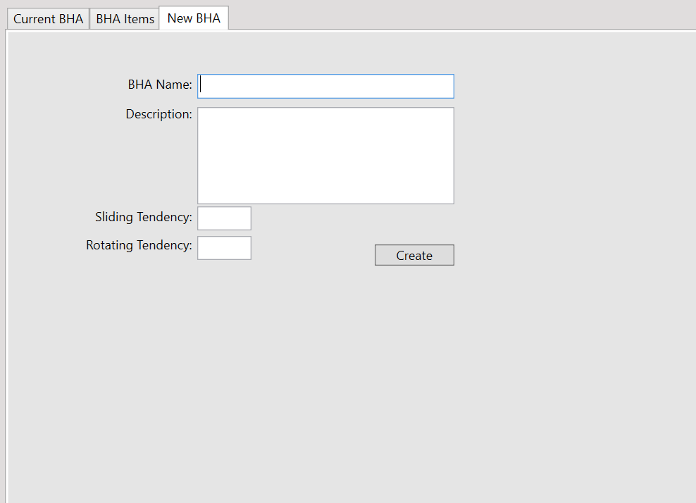
Clicking the “Create” button, adds this new BHA to the system. Return to the Current BHA sub-Tab, then select the new BHA from the available BHA list. Edit it by adding the desired components, and then select on the general tab in order to assign it to the desired well.
Finally, back on the Current BHA sub-Tab, below the list of available BHAs, there is a “Delete BHA”. Use this to permanently remove a BHA from the list.
- Note: The BHA Default item can not be deleted. Any wells which have the BHA being deleted as the currently assigned BHA will have the BHA Default assigned after the deletion.

The Formation Tab
The Formation tab allows the user to manage and edit formations which are available for the Simulator.
A formation is a geologic model of a column directly below the well head. The model is composed of a True Vertical Depth value, and a number of associated properties found at that depth. Formation beds may have varying properties, and the beds are defined as starting from the depth and descending down until the next depth/layer is defined.
The tab displays 2 sub-Tabs, the “Current” sub-Tab and a “New” sub-Tab.
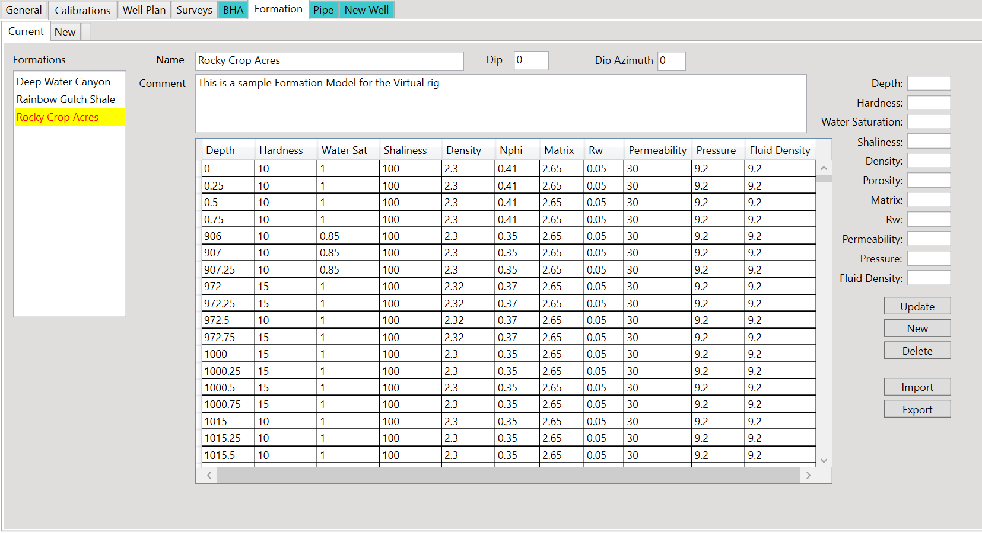
The Current sub-Tab displays a list of Formations which are defined within the simulator and which can be assigned to any well. The Formation which is currently selected for the Well selected in the Available Wells list is selected by default. To work with a different formation, simply select if from the list. Remember, to change the formation assigned to the current well, use the Selected Formation drop down list on the General Tab.
The sub-Tab also contains a few directly editable fields, such as Name, Comment (for a Description), a Formation Dip, and a Formation Dip Azimuth. The Formation Dip is the number of degrees of variation from the horizontal, and the Dip Azimuth is the Azimuth or direction in Degrees, of the downward slope of the dip.
Interactions with dipping formations while drilling use a simple linear dip with an assumed constant dip angle. Considering the formation model is for the column directly below the rig, as directional wells increase the horizontal displacement from the well head, the formation dip calculates the formation values seen at the Bit and LWD sensors based on displacement, Dip and Dip Azimuth.
- Note: These direct edit items can be changes by simply clicking in the text boxes and making the desired change. There is no need to click any update buttons, etc.
Below the Direct edit boxes there is a table of the formation properties. Each row in the table includes a Depth, and a number of properties:
      - Hardness
      - Water Saturation
      - Shaliness
      - Density
      - NPhi
      - Matrix
      - Rw
      - Permeability
      - Pressure
      - Fluid Density
Formation Hardness is a value which indicates how hard the formation is to drill. It is usually in a range of 1 to 10, with 10 being the hardest.
Water Saturation is the percentage of the pore space in a porous rock formation that is filled with water. Typically, a “Sand” will have it’s non-rock volume filled with water so that it would be 100% filled, or a value of 1. We are describing how much of the non-Rock is water. In some cases, there may be trace amounts of hydro-carbon that could be clinging to the surface of the sand grains, so that even though the sand is a ”wet” sand, the water saturation may be around 85%, or .85. In zones that have the pore space filled with Oil or Gas, there is commonly a small amount of water still clinging to the rock surface, so that the water saturation may be around 10% or .1. In zones that are primarily Shale, the water saturation would be 1.
Shaliness is a value which represents the volume of Shale present as a percentage of the total formation. Shale is a rock like substance that is made of highly compressed clays. They contain as large amount of water trapped within the Clay molecules. This may influence some measurements, especially Neutron Porosity. Shale also emits a higher level of naturally occurring Gamma Radiation, so that Solid Shales would have a high count and clean sands with no shale would tend to have low counts. Shaliness is given as a number between 100 for pure shale down to 0 for perfectly clean sand (very rare) so that clean sands typically has a value of 10.
Density is the raw measure of the bulk volumetric density of a section of formation. It is given as a measure of Grams per Cubic Centimeter. This is the composite of the percentage of pure rock (matrix material) and pore space filled with a fluid density. Based on these values, the simulator will calculate the porosity of the formation for log evaluation purposes. Typically the Density will range from around 2.1 to 2.3 gm/cc but this depends on the type of formation (Sandstone or Limestone matrix).
NPHI is the Neutron Porosity. This is the Porosity ( really a Hydrogen Index) as measured by a Neutron Porosity tool. This value is a value of a fraction of 1, so that it would typically have a value of .41 or so for zones of Shale, and then read closer to a true porosity of zones which are not shale. This would normally range from .33 as a maximum available porosity down to .1 to .12 for tighter formations.
Matrix is a value of the density of pure rock material where there is zero porosity. This is used in conjunction with the Density Measure and Fluid Density to compute the formation Porosity. These values would typically be consistent throughout the entire column but rarely you could see a limestone matrix string in a sandstone formation. Sandstone has a Quartz mineral as it’s base, so it has a value of 2.65. Limestone would have a value of 2.71.
Rw is the Resistivity value of the connate water, or the water filling the void space. This is typically a very salty water, so it typically has a value of between .01 to .05. These values are used in conjunction with the porosity and water saturation to compute the values of Resistivity that a logging tool would register while drilling the formation.
Permeability is a measure of the ease which fluids pass through a porous material. In our case, how easy would the formation water, oil or gas flow.
Pressure is a value which indicates the equivalent mud weight which would be needed to balance the formation fluids with the drilling column.
  - Note: Permeability and Pressure are include here for potential future use in the drilling simulation. They are not currently implemented, but hope to be in future versions.
Fluid Density is a value which defines the density of the fluid filling the pore space. In zones filled with Water, the value would be 1 g/cc, however, Oil may see a value of ~ .93 and zones with Gas may have lower values, of ~.85.
Selecting any row in the formation table highlights the row and populates the edit boxes next to the table. Editing any of these values, and clicking the “Update” saves the changes to that row. Similar to the BHA editor, you can enter values with a different depth and click “New” to add a new row with those properties. And, you can click the “Delete” Button to remove a row completely.
Although editing items here allows changes and update, etc, making a large number of changes can be tedious. There is an “Export” button which will allow you to export the current formation and save it as a “CSV” file. The CSV file can be opened with Microsoft Excel or similar Spreadsheet programs which may make bulk changes much easier. After editing, save the results as a “CSV” formatted file, keeping the same format of Column headers, and import the results. Import will completely replace the data of the currently selected formation with the values being imported.
The New Formation sub-Tab is a simple tab with a few entries. Fill out the name, description, dip, and dip azimuth. Click the “Add New Formation” button and a new basic formation will be created. Return to the Current sub-Tab and select your new formation for editing or importing.
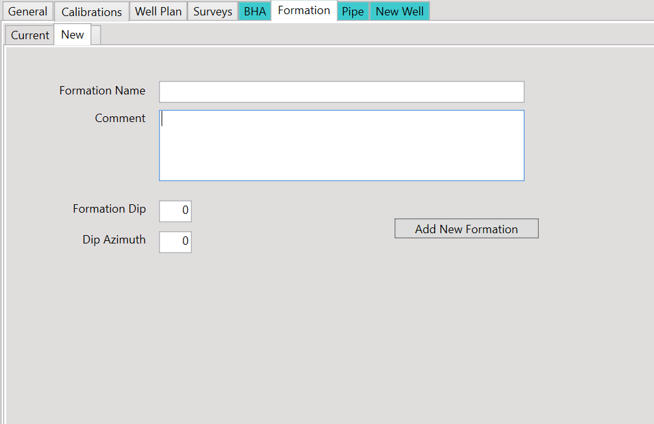

Pipe Tab
The Pipe Tab allows the management of multiple sets of drill pipe.
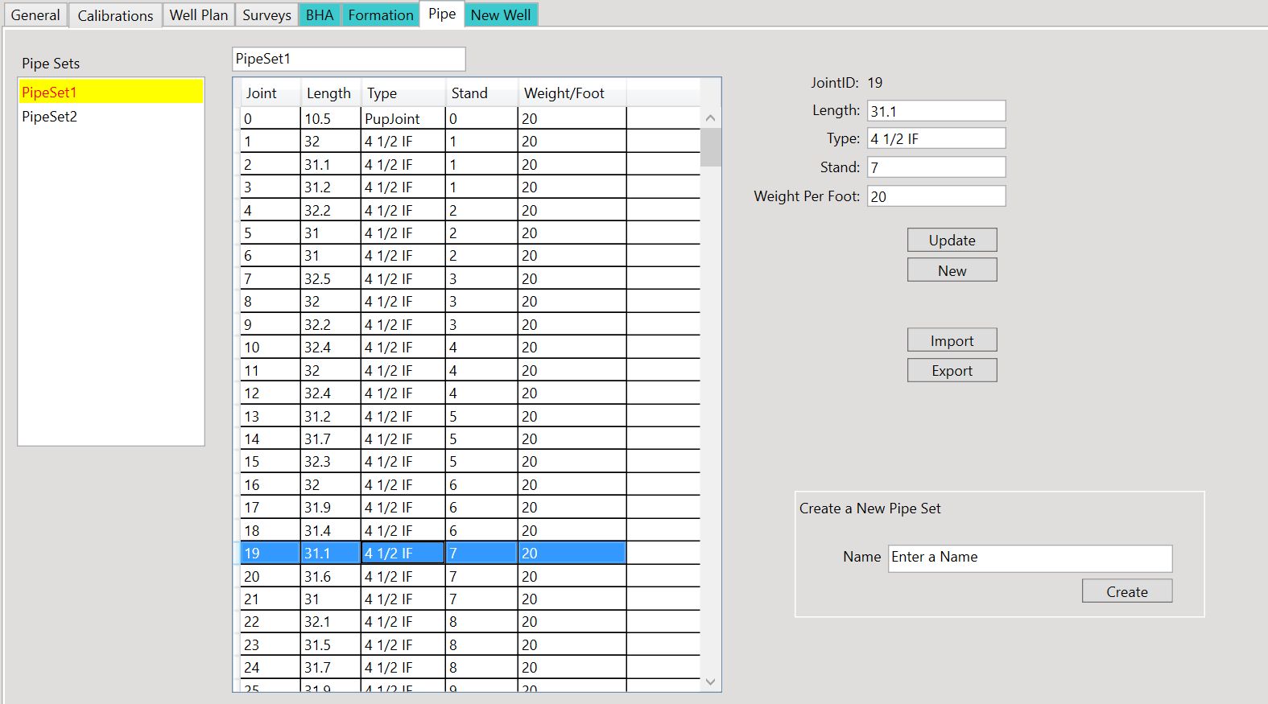
The tab contains a list of the defined pipe sets, when opening the tab, it selects and highlights the pipe set which is currently assigned to the currently selected well in the Available Wells list.
There is a name field to allow you to change the name if desired. A pipe table displays the list of pipe in the selected set with it’s detail including:
- Joint ID number
- Joint Length
- Type of Pipe
- Stand Number
- Weight per foot
Selecting a row allow you to edit that pipe joint’s attributes. Click the “Update” button to save the changes. Fill out the attributes and click the “New” button to add a joint to the pipe set.
- Note: The first joint listed, with ID of 0, is a pup joint. When the simultion starts, calculations are made and values are initialize based on the last survey depth. In order for the amount of pipe to be in the hole so that total pipe length and BHA length correctly align, the pup joint length is calcualted and adjusted.
As with other components of the simulator, when making bulk changes, you may find it easier to export the details to a CSV file and work with a spreadsheet, then import the changes. “Export” and “Import” buttons provide this functionality.
To create a new Pipe Set, provide a name and click the “Create” button. The new pipe set will be available in the Pipe Set listing, where it can be selected and edited or imported.

New Well Tab
When you decide that you want to create a new well for your simulation, select the “New Well” tab.
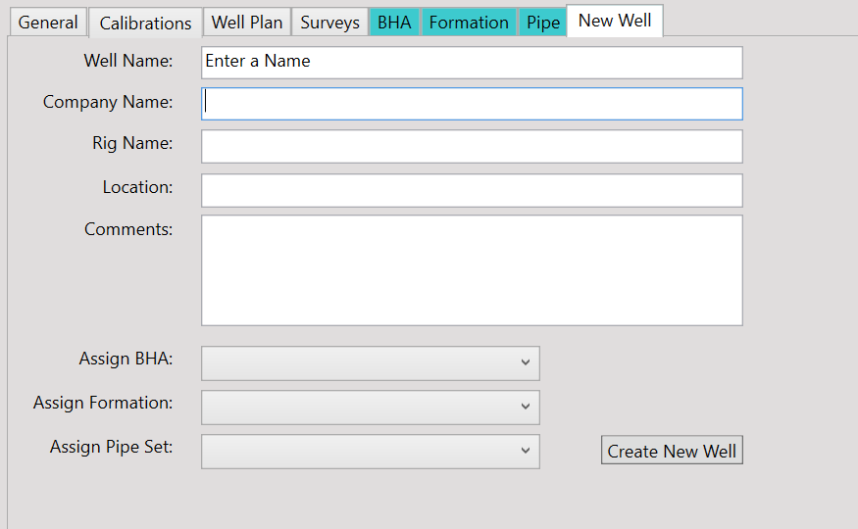
Enter the desired names and values, then select which BHA, Formation and Pipe Set should be assigned to the well. Click the “Create New Well” to add this well to the simulator. The new well will be generated, with a number of default settings.
After the new well has been created, return to the General tab. Ensure that the new well is selected in the Available Wells list, and update the settings as needed for this well. Visit the Calibrations tab and confirm the calibrations are correct. If your BHA will have a Positive Displacement Motor, update the Motor Rotation per Gallon value, etc. Visit the Well Plan tab and edit or import your Well Plan points. Visit the Survey Tab and edit or import surveys for the portion of the well you would like to have already constructed. If desired, edit or create a new BHA, a new Formation, and/or a new Pipe Set. Then you are ready to start the simulator.

Deleting a Well
On the main portion of the Well Management form, below the List of Available Wells, there is a “Delete Well” Button. If, over time, you have created a number of wells and desire to remove one from the system, select that well in the list, then click the “Delete Well” Button. This will permanently delete the well, it’s settings, it’s Well Plan and Surveys, and it’s logging data that may have been captured. BHAs, Formations and Pipe Sets are not impacted. It is recommended to use caution when deleting wells, and strongly recommended not to delete all wells from the simulator.

Control Panel
In the menu selection, under the Setup item, there is a “Control Panel” item, shown highlighted here.
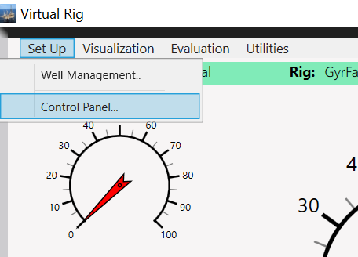
The control panel launches a new window, the Panel Configuration window.
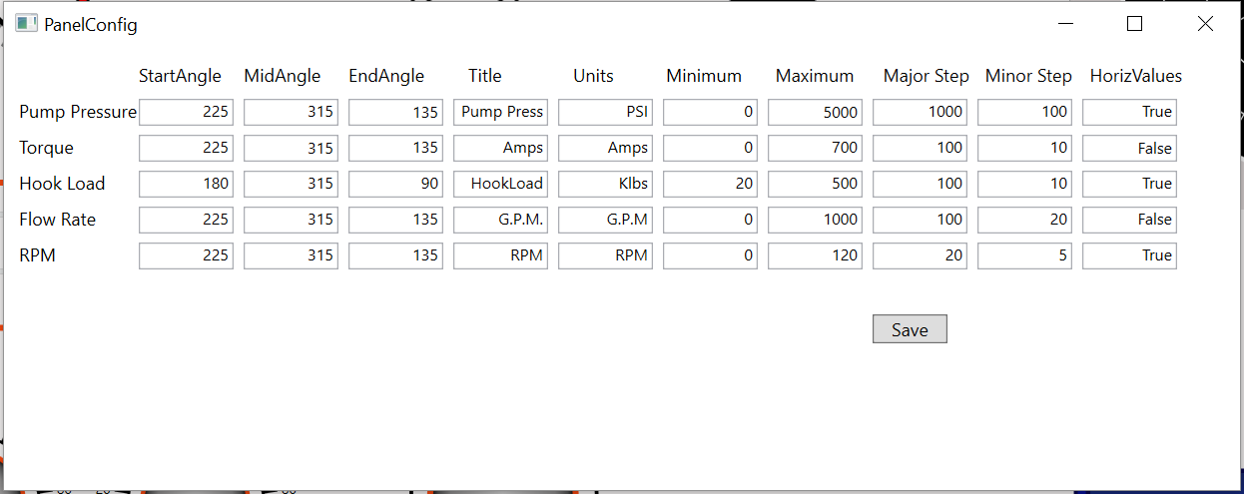
This window allows the changing of the Control Panel Gauges. Each gauge can have a Start, Mid and End Angle which determines the Gauge’s sweep. The title appears below the Gauge, and the units appear above the gauge. Minimum and maximum values define the scale of the gauge, and major/minor steps define the frequency of tick marks on the scale. HorizValues indicate if the numbering of the scale should be presented horizontally (true) or rotated around the scale (false).
After editing the gauges as desired, click the “Save” button to save the changes. You will need to exit and re-start the simulator for the changes to take effect.

Visualization
Under the Visualization menu, there are 3 options:
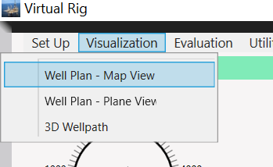
- Map View
- Plane View
- 3D WellPath

Map View
Selecting the Map view creates a display of the Well Geometry as viewed from above.
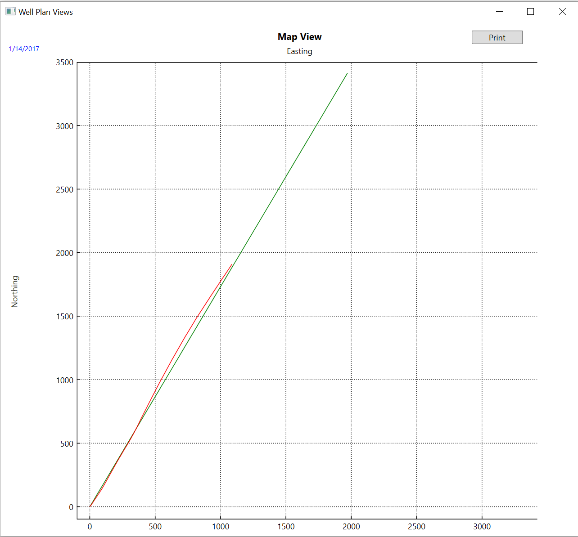
This is a projection of the well, looking straight down. The Green line is the projection of the Well Plan. The Red line is the projection from Surveys.
- Note: The views presented are for the well which is selected in the Well Selector.
To get a better look, you can click and drag your mouse over a selected portion of the view and zoom in. Right click the mouse to revert back to full view.
There is also a print feature to allow printing the view.

Plane View
This is a projection of the well on to a vertical plane, or how the well would appear looking at it from the side. In order to create plane view, you have to define the azimuth of the plane of projection. In the Map view above, we see that the well is roughly on a 30 degree azimuth.
When we select the Plane view, a small dialog box appears asking for the plane of projection
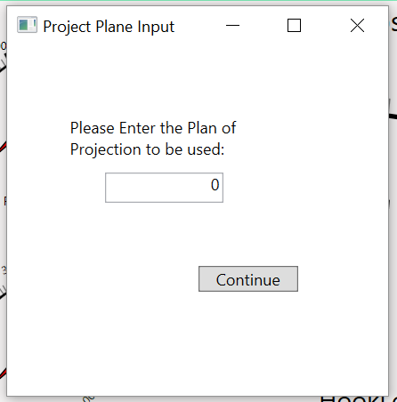
In this case we would enter 30 and click the “Continue” Button. The Plane view will be calculated and presented:
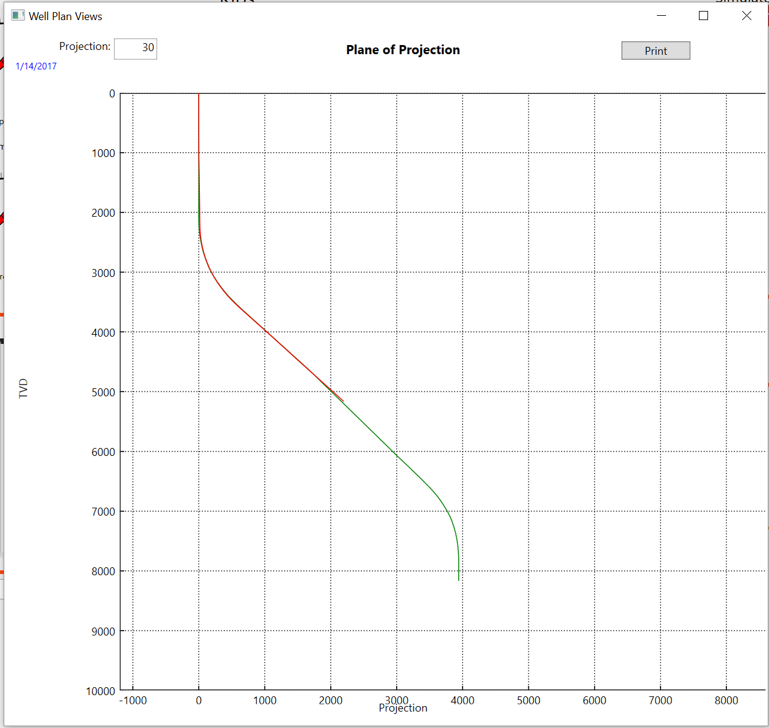
Here we see the green Well Plan, and the red, Surveys for the portion drilled. Clicking and dragging allows you to zoom in for more detail. Right-clicking the mouse zooms back out.

3D WellPath
This feature presents the well in a “3 dimensional” cube.
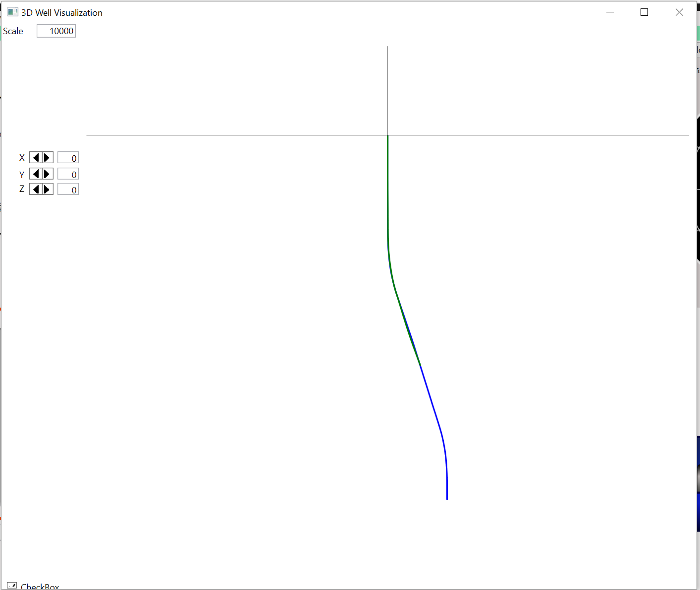
X, Y, and Z axis controllers allow you to click on the increase/decrease arrows, or enter a number directly in order to rotate the cube around the axis. The X axis is horizontal, the Y Axis is vertical, and the Z Axis is straight in or out of the projection.
Below, we have canted the well from vertical, tipped the well slightly from the horizontal, and spun the well around the vertical axis 30 degrees. Recall that the azimuth from the map view was roughly 30 degrees, and in the Plane view we projected onto a 30 degree plane. Now we are looking at that plane edgewise.
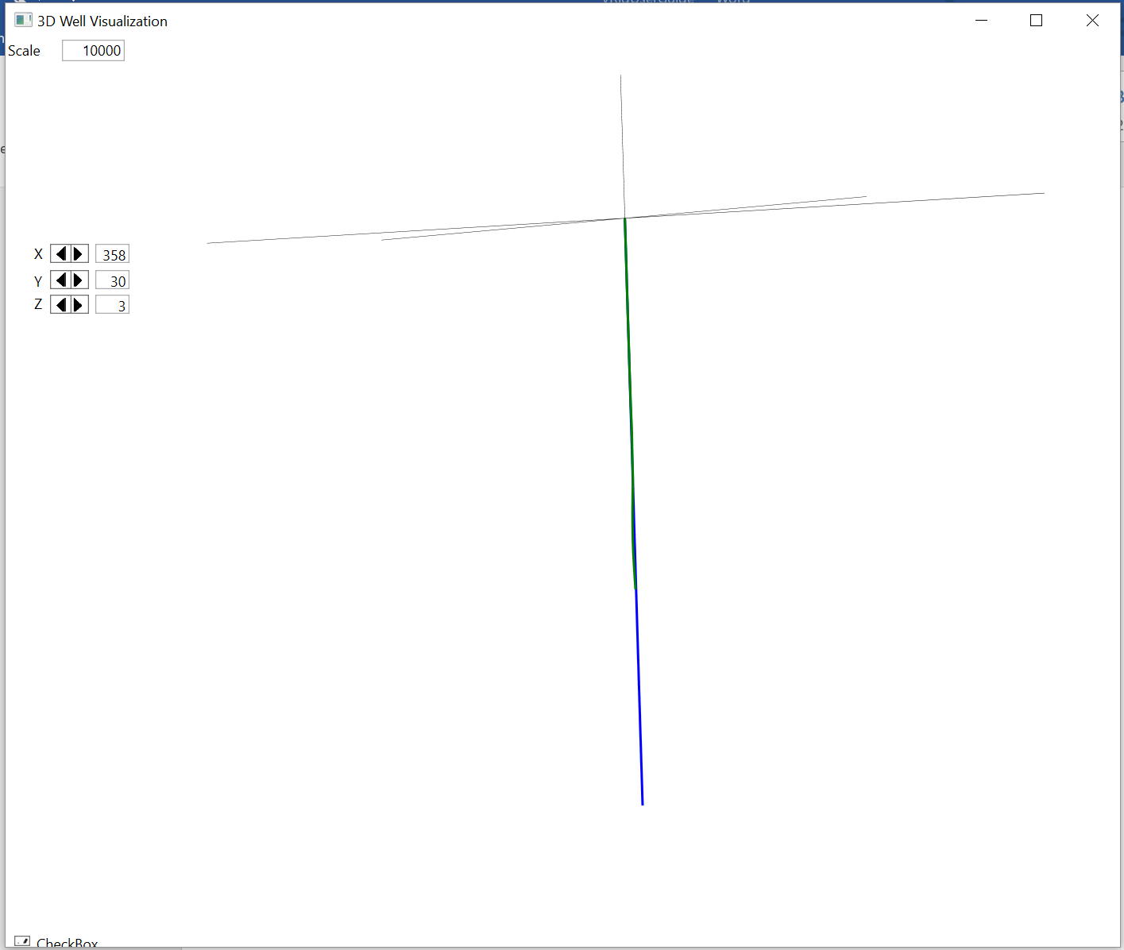
We can adjust the Y Axis to 300, which is perpendicular to the well’s general azimuth and remove the tilts, to reproduce the Plane View with the 30 degree plane of projection.
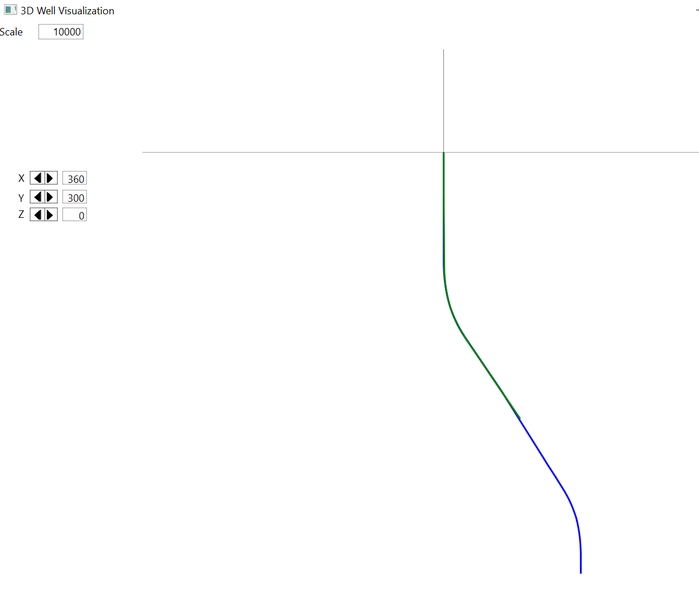
This feature also allows the click/drag to zoom in for more details. Using the 3D WellPath, you can look at the well geometry from almost any perspective.

Evaluation
The Evaluation menu provides an option to display Formation evaluation logs that would have been acquired by formation evaluation tools during the sections you have drilled. There are 2 sets of logs,
      - Log Viewer presents Measured Depth logs
      - TVD Log Viewer presents are plotted on True Vertical Depth
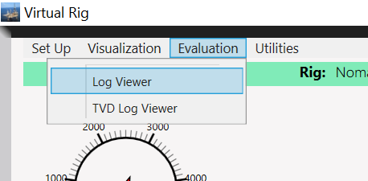
Clicking the desired Viewer brings up the log display. Logs are presented in a 3 Track mode, with Gamma Ray values in the first track, a depth track displaying the measured or TVD Depth, a Resistivity track with 4 decade logarithmic scale, and a porosity track displaying the formation porosities as measured by the density or neutron tools.
The logs are plotted at a scale of ~5 inches per 100 feet. A scroll bar on the right side of the viewer allows you to scroll up or down when the log data cannot be displayed on single screen. A print button brings up a print dialog which allows you to print the logs if desired.
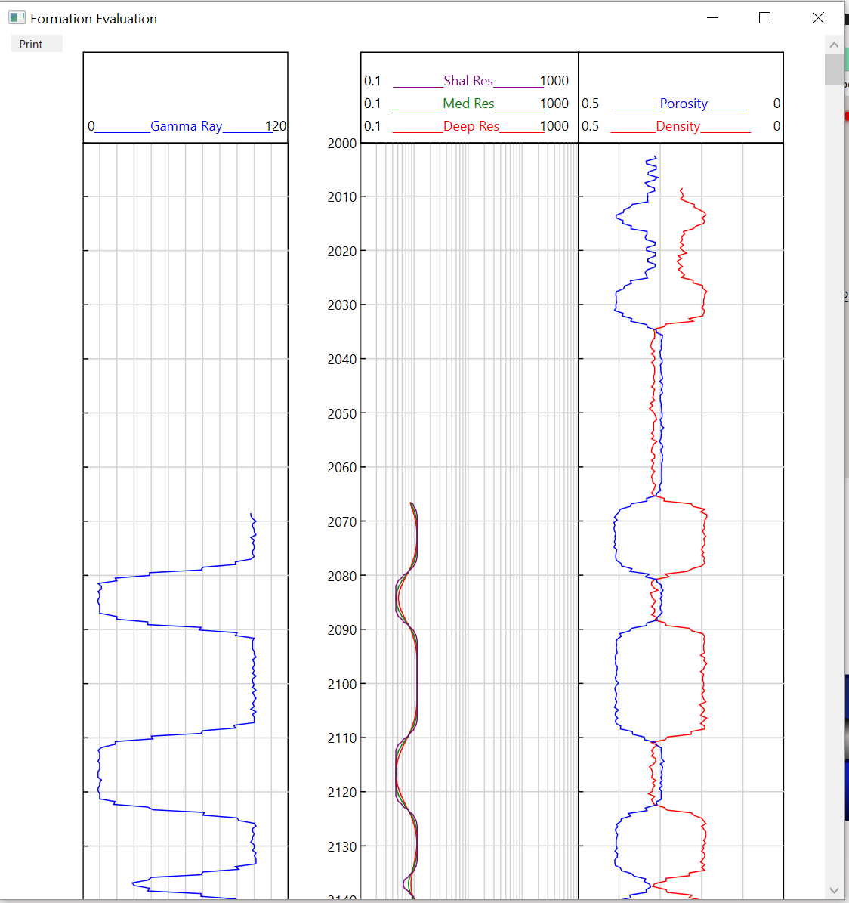
The logging data represents the typical types of formation evaluation data that would be available when logging a real well. From the logs, you should be able to perform analysis to identify shales and sands, and identify which sands may be hydrocarbon bearing. You should be able to perform calculations from the logs to determine the Water Saturation and potential quality of pay zones, etc.

Utilities
vRig contains a few utility features. These include:
- A Kickoff Point Calculator
- Database Backup and Restore
- A Well Reset Feature
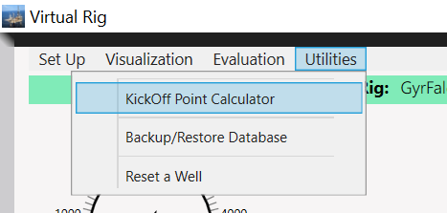

KickOff Point Calculator
This feature allows the directional driller to determine the depth where the well should be kicked off in order to land at a specified True Vertical Depth. As an example, suppose a vertical pilot well has been drilled, and the final log section looks like this:
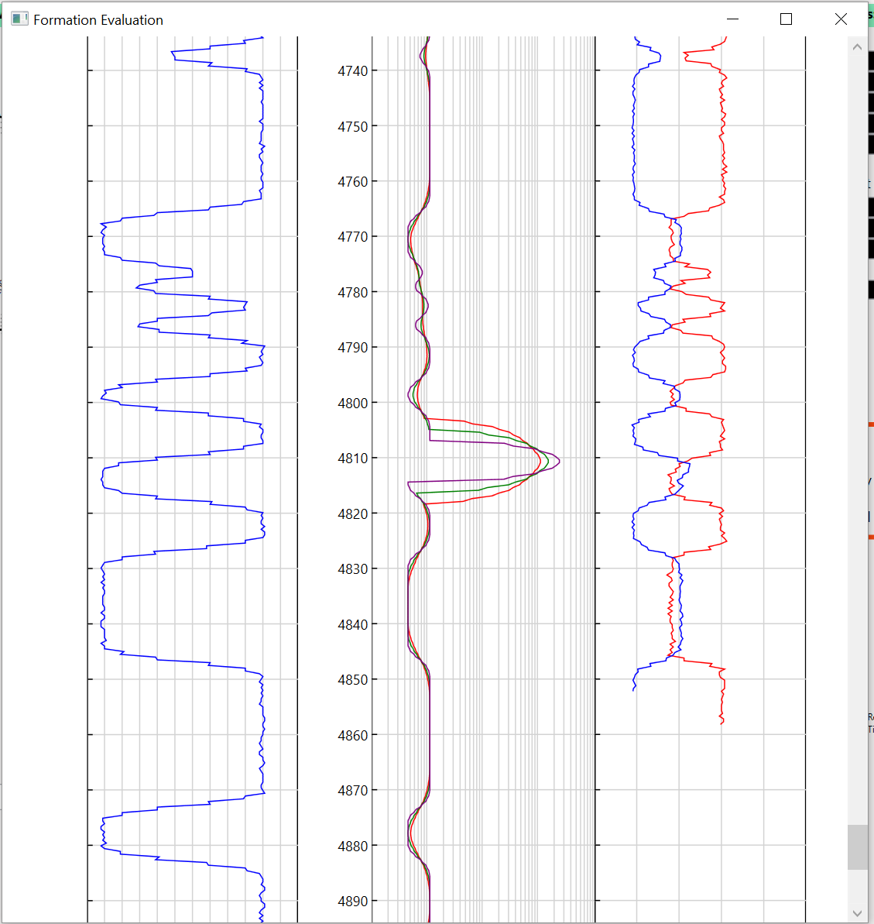
There is a promising pay sand located at 4810’ and we would like to drill a horizontal well which lands at 90 degrees inclination at that depth.
Using the Kick Off Point calculator we can enter values:
- End of Build TVD: 4810
- Start of Build Inclination: 0
- End of Build Inclination: 90
- Build Rate in degrees per 100 feet: 4
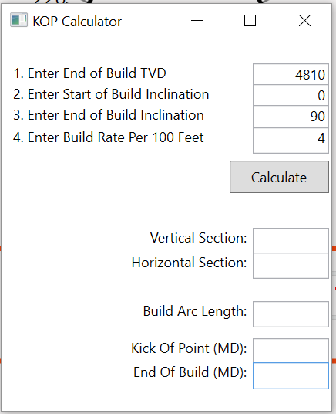
Clicking the Calculate button provides the results:
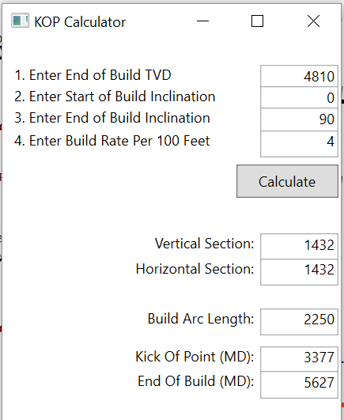
This shows that the Vertical and Horizontal sections for the well would be 1432’. The Arc Length of the build would be 2250’ of measured depth. Subtracting the Vertical Section from the desired TVD target of 4810 gives us the measured depth of the Kick Off Point or 3377’, and the measured depth when the well is landed is 5627’. This does not account for the formation’s dip, however with the well’s azimuth, Horizontal Section, Dip and Dip Azimuth, you can determine any corrections needed for Dip.

Database Backup and Restore
This feature allows the vRig database to be backed up and restored. vRig uses a light-weight version of Microsoft SQL. Open the Backup/Restore window and click the Backup Database button.
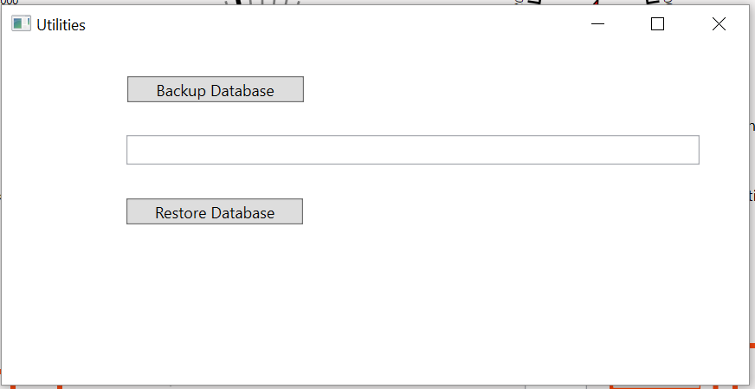
In the pop up dialog box, navigate to where you would like to save the backup. It is recommended to name the Backup File with a “.bak” extension. Also, SQL sometimes is fussy about user account rights and where it can same files. It may be best to create a simple c:\vRigData folder as the selected backup path.
- Note: SQL generates a Log file that records all transactions. Over time, this file can grow in size to become quite large. Backing Up the database truncates the log file.
- Note: Creating a .bak file can be an easy way of exchanging a well with another user.
To restore a database, click on the Restore Button, and navigate to where the .bak is saved. Select the bak file to restore and click the Open button in the Open file dialog box.

Reset A Well
This feature allows a well to be reset to a specified depth. Opening the Reset window presents a list of wells in the simulator. Select the well to be reset.
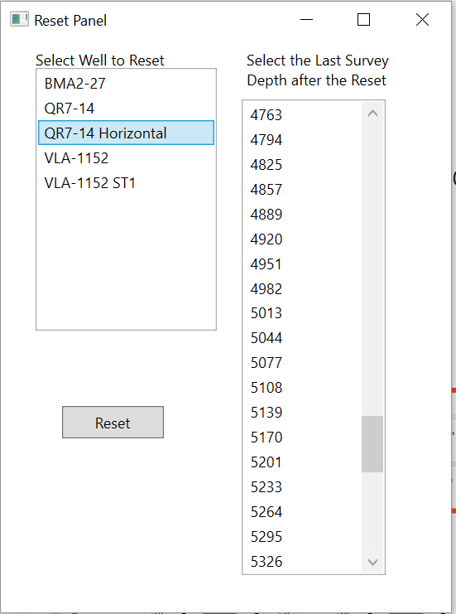
When the well is selected, the list of Survey depths updates. Scroll down and select the survey depth which should be the last good survey. Clicking the Reset button will delete all surveys below that point, and delete the appropriate logging data for that depth and below.

