EXTREEMS-QED Research Program
Project: Classification of Promoter Regions in E. Coli Based on Free Energy
Software: Python, Weka, R(?)

Description. For this project you will characterize the promoter regions of the K-12 MG1655 genome in terms of sequence motifs and free energy profiles. Information on extracting free energy profiles can be obtained from [1, 2]; for sequence motifs see [3]. We will define a promoter region as the portion of a sequence that extends 80 nt upstream of a transcription start site (TSS) and 20 nt downstream; that is, the range [-80, +20] with respect to the transcription start site.

Materials. You will need to obtain the Escherichia coli K-12 MG1655 genome sequence and associated TSS’s. TSS’s for this organism can be downloaded from www.ecocyc.org. The genome sequence is available at NCBI and other sites.

DNA to Free Energy
- Use the method describe in the referenced papers [1, 2] to compute the average free energy for each position in the E. coli genome. Write results to a separate file. (See Figure 1 below for a listing of free energy values.)

Positive Set of Promoters
- Use the TSS data to extract promoter regions from the free energy data. For each TSS, there should be an associated list of 100 free energy values representing [-80, + 20]. You should write each list to a file (one per line). The free energy values should be comma or tab delimited, for later importation back into Python.

Negative Set of Promoters
- Randomly extract 100 nt regions that represent non-promoters. For best results, do not use regions that overlap with known promoters. Select two non-promoters, for each promoter obtained from Part B, above.

Graph Promoters
- Use a line graph to display the average free energy for all promoter regions. The nucleotide sequence position should be shown on the x-axis and the average free energy on the y-axis. You can use Python to do the graphing. If the free energy in promoter regions differs, there should be a distinctive difference in the two graphs.

Promoter Prediction
- Combine the promoter and non-promoter files. Randomly select two-thirds of the data for training and one-third for testing. Convert the training and testing data to Weka format and do classification. Report accuracy, precision, recall, and the confusion matrix.

References

- Allawi, H. T., SantaLucia, J. Jr. (1997). Thermodynamics and NMR of internal G.T mismatches in DNA. Biochemistry, 36, 10581–10594.

- Kanhere, A., Bansal, M. (2005). A novel method for prokaryotic promoter prediction based on DNA stability. BMC Bioinformatics, 6, 1471–2105.

- Bailey TL, Williams N, Misleh C, Li WW. Meme: discovering and analyzing DNA and protein sequence motifs. Nucleic Acids Res. 2006;34:W369–W373.

- Weka Data Mining Software [http://www.cs.waikato.ac.nz/ml/weka/index.html]. Last accessed 12/16/2016.

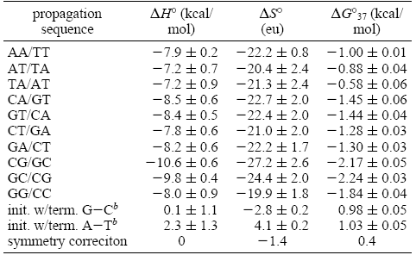

Figure 1: Free Energy Values

