**CMB114 CW3 Tutorials and Testing**

**Basic Graphic-User Interface (GUI) Run-Through:**

The GUI has a fairly intuitive layout, with the configuration of the unit converter on the left-hand side of the window, with the output on the right-hand side of the window.

The Quantum Calculator section is very similar, configuration at the top and output at the bottom.

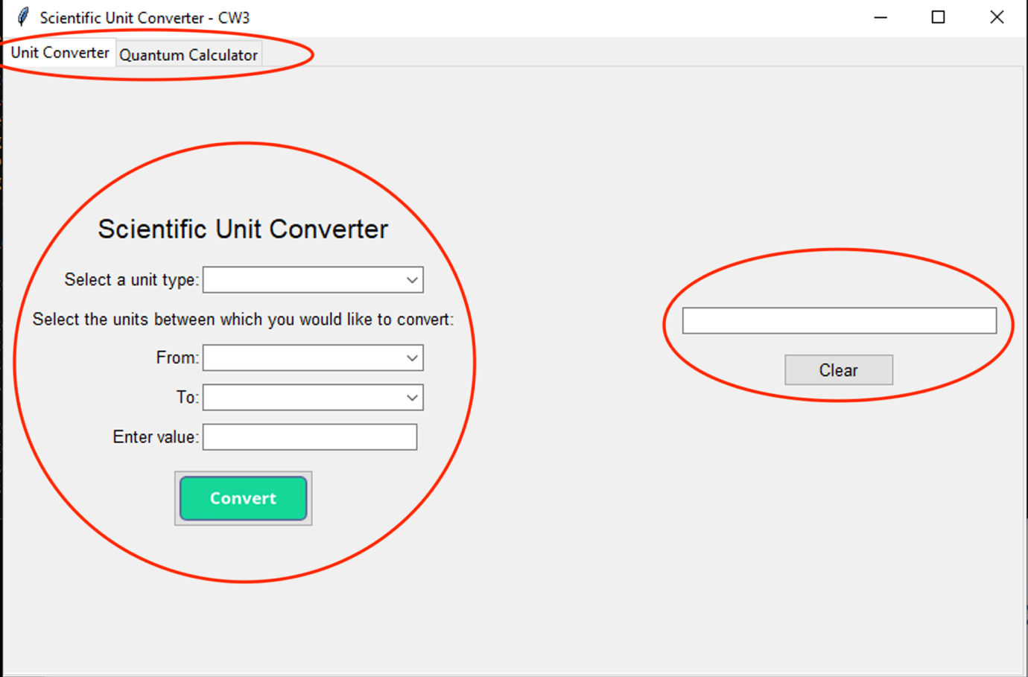

1

2

3

1 – The different sections of the GUI can be navigated between using the tabs in the top left of the window.

2 – In this section of the GUI the user can configure the unit conversion they wish to make.

3 – The output of the conversion calculation is displayed on this side of the GUI alongside some reference text.

1

2

1 – This section allows the user to input the value of their selected property for the associated properties to be output below.

2 – This section allows the user to make the calculation and, subsequently, clear the output in order to run another calculation.

**GUI Testing:**

**Unit Converter Tesing:**

Throughout the development of the code, each of us has run various minor tests here and there to ensure that components of the code work.

Below, the GUI’s functionality is tested vs that of Google’s standard unit converter to check that our calculations are correct.

Length:

Time:

Volume:

Pressure:

Energy:

**Quantum Calculator Testing:**

In the following example, Excel was used alongside the equations and constants from the FP-3 CMB105 lecture slides, to prove that the calculations made by the application are accurate.

Firstly, with Enegry:

Another example, this time with the input as Wavenumber:

With Time:

With Frequency:

And finally, Wavelength:

**Basic CLI (Command-Line Interface) Run-Through for Unit Conversion:**

When the CLI is run, the user is asked which section of the application they would like to access. Alternatively, they can navigate back to the project directory.

Supposing the user wanted to perform a unit conversion in the capacity of Volume, they would be met with the following options:

The user has been directed successfully to the conversions with type volume. The user is then prompted to select the units they would like to convert from. Alternatively, they can navigate back to the main menu.

Following through the CLI’s options, the user can complete their calculation:

**Basic CLI (Command-Line Interface) Run-Through for Quantum Calculations:**

The quantum calculations option can be accessed via the opening selections by inputting the value 6.

Upon accessing the quantum calculations, the user will be prompted again for an input, this is regarding the property type.

For example, if the user were to chose option 1, they would again be prompted to input a value. Finally, after the value has been inputted, the user will receive results from the quantum calculations, which have been conducted via the import of quantum.py. The user will then be taken back to the opening options.

**CLI Testing:**

Due to the multiple aspects of user input required in the command line interface, there are a lot of elements that could cause the program to break.

|  |  |  |  |  |  |
| --- | --- | --- | --- | --- | --- |
| **Test no.** | **Part of the code** | **Input** | **Expected output** | **Output** | **Pass/Fail** |
| 1 | Opening options() | Integer within the range (0<choice<9) | Program continues correctly | Program continues correctly | Pass |
| 2 | Opening options() | Integer outside the range (0<choice<9) | Program detects out of range | Program detects error and asks for another input | Pass |
| 3 | Opening options() | Float | Program detects issue with input | Program detects error and asks for another input | Pass |
| 4 | Opening options() | String | Program detects issue with input | Program detects error and asks for another input | Pass |
| 5 | conversion (starting unit) | Integer within the range | Program continues correctly | Program continues correctly | Pass |
| 6 | conversion (starting unit) | Integer outside the range | Program detects out of range | Program detects error and asks for another input | Pass |
| 7 | conversion (starting unit) | Float | Program detects issue with input | Program detects error and asks for another input | Pass |
| 8 | conversion (starting unit) | String | Program detects issue with input | Program detects error and asks for another input | Pass |
| 9 | conversion (entering value) | Integer | Program continues correctly | Program continues correctly | Pass |
| 10 | conversion (entering value) | Float | Program continues correctly | Program continues correctly | Pass |
| 11 | conversion (entering value) | String | Program detects issue with input | Program detects error and asks for another input | Pass |
| 12 | conversion (ending unit) | Integer | Program continues correctly | Program continues correctly | Pass |
| 13 | conversion (ending unit) | Integer outside the range | Program detects out of range | Program detects error and asks for another input | Pass |
| 14 | conversion (ending unit) | Float | Program detects issue with input | Program detects error and asks for another input | Pass |
| 15 | conversion (ending unit) | String | Program detects issue with input | Program detects error and asks for another input | Pass |
| 16 | quantum (ending unit) | Integer | Program continues correctly | Program continues correctly | Pass |
| 17 | quantum (property type) | Integer outside the range | Program detects out of range | Program detects error and asks for another input | Pass |
| 18 | quantum (property type) | Float | Program detects issue with input | Program detects error and asks for another input | Pass |
| 19 | quantum (property type) | String | Program detects issue with input | Program detects error and asks for another input | Pass |
| 20 | quantum (value entry) | Integer | Program continues correctly | Program displays calculations, returns to opening | Pass |
| 21 | quantum (value entry) | Float | Program continues correctly | Program displays calculations, returns to opening | Pass |
| 22 | quantum (value entry) | String | Program detects issue with input | Program detects error and asks for another input | Pass |

Test

1:

2:

3:

4:

5:

6:

7:

8:

9:

10:

11:

12:

13:

14:

15:

16:

17:

18:

19:

20:

21:

22:

