PuzzleForge: Response to Reviewer Comment 4
Illustrated rebuttal · 97 seeds / 1,440 blind items · 29 October 2026
At a glance
B1 (direct): 27.9% valid; PF is +48.4 pp.
B2 (one-pass generator): 73.3% valid, statistically tied with PF (76.3%).
PF yields 1.86x more valid >=3-step items per slot (62.7% vs 33.8%).
Two judge families agree on 83.4% of verdicts; the B1 gap holds and the PF-B2 tie holds.

REVIEWER COMMENT
4. The experiments primarily demonstrate the usefulness of PF-86K rather than the effectiveness of PuzzleForge as a framework.
Much of the experimental section evaluates the difficulty of PF-86K and the downstream improvements. These results support PF-86K as a useful dataset, but provide less evidence that PuzzleForge is a superior data-generation framework.
Important framework-level baselines are missing, such as direct LLM-based instance synthesis and direct LLM generation of executable generators without the proposed multi-stage decomposition. Otherwise, the paper may be more appropriately framed primarily as a benchmark/data contribution rather than a methodological framework contribution.

Response
We ran both baselines the comment names: direct instance synthesis (B1) and one-pass synthesis of a reusable generator with no multi-stage decomposition (B2), against the full pipeline (PF), on 97 shared seeds, blind-judging 1,440 items (480 per condition).
Design. All three conditions use GPT-5.2. PF is the paper's released test split: a 2% random holdout per generator, after the pipeline's own deduplication and generator filtering; the holdout itself is not quality-selected. B1 and B2 share model, decoding and a 20-item quota. B2 gets three execution-debug attempts with real errors, but no expansion agent, DSL, semantic verification or solve-based filtering, which makes it the stronger baseline. The judge sees only the problem, a canonical answer and anonymous certificates; method and seed are stripped.
Table 1. What each pipeline yields per requested slot (480 slots per condition; token row at 20 instances/unit).
 | PF | B2 | B1
valid items (of 480 slots) | 366 (76.3%) | 352 (73.3%) | 134 (27.9%)
valid, >=3 dependent steps | 301 (62.7%) | 162 (33.8%) | 28 (5.8%)
reasoning depth, mean (0-4) | 2.94 | 2.34 | 1.93
median length (chars) | 692 | 321 | 297
near-dup @0.8 | 3.0% | 24.9% | 6.2%
tokens / valid item (20/u) | 12,267 | 527 | 4,571
Percentages per slot (denominator 480); near-dup is over the 1,284 matched items per condition, not the 480 judged slots. Paired differences are seed-macro; inference is seed-paired (Wilcoxon, Holm across 21 tests, 2,000 seed bootstrap).
Against B1, PF is far better on validity (+0.484 [+0.406, +0.556], p = 5.0e-14) and depth (+0.844). B1's failure is silent: 71.7% of items are invalid, yet only one has no output, and 331 of the 344 invalid items carry a wrong canonical answer. Execution grounding is the decisive factor, and B1 is not the strong baseline.
Against B2, validity is a tie: generator-level 0.775 vs 0.774; seed-level +0.027 [-0.054, +0.114], which becomes -0.010 when B2's five zero-output seeds are dropped. PF's advantage is yield: 62.7% vs 33.8% of slots produce a valid >=3-step item (1.86x; unit-matched 63.8% [56.6, 70.5] vs 33.8%).
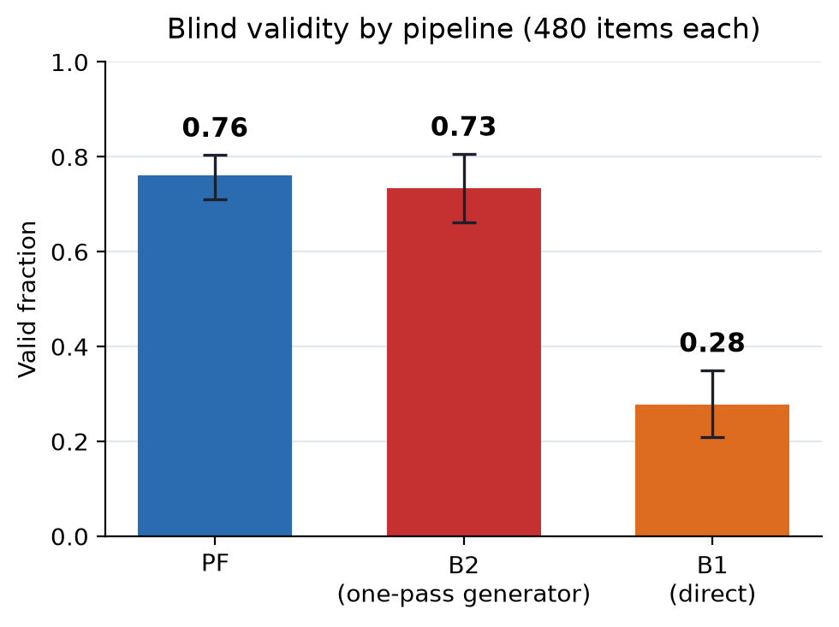
Figure 1. Blind validity by pipeline (480 items each; bars are seed-macro means, whiskers are 95% bootstrap intervals over seeds).
Because PF items are also about twice as long (median 692 vs 321 chars), we tested the length confound directly rather than relying on one model. The raw depth gap is +0.602; OLS with log length gives +0.418, while strict matching is more conservative: nearest length (caliper 0.5) gives +0.439 [+0.150, +0.764]; coarsened exact matching on seed x length quintile gives +0.207 [-0.020, +0.443], and the top length quintile is essentially flat (-0.14). Single-subquestion items, which rule out "PF just bundles sub-questions", give +0.541 [+0.353, +0.827] raw and +0.548 [+0.120, +0.900] length-matched. We therefore use depth as supporting evidence and anchor the main claim on the >=3-step yield: +24.6 pp [+11.6, +35.9] after standardising B2 to PF's length distribution, and +15.8 pp [-1.2, +33.7] under strict nearest-length matching. The direction is stable in every specification; the strict matched estimate is smaller because the length overlap is thin, but it remains positive.
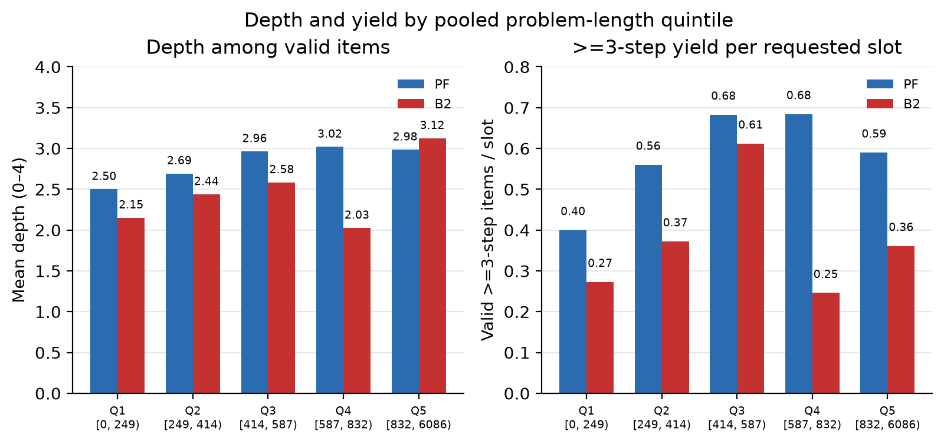
Figure 2. Depth among valid items and >=3-step yield per requested slot, by pooled problem-length quintile. PF is higher on yield in every quintile; B2 matches PF on depth only in Q5, where B2 has 16 valid items.
Diversity. Unit-matched (PF generator, B2/B1 seed) near-duplicate @0.8 is 13.2% vs 24.9%; identical constraint-tag sets 30.2% vs 53.1%; reasoning-tag sets 46.1% vs 56.8%. PF's seed-level 3.0% is partly a mixing effect (five items from three generators), which we correct. Against B1, PF has more near-duplicates (13.2% vs 6.2%) but fewer identical tag sets; B1's items are also shorter.
Cost. At the paper's 200-instance scale, PF is 1,227 tokens per valid item vs 50 for B2 and 4,571 for B1; at 20 instances, 12,267 vs 527 and 4,571. PF/B2 is ~23-25x at either scale, and PF's spec cost is 0.34-0.55M tokens per seed vs B2's 7.7k (45-70x). Cost is the trade-off: PF's extra budget buys >=3-step yield and structural diversity. We report it explicitly rather than claim a cost advantage; the earlier draft compared PF at 200 instances/generator with B2 at 20/seed, and the corrected table puts both on the same basis.
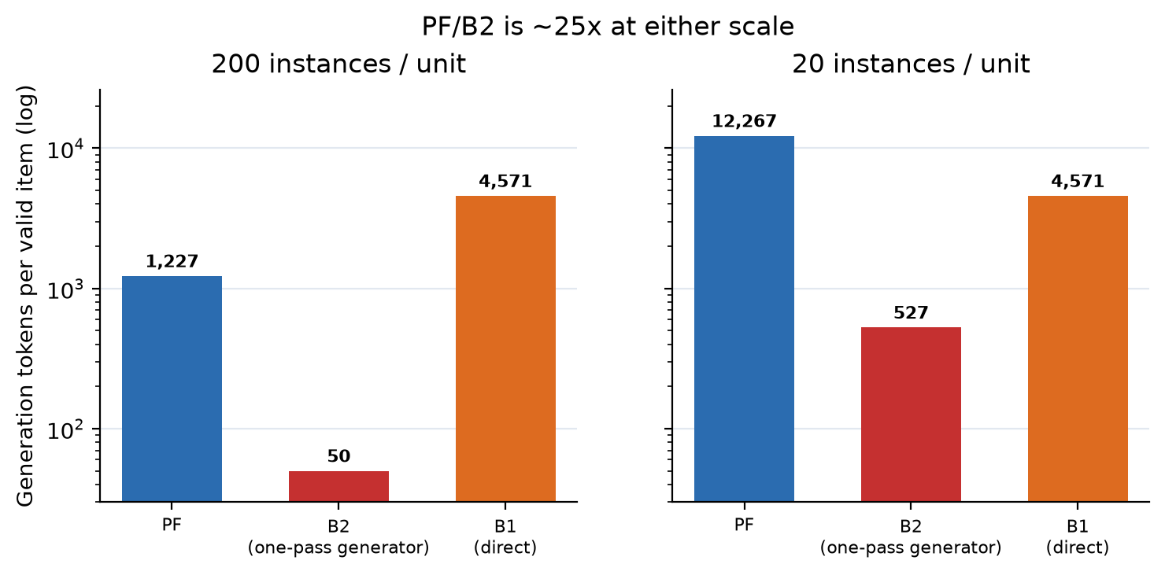
Figure 3. Generation tokens per valid item at two amortisation scales. PF/B2 is ~25x at either scale; B2's 50 at 200 instances/unit is the design-scale number.
Judge reliability. On a 560-item cross-family subsample (both models see the same three solver attempts; one verdict per model), exact verdict agreement is 83.4% (Cohen's kappa 0.67). The two families differ in strictness: PF's invalid rate is 30.9% under gpt-5.6-luna but 12.6% under gemini-3.1-pro-preview, and the PF-B2 validity difference flips sign (luna 0.686 vs 0.730; gemini 0.863 vs 0.789). B1 is 25.5% vs 27.5% valid, i.e. 72-74% invalid under both. The PF-B2 validity difference is therefore within judge noise; the B1 gap is not. The depth gap is +0.729 (luna) and +0.536 (gemini) on items both call valid.
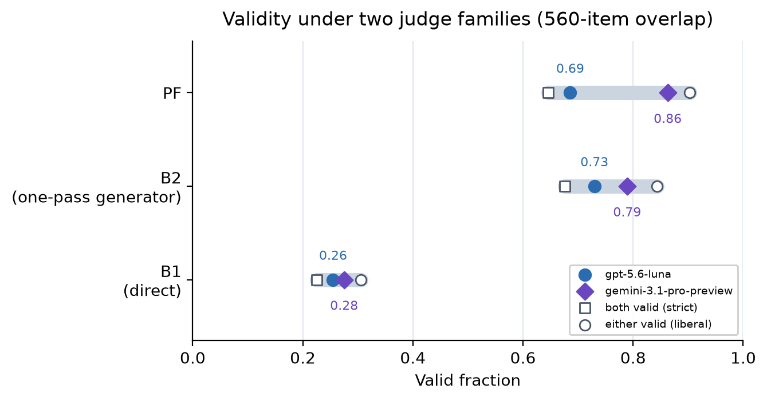
Figure 4. Validity under two judge families on the 560-item overlap. The bar spans strict (both valid) to liberal (either valid); points are the two families. B1 stays far below PF/B2 under both.
Two real items behind the 23.1%
The judge marks 111/480 (23.1%) of PF's released test items invalid, 89 for a wrong canonical answer. Two real items show why this figure needs care. In PF / operation_21/08, the double integral of a separable trigonometric polynomial, the released answer is [[0.133046]] while an independent evaluation gives [[-0.133046]]: a sign error, a genuinely invalid item. In PF / number_wall/14, a compound-interest problem (2433 at 3% quarterly for 3 years, then +3723 at 6% quarterly for 4 years), the released answer is 7946.95 while the computation gives 7946.9444, which rounds to 7946.94: a 0.01 rounding difference, cosmetic rather than a broken puzzle. Both count as invalid, so 23.1% is an upper-end proxy that mixes substantive and cosmetic errors. The cross-family panel shows the same sensitivity: PF's invalid rate is 30.9% under luna and 12.6% under gemini, while B1 is 72-74% under both. The revision will report the two categories separately and correct the released labels.

Framing. We agree the framing should be explicit, and the added comparisons let us state it precisely. The framework's contribution is the yield of >=3-step items and structural diversity per seed; the trade-off is ~25x generation tokens, with validity on par with the strongest one-pass baseline. The revision will present this as a framework-level contribution alongside the dataset contribution, add the generator-level and length-matched tables, and rewrite the abstract and introduction to match. This is a more precise claim than an unqualified "superior framework".
Prompts, generators, traces, blind keys and the per-request token ledger are released with the paper and the revision.

中文翻译
我们补上了审稿人点名的两个框架级基线：直接造题（B1）与不做多阶段分解、直接生成可复用生成器（B2），在 97 个共享 seed 上与完整流水线（PF）做盲评比较，1,440 道题，每组 480 道。
设置。 三组都用 GPT-5.2。PF 是论文发布的 test split：每个生成器 2% 的随机 holdout，已经过流水线自己的去重与生成器过滤；holdout 本身不是按质量挑的。B1/B2 同模型、同解码参数、同 20 题配额。B2 有三次带真实执行报错的调试机会，但没有 expansion agent、DSL、语义验证或 solve-based filtering，因此是更强的基线。评审只看题面、规范答案与匿名证书，方法和 seed 已剥离。
表 1. 三条流水线每个请求槽位的产出（每条件 480 槽位；token 行为 20 实例/单位）。
 | PF | B2 | B1
有效题（480 槽位） | 366 (76.3%) | 352 (73.3%) | 134 (27.9%)
有效且 >=3 步 | 301 (62.7%) | 162 (33.8%) | 28 (5.8%)
推理深度均值 (0-4) | 2.94 | 2.34 | 1.93
题面长度中位（字符） | 692 | 321 | 297
near-dup @0.8 | 3.0% | 24.9% | 6.2%
每有效题 token（20/单位） | 12,267 | 527 | 4,571
百分比按槽位计（分母 480）；near-dup 是在每条件 1,284 个 matched 题上算的，不是 480 个盲评槽位。配对差为 seed 宏平均；推断按 seed 配对（Wilcoxon，21 项 Holm，2,000 次 seed bootstrap）。
对 B1，PF 在有效率（+0.484 [+0.406, +0.556]，p = 5.0e-14）与深度（+0.844）上明显更好。B1 的失败是静默的：71.7% 的题无效，却只有 1 题无输出，344 道无效题里 331 道规范答案错误。执行接地是决定性因素，B1 不是强基线。
对 B2，有效率持平：生成器级 0.775 vs 0.774；seed 级 +0.027 [-0.054, +0.114]，去掉 B2 五个零产出 seed 后变为 -0.010。PF 的优势在产出率：62.7% vs 33.8% 的槽位产出一道有效且 >=3 步的题（1.86 倍；单位匹配后 63.8% [56.6, 70.5] vs 33.8%）。
图 1. 三条流水线的盲评有效率（每组 480 题；柱为 seed 宏平均，须为 2,000 次 seed bootstrap 的 95% 区间）。
PF 的题面也约长一倍（中位 692 vs 321 字符），所以我们直接检验长度混杂，而不是只依赖一个模型。原始深度差 +0.602；OLS 加 log(length) 为 +0.418；严格匹配更保守：最近邻（caliper 0.5）+0.439 [+0.150, +0.764]；按 seed × 长度五分位的 CEM +0.207 [-0.020, +0.443]，最高长度分位基本持平（-0.14）。单小问子组（排除"PF 只是把小问拼在一起"）给出 +0.541 [+0.353, +0.827]（原始）与 +0.548 [+0.120, +0.900]（长度匹配）。因此我们以 depth 作为支持性证据，主主张落在 >=3 步产出率上： 把 B2 按 PF 的长度分布标准化后 +24.6 pp [+11.6, +35.9]；严格最近邻匹配后 +15.8 pp [-1.2, +33.7]。方向在所有设定下一致；严格匹配的重叠较少、估计更小，但方向不变。
图 2. 按题面长度五分位分层的 depth（仅有效题）与每槽位 >=3 步产出率。PF 在每个分位的产出率都更高；B2 只在 Q5 的 depth 追平，而 Q5 的 B2 只有 16 道有效题。
多样性。 单位匹配（PF = 生成器，B2/B1 = seed）后，near-dup @0.8 是 13.2% vs 24.9%；约束标签集合相同 30.2% vs 53.1%；推理标签集合相同 46.1% vs 56.8%。PF 的 seed 级 3.0% 部分是"5 道题来自 3 个生成器"的混合效应，我们做了校正。对 B1，PF 的 near-dup 更高（13.2% vs 6.2%），但两个 tag 集指标都更好；B1 的题面也更短。
成本。 按论文的 200 实例/单位尺度，PF 每有效题 1,227 token，B2 是 50，B1 是 4,571；按 20 实例/单位，分别是 12,267、527、4,571。PF/B2 在两个尺度上都是 ~23-25 倍；PF 的 spec 成本是 0.34-0.55M token/seed，B2 是 7.7k（45-70 倍）。成本是 trade-off：PF 多出的预算买到的是 >=3 步产出与结构多样性。我们明确报告这一点，不声称成本优势；上一版把 PF 的 200 实例/generator 与 B2 的 20 实例/seed 放在同一行，修正后的表把两者放在同一摊销尺度。
图 3. 两个摊销尺度下每道有效题的生成 token。PF/B2 在两个尺度上都是 ~25 倍；B2 在 200 实例/单位下是 50，这是设计尺度的数字。
评审可靠性。 在 560 道交叉子样本上（两个家族看到同样的 3 个 solver 尝试，每个模型一个 verdict），exact agreement 83.4%，Cohen's kappa 0.67。两个家族的严格度不同：PF 的 invalid 率在 gpt-5.6-luna 下是 30.9%，在 gemini-3.1-pro-preview 下是 12.6%；PF−B2 的有效率差随 judge 翻符号（luna 0.686 vs 0.730；gemini 0.863 vs 0.789）。B1 在两个家族下分别是 25.5% 与 27.5% valid，即 72-74% invalid。因此 PF−B2 的有效率差在 judge 噪声内，B1 的差距不在。 两家都判 valid 的题上，depth 差是 +0.729（luna）与 +0.536（gemini）。
图 4. 560 题重叠样本上两个评审家族的有效率。横条从 strict（两家都判 valid）到 liberal（任一家判 valid）；点是两个家族。B1 在两个家族下都远低于 PF/B2。
23.1% 背后的两个真实例子
judge 判 PF 发布 test set 的 111/480（23.1%）为 invalid，其中 89 道是规范答案错误。两个真实例子说明这个数字需要拆开看。PF / operation_21/08 是一道可分离三角多项式在矩形区域上的二重积分题，发布答案是 [[0.133046]]，独立计算是 [[-0.133046]]：符号错误，真正无效的题。PF / number_wall/14 是一道复利题（2433 元按 3% 季度复利存 3 年，再加 3723 元按 6% 季度复利存 4 年），发布答案是 7946.95，计算值是 7946.9444，四舍五入应为 7946.94：0.01 的舍入差，属于瑕疵，不是坏题。两者都被算作 invalid，所以 23.1% 是混合了"实质错误"与"瑕疵"的偏高代理。跨家族 panel 显示同样的敏感性：PF 的 invalid 率在 luna 下 30.9%、gemini 下 12.6%，而 B1 在两个家族下都是 72-74%。修订版会把两类错误分开报告，并修正发布标签。

定位。 我们同意定位要写清楚，新增的比较让我们可以写得更精确。框架的贡献是每 seed 产出的 >=3 步题比例与结构多样性；代价是 ~25 倍生成 token，有效率与最强的一遍生成器基线持平。修订版会把这条作为框架级贡献与数据集贡献并列，补上生成器级与长度匹配的表，并同步改写 abstract 与 intro。这比笼统的"框架更优"更精确、也更站得住。
prompt、生成器、trace、盲评 key 与逐请求 token 账本随论文与修订版释放。

