**ISyE 3104 Exam 1 – Part II of II**

**Instructor: Damon P. Williams, Ph.D.**

Name (Print Neatly): _____________________________________________________

Point values are indicated next to each problem – please take these into consideration as you budget your time during the exam. If you are having difficulty with a question, sometimes it is beneficial to work on another question, and then come back.

You must show your work in order to receive full credit. Clearly identify your final answers (with a box, etc.) A lack of neatness and legibility can result in a reduction of your grade.

This is a closed book, closed notes exam; you are permitted to use the following in the exam:

* Calculator
* Pencil & erasers

You are obligated to comply with the Honor Code of Georgia Tech. You are not allowed to receive or give aid on this examination; in particular, you are not allowed to discuss this exam with anyone who may be taking it at a later date.

**Please write the following Honor Pledge:**

“I have neither given nor received aid on this examination,” and sign your name below.

*Instructors are not required to grade tests in which the signed Honor Pledge does not appear.*

Signature: __________________________________________________________________

**Point Summary**

|  |  |  |
| --- | --- | --- |
| **Question** | **Points** | **Out of** |
| Short Answer # 2 |  | 25 |
| Short Answer # 3 |  | 15 |
| Short Answer # 4 |  | 18 |
| **Part II Subtotal** |  | **58** |

1. **Short Answer (Cont’d) – Solve the following. Show all of your work. Write neatly and legibly. Place a box around your final answers.**
2. The figure below shows the process map of the Wramblin’ Wreck Top Flow Line for which parts are in heavy demand. Jobs arrive to R2-D2 at a rate of 10 jobs per hour. R2-D2 has an average process time of 5 minutes per job, C-3PO’s average process time is 10 minutes, R3-S6’s average process time is 30 minutes, and IG-88’s is 10 minutes per job. There is plenty of buffer space for items to wait in front of C-3PO after they have been processed by R2-D2. It is reasonable to assume that the interarrival and process times are exponentially distributed. [25 pts]

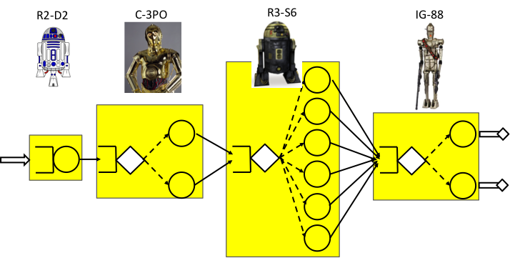

1. What is T0? [5 pts]
2. Which station is the bottleneck and why? [5 pts]
3. What is the capacity of the line? [5 pts]
4. Suppose C-3PO undergoes a preemptive failure on average every 110 hours with a repair time that lasts an average of 2 hours with a standard deviation of 2 hours. What is the capacity of the line? [5 pts]
5. Given the conditions in (d) what is the line throughput? [5 pts]

Rework = 40%

5 min

8 min

6 min

Scrap = 50%

1. Consider the line above with three workstations and a 6 units per hour arrival rate. [15 pts]
   1. Is the line balanced? Why or why not? [4 pts]
   2. What is the utilization of each workstation? [6 pts]
   3. What is the capacity of the line? [5 pts]
2. Consider a balanced stable line with five identical stations in series, each consisting of a single machine with low variability process times and infinite buffers. Suppose the arrival rate is ra,utilization of all machines is 85%, and the arrival SCV is ca2 = 1. What happens to WIP, CT, and TH when we do the following, one at a time? [18 pts]

* 1. Decrease the arrival rate. [6 pts]
  2. Increase the variability of station 1(assume that the system remains stable). [6 pts]
  3. Decrease the capacity of station 5 (assume that the system remains stable). [6pts]

# Summary of Formulas for computing Effective Process Time Parameters

|  |  |  |  |
| --- | --- | --- | --- |
| **Situation** | **Natural** | **Preemptive** | **Nonpreemptive** |
| **Examples** | **Reliable Machine** | **Random Failures** | **Setups; Rework** |
| Parameters | $$t_{0},c_{0}$$ (basic) | Basic plus $$m_{f},m_{r},{c_{r}}^{2}$$ | Basic plus $$N_{s},t_{s},{c_{r}}^{2}$$ |
| $$t_{e}$$ | $$t_{0}$$ | $$\frac{t_{0}}{A}, A= \frac{m_{f}}{m_{f}+m_{r}}$$ | $$t_{0}+\frac{t_{s}}{N_{s}}$$ |
| $${σ_{e}}^{2}$$ | $${t_{0}}^{2}{c_{0}}^{2}$$ | $$\frac{{σ_{0}}^{2}}{A^{2}}+\frac{({m_{r}}^{2}+{σ_{r}}^{2})(1-A)t_{0}}{Am_{r}}$$ | $${σ_{0}}^{2}+\frac{{σ_{s}}^{2}}{N_{s}}+{\frac{N_{s}-1}{{N_{s}}^{2}}t_{s}}^{2}$$ |
| $${c_{e}}^{2}$$ | $${c_{0}}^{2}$$ | $${c_{0}}^{2}+\left(1+{c_{r}}^{2}\right)A(1-A)\frac{m_{r}}{t_{0}}$$ | $$\frac{{σ_{e}}^{2}}{{t_{e}}^{2}}$$ |