Name: _______Practice Exam 1___________________ Date: __Econ 2100___________

|  |  |  |
| --- | --- | --- |
| 1. | A new fast-food restaurant offered a free meal (valued at $5) a week for a year to its first 100 customers. Ramona camped out for 48 hours before the opening to be one of the first 100 customers. The cost of the free meal a week for a year for Ramona was: | |
| A) | zero. |
| B) | $260. |
| C) | whatever she would have done with those 48 hours. |
| D) | The cost is impossible to determine. |

|  |  |  |
| --- | --- | --- |
| 2. | Zoe's grandparents are excited about finally paying off their mortgage, because, as they say, “Our cost of housing is now zero.” Zoe should explain to them the economic principle of: | |
| A) | marginal analysis: if the additional cost of housing is zero, then their additional benefit is also zero. |
| B) | opportunity cost: by living in the house, they are giving up the opportunity to sell the house, buy a smaller one, and pocket the difference. |
| C) | efficiency: if their cost of housing is now zero, they should let Zoe move in without charging her any rent. Zoe is better off, and her grandparents aren't hurt. |
| D) | equity: it is unfair that some people are still paying off their mortgage. |

|  |  |  |
| --- | --- | --- |
| 3. | A new startup airline is offering free round-trip tickets to anywhere to the first 600 people who enter the office on the airline's first day of business. You arrive 24 hours before they are scheduled to open to be sure to get the free tickets, and you buy food from vendors while waiting in line. The economic cost of the tickets to you is: | |
| A) | zero. |
| B) | just the cost of food while you wait in line. |
| C) | the cost of food while you wait in line and the opportunity cost of your time. |
| D) | the actual value of the ticket. |

|  |  |  |
| --- | --- | --- |
| 4. | Lena and Jess are roommates. Lena hates to clean the bathroom. Jess will agree to clean the bathroom only if Lena vacuums the living room. This statement best represents this economic concept: | |
| A) | The real cost of something is what you must give up to get it. |
| B) | “How much” is a decision at the margin. |
| C) | People usually exploit opportunities to make themselves better off. |
| D) | There are gains from trade. |

|  |  |  |
| --- | --- | --- |
| 5. | During the Great Depression, consumers and producers in the United States dramatically reduced their spending as compared to the quantity of goods and services available at the time. This statement best represents this economic concept: | |
| A) | Resources are scarce. |
| B) | When markets don't achieve efficiency, government intervention can improve society's welfare. |
| C) | Overall spending sometimes gets out of line with the economy's productive capacity. |
| D) | Government policies can change spending. |

|  |  |  |
| --- | --- | --- |
| 6. | The fact that a society's production possibility frontier is bowed out or concave to the origin of a graph demonstrates the law of: | |
| A) | increasing opportunity cost. |
| B) | decreasing opportunity cost. |
| C) | constant opportunity cost. |
| D) | concave opportunity cost. |

Use the following to answer questions 7-8:

**Figure: Production Possibility Frontier Curve for Tealand**

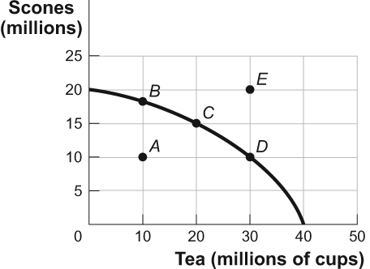

|  |  |  |
| --- | --- | --- |
| 7. | (Figure: Production Possibility Frontier for Tealand) Look at the figure Production Possibility Frontier for Tealand. In the figure, if Tealand is producing 10 million scones and 10 million cups of tea (point *A*), we know that the economy: | |
| A) | is using its resources efficiently. |
| B) | is using its resources inefficiently. |
| C) | is fully employing its resources. |
| D) | has found new resources. |

|  |  |  |
| --- | --- | --- |
| 8. | (Figure: Production Possibility Frontier for Tealand) Look at the figure Production Possibility Frontier for Tealand. In the figure, Tealand is producing at point *C* on its production possibility frontier. What is the opportunity cost in Tealand of increasing the production of tea from 20 million cups to 30 million cups? | |
| A) | 10 million cups of tea |
| B) | 5 million scones |
| C) | 10 million scones |
| D) | The answer is impossible to determine from the information given. |

Use the following to answer questions 9-10:

**Figure: Tom's Production Possibilities**

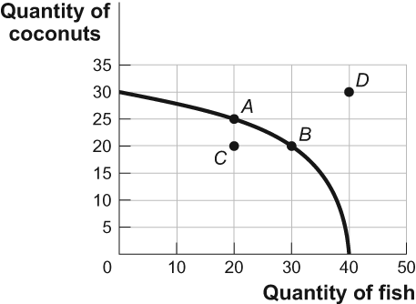

|  |  |  |
| --- | --- | --- |
| 9. | (Figure: Tom's Production Possibilities) In the figure Tom's Production Possibilities, which of the point or points represents the combination of coconuts and fish feasible for Tom to produce at this time? | |
| A) | *A* only |
| B) | *A* and *B* |
| C) | *A,* *B,* and *C* |
| D) | *D* only |

|  |  |  |
| --- | --- | --- |
| 10. | (Figure: Tom's Production Possibilities) In the figure Tom's Production Possibilities, the opportunity cost for Tom to move from point *C* on the curve to point *A* is: | |
| A) | 10 coconuts. |
| B) | 30 fish. |
| C) | 5 coconuts. |
| D) | There is no opportunity cost in terms of fish. |

|  |  |  |
| --- | --- | --- |
| 11. | If they spend all night writing computer programs, Laurence can write 10 programs while Carrie Anne can write 5. If they spend all night making sunglasses, Laurence can make 6 while Carrie Anne can make 4. Given this information and supposing Laurence and Carrie Anne have constant opportunity costs, we know that: | |
| A) | Laurence has an absolute advantage in programs but not in sunglasses. |
| B) | Laurence has an absolute advantage in both programs and sunglasses. |
| C) | Carrie Anne has an absolute advantage in programs but not in sunglasses. |
| D) | Carrie Anne has an absolute advantage in both programs and sunglasses. |

|  |  |  |
| --- | --- | --- |
| 12. | Mark and Julie are going to sell brownies and cookies for their third annual fundraiser bake sale. In one day, Mark can make 40 brownies or 20 cookies, and Julie can make 15 brownies or 15 cookies. What is Mark's opportunity cost to produce one brownie? | |
| A) | 1 cookie |
| B) | 1 brownie |
| C) | 1/2 cookie |
| D) | 1/2 brownie |

|  |  |  |
| --- | --- | --- |
| 13. | Assume that Colombia gives up three motorcycles for each ton of coffee it produces, while Bolivia gives up seven motorcycles for each ton of coffee it produces. | |
| A) | Colombia has a comparative advantage in motorcycle production and should specialize in coffee. |
| B) | Colombia has a comparative advantage in coffee production and should specialize in the production of motorcycles. |
| C) | Colombia has a comparative advantage in coffee production and should specialize in coffee production. |
| D) | Colombia has a comparative advantage in motorcycle production and should specialize in motorcycle production. |

Use the following to answer question 14:

**Figure: Unemployment Rate over Time**

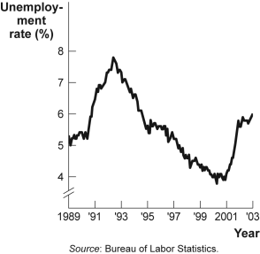

|  |  |  |
| --- | --- | --- |
| 14. | (Figure: Unemployment Rate over Time) Look again at the figure Unemployment Rate over Time. From 1991 to 1993 the unemployment rate has: | |
| A) | decreased from approximately 5% to approximately 4%. |
| B) | increased from approximately 5.5% to approximately 7%. |
| C) | decreased from approximately 7.8% to approximately 5%. |
| D) | increased from approximately 4% to approximately 6.3%. |

|  |  |  |
| --- | --- | --- |
| 15. | The owner of the Dismal Philosopher, one of five bookstores on College Road, asks you to make a graph showing each bookstore's share of all book purchases on College Road. The best way to show this information is with a(n): | |
| A) | scatter diagram. |
| B) | pie chart. |
| C) | time-series graph. |
| D) | independent graph. |

|  |  |  |
| --- | --- | --- |
| 16. | Raclette is a popular wintertime dish in Switzerland. It is essentially melted Raclette cheese over boiled new potatoes. If the price of Raclette cheese decreased, we would expect to see: | |
| A) | an increase in demand for Raclette cheese. |
| B) | an increase in demand for new potatoes. |
| C) | no effect on the demand for either of the Raclette ingredients, since this is a traditional dish and its consumption does not depend on the prices of the ingredients. |
| D) | an increase in demand for Raclette cheese and for new potatoes. |

|  |  |  |
| --- | --- | --- |
| 17. | Over the past several years, consumers have had an increasing interest in getting a tattoo. This means that the ________ tattoos has ________. | |
| A) | quantity demanded of; increased |
| B) | demand for; decreased |
| C) | demand for; increased |
| D) | quantity demanded of; decreased |

Use the following to answer question 18:

**Figure: Demand for DVDs**

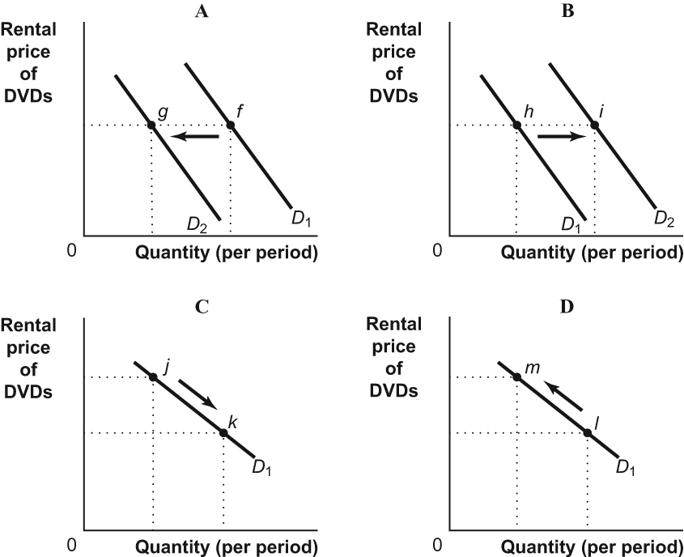

|  |  |  |
| --- | --- | --- |
| 18. | (Figure: Demand for DVDs) Look at the figure Demand for DVDs. A decrease in the price of movie tickets (a substitute) would result in a change illustrated by the move from: | |
| A) | *f* to *g* in panel A. |
| B) | *h* to *i* in panel B. |
| C) | *j* to *k* in panel C. |
| D) | *l* to *m* in panel D. |

|  |  |  |
| --- | --- | --- |
| 19. | In the local market for coffee, what happens if Joyce's Java and Everyday Joe's coffee shops go out of business? | |
| A) | The supply curve shifts to the right. |
| B) | The demand curve shifts to the left. |
| C) | The supply curve shifts to the left. |
| D) | The demand curve shifts to the right. |

|  |  |  |
| --- | --- | --- |
| 20. | Over the past few years, the technology associated with producing flat-panel televisions has improved. This has led to ________ in ________ flat-panel televisions. | |
| A) | an increase; the supply of |
| B) | an increase; the demand for |
| C) | a decrease; the supply of |
| D) | a decrease; the quantity supplied of |

Use the following to answer questions 21-22:

**Figure: The Supply of DVD Rentals**

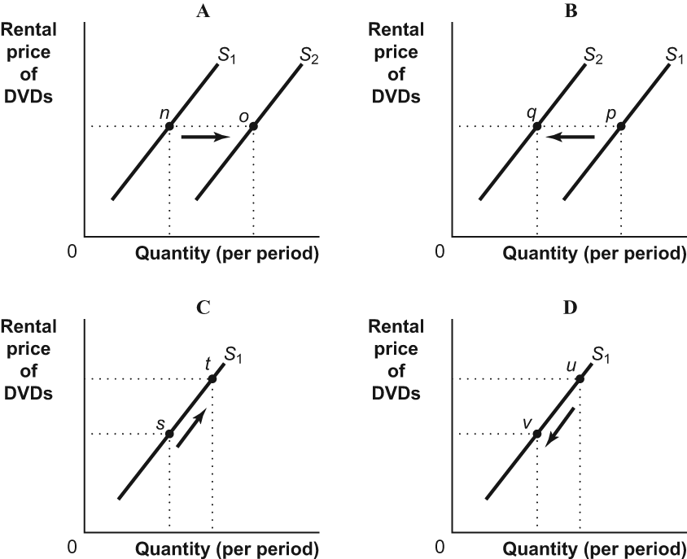

|  |  |  |
| --- | --- | --- |
| 21. | (Figure: The Supply of DVD Rentals) Look at the figure The Supply of DVD Rentals. A decrease in the price of DVD rentals would result in a change illustrated by the move from: | |
| A) | *n* to *o* in panel A. |
| B) | *p* to *q* in panel B. |
| C) | *s* to *t* in panel C. |
| D) | *u* to *v* in panel D. |

|  |  |  |
| --- | --- | --- |
| 22. | (Figure: The Supply of DVD Rentals) Look at the figure The Supply of DVD Rentals. A decrease in the price of DVDs sold by movie producers to rental stores would result in a change illustrated by the move from: | |
| A) | *n* to *o* in panel A. |
| B) | *p* to *q* in panel B. |
| C) | *s* to *t* in panel C. |
| D) | *u* to *v* in panel D. |

|  |  |  |
| --- | --- | --- |
| 23. | What is the difference between a shortage and scarcity? | |
| A) | Scarcity will almost always exist, but a shortage will exist only if the price is kept below the equilibrium level. |
| B) | Scarcity is a result of two or more alternative uses, and quantities of supply and demand adjusting to flexible prices will create shortages. |
| C) | A shortage will exist when a good is scarce. |
| D) | There is no distinction between the two. They are the same thing. |

|  |  |  |
| --- | --- | --- |
| 24. | The market price of airline flights increased recently. Some economists suggest that the price increased because there has been an increase in the number of business travelers. They believe that in the market for flights: | |
| A) | supply increased. |
| B) | supply decreased. |
| C) | demand increased. |
| D) | demand decreased. |

|  |  |  |
| --- | --- | --- |
| 25. | A newspaper recently reported that the price of new cars has decreased and the quantity of new cars sold has dropped. The new price and quantity could have been caused by: | |
| A) | a decrease in buyers' incomes. |
| B) | an increase in buyers' incomes. |
| C) | an increase in production costs. |
| D) | a decrease in production costs. |

|  |  |  |
| --- | --- | --- |
| 26. | Consider two competing motorcycle manufacturers, Harley-Davidson and Honda, which are considered substitutes. If Harley-Davidson raises the price of its motorcycles, we can expect a shift to the: | |
| A) | right in the supply curve of Hondas and lower prices for Hondas. |
| B) | left in the supply curve of Hondas and higher prices for Hondas. |
| C) | right in the demand curve for Hondas and higher prices for Hondas. |
| D) | left in the demand curve for Hondas and lower prices for Hondas. |

Use the following to answer question 27:

**Figure: Demand for Shirts**

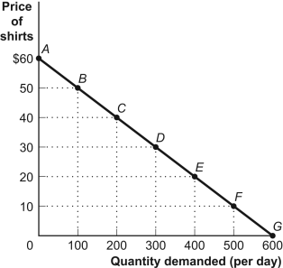

|  |  |  |
| --- | --- | --- |
| 27. | (Figure: Demand for Shirts) The price elasticity of demand for the segment *BC*, using the midpoint method, is: | |
| A) | greater than 3.33. |
| B) | 3.33. |
| C) | 3. |
| D) | 0.33. |

|  |  |  |
| --- | --- | --- |
| 28. | A men's tie store sold an average of 30 ties per day when the price was $5 per tie. The same store sold 60 of the same ties per day when the price was $3 per tie. In this case, the absolute value of the price elasticity of demand, using the midpoint method, is: | |
| A) | greater than zero but less than 1. |
| B) | equal to 1. |
| C) | greater than 1 but less than 3. |
| D) | greater than 3. |

|  |  |  |
| --- | --- | --- |
| 29. | Suppose the price of Vanilla Coke increases by 9% and quantity demanded falls by 13% overall but only 4% for loyal Coca-Cola customers. This means that for the general public there are ________ for Vanilla Coke, but for loyal Coca-Cola customers, Vanilla Coke is more of a ________ item. This means that Coca-Cola will enjoy an increase in total revenue only from ________. | |
| A) | several substitutes; necessity; loyal Coca-Cola customers |
| B) | few substitutes; luxury; the general public |
| C) | no substitutes; necessity; the general public |
| D) | several substitutes; necessity; the general public |

|  |  |  |
| --- | --- | --- |
| 30. | Assume the absolute value of the price elasticity of demand for corn has been estimated to be 2.33. Flash floods destroy 10% of the nation's crop of corn. Which of the following best describes how this will affect total expenditures on corn, all other things equal? (Hint: Consider the change in corn prices.) | |
| A) | Total expenditures will remain unchanged. |
| B) | Total expenditures will fall. |
| C) | Total expenditures will rise. |
| D) | Not enough information is given to answer the question. |

**Answer Key**

|  |  |
| --- | --- |
| 1. | C |
| 2. | B |
| 3. | C |
| 4. | D |
| 5. | C |
| 6. | A |
| 7. | B |
| 8. | B |
| 9. | C |
| 10. | D |
| 11. | B |
| 12. | C |
| 13. | C |
| 14. | B |
| 15. | B |
| 16. | B |
| 17. | C |
| 18. | A |
| 19. | C |
| 20. | A |
| 21. | D |
| 22. | A |
| 23. | A |
| 24. | C |
| 25. | A |
| 26. | C |
| 27. | C |
| 28. | C |
| 29. | A |
| 30. | B |