Exam 1

Econ 2100

Spring 2015

Dr. Fritz

Name: __________________________ Date: _____________

|  |  |  |
| --- | --- | --- |
| 1. | Margo spends $10,000 on one year's college tuition. The opportunity cost of spending one year in college for Margo is: | |
| A) | $10,000. |
| B) | whatever she would have purchased with the $10,000 instead. |
| C) | whatever she would have earned had she not been in college. |
| **D)** | **whatever she would have purchased with the $10,000 and whatever she would have earned had she not been in college.** |

|  |  |  |
| --- | --- | --- |
| 2. | The university recently inherited a large mansion from a wealthy alumnus. The university plans to use the mansion for faculty parties and to house distinguished guests. The opportunity cost of the mansion to the university is: | |
| A) | zero, because it was a gift. |
| B) | the original cost of building the mansion. |
| **C)** | **the amount the university would receive if it sold the mansion.** |
| D) | the cost of catering the parties at the mansion. |

|  |  |  |
| --- | --- | --- |
| 3. | If you decide to go to Cancun with your friends during spring break, you realize you cannot go to Paris with your sister in the summer. This statement best represents this economic concept: | |
| **A)** | **The real cost of something is what you must give up to get it.** |
| B) | “How much” is a decision at the margin. |
| C) | People usually exploit opportunities to make themselves better off. |
| D) | There are gains from trade. |

|  |  |  |
| --- | --- | --- |
| 4. | Marla will make $10 by tutoring for an additional hour, but she will lose an hour of studying for her economics test. Marla decides to study rather than tutor. Marla's choice indicates that she: | |
| **A)** | **values an additional hour of studying more than the $10 she would earn tutoring.** |
| B) | values an hour of studying less than the $10 she would earn tutoring. |
| C) | does not understand that there is no benefit from studying. |
| D) | doesn't need the money. |

|  |  |  |
| --- | --- | --- |
| 5. | Two neighbors, Molly and Sandy, are separated by a white picket fence. Each neighbor has a garden that grows tomatoes and peppers. How could Molly and Sandy gain from trade? | |
| A) | Molly could trade tomatoes to Sandy in exchange for peppers if Molly was the more efficient grower of peppers. |
| B) | Sandy could trade tomatoes to Molly in exchange for peppers if Sandy was the more efficient grower of peppers. |
| C) | Sandy could trade peppers to Molly in exchange for tomatoes if Molly was the more efficient grower of peppers. |
| **D)** | **Molly could trade peppers to Sandy in exchange for tomatoes if Molly was the more efficient grower of peppers.** |

|  |  |  |
| --- | --- | --- |
| 6. | If in the country of Equitania 20% of the population receives 80% of the income and the remaining 80% of the population receives 20% of the income: | |
| A) | this situation is definitely efficient. |
| B) | this situation cannot be economically efficient, since efficiency requires a more equal distribution of income. |
| **C)** | **this situation may be efficient.** |
| D) | such a situation could never be either efficient or equitable. |

|  |  |  |
| --- | --- | --- |
| 7. | At various times, the nations of the Organization of Petroleum Exporting Countries (OPEC) have restricted the supply of oil to increase their profits. This is an example of: | |
| A) | individual actions whose side effects are not properly taken into account by the market. |
| **B)** | **one party preventing mutually beneficial trades in an attempt to capture a greater share of resources for itself.** |
| C) | the unsuitability of some goods for efficient management by markets. |
| D) | regulating self-interest. |

|  |  |  |
| --- | --- | --- |
| 8. | Market failure occurs when: | |
| A) | prices of essential goods such as gas become very high. |
| **B)** | **individual actions have side effects that are not properly taken into account.** |
| C) | mutually beneficial trades take place. |
| D) | a business declares bankruptcy. |

|  |  |  |
| --- | --- | --- |
| 9. | The federal government regulates how much carbon dioxide a factory can emit. This statement best represents this economic concept: | |
| A) | Resources are scarce. |
| B) | “How much” is a decision at the margin. |
| C) | Markets usually lead to efficiency. |
| **D)** | **When markets don't achieve efficiency, government intervention can improve society's welfare.** |

Use the following to answer questions 10-11:

**Figure: Consumer and Capital Goods**

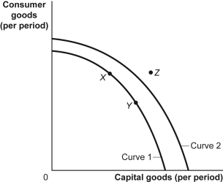

|  |  |  |
| --- | --- | --- |
| 10. | (Figure: Consumer and Capital Goods) Look at the figure Consumer and Capital Goods. The movement from curve 1 to curve 2 indicates: | |
| **A)** | **economic growth.** |
| B) | a change from unemployment to full employment. |
| C) | a decrease in the level of technology. |
| D) | instability. |

|  |  |  |
| --- | --- | --- |
| 11. | (Figure: Consumer and Capital Goods) Look at the figure Consumer and Capital Goods. Point *Z:* | |
| **A)** | **is unattainable, all other things unchanged.** |
| B) | is attainable if the economy is able to reach full employment. |
| C) | is attainable if the quantity and/or quality of factors decreases. |
| D) | will be attained as soon as the economy becomes efficient and moves to curve 2. |

|  |  |  |
| --- | --- | --- |
| 12. | If Poland decides to increase the production of steel—and decrease the production of vodka—the bowed-out production possibility frontier would suggest that there will be ________ opportunity cost of producing more steel. | |
| **A)** | **an increasing** |
| B) | a decreasing |
| C) | a nonexistent |
| D) | an unchanged |

|  |  |  |
| --- | --- | --- |
| 13. | As long as producers have different ________, each producer has a comparative advantage in something. | |
| A) | direct costs |
| B) | benefits |
| C) | utility |
| **D)** | **opportunity costs** |

|  |  |  |
| --- | --- | --- |
| 14. | In one hour, the United States can produce 25 tons of steel or 250 automobiles. In one hour, Japan can produce 30 tons of steel or 275 automobiles. This information implies that: | |
| A) | Japan has a comparative advantage in the production of automobiles. |
| B) | the United States has an absolute advantage in the production of steel. |
| C) | Japan has a comparative advantage in the production of both goods. |
| **D)** | **the United States has a comparative advantage in the production of automobiles.** |

|  |  |  |
| --- | --- | --- |
| 15. | If they spend all night writing computer programs, Laurence can write 10 programs while Carrie Anne can write 5. If they spend all night making sunglasses, Laurence can make 6 while Carrie Anne can make 4. We know that: | |
| **A)** | **Laurence has a comparative advantage in programs.** |
| B) | Laurence has a comparative advantage in both programs and sunglasses. |
| C) | Carrie Anne has a comparative advantage in programs. |
| D) | Carrie Anne has a comparative advantage in both programs and sunglasses. |

|  |  |  |
| --- | --- | --- |
| 16. | If Brazil gives up 3 automobiles for each ton of coffee it produces, while Peru gives up 7 automobiles for each ton of coffee it produces, then: | |
| A) | Brazil has a comparative advantage in automobile production and should specialize in coffee. |
| B) | Brazil has a comparative advantage in coffee production and should specialize in the production of automobiles. |
| **C)** | **Brazil has a comparative advantage in coffee production and should specialize in coffee production.** |
| D) | Brazil has a comparative advantage in automobile production and should specialize in automobile production. |

|  |  |  |
| --- | --- | --- |
| 17. | Dr. Colgate is a dentist who employs an assistant, Ms. Crest. If Dr. Colgate worked all day at the front desk, she could answer 40 phone calls. If she worked all day with patients, she could clean the teeth of 40 patients. If Ms. Crest worked all day at the front desk, she could answer 60 phone calls. If she worked all day with patients, she could clean the teeth of 20 patients. Which of the following is true? | |
| A) | Dr. Colgate has an absolute advantage in answering phones. |
| **B)** | **Ms. Crest has a comparative advantage in answering phones.** |
| C) | Ms. Crest has an absolute advantage in cleaning patients' teeth. |
| D) | Dr. Colgate has a comparative advantage in answering phones. |

Use the following to answer questions 18-19:

**Figure: Seasonally Adjusted Unemployment Rate**

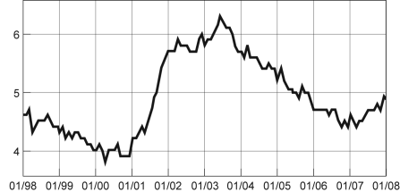

*Source:* Bureau of Labor Statistics, 2008.

|  |  |  |
| --- | --- | --- |
| 18. | (Figure: Seasonally Adjusted Unemployment Rate) Look at the figure Seasonally Adjusted Unemployment Rate. The distance between each labeled point on the horizontal axis is one year. What is the approximate slope of the graph between 1/2004 and 1/2006? | |
| A) | 1/2 |
| B) | 1 |
| **C)** | **–1/2** |
| D) | –2 |

|  |  |  |
| --- | --- | --- |
| 19. | (Figure: Seasonally Adjusted Unemployment Rate) Look again at the figure Seasonally Adjusted Unemployment Rate. The distance between each labeled point on the horizontal axis is one year. Using this graph, the unemployment rate was at a minimum in ________ and a maximum in ________. | |
| A) | 2003; 2000 |
| B) | 2007; 2001 |
| C) | 2003; 1999 |
| **D)** | **2000; 2003** |

|  |  |  |
| --- | --- | --- |
| 20. | The owner of the Dismal Philosopher, one of five bookstores on College Road, asks you to make a graph showing each bookstore's share of all book purchases on College Road. The best way to show this information is with a(n): | |
| A) | scatter diagram. |
| **B)** | **pie chart.** |
| C) | time-series graph. |
| D) | independent graph. |

|  |  |  |
| --- | --- | --- |
| 21. | Which of the following factors would cause a movement along the demand curve for a particular good? | |
| A) | a change in the prices of related goods |
| **B)** | **a change in the price of that good** |
| C) | a change in the size of the population |
| D) | either a change in the price of that good or a change in the size of the population |

|  |  |  |
| --- | --- | --- |
| 22. | In much of the country, homeowners choose to heat their houses with either natural gas or home heating oil. Which of the following would cause a change in the demand for natural gas? | |
| A) | a change in the price of home heating oil |
| B) | a change in income |
| C) | an increase in consumer tastes for natural gas as an energy source |
| **D)** | **All of the answers are correct.** |

|  |  |  |
| --- | --- | --- |
| 23. | When the economy takes a downturn and the incomes of many people decrease, vacationers are more likely to take car trips than to fly. Which of the following provides one possible explanation for this phenomenon? | |
| A) | Air travel and vacation travel by car are complementary goods. |
| B) | Air travel and vacation travel by car are both normal goods. |
| **C)** | **Air travel is a normal good, and vacation travel by car is an inferior good.** |
| D) | Air travel is an inferior good, and vacation travel by car is a normal good. |

|  |  |  |
| --- | --- | --- |
| 24. | Which of the following will *not* cause an increase in demand for good X? | |
| A) | a decrease in income if good X is an inferior good |
| B) | an increase in income if good X is a normal good |
| **C)** | **a decrease in the price of good X** |
| D) | an increase in consumers' taste for good X |

Use the following to answer questions 25-26:

**Figure: Demand for DVDs**

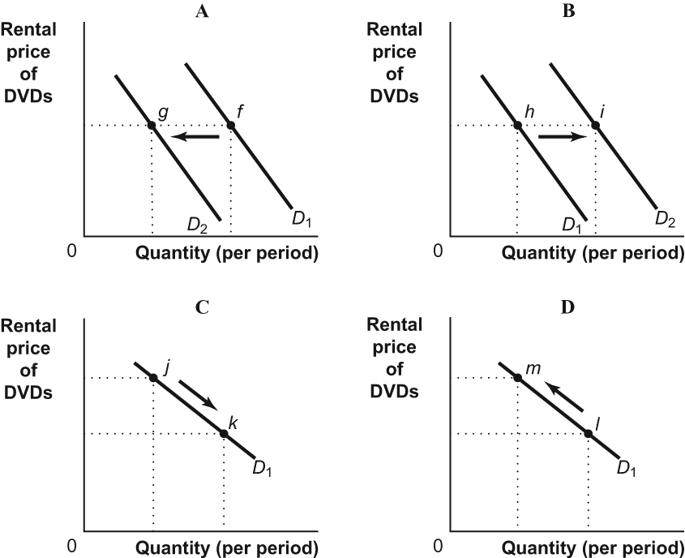

|  |  |  |
| --- | --- | --- |
| 25. | (Figure: Demand for DVDs) Look at the figure Demand for DVDs. A decrease in the rental price of DVD would result in a change illustrated by the move from: | |
| A) | *f* to *g* in panel A. |
| B) | *h* to *i* in panel B. |
| **C)** | ***j* to *k* in panel C.** |
| D) | *l* to *m* in panel D. |

|  |  |  |
| --- | --- | --- |
| 26. | (Figure: Demand for DVDs) Look at the figure Demand for DVDs. A decrease in the price of DVD players (a complement) would result in a change illustrated by the move from: | |
| A) | *f* to *g* in panel A. |
| **B)** | ***h* to *i* in panel B.** |
| C) | *j* to *k* in panel C. |
| D) | *l* to *m* in panel D. |

|  |  |  |
| --- | --- | --- |
| 27. | In the market for wheat, what would happen if the price of ethanol (which is made from corn) increased dramatically? | |
| A) | an increase in the supply of wheat |
| **B)** | **a decrease in the supply of wheat** |
| C) | an increase in the demand for wheat |
| D) | a decrease in the demand for wheat |

|  |  |  |
| --- | --- | --- |
| 28. | Which of the following *always* results in an increase in price and quantity? | |
| A) | an increase in supply and a decrease in demand |
| **B)** | **an increase in demand with no change in supply** |
| C) | an increase in supply with no change in demand |
| D) | a decrease in demand and supply |

|  |  |  |
| --- | --- | --- |
| 29. | Pizza and hamburgers are substitutes. A rise in the price of a pizza causes a ________ in the equilibrium price of a hamburger and a(n) ________ in the equilibrium quantity of hamburgers. | |
| **A)** | **rise; increase** |
| B) | rise; decrease |
| C) | fall; increase |
| D) | fall; decrease |

Use the following to answer question 30:

**Figure: Market for Lattes**

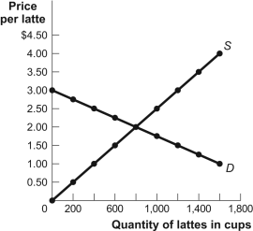

|  |  |  |
| --- | --- | --- |
| 30. | (Figure: Market for Lattes) In the market for lattes shown in the figure, what is the price elasticity of demand between prices of $2 and $2.50 per cup, using the midpoint formula? | |
| A) | 1 |
| B) | 1.29 |
| C) | 2.51 |
| **D)** | **3** |

|  |  |  |
| --- | --- | --- |
| 31. | A local restaurant has estimated that the price elasticity of demand for meals is equal to 2. If the restaurant increases menu prices by 5%, it can expect the number of customers to decrease by ________and total revenue to ________. | |
| A) | 10%; increase |
| B) | 5%; stay constant |
| **C)** | **10%; fall** |
| D) | 2.5%; fall |

|  |  |  |
| --- | --- | --- |
| 32. | You manage a popular nightclub, and lately revenues have been disappointing. Your bouncer suggests that raising drink prices will increase revenues, but your bartender suggests that decreasing drink prices will increase revenues. You aren't sure who is right, but you do know that: | |
| A) | your bouncer thinks the demand for drinks is elastic, while your bartender thinks the demand for drinks is inelastic. |
| **B)** | **your bouncer thinks the demand for drinks is inelastic, while your bartender thinks the demand for drinks is elastic.** |
| C) | both the bouncer and bartender think the demand for drinks is elastic. |
| D) | both the bouncer and bartender think the demand for drinks is inelastic. |

|  |  |  |
| --- | --- | --- |
| 33. | If an increase in the price of a good leads to an increase in total revenue: | |
| A) | the supply curve must be price inelastic. |
| **B)** | **the demand curve must be price inelastic.** |
| C) | the supply curve is price elastic. |
| D) | the demand curve must be price elastic. |

**Answer Key**

|  |  |
| --- | --- |
| 1. | D |
| 2. | C |
| 3. | A |
| 4. | A |
| 5. | D |
| 6. | C |
| 7. | B |
| 8. | B |
| 9. | D |
| 10. | A |
| 11. | A |
| 12. | A |
| 13. | D |
| 14. | D |
| 15. | A |
| 16. | C |
| 17. | B |
| 18. | C |
| 19. | D |
| 20. | B |
| 21. | B |
| 22. | D |
| 23. | C |
| 24. | C |
| 25. | C |
| 26. | B |
| 27. | B |
| 28. | B |
| 29. | A |
| 30. | D |
| 31. | C |
| 32. | B |
| 33. | B |