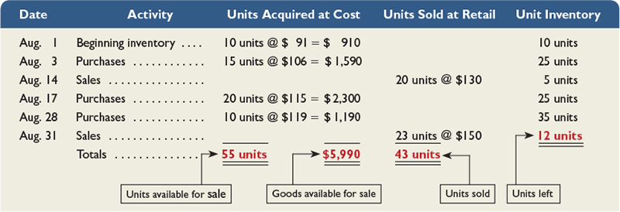

1. Journal entry for August 3rd transaction

Debit Inventory 1,590

Credit Cash / Accounts Payable 1,590

2. Journal entries for August 14th transaction

Debit Cash / Accounts Receivable 2,600

Credit Sales Revenue 2,600

Debit Cost of Goods Sold \*\*\*\*\*

Credit Inventory \*\*\*\*\*

Rationale for the amount entered as Cost of Goods Sold:

The amount you enter here will depend on the Inventory Costing method you use. There is more than once correct answer possible.