MGT 3000: Exam I

Spring 2015

VERSION: 1

**Name**

## DO NOT OPEN

**until given instructions to do so**

### *Instructions*

1. Use a #2 pencil only; mark your responses on your Scantron answer sheet as well as your exam book; mark clearly and erase completely as needed.
2. On your Scantron answer sheet, write **your name** **and** **Test Form letter (version 1 or 2) noted above.**
3. All multiple-choice answers must be marked on your Scantron answer sheet to be graded.
4. Confirm that you have nine (9) numbered pages.
5. Multiple-choice questions are two and a half (2.5) points each; all other questions have their point value noted with the problem.
6. Bring your entire exam book, and Scantron answer sheet to the front of the room when you have finished the exam.
7. You are reminded of the University’s honor policy which requires you do your own work and not give or receive assistance on this exam.

**MULTIPLE CHOICE QUESTIONS (20 * 2.5 = 50 POINTS)**

1. Which of the following statements is correct?

|  |  |
| --- | --- |
| A. | Assets on the balance sheet include retained earnings. |

|  |  |
| --- | --- |
| B. | Retained earnings includes common stock. |

|  |  |
| --- | --- |
| C. | The balance sheet equation states that assets equal liabilities. |

|  |  |
| --- | --- |
| **D.** | A corporation's net income does not necessarily equal its net cash flow from operations. |

1. Willie Company's retained earnings increased $20,000 during 2014. What was Willie's 2014 net income or loss given that Willie declared $25,000 of dividends during 2014?

|  |  |
| --- | --- |
| A. | Net income was $5,000. |

|  |  |
| --- | --- |
| **B.** | Net income was $45,000. |

|  |  |
| --- | --- |
| C. | Net loss was $45,000. |

|  |  |
| --- | --- |
| D. | Net loss was $5,000. |

1. Which of the following statements is **true**?

|  |  |
| --- | --- |
| A. | Contributed capital is a noncurrent asset. |

|  |  |
| --- | --- |
| **B.** | Current liabilities are debts expected to be paid within the next year. |

|  |  |
| --- | --- |
| C. | Current assets are resources of a company that might include cash and copyrights. |

|  |  |
| --- | --- |
| D. | Patents, copyrights, and research and development expense are classified as intangible assets on the balance sheet. |

1. Which of the following would **not** be included under the account category of expenses within the chart of accounts?

|  |  |
| --- | --- |
| A. | Cost of goods sold. |

|  |  |
| --- | --- |
| B. | Interest expense. |

|  |  |
| --- | --- |
| **C.** | Prepaid insurance expense. |

|  |  |
| --- | --- |
| D. | Income tax expense. |

1. A corporation purchased factory equipment using cash. Which of the following statements regarding this purchase is correct?

|  |  |
| --- | --- |
| A. | The cost of the factory equipment is an expense at the time of purchase. |

|  |  |
| --- | --- |
| **B.** | The total assets will not change. |

|  |  |
| --- | --- |
| C. | The total liabilities will increase. |

|  |  |
| --- | --- |
| D. | The current stockholders' equity will decrease. |

1. A landlord collected $5,000 cash from a tenant for December 2015's rent but the tenant's rent for December is $8,000. Which of the following is **true** with respect to the landlord's financial statements?

|  |  |
| --- | --- |
| A. | $8,000 would be reported on the statement of cash flows. |

|  |  |
| --- | --- |
| B. | $8,000 would appear on the balance sheet as rent receivable. |

|  |  |
| --- | --- |
| **C.** | $8,000 would appear on the income statement as rent revenue earned. |

|  |  |
| --- | --- |
| D. | $5,000 would appear on the balance sheet as prepaid rent. |

1. Which of the following journal entries is prepared when cash is received from a customer prior to delivery of the goods or services?  
     
    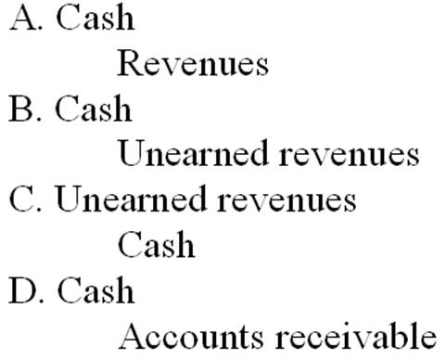

|  |  |
| --- | --- |
| A. | Option A |

|  |  |
| --- | --- |
| **B.** | Option B |

|  |  |
| --- | --- |
| C. | Option C |

|  |  |
| --- | --- |
| D. | Option D |

1. During 2014, Sigma Company earned service revenues amounting to $700,000, of which $630,000 was collected in cash; the balance will be collected in January, 2015. Also in 2014 there were collections of cash prior to the delivery of goods/services totaling $10,000. What amount should the 2014 income statement report for service revenues?

|  |  |
| --- | --- |
| A. | $630,000. |

|  |  |
| --- | --- |
| **B.** | $700,000. |

|  |  |
| --- | --- |
| C. | $70,000. |

|  |  |
| --- | --- |
| D. | $570,000. |

1. Which of the following journal entries is correct when a company has incurred an expense for work performed but has **not** yet paid for theses salaries to employees?  
     
    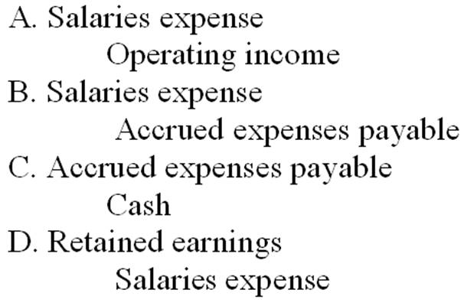

|  |  |
| --- | --- |
| A. | Option A |

|  |  |
| --- | --- |
| **B.** | Option B |

|  |  |
| --- | --- |
| C. | Option C |

|  |  |
| --- | --- |
| D. | Option D |

1. A company purchased $20,000 of inventory during February and will pay for it during March. Which of the following statements is **false,** assuming the inventory was sold during March?

|  |  |
| --- | --- |
| A. | The company's accounts payable will include the $20,000 on the February month-end balance sheet. |

|  |  |
| --- | --- |
| B. | The statement of cash flows will report an operating cash outflow of $20,000 during March. |

|  |  |
| --- | --- |
| **C.** | The income statement will report cost of goods sold of $20,000 during February. |

|  |  |
| --- | --- |
| D. | The company's inventory will include the $20,000 on the February month-end balance sheet. |

1. Which of the following accounts normally have a credit balance?

|  |  |
| --- | --- |
| A. | Unearned revenues; Prepaid rent; Revenues. |

|  |  |
| --- | --- |
| B. | Revenues; Expenses; Retained earnings. |

|  |  |
| --- | --- |
| C. | Revenues; Cash; Unearned revenue. |

|  |  |
| --- | --- |
| **D.** | Accounts payable; Retained earnings; Revenues. |

1. Which of the following journal entries correctly records a transaction where services were provided to a customer on account?  
     
    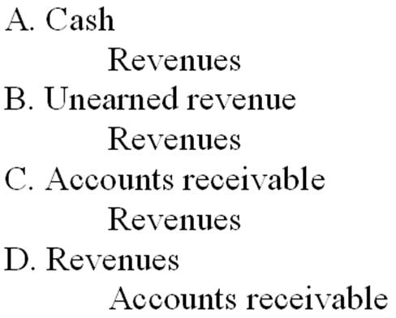

|  |  |
| --- | --- |
| A. | Option A |

|  |  |
| --- | --- |
| B. | Option B |

|  |  |
| --- | --- |
| **C.** | Option C |

|  |  |
| --- | --- |
| D. | Option D |

1. On December 31, 2014, Avery Corporation paid $10,000 for next year's insurance policy. This transaction should be recorded as follows by Avery:  
     
    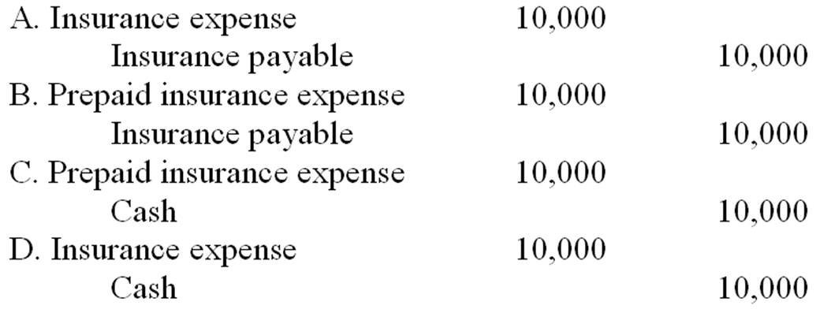

|  |  |
| --- | --- |
| A. | Option A |

|  |  |
| --- | --- |
| B. | Option B |

|  |  |
| --- | --- |
| **C.** | Option C |

|  |  |
| --- | --- |
| D. | Option D |

1. On January 1, 2014, Ryan Company paid the premium on a three-year insurance policy in the amount of $6,000. At that time, the full amount paid was recorded as prepaid insurance. After recording the adjusting entry for the insurance policy on December 31, 2014, what would be the balance in Ryan Company's prepaid insurance account?

|  |  |
| --- | --- |
| A. | $6,000. |

|  |  |
| --- | --- |
| B. | $2,000. |

|  |  |
| --- | --- |
| C. | $3,000. |

|  |  |
| --- | --- |
| **D.** | $4,000. |

1. On July 1, 2014, Goode Company borrowed $100,000. The company signed a note payable with interest at 6 percent per year. The note and interest are due on December 31, 2014. On December 31, 2014, Goode paid $103,000 to settle the debt in full. Assuming **no** accruals for interest have been made during the year, transaction analysis of the $103,000 cash payment on December 31, 2014 should reflect which of the following?

|  |  |
| --- | --- |
| A. | A decrease in assets of $103,000 and a decrease in liabilities of $103,000. |

|  |  |
| --- | --- |
| B. | A decrease in assets of $100,000, a decrease in stockholders' equity of $3,000, and a decrease in liabilities of $103,000. |

|  |  |
| --- | --- |
| C. | A decrease in stockholders' equity of $100,000, a decrease in liabilities of $3,000, and a decrease in assets of $103,000. |

|  |  |
| --- | --- |
| **D.** | A decrease in liabilities of $100,000, a decrease in stockholders' equity of $3,000, and a decrease in assets of $103,000. |

1. What is the effect on the financial statements when a company fails to record depreciation expense at year-end?

|  |  |
| --- | --- |
| A. | Net income is overstated and stockholders' equity is understated. |

|  |  |
| --- | --- |
| B. | Expenses are understated and stockholders' equity is understated. |

|  |  |
| --- | --- |
| C. | Expenses are understated and liabilities are overstated. |

|  |  |
| --- | --- |
| **D.** | Net income is overstated and assets are overstated. |

1. On January 1, 2014, the general ledger of Global Corporation included supplies of $1,000. During 2014, supplies purchases amounted to $5,000. A physical count of inventory on hand at December 31, 2014 determined that the amount of supplies on hand was $1,200. How much is the 2014 supplies expense?

|  |  |
| --- | --- |
| A. | $6,000. |

|  |  |
| --- | --- |
| B. | $5,200. |

|  |  |
| --- | --- |
| **C.** | $4,800. |

|  |  |
| --- | --- |
| D. | $1,000. |

1. Based on the following information from Repicor Company’s Balance Sheet, what is Repicor’s current ratio?

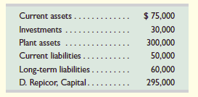

|  |  |
| --- | --- |
| **A.** | **1.5** |

|  |  |  |  |
| --- | --- | --- | --- |
| B. |  |  | 1. |

|  |  |
| --- | --- |
| C. | 0.5 |

|  |  |
| --- | --- |
| D. | 0.95. |

1. Bonaventure Company has total assets of $1,000,000, liabilities of $400,000, and equity of $600,000. What is its debt ratio (rounded to a whole percent)?

|  |  |
| --- | --- |
| **A.** | **40%.** |

|  |  |
| --- | --- |
| B. | 167%. |

|  |  |
| --- | --- |
| C. | 67%. |

|  |  |
| --- | --- |
| D. | 150%. |

1. Geek Squad performs services for a customer and bills the customer for $500. How would Geek Squad record this transaction?

|  |  |
| --- | --- |
| **A.** | **Both accounts receivable and revenues increase by $500;** |

|  |  |  |
| --- | --- | --- |
| B. |  | Cash increases by $500; revenues increase by $500 |

|  |  |
| --- | --- |
| C. | Both accounts payable and revenues increase by $500. |

|  |  |
| --- | --- |
| D. | Nothing to record because no cash has been received. |

**PROBLEM 1: 20 POINTS**

Tremor Co. had the following transactions in the last two months of its **financial year ending May 31, 2014.**

Apr. 1 Paid $2,450 cash to a Consulting firm for future consulting services.

1 Paid $3,600 cash for 12 months insurance through March 31st of 2015.

30 Received $8,500 cash for future services to be provided to a customer.

May 1 Paid $4,450 cash for future newspaper advertising to begin on June 1, 2014.

On May 31st, 2014, the accountant is informed that the consulting firm to whom they provided $2,450 cash for future consulting services on April 1st have lost their license to consult and consequently not provided any consulting services as promised so far. However, the new management assures Tremor that the new partners will provide those services later in 2014. Tremor Co. has not begun any work for the customer from whom they received $ 8,500 in cash.

**Determine whether any adjusting entries are required and, if so, provide the same.**

|  |  |  |  |
| --- | --- | --- | --- |
|  |  | **DEBIT** | **CREDIT** |
| 1 |  |  |  |
| 2 |  |  |  |
| 3 |  |  |  |
| 4 |  |  |  |

**PROBLEM 2: 30 POINTS**

Use the following adjusted trial balance of Wilson Company to prepare a Classified Balance Sheet for The Wilson Company as on 31st December, 2014. There were no transactions in Wilson’s Capital Account during the year (i.e., no fresh capital contributions or withdrawals).

**HINT:** In order to prepare the Balance Sheet, you probably need to know the Net Income for the year and determine whether (and if so, by how much) Wilson’s Capital Account changes. I do not need a formal Income statement or a Statement of Owners’ Equity, but you might find it useful to do some rough work and figure out those details before you start working on the Balance Sheet.

**Wilson Trucking Company**

**Adjusted Trial Balance 12/31/2014**



**NOTE:** Use this space for rough work. Start Balance Sheet on next page. Label all sections of the Balance Sheet appropriately.



**ANSWER: PROBLEM 2**

**WILSON TRUCKING Co.**

**Balance Sheet**

**December 31, 2014**

***Assets***

**Current assets**

**Cash $ 8,000**

**Accounts Receivable 17,500**

**Supplies 3,000**

**Total current assets $ 28,500**

**Non current assets**

**Land 85,000**

**Trucks 172,000**

**Accumulated depreciation—Trucks (36,000) 136,000**

**Total assets $249,500**

***Liabilities***

**Current liabilities**

**Accounts payable $ 12,000**

**Interest payable 4,000**

**Total current liabilities $ 16,000**

**Noncurrent liabilities**

**Long-term note payable 53,000**

**Total liabilities 69,000**

***Equity***

**V. Ace, Capital 180,500**

**Total liabilities and equity $249,500**

**ROUGH Work**