MSE 2001 – Spring 2015 Final Exam

[Mohan Srinivasarao]

Since he doesn’t give back final exams, I tried my best to remember everything that was on it for whoever takes his final in the future… – Cassidy

Lots of vocabulary then all of these problems – pretty much all of it was from our previous exams or from Spring 2014 MSE 2001A Word (with some additional vocabulary from Ch. 9 & 11 and maybe a couple of problems I forgot)

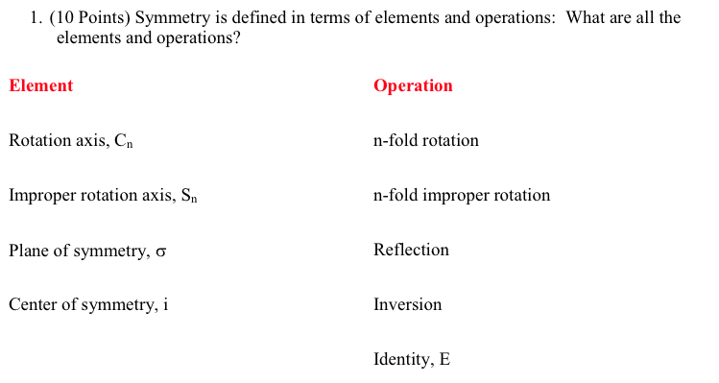

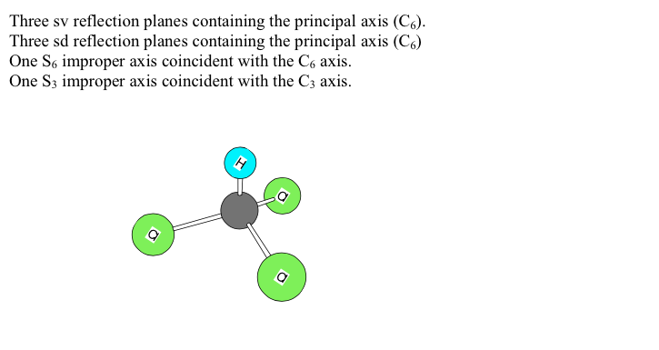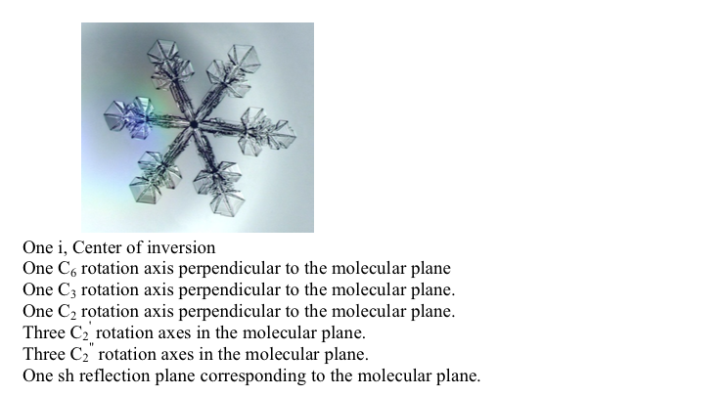

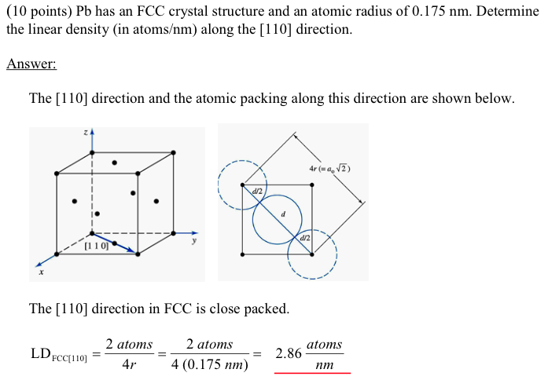

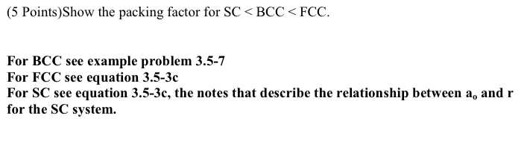

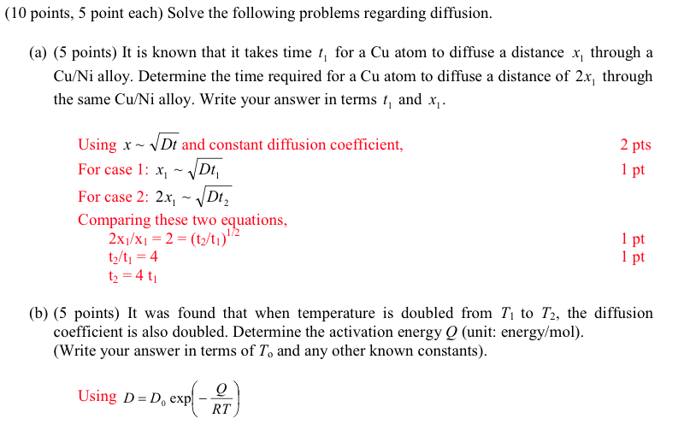

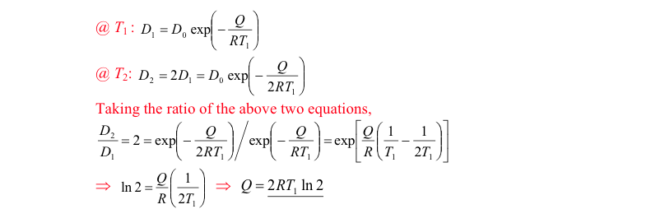

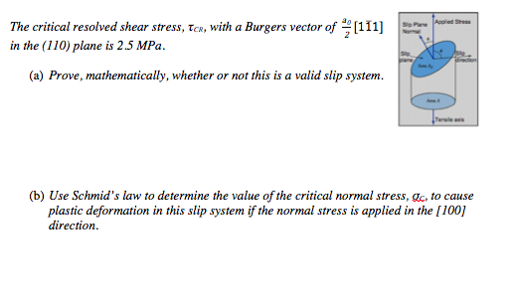

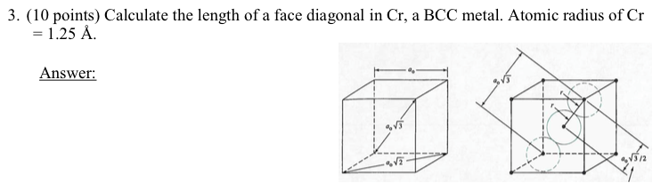

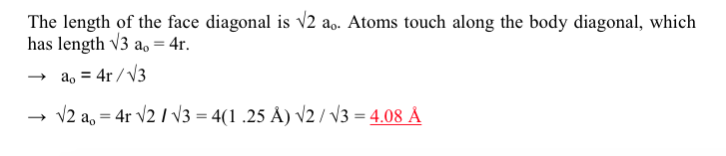

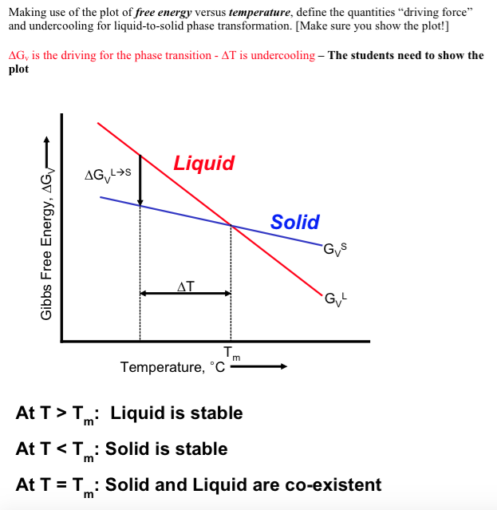

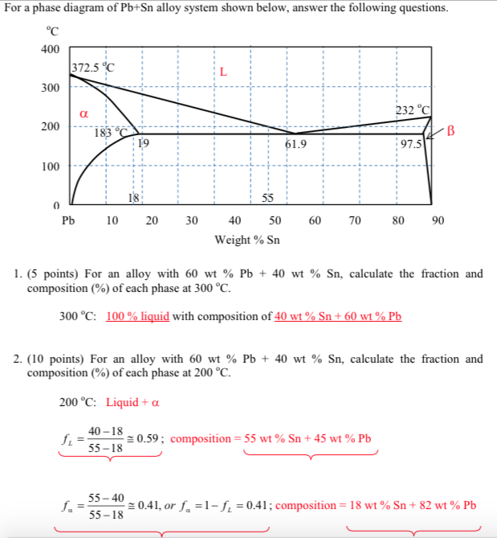

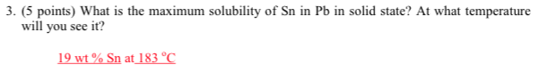

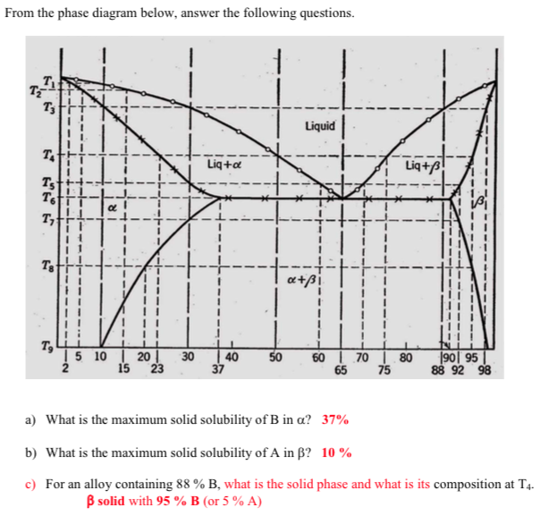

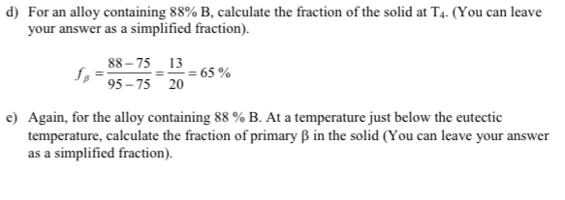

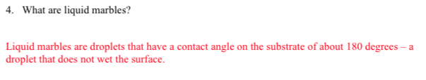

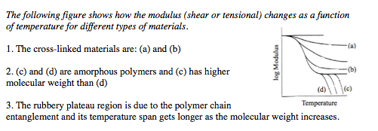

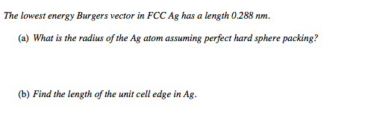

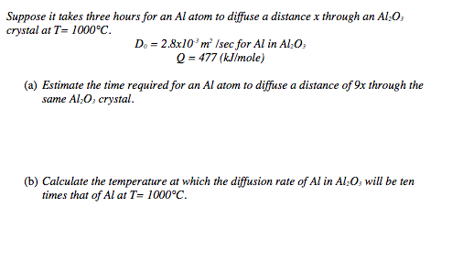

He gives you these 4 diagrams and asks you to define stress relaxation, creep compliance, etc. and you may need to draw the Maxwell models for them and explain why there is a dashed versus solid line. It’s the exact same diagram and questions from the Ch. 11 quiz.

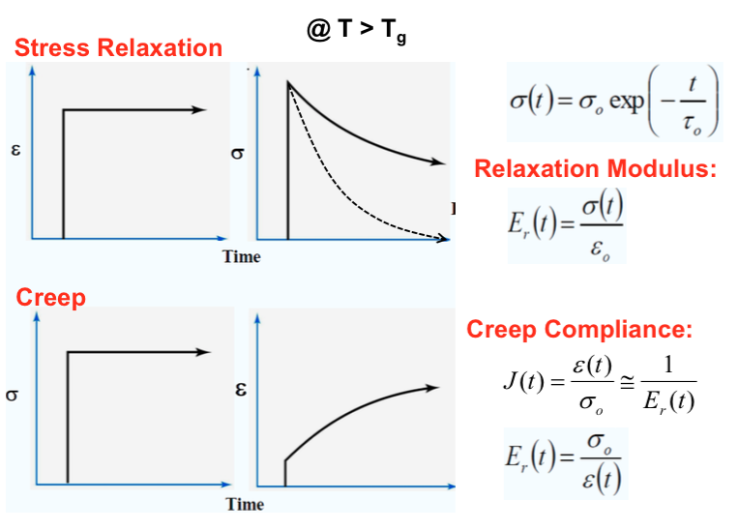

He gives you this diagram and asks what does the negative slope between ice and water means.

