MSE 2001A Final Exam, 5-1-2015

Your name (print) Your major

Please ONLY use the space below each question to provide your answer. You will have 170 minutes to work on this test. No notes, books, or reference materials of any kind can be used during this exam.

Sign below to confirm that all work on this test is yours and yours only.

Signature

Question | Possible points | Points earned
1-10 | 30
11-30 | 60
31 | 25
32-34 | 35
35-36 | 25
37-39 | 25
Extra point questions | 20
Total | 220

Part I. Briefly explain the following concepts in a few sentences. (3 pts each, total of 30 pts)

1. Valence electrons

2. Lattice

3. Point defect

4. Slip system

5. Glass transition temperature

6. Fermi energy

7. Isomorphous binary diagram

8. Heterogeneous nucleation

9. Plastic deformation

10. Extrinsic semiconductor
Part II. Multiple choice questions. (3 pts each, total of 60 pts)

11. How many carbon atoms are there in the unit cell of graphene?
a) 1
b) 2
c) 3
d) 4

12. Cu and Ag atoms have very similar size. If one of the Ag atoms in the FCC unit cell is replaced by one Cu atom, what is the density of the Ag-Cu alloy? The density of Ag is 10.49 g/cm³; the atomic masses of Ag and Cu are 107.87 and 63.54 g/mol, respectively.
a) 7.92 g/cm³
b) 10.12 g/cm³
c) 9.41 g/cm³
d) 4.31 g/cm³

13. How many tetrahedral and octahedral holes are occupied in the unit cell of NaCl (an FCC crystal)?
a) 4 tetrahedral and 0 octahedral holes
b) 8 tetrahedral and 0 octahedral holes
c) 0 tetrahedral and 4 octahedral holes
d) 0 tetrahedral and 8 octahedral holes

14. The bond-energy curves for two engineering materials are shown below. Which material has a higher Young’s modulus?

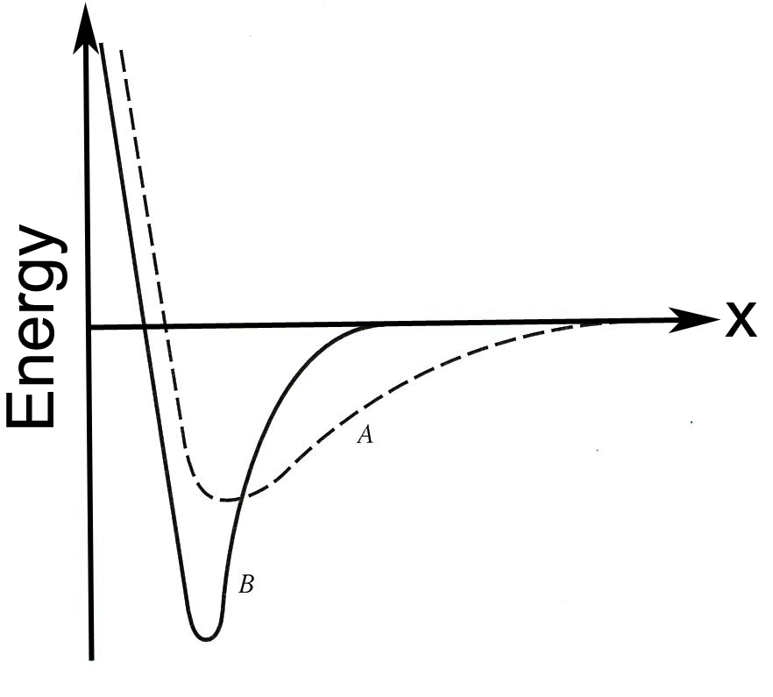

a) Material A
b) Material B

15. For the (100) plane of gold (Au, an FCC metal with a lattice constant of a₀), the planar density of Au atoms on the (100) plane is
a) 2/a₀²
b) 1/a₀²
c) 1/4a₀²
b) 1/8a₀²
16. When an FCC crystal is loaded (stressed) in the [101] direction, the resolved shear stress on this FCC slip system is τ_{fcc}. If the same load is applied to a BCC crystal in the [101] direction, what is the resolved shear stress on the BCC slip system, τ_{bcc}?
a) τ_{fcc} < τ_{bcc}
b) τ_{fcc} = τ_{bcc}
c) τ_{fcc} > τ_{bcc}
d) can’t be determined

17. Rank the magnitudes of the diffusion coefficients from the least to the greatest for the following systems:

(1) N in Fe at 700 ºC
(2) Cr in Fe at 700 ºC
(3) N in Fe at 900 ºC
(4) Cr in Fe at 900 ºC

Note: both Fe and Cr have the BCC crystal structure, and the atomic radii for Fe, Cr, and N are 0.124, 0.125, and 0.065 nm, respectively.

a) (1), (2), (3), (4)
b) (2), (4), (1), (3)
c) (3), (1), (2), (4)
d) (2), (4), (3), (1)

18. The time-dependent diffusion can be described by
a) Fick’s first law
b) Fick’s second law

19. What is the slip system of a BCC crystal structure?
a) {100}<110>
b) {111}<110>
c) {100}<010>
d) {110}<111>

20. The creation of vacancies in a perfect crystal would
a) decrease the entropy of the crystal
b) decrease the Gibbs free energy of the crystal

21. The high-temperature phase of FCC iron and carbon is
a) Austenite
b) Ferrite
c) Martensite
d) Cementite

22. The solid state analog of the eutectic reaction is
a) the eutectoid reaction
b) the petritectic reaction
c) the proeutectic reaction
d) the monotectic reaction

23. A constitute of carbon steels that forms from austenite at relatively low undercoolings.
a) Bainite
b) Pearlite
c) Martensite
d) Cementite

24. The barrier to nucleation decreases as undercooling
a) increases
b) decreases

25. If we use the Gibbs phase rule to describe the eutectic reaction along the eutectic isotherm between the points of maximum solubility, how many degrees of freedom are there – i.e., how many independent variables are required to specify the equilibrium?
(Hint: Assume that the pressure is fixed; Gibbs phase rule: F = C – P + 1)
a) 3
b) 2
c) 1
d) 0
26. Which of the following materials rarely exhibits significant plastic deformation?
a) Metal
b) Polymer
c) Ceramic

27. As the temperature increases, the number of mobile electrons in a semiconductor
a) decreases
b) increases

28. The figure below shows the stress-strain behavior for three different materials. Which material has the highest toughness?

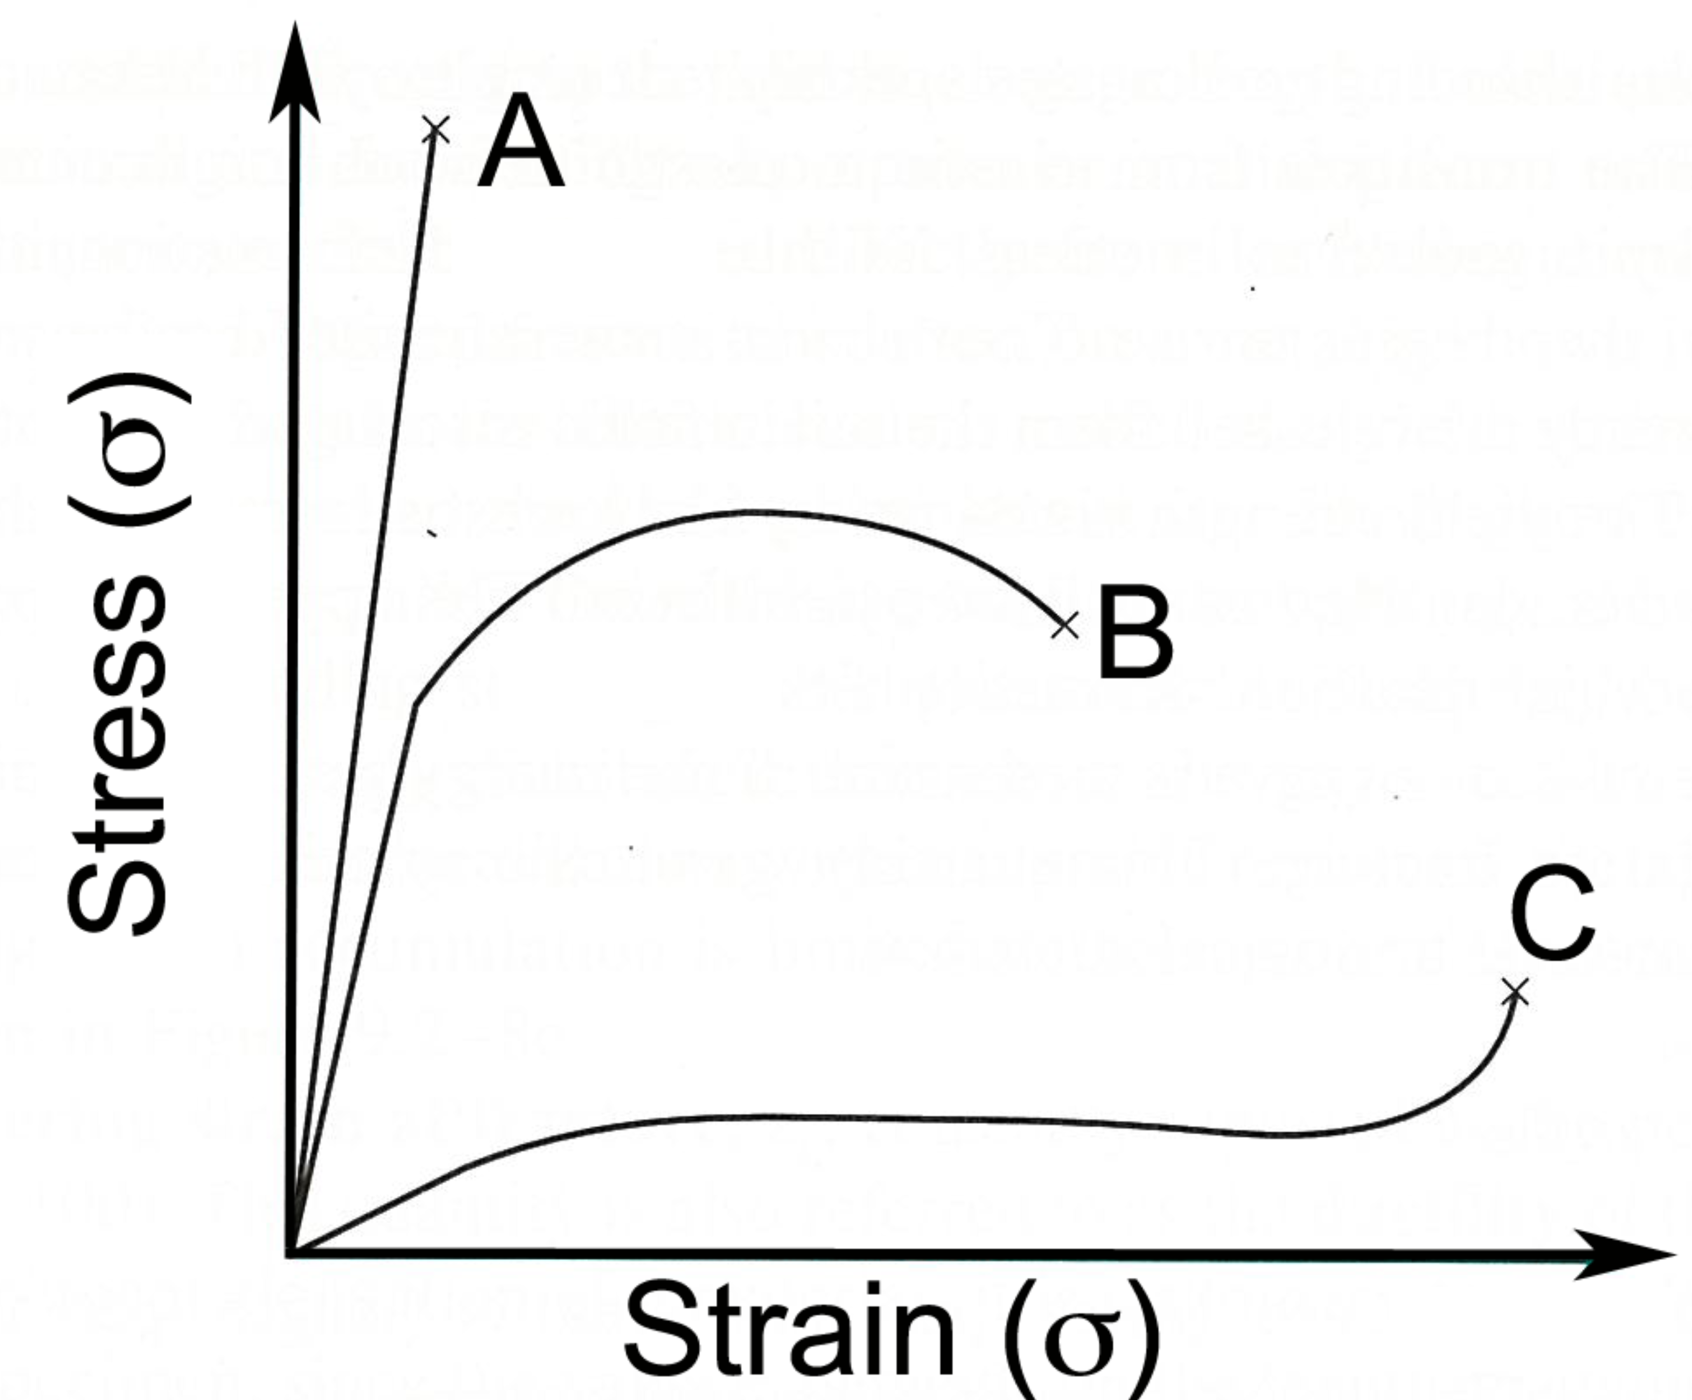
a) Material A
b) Material B
c) Material C

29. Of those metals listed in the table below. Which material is most ductile?

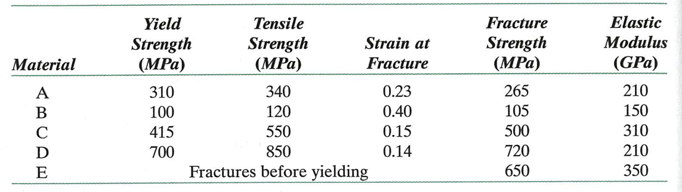

a) Material A
b) Material B
c) Material C
d) Material D

30. As the temperature increases, the resistivity of a metal
a) increases
b) decreases
Part III. Answer the problems below in the space provided. (total of 110 pts)

31. The resistance (R) of an aluminum (Al) wire is 0.0283 Ω. The length (L) and the cross section area (A) of this wire are 1 m and 1 mm², respectively. Assume that current is carried entirely by electrons and that the electron mobility (μ) is 1.22 x 10⁻³ m²V⁻¹s⁻¹.
(25 pts)

a) Calculate the conductivity (σ) of this Al wire. (hint: 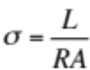) (5 pts)

b) Calculate the mobile electron density (N) in the unit of mobile electrons/m³.(5 pts)
(hint: 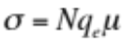, where q_{e} = 1.6 x 10⁻¹⁹ C)

c) Al is an FCC metal with an atomic radius (r) of 0.143 nm. Calculate the atomic density of Al atoms in the unit of atoms/m³). (5 pts)
(hint: the lattice constant of FCC metal (a₀) can be calculated by 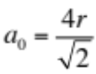, where r is the atomic radius)

d) Calculate the number of mobile electrons per Al atom. (5 pts)

e) Assume that Al is a substitutional impurity, will Al act as a donor or acceptor when added to semiconductor Ge? (5 pts)
(hint: the valence electrons of Al and Ge are 3 and 4, respectively.)

32. Rank the following iron-carbon alloys and associated microstructures from the highest to the lowest tensile strength. Justify your ranking. (10 pts)

0.25 wt% C with spheroidite
0.25 wt% C with coarse pearlite
0.6 wt% C with fine pearlite
0.6 wt% C with coarse pearlite.

33. The figure shown below is the isothermal transformation diagram of a eutectoid steel. Sketch a hypothetical heat transformation for austenite (stable above 727 ºC) that produces the following microstructures: 50% pearlite, 25% bainite, and 25% martensite. (10 pts)

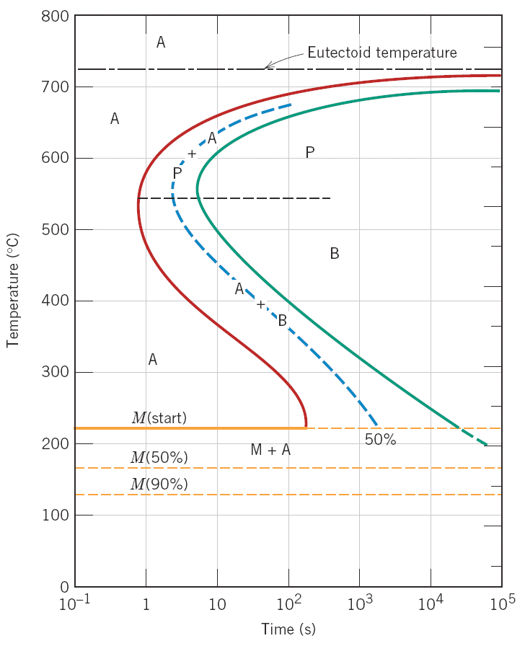
34. The figure below gives a binary equilibrium diagram for a hypothetical two-component eutectic system. T_{A} and T_{B} represent the equilibrium melting temperatures of pure components A and B, respectively. (15 pts)

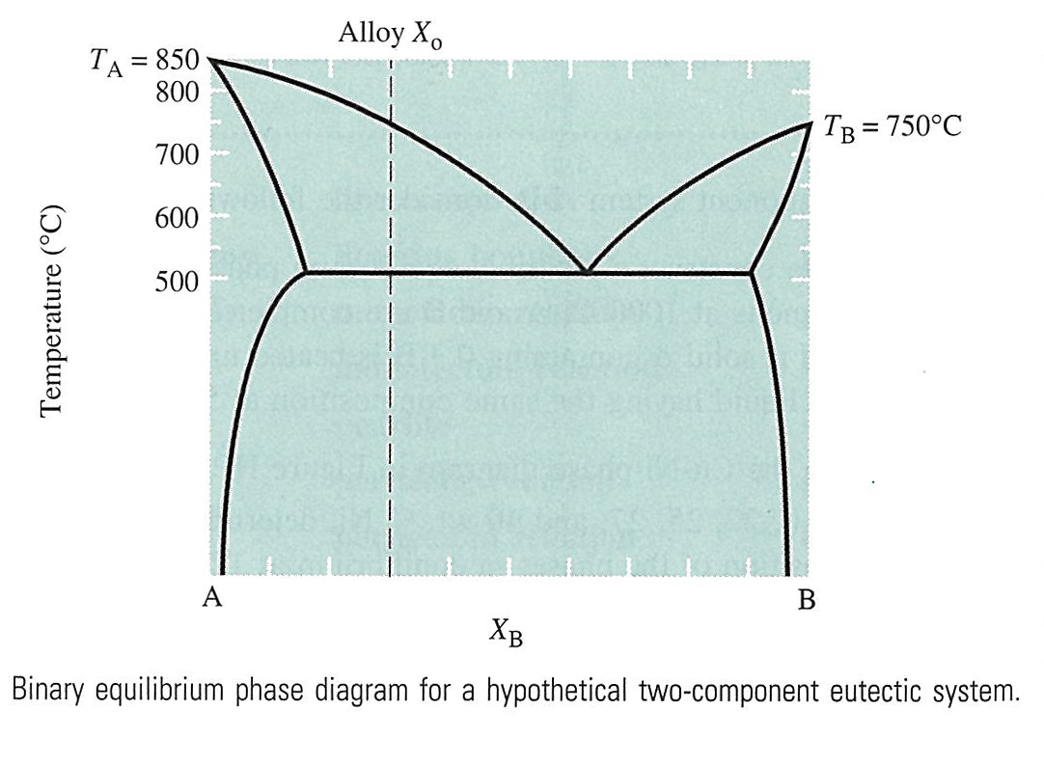

a). Sketch an equilibrium cooling curve from above the eutectic to room temperature for an alloy of eutectic composition. (5 pts)

b). Explain why the equilibrium cooling curve for alloy X₀ is different from the equilibrium cooling curve for a eutectic alloy? (5 pts)

c). What is the maximum solubility of A in B? (5 pts)

35. Why could Silly Putty (the children’s toy) behave like a glass or a fluid at room temperature when the material is pulled rapidly or slowly, respectively? (10 pts)

36. If a metallic material is cooled through its melting temperature at an extremely rapid rate, it will form a noncrystalline solid (i.e., a metallic glass). (15 pts)

a) Sketch the specific volume of metallic glass as a function of temperature. (10 pts)

b) Will the electrical conductivity of the noncrystalline metal be greater or lower than its The crystalline counterpart? Why? (5 pts)

37. Explain why water shows an anomalous behavior of expansion upon freezing when it changes phase from liquid to ice. (10 pts)

38. Use the bond type to explain the different ductile and brittle behaviors of metal and ionic solids. (10 pts)

39. Use carbon as an example to describe the structure and property relationship for diamond and graphite. (5 pts)
Part V. Questions for Extra Points (5pts each, total of 20 pts,)

1. The following is a portion of the H₂O-NaCl phase diagram. (5 pts)

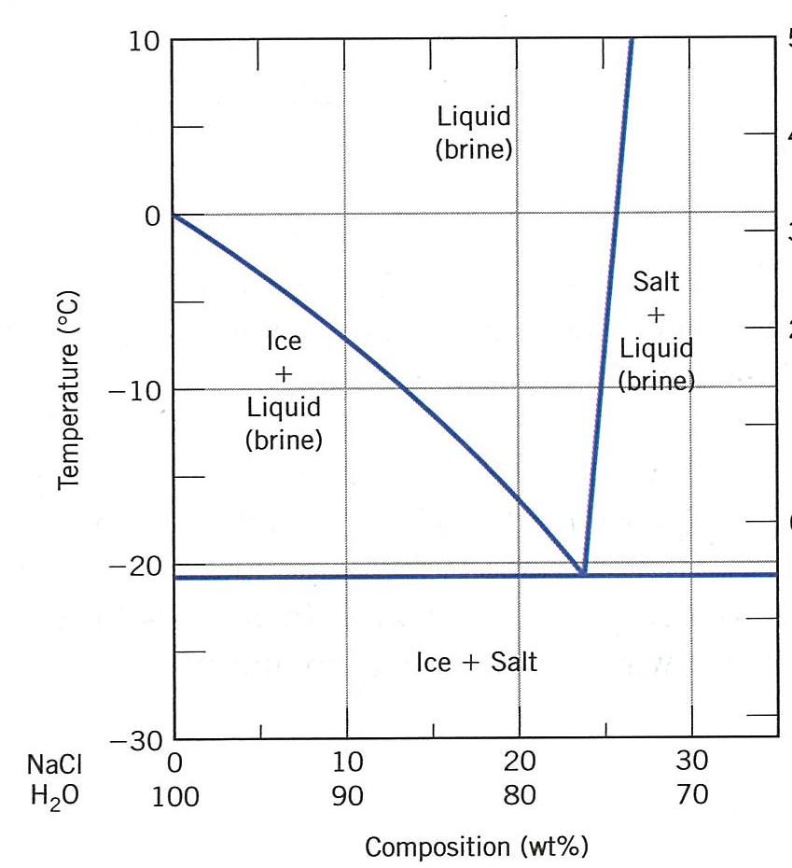

a) Briefly explain how spreading salt on ice that is at a temperature below 0ºC can cause the ice to melt. (3 pts)

b) At what temperature is salt no longer useful in causing ice to melt? (2 pts)

2. At relatively high temperatures, both donor- and acceptor-doped semiconducting materials will exhibit intrinsic behavior. Make a schematic plot of Fermi energy versus temperature for an n-type semiconductor up to a temperature at which it becomes intrinsic. Also note on this plot energy positions corresponding to the top of the valence band and the bottom of the conduction band. (5 pts)

3. The room-temperature electrical resistivities of pure lead and pure tin are 2.06 x 10⁻⁷ and 1.11 x 10⁻⁷ Ω-m, respectively. Based on the phase diagram below, make two schematic graphs of the electrical resistivity versus composition for all compositions between pure lead and pure tin at room temperature (25 ºC) and 150 ºC, respectively. (5 pts)

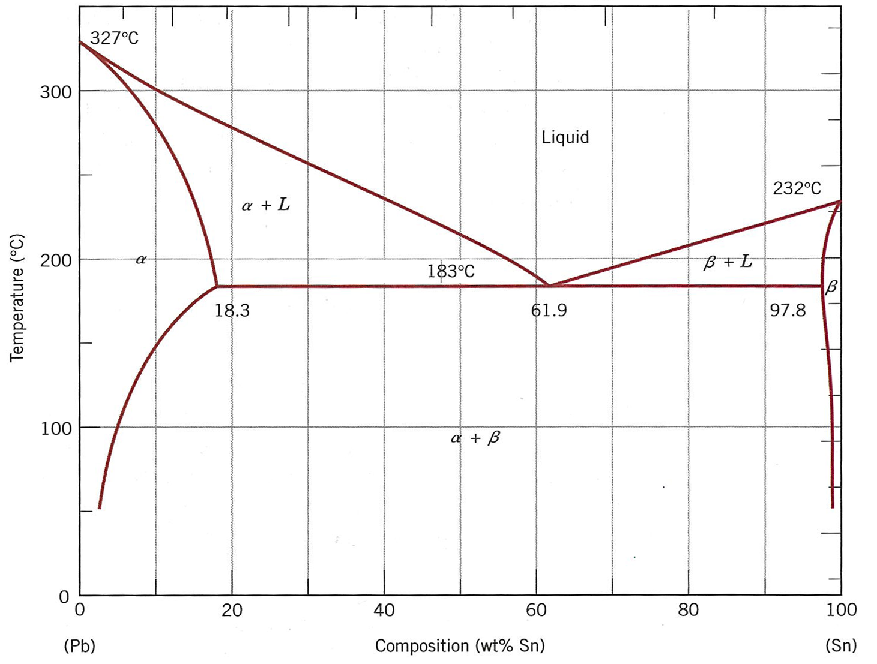

4. Use a two-dimensional model, for example, a square lattice of atoms, to explain how the fractions of atoms at the corners, on the edges, and in the bulk change with the size (in this case, the area) of the crystal. (5 pts)

