MSE 2001A EXAM #1, 2-2-2015

Your name (print) Your major

Please ONLY use the space below each question to provide your answer. You will have 50 minutes to work on this test. No notes, books, or reference materials of any kind to be used on this exam.

Sign below to confirm that all work on this test is yours and yours only.

Signature

Question | Possible points | Points earned
1 | 20
2 | 20
3 | 10
4 | 15
5 | 15
6-7 | 20
Extra point questions | 10
Total | 110

1. Use carbon as an example to describe the structure and property relationship for diamond and graphite. Draw the unit cell of graphene. How many carbon atoms are there in the unit cell of graphene? (20 pts)

2. The ionic radii of silver ion (Ag⁺) and chloride ion (Cl⁻) are 0.128 nm and 0.181 nm, respectively. (20 pts)

a) Calculate the radius ratio of Ag⁺ to Cl⁻ and determine the crystal structure of AgCl. (5 pts)

b) What is the coordination numbers of Ag⁺ and Cl⁻ ions, respectively? How many cations and anions are contained in the unit cell? (10 pts)

c) How many vacant tetrahedral and octahedral holes are available in one unit cell of AgCl? (5 pts)

3. Use the bond type to explain the different ductile and brittle behaviors of metal and ionic solids. (10 pts)

4. An X-ray diffraction pattern of copper (FCC) using Cu Kα radiation (λ=0.1542 nm) displays a diffraction maximum at a scattering angle of 2θ = 90.04º, corresponding to the diffraction from (131) planes. Calculate the lattice parameter of copper, a₀, in nm. (15 pts)

Bragg’s law: 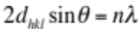and assume n=1 in the equation
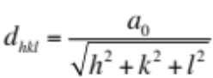for a cubic crystal structure

5. Sketch the (100) plane of gold (an FCC lattice) and calculate its planar density of gold atoms on the (100) plane. (15 pts)

6. A reaction or structural change would occur at an observable rate only if (5 pts)
a) thermodynamics is favorable.
b) kinetics is favorable
c) both thermodynamics and kinetics are favorable
d) Cannot be determined

7. The bond-energy curves for two engineering materials are shown below. Your task is to select the better material for use in each specific application described below: (15 pts)

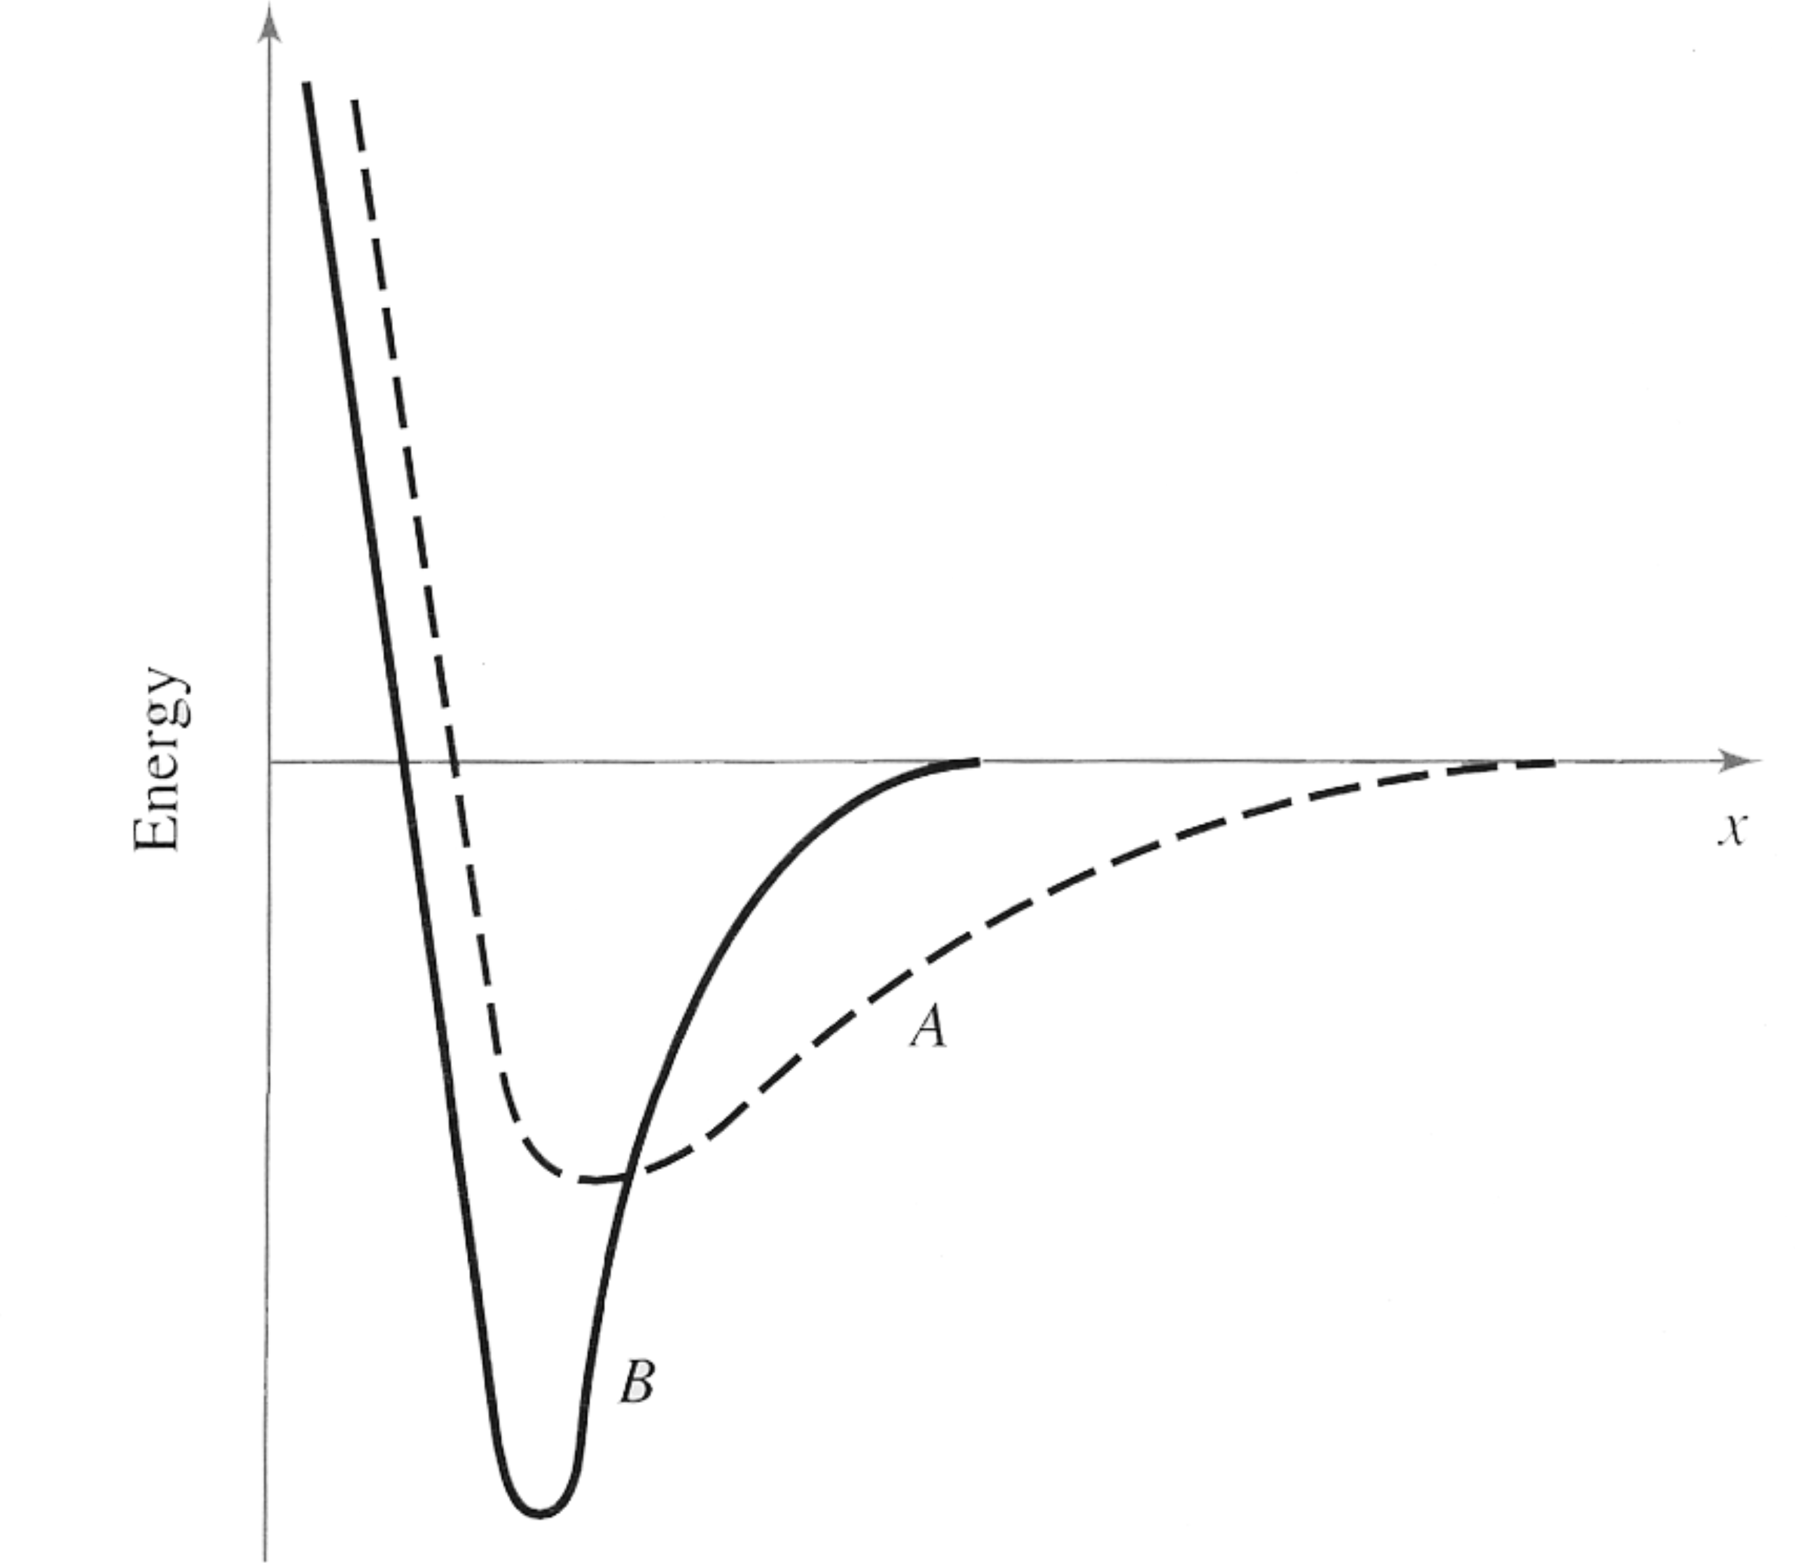

I) A beam that shows significant deflection under moderate loads (5 pts)
a) Material A
b) Material B

II) A polymer that can be recycled at low temperature (5 pts)
a) Material A
b) Material B

III) A device designed to sense the change in temperature by changing its dimension (5 pts)
a) Material A
b) Material B

Questions for Extra Points (10 pts)

1. Explain why water shows an anomalous behavior of expansion upon freezing when it changes phase from liquid to ice. (5 pts)

2. Cu and Ag atoms have very similar size. If one of the Ag atoms in the FCC unit cell is replaced by one Cu atom, what is the density of the Ag-Au alloy? The density of Ag is 10.49 g/cm³; the atomic masses of Ag and Cu are 107.87 and 63.54 g/mol, respectively. (5 pts)

