MSE 2001A EXAM #2, 3-2-2015

Your name (print) Your major

Please ONLY use the space below each question to provide your answer. You will have 50 minutes to work on this test. No notes, books, or reference materials of any kind to be used on this exam.

Sign below to confirm that all work on this test is yours and yours only.

Signature

Question | Possible points | Points earned
1-5 | 15
6-10 | 15
11-12 | 15
13-17 | 15
18 | 15
19 | 10
20 | 15
Extra point questions | 10
Total | 110

Part I: Multiple-choice questions 1-17. Please circle the correct answer.
(3 pts per question, total of 60 pts)

1. The time-dependent diffusion can be described by (3 pts)

a) Fick’s first law
b) Fick’s second law

2. What type of defect in an ionic crystal involves missing ions? (3 pts)

a) Schottky defect
b) Frenkel defect

3. What type of dislocation has the Burgers vector, b, and the unit tangent vector, t, that are parallel to each other? (3 pts)

a) Screw dislocation
b) Edge dislocation

4. Rank the magnitudes of the diffusion coefficients from least to greatest for the following systems: (3 pts)

(1) N in Fe at 700 ºC
(2) Cr in Fe at 700 ºC
(3) N in Fe at 900 ºC
(4) Cr in Fe at 900 ºC

Note: both Fe and Cr have the BCC crystal structure, and the atomic radii for Fe, Cr, and N are 0.124, 0.125, and 0.065 nm, respectively.

a) (1), (2), (3), (4)
b) (2), (4), (1), (3)
c) (3), (1), (2), (4)
d) (2), (4), (3), (1)

5. What is the slip system for BCC crystal structure? (3 pts)

a) {100}<110>
b) {111}<110>
c) {100}<010>
d) {110}<111>
6. What is the measure of a material’s resistance to flow? (3 pts)

a) Critical resolved shear stress
b) Viscosity

7. For a slip to occur in a particular slip system, a nonzero component of force must exist parallel to the slip direction. (3 pts)

a) True
b) False

8. The creation of vacancies in a perfect crystal would (3 pts)

a) increase the entropy of the crystal
b) increase the Gibbs free energy of the crystal

9. A rapidly cooled glass has a higher glass transition temperature than a slowly cooled glass of the same composition. (3 pts)

a) True
b) False

10. At a constant temperature, the activation energy for diffusion along grain boundaries is lower than that in the bulk material. (3 pts)

a) True
b) False

11. Suppose one attempts to add a small amount of Ni to Cu to create a solid solution.

Which element is the solvent? (3 pts)
a) Ni
b) Cu

Which element is solute? (3 pts)
a) Ni
b) Cu

The resulting solid solution is (3 pts)
a) Substitutional solid solution
b) Interstitial solid solution

Do you think Ni and Cu will be completely soluble to each other? (3 pts)
a) Yes
b) No

12. What is the direction and length of the lowest-energy (i.e. the shortest) Burgers vector in the CsCl ionic crystal? (3 pts)

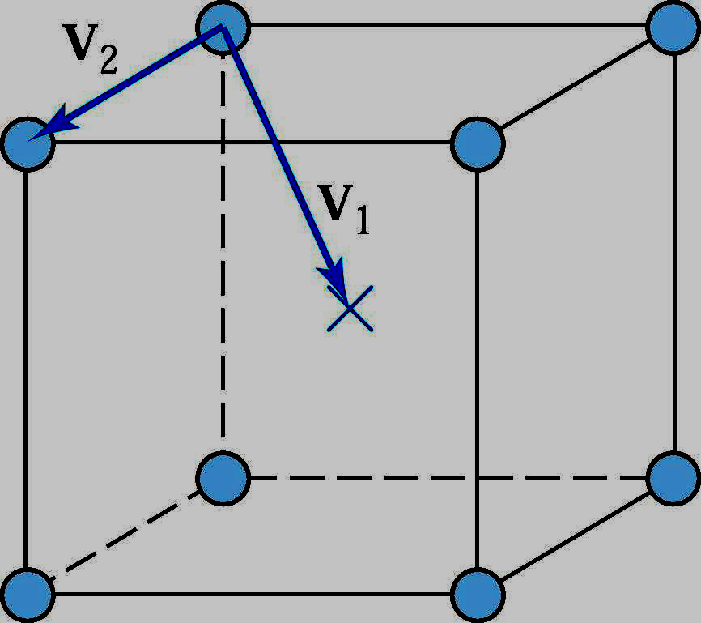

a) V₁
b) V₂
13. When the motion of dislocation in an alloy is impeded, the alloy’s strength increases. (3 pts)

a) True
b) False

14. Amorphous materials lack the long range order characteristic of crystalline materials. (3 pts)

a) True
b) False

15. Increasing the grain size would decrease the strength of a metal or alloy. (3 pts)

a) True
b) False

16. The Figure below shows the modulus-temperature curves for polyisobutylene and polystyrene. At room temperature, which of the material is at the rubbery state? (3 pts)
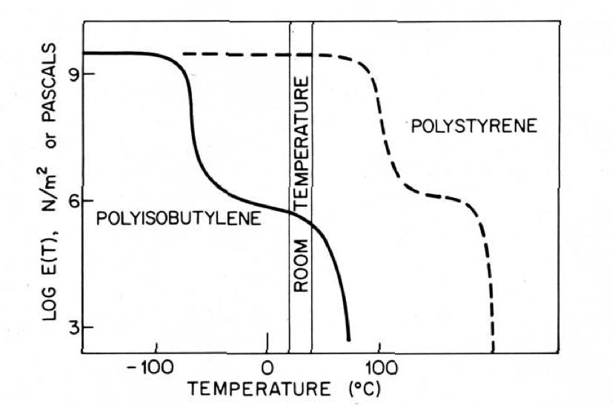
a) Polyisobutylene
b) Polystyerene

17. The Burgers vectors in ionic crystals are often longer than those in metallic crystals for an edge dislocation.

a) True
b) False
Part II: Problems 18-20. Show your work and circle your answer in the space provided.
(Total of 40 pts)

18. A tensile stress (σ) of 123 MPa is applied to BCC Fe in the [110] direction. What is the resolved shear stress (τ) on the (010)[101] slip system? (15 pts)

Hint: 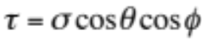, where θ and φ are the angles between the loading and slip direction and loading and the normal to the slip plane, respectively.
The angle (ϕ) between two directions, vectors A (A = ui + vj + wk) and B (B = u’i + v’j + w’k), can be determined by taking the vector dot product:

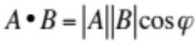; 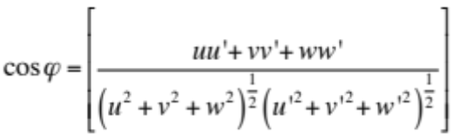

19. A steel part is case hardened by carburizing in a carbonaceous atmosphere at 1200 K. A case depth of 0.2 mm is produced after 1 hour. How long does it take to produce a case depth of 0.8 mm under the same condition? (10 pts)

Hint: effective penetration distance, x_{eff}, can be calculated by the following equation:

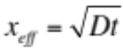, where D is the diffusion coefficient and t is the diffusion time

20. An engineer ran an experiment to measure the specific volume of a polymer as a function of temperature. Is this a noncrystalline, crystalline, or semicrystalline material? Explain which features in the data support your claim. (15 pts)

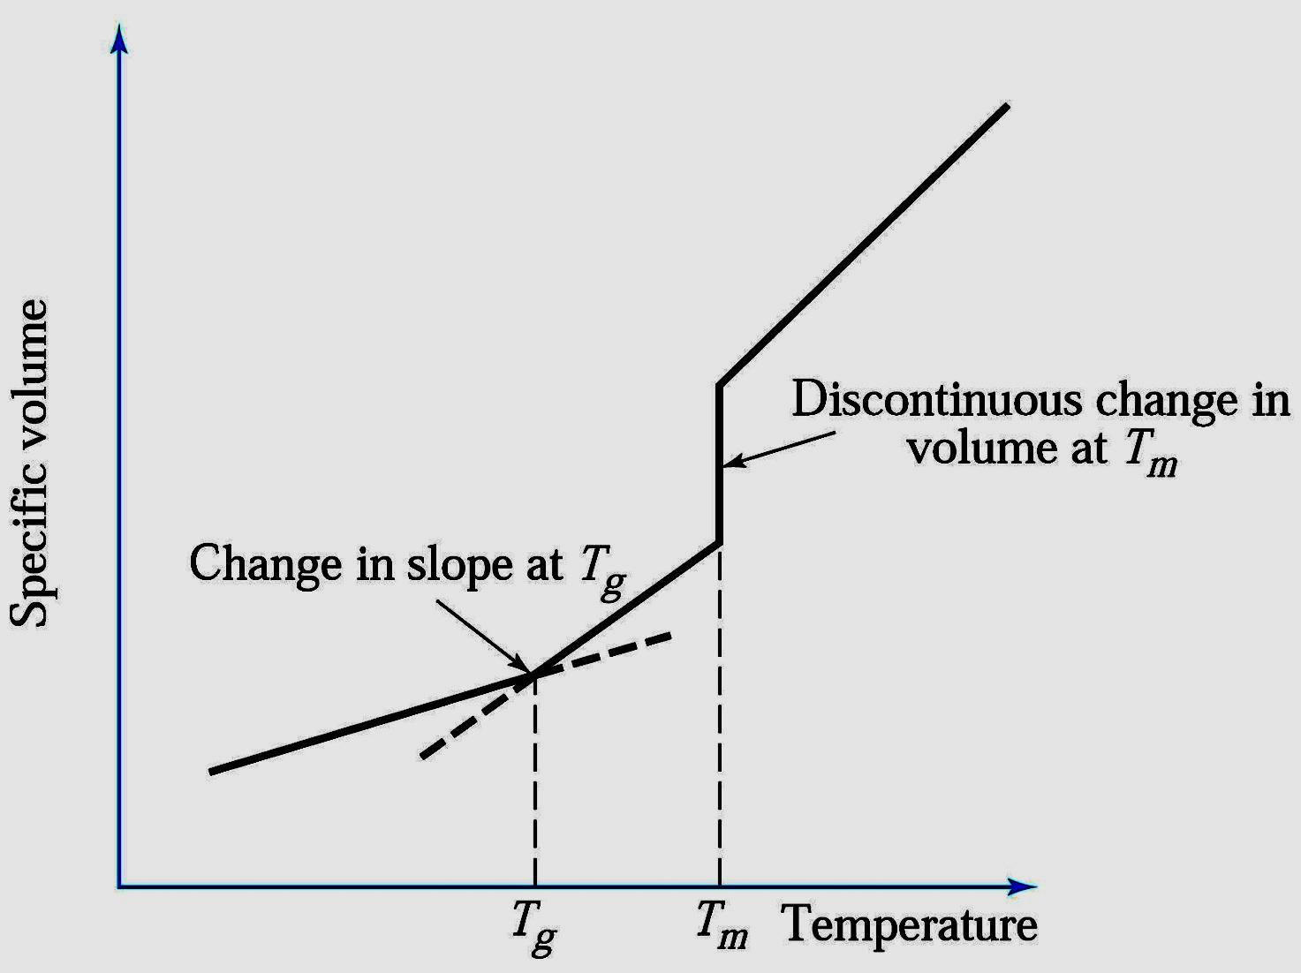

Questions for Extra Points (10 pts)

1. When single-crystal FCC and BCC metals are loaded (stressed) in the [101] direction, do you expect the same resolved shear stress on their slip systems? Justify your answer. (5 pts)

Hint: , where θ and φ are the angles between the loading and slip direction and loading and the normal to the slip plane, respectively.

2. Why could Silly Putty (the children’s toy) behave like a glass or a fluid at room temperature when the material is pulled rapidly or slowly, respectively? (5 pts)

