MSE 2001A EXAM #3, 4-8-2015

Your name (print) Your major

Please ONLY use the space below each question to provide your answer. You will have 50 minutes to work on this test. No notes, books, or reference materials of any kind can be used during this exam.

Sign below to confirm that all work on this test is yours and yours only.

Signature

Question | Possible points | Points earned
1-5 | 10
6-10 | 10
11-15 | 10
16-20 | 10
21-22 | 10
23 | 30
24 | 20
Extra point questions | 10
Total | 110

Part I: Questions 1-20. Please circle the correct answers.
(2 pts per question with a total of 40 pts)

1. The high-temperature phase of FCC iron and carbon is cementite.

a) True
b) False

2. Heating pearlite or bainite at about 700 ºC for 18-24 hours produces spheroidite.

a) True
b) False

3. Eutectoid reaction is in the solid state analog of the eutectic reaction.

a) True
b) False

4. Larger undercoolings typically produce coarser microstructures than those formed at smaller undercoolings.

a) True
b) False

5. In a eutectic system, the solubility of one component in the other always decreases as the temperature increases toward the eutectic temperature.

a) True
b) False

6. For liquid-to-solid transformation, the overall transformation rate is determined by the nucleation and growth rates.

a) True
b) False

7. The interface between two phases always decreases the system’s Gibbs free energy.

a) True
b) False

8. An alloy of eutectic composition has a lower melting point than does either component.

a) True
b) False

9. As undercooling increases, the energy barrier to nucleation decreases. (3 pts)

a) True
b) False

10. Good wetting is associated with a large wetting angle.

a) True
b) False

11. Martensite is produced by rapidly quenching austenite to a sufficiently low temperature for eliminating carbon diffusion.

a) True
b) False

12. The simplest two-component system is an isomorphous system in which complete solubility can occur over the entire composition range in both the liquid and solid states.

a) True
b) False

13. As the clustering tendency of a solid increases, there is a depression in the liquidus and solidus temperature.

a) True
b) False

14. A coherent interface arises when there is a one-to-one correspondence of atomic planes across the boundary separating two phases. This type of surface has a higher interfacial energy than that of a semi-coherent interface.

a) True
b) False

15. Once the critical radius of a nucleus is reached, any further increase in the particle size will result in reduction in the free energy of the system.

a) True
b) False

16. The energy barrier for heterogeneous nucleation is lower than that for homogeneous nucleation.

a) True
b) False

17. The solidification of an alloy (liquid) of eutectic composition yields a microstructure that includes the alternating layers of two solid phases.

a) True
b) False

18. For a peritectic reaction, upon cooling, a liquid phase and one solid phase are transformed to another solid phase.

a) True
b) False

19. Coarse pearlite forms at higher temperatures (isothermally) and for higher cooling rates (continuous cooling rate).

a) True
b) False

20. Phase diagrams provide no information about the time-dependence of transformation process. In contrast, isothermal transformation diagrams involve the element of time.

a) True
b) False

Part II: Questions 21-24. Show your work and circle your answer in the space provided.
(Total of 60 pts)

21. Sketch a general curve of fraction transformed versus log(time) (the S curve) for a phase transformation that involves nucleation and growth. Label the axes. (5 pts)

22. If we use the Gibbs phase rule to describe the eutectic reaction along the eutectic isotherm between the points of maximum solubility, how many components and phases are present at the equilibrium? How many degrees of freedom are there – i.e. how many independent variables are required to specify the equilibrium? (5pts)

(Hint: Assume that the pressure is fixed; Gibbs phase rule: F = C – P + 1)
23. Consider the following questions using the Pb-Sn phase diagram shown below. (30 pts)

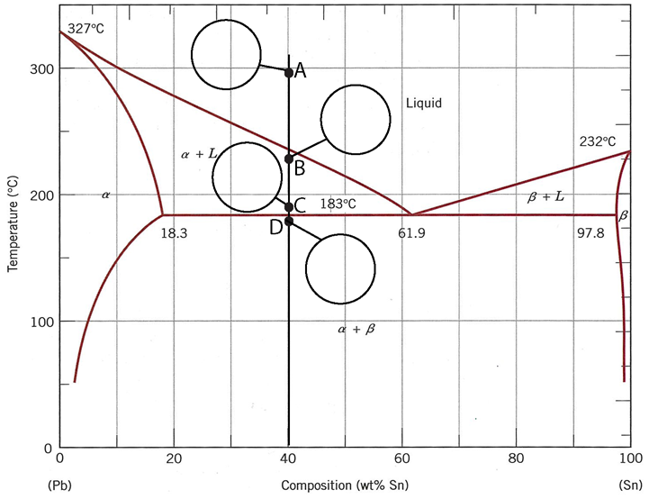

a. In the circles, draw the microstructures at the four points (A-D) as shown on the graph for a 40 wt% Sn alloy. Specify the phases that are present in the microstructures. (8 pts)

b. Write down the eutectic reaction occurs at 61.9 wt% Sn. (3 pts)

c. What is the maximum solubility of lead (Pb) in tin (Sn)? (3 pts)

d. What is the primary phase and what fraction of the alloy does the primary form of this phase occupy if the alloy is 60 wt% of Pb? Show all relevant calculation and neglect changes in composition for phases below the eutectic temperature. (8 pts)

e. What phases are present in an alloy of the eutectic composition just below the eutectic temperature and what are the relative fractions? Show all relevant calculations. (8 pts)

24. The figure below shows the binary equlilibrium phase diagram for the hypothetical two- component A-B system. (20 pts)
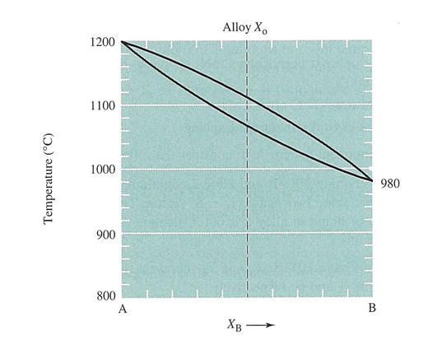

a. What is the name given to this type of equilibrium diagram? (4 pts)

b. Label the regions (including lines) of the phase diagram in the above figure. (4 pts)

c. If component A is FCC, what is the crystal structure of component B? (4 pts)

d. Sketch cooling curves for alloy X₀ and pure component B. Label the axes (8 pts)

Part III: Questions for Extra Points (10 pts)

1. Draw the pair of Gibbs free energy curves, G_{liquid} and G_{solid}, as function of composition X_{B} at the temperature of T₃. (5 pts)

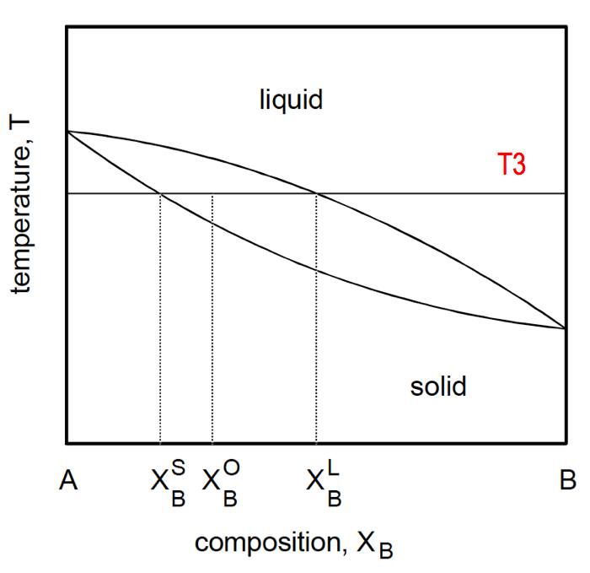

2. The figure shown below is the isothermal transformation diagram of a eutectoid steel. Sketch a hypothetical heat transformation for austenite (stable above 727 ºC) that produces the following microstructures: 50% pearlite, 25% bainite, and 25% martensite. (5 pts)

