ECON 2105 Quiz #1 Chapter2

Name: __________________________ Date: _01/21/2015____________

1. | One of the controversies surrounding America's energy markets is the trade-off between energy production and clean air. Assuming clean air has value, the United States will be on its production possibility frontier if and only if:
 | A) | the price of energy is relatively low.
 | B) | resources used to produce clean air and energy are not being fully utilized.
 | C) | resources used to produce clean air and energy are being fully utilized.
 | D) | pollution is eliminated.

2. | The effect of an increase in productive inputs such as labor and capital can be shown by:
 | A) | an outward shift of the production possibility frontier.
 | B) | a movement from one point to another along the production possibility frontier.
 | C) | an inward shift of the production possibility frontier.
 | D) | a point inside of the production possibility frontier.

3. | Consider a production possibility frontier for Iraq. If in 2014 Iraq's resources are not being fully utilized, Iraq will be somewhere ________ of its production possibility frontier.
 | A) | near the bottom
 | B) | inside
 | C) | near the top
 | D) | outside

4. | All points inside the production possibility frontier represent:
 | A) | infeasible production points.
 | B) | efficient production points.
 | C) | economic growth.
 | D) | inefficient production points.

Use the following to answer question 5:

Figure: Guns and Butter

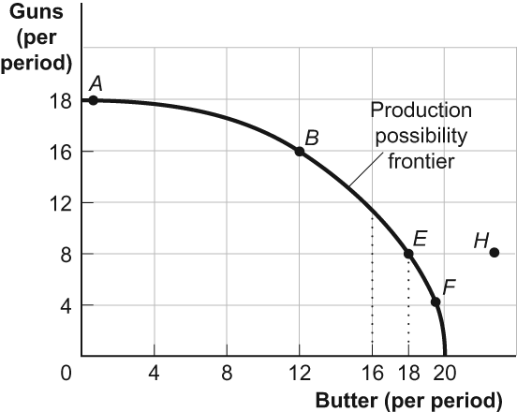

5. | (Figure: Guns and Butter) Look at the figure Guns and Butter. If the economy were operating at point B, producing 16 guns and 12 pounds of butter per period, a decision to move to point E and produce 18 pounds of butter:
 | A) | makes it clear that this economy experiences decreasing opportunity costs.
 | B) | involves a loss of 8 guns per period.
 | C) | involves a loss of 4 guns per period.
 | D) | indicates you can have more butter and guns simultaneously.

Use the following to answer questions 6-7:

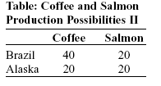

6. | (Table: Coffee and Salmon Production Possibilities II) Look at the table Coffee and Salmon Production Possibilities II. This table shows the maximum amounts of coffee and salmon that Brazil and Alaska can produce if they just produce one good. Brazil has a comparative advantage in producing:
 | A) | both coffee and salmon.
 | B) | neither coffee nor salmon
 | C) | salmon only.
 | D) | coffee only.

7. | (Table: Coffee and Salmon Production Possibilities II) Look at the table Coffee and Salmon Production Possibilities II. This table shows the maximum amounts of coffee and salmon that Brazil and Alaska can produce if they just produce one good. Alaska has an absolute advantage in producing:
 | A) | neither coffee nor salmon.
 | B) | coffee only.
 | C) | salmon only.
 | D) | both coffee and salmon.

8. | An economy is said to have a comparative advantage in the production of a good if it can produce that good:
 | A) | outside its production possibilities curve.
 | B) | with more resources than another economy.
 | C) | at a lower opportunity cost than another economy.
 | D) | with a higher opportunity cost than another economy.

9. | If they spend all night writing computer programs, Laurence can write 10 programs while Carrie Anne can write 5. If they spend all night making sunglasses, Laurence can make 6 while Carrie Anne can make 4. Given this information and supposing Laurence and Carrie Anne have constant opportunity costs, we know that:
 | A) | Carrie Anne has an absolute advantage in both programs and sunglasses.
 | B) | Carrie Anne has an absolute advantage in programs but not in sunglasses.
 | C) | Laurence has an absolute advantage in programs but not in sunglasses.
 | D) | Laurence has an absolute advantage in both programs and sunglasses.

10. | If the opportunity cost of manufacturing machinery is higher in the United States than in Britain and the opportunity cost of manufacturing sweaters is lower in the United States than in Britain, then the United States will:
 | A) | export sweaters to Britain and import machinery from Britain.
 | B) | export both sweaters and machinery to Britain.
 | C) | import sweaters from Britain and export machinery to Britain.
 | D) | import both sweaters and machinery from Britain.

Answer Key

1. | C
2. | A
3. | B
4. | D
5. | B
6. | D
7. | A
8. | C
9. | D
10. | A

