ECON 2150 Quiz #3 Chapter 4

Name: __________________________ Date: _____________

Use the following to answer question 1:

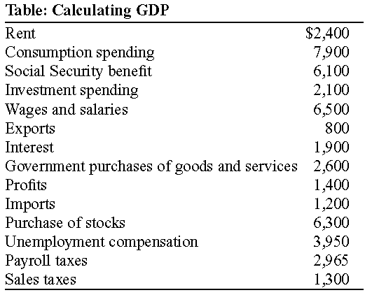

1. | (Table: Calculating GDP) Using the information in the table provided, which of the following is the correct calculation for GDP?
 | A) | $47,475
 | B) | $12,200
 | C) | $21,485
 | D) | $34,085

Use the following to answer question 2:

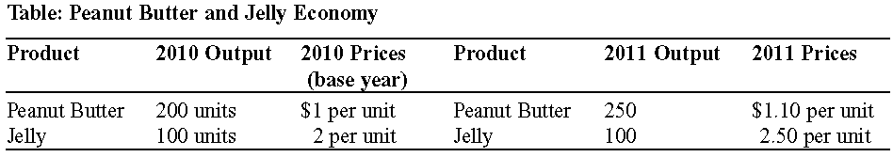

2. | (Table: Peanut Butter and Jelly Economy) Between 2010 and 2011, nominal GDP:
 | A) | increased by 12.5%.
 | B) | decreased by 12.5%.
 | C) | increased by 16.67%.
 | D) | increased by 31.25%.

3. | Consider an economy that produces only two goods: DVDs and DVD players. Last year, 10 DVDs were sold at $20 each and 5 DVD players were sold at $100 each, while this year 15 DVDs were sold at $10 each and 10 DVD players were sold at $50 each. Real GDP this year using last year as the base year is:
 | A) | $100.
 | B) | $700.
 | C) | $1,300.
 | D) | $300

4. | In the country of Sildavia, a market basket of goods and services cost $130 in 2009, $140 in 2010, and $160 in 2011. Based on this information and considering 2009 as the base year, inflation from 2009 to 2011 was:
 | A) | 7.14%.
 | B) | 7.69%.
 | C) | 14.28%.
 | D) | 23.07%.

5. | Which of the following is NOT included in investment spending in the national income accounts?
 | A) | new residential construction
 | B) | the purchase of machinery and other productive physical capital
 | C) | the purchase of stocks and bonds by a business
 | D) | spending on inventories

Use the following to answer question 6:

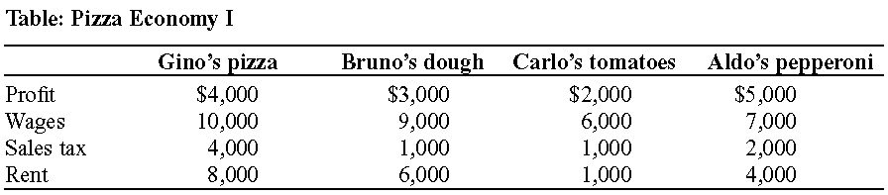

6. | (Table: Pizza Economy I) Based on the accompanying table, GDP in this economy is:
 | A) | $73,000.
 | B) | $65,000.
 | C) | $57,000.
 | D) | $51,000.

Use the following to answer question 7:

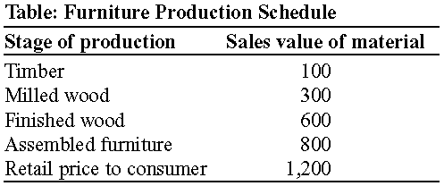

7. | (Table: Furniture Production Schedule) What is the total value added at all stages of the production process of the furniture as described in the accompanying table?
 | A) | $800
 | B) | $1,200
 | C) | $1,800
 | D) | $2,000

8. | The value of all the following goods is included in the calculation of GDP EXCEPT:
 | A) | the value of Firestone tires sold at your local garage.
 | B) | the value of Bridgestone tires purchased by Ford Motor Co.
 | C) | the value of Goodyear tires purchased by the United States Secret Service.
 | D) | the value of Michelin tires purchased by Canadian car collectors.

9. | In the country of Sildavia, a market basket of goods and services cost $130 in 2009, $140 in 2010, and $160 in 2011. Based on this information and considering 2009 to be the base year, the price index in 2011 was:
 | A) | 100.
 | B) | 107.69.
 | C) | 123.07.
 | D) | 130.

Use the following to answer question 10:

Figure: Circular-Flow Model

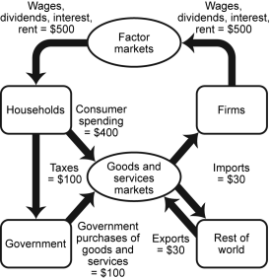

10. | (Figure: Circular-Flow Model) If the circular-flow model is in equilibrium (the sum of money flowing into each box is equal to the sum of the money flowing out of that box), which of the following is likely to happen if there is an increase in investment spending?
 | A) | a decrease in the nominal GDP
 | B) | an increase in the nominal GDP
 | C) | an increase in the unemployment rate
 | D) | a decrease in the inflation rate

Answer Key

1. | B
2. | D
3. | C
4. | D
5. | C
6. | B
7. | B
8. | B
9. | C
10. | B

