ECON 2105 Quiz #4 Chapter 5 (Take Home)

Due Date: In class on Wednesday, 03/11/2015. No late submissions and no email submissions will be accepted.

By doing this quiz as a take home, the University's Academic Honor Code will still be enforced.

Name: __________________________ Date: _____________

Use the following to answer question 1:

Figure: Technological Progress and Productivity Growth

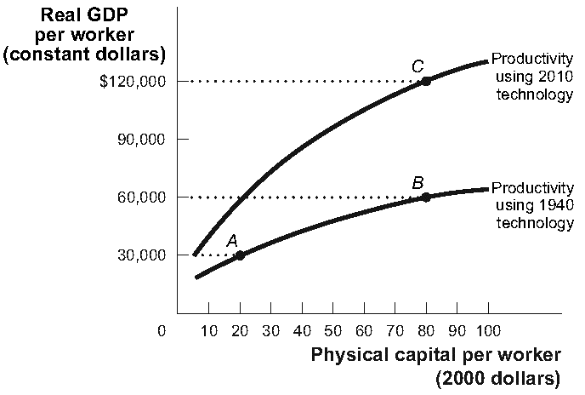

1. |  | (Figure: Technological Progress and Productivity Growth) Which of the following changes in real GDP would be most likely to result over time from the deterioration of the nation's infrastructure?
A) | B to C
B) | B to A
C) | A to B
D) | C to B

2. |  | Real GDP per capita, growing at a constant rate over a 35-year period, doubles in size at the end of that period. What must the annual growth rate of real GDP per capita be for this economy?
A) | 15%
B) | 4%
C) | 1%
D) | 2%

Use the following to answer questions 3-4:

Scenario: Open Economy S = I
In an open economy the GDP is $12 trillion this year. Consumption is $8 trillion, and government spending is $2 trillion. Taxes are $0.5 trillion. Exports are $1 trillion, and imports are $3 trillion.

3. |  | (Scenario: Open Economy S = I) How much is the net capital inflow?
A) | $4 trillion
B) | $3 trillion
C) | $1 trillion
D) | $2 trillion

4. |  | (Scenario: Open Economy S = I) How much is national saving?
A) | $2 trillion
B) | $5.5 trillion
C) | $3.5 trillion
D) | $4 trillion

5. |  | According to the rule of 70, if a country's real GDP per capita grows at an annual rate of 2% instead of 3%, it will take _____ for that country to double its level of real GDP per capita.
A) | 30 additional years
B) | 35 additional years
C) | 11.67 additional years
D) | 23.3 additional years

Use the following to answer question 6:

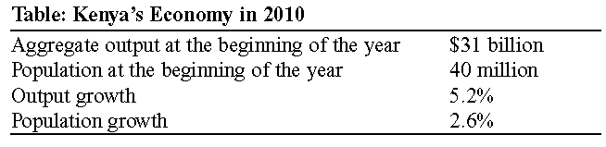

6. |  | (Table: Kenya's Economy in 2010) During 2010, and assuming no changes in the price level, aggregate output per capita in Kenya grew at a rate of:
A) | 5.2%.
B) | 0.6%.
C) | 7.8 %.
D) | 2.6%.

Use the following to answer question 7:

Table: Hypothetical Relationship
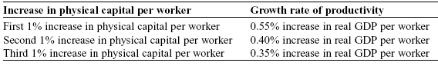

7. |  | (Table: Hypothetical Relationship) The accompanying table represents a hypothetical relationship between physical capital per worker and the growth rate of productivity. This economy is experiencing:
A) | decreasing total productivity.
B) | constant total productivity.
C) | diminishing returns to physical capital per worker.
D) | increasing returns to physical capital per worker.

8. |  | Diminishing returns to physical capital means that as more and more physical capital is combined with a fixed amount of human capital and a fixed technology, eventually:
A) | aggregate output or real GDP grows.
B) | additions to aggregate output or real GDP increase.
C) | aggregate output or real GDP declines.
D) | additions to aggregate output or real GDP decline.

9. |  | A shift away from taxing asset income and toward taxing consumption would lead to:
A) | a larger supply of loanable funds, a lower interest rate, and faster economic growth.
B) | a larger government budget deficit and slower economic growth.
C) | a smaller supply of loanable funds, a higher interest rate, and faster economic growth.
D) | a larger demand for loanable funds, a higher interest rate, and slower economic growth.

Use the following to answer question 10:

Figure: The Market for Loanable Funds III

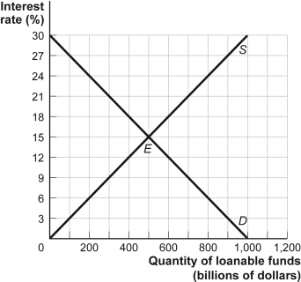

10. |  | (Figure: The Market for Loanable Funds III) If the government in a closed economy is running a budget balance of zero when it decides to increase defense spending by $200 billion and then finances the spending by selling bonds, the equilibrium interest rate will:
A) | rise to 16.5%.
B) | rise to 21%.
C) | fall to 12%.
D) | rise to 18%.

Answer Key

1. | B
2. | D
3. | D
4. | A
5. | C
6. | D
7. | C
8. | D
9. | A
10. | D

