ECON 2105 Quiz #5 Chapters 6-7

Name: __________________________ Date: _____________

1. | Aggregate demand will increase in all of the following cases except if:
 | A) | government purchases of goods rise.
 | B) | the quantity of money increases.
 | C) | interest rates increase.
 | D) | household wealth rises, but prices are constant.

2. | If the planned aggregate spending rises by $25 billion and the MPC is 0.8, then equilibrium GDP changes by:
 | A) | $200 billion.
 | B) | $25 billion.
 | C) | $250 billion.
 | D) | $125 billion.

Use the following to answer question 3:

Figure: The Aggregate Consumption Function and Planned Aggregate Spending

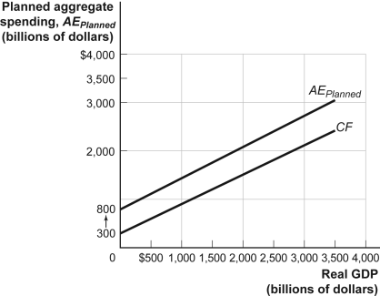

3. | (Figure: The Aggregate Consumption Function and Planned Aggregate Spending) If aggregate wealth decreases in this economy, then the:
 | A) | economy will move upward along the AE.
 | B) | economy will move downward along the AE.
 | C) | AE will shift down.
 | D) | AE will shift up.

4. | The short-run aggregate supply curve would shift to the left for all the following reasons EXCEPT:
 | A) | an increase in the price of commodities used for production.
 | B) | a decrease in productivity.
 | C) | an increase in nominal wages.
 | D) | an increase in interest rates.

Use the following to answer question 5:

Figure: Policy Alternatives

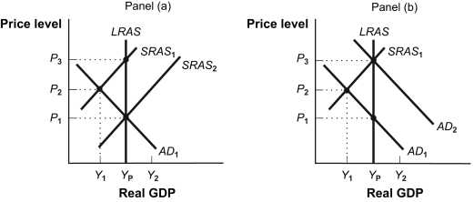

5. | (Figure: Policy Alternatives) Assume that the economy depicted in panel (a) is in short-run equilibrium with AD₁ and SRAS₁. If the economy is left to correct itself:
 | A) | long-run equilibrium will be established at Y_{P} and P₃.
 | B) | the aggregate demand curve will shift leftward.
 | C) | lower wages will result in a gradual shift from SRAS₁ to SRAS₂.
 | D) | real interest rates will fall which will shift SRAS rightward.

6. | If the economy is in a recessionary gap, then:
 | A) | AD will shift to the right and prices of goods will rise until the economy goes back to producing potential output.
 | B) | nominal wages will rise and SRAS will shift to the left and the economy will eventually restore itself.
 | C) | nominal wages will fall and SRAS will shift to the right until the economy is at full employment.
 | D) | the economy will remain in a recession forever without any kind of government intervention.

Use the following to answer question 7:

Figure: Aggregate Expenditures I

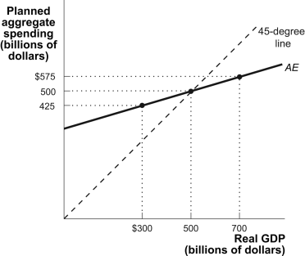

7. | (Figure: Aggregate Expenditures I) Refer to the figure Aggregate Expenditures I. When real GDP is $700 billion, there will be a:
 | A) | $200 million increase in unplanned inventory investment.
 | B) | $200 million decline in unplanned inventory investment.
 | C) | $125 million increase in unplanned inventory investment.
 | D) | $125 million decline in unplanned inventory investment.

8. | If real GDP is less than aggregate expenditure, then inventories will:
 | A) | increase, and firms will lower their product prices.
 | B) | fall, and firms will increase their future production.
 | C) | fall, and firms will increase the prices of their products.
 | D) | increase, and firms will cut back on future production.

9. | The Federal Reserve, the central bank of the United States, has been cutting the interest rate in order to stimulate the recessionary economy. Interest cuts by the Federal Reserve are supposed to:
 | A) | increase investment spending and thus increase GDP via the multiplier.
 | B) | increase cash holding by the general public thus lowering their dependence on credit.
 | C) | lower the savings rate in the economy and stop leakages.
 | D) | increase government spending on the economic infrastructure and thus increase GDP through the multiplier process.

10. | Suppose the economy is in a short-run equilibrium where the actual output is greater than potential output. The economy is in:
 | A) | an inflationary gap, prices of goods will increase and AD will shift to the right until the economy is in long-run equilibrium.
 | B) | an inflationary gap, nominal wages will increase and SRAS will shift to the left until the actual GDP is equal to the potential GDP in the long run.
 | C) | a recessionary gap, prices of goods will decrease and LRAS will shift to the left until the economy is in long-run equilibrium.
 | D) | a recessionary gap, nominal wages will decrease and AD will shift to the left until the actual GDP is equal to the potential GDP in the long run.

Answer Key

1. | C
2. | D
3. | C
4. | D
5. | C
6. | C
7. | C
8. | B
9. | A
10. | B

