ECON 2105 Exam #1 Chapters 2-3 VERSION A

Format: 25 Multiple Choice Questions
Resources Allowed: calculator (no cell phones); 4 pages of notes (2 sheets of paper, front and back only). Use of notes in excess of pages allowed will result in confiscation of exam and a grade of zero awarded.

Extra Credit Paper for Exam #1: Worth 7 points. Turn in with your completed exam. Will not be accepted late or by email

Name: __________________________ Date: _____________

1. | If tortilla chips are a normal good, what happens to equilibrium price and quantity when there is an increase in income?
 | A) | Equilibrium price increases and equilibrium quantity decreases.
 | B) | Equilibrium price increases and equilibrium quantity increases.
 | C) | Equilibrium price decreases and equilibrium quantity increases.
 | D) | Equilibrium price decreases and equilibrium quantity decreases.

2. | If goods A and Z are complements, an increase in the price of good Z will:
 | A) | decrease the demand for both good A and good Z.
 | B) | increase the demand for good A.
 | C) | decrease the demand for good A.
 | D) | decrease the demand for good Z.

3. | Suppose the input costs associated with manufacturing hair replacement treatments decreases over time. This would lead to:
 | A) | a decrease in quantity supplied and lower prices.
 | B) | an increase in demand and higher prices.
 | C) | a decrease in the supply of such treatments, higher prices, and a decrease in the equilibrium quantity.
 | D) | an increase in the supply of such treatments, lower prices, and an increase in the equilibrium quantity.

4. | Suppose Indiana produces only steel and corn, with fixed amounts of land, labor, and capital resources. Which of the following best creates potential economic growth?
 | A) | The Midwestern United States has a devastating drought.
 | B) | The United States imports more and more low-cost steel from Asian countries.
 | C) | The unemployment rate in Indiana rises from 5% to 6%.
 | D) | The percentage of Indiana residents with a college degree rises from 25% to 30%.

Use the following to answer question 5:

Figure: Demand for Coconuts

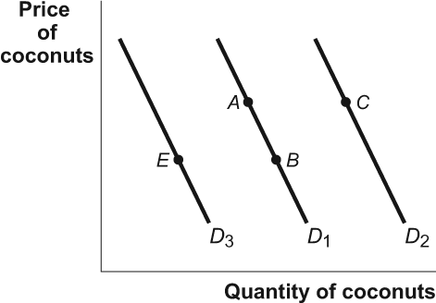

5. | (Figure: Demand for Coconuts) Look at the figure Demand for Coconuts. If fish is a substitute good for coconuts and the price of fish increases, it will be represented in the figure as a movement from:
 | A) | B to A.
 | B) | C to A.
 | C) | B to E.
 | D) | A to C.

Use the following to answer question 6:

Figure: Shifts in Demand and Supply III

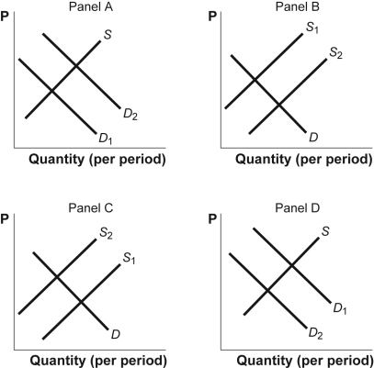

6. | (Figure: Shifts in Demand and Supply III) Look at the figure Shifts in Demand and Supply III. The figure shows how supply and demand might shift in response to specific events. Suppose a wet and sunny year increases the nation's corn crop by 20%. Which panel best describes how this will affect the market for corn?
 | A) | panel C
 | B) | panel A
 | C) | panel D
 | D) | panel B

7. | If the supply and demand curves intersect at a price of $47, then any price above that would result in:
 | A) | equilibrium.
 | B) | an increase in demand.
 | C) | a surplus.
 | D) | a shortage.

8. | You notice that the price of DVD players falls and the quantity of DVD players sold increases. This set of observations can be the result of the:
 | A) | supply of DVD players shifting to the left.
 | B) | demand for DVD players shifting to the right.
 | C) | demand for DVD players shifting to the left.
 | D) | supply of DVD players shifting to the right.

9. | A new wonder diet that results in a dramatic weight loss sweeps through America. The key to the diet is to eat unlimited amounts of red meat (beef) but no poultry or carbohydrate-rich foods. As millions of Americans switch to the new diet, we can expect:
 | A) | a decrease in the demand for poultry, leading to a shift to the left in the demand curve for poultry and lower poultry prices.
 | B) | a decrease in the supply of poultry, leading to a shift to the left in the supply curve for poultry and higher poultry prices.
 | C) | an increase in the supply of poultry, leading to a shift to the right in the supply curve for poultry and higher poultry prices.
 | D) | a decrease in the demand for poultry, leading to a shift to the right in the demand curve for poultry and lower beef prices.

Use the following to answer question 10:

Figure: Tom's Production Possibilities

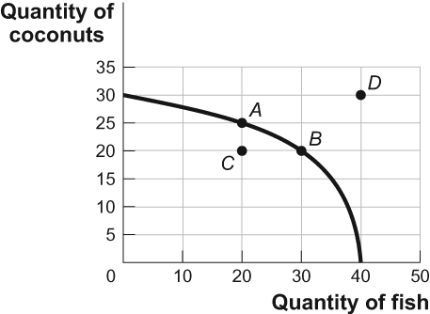

10. | (Figure: Tom's Production Possibilities) Look at the figure Tom's Production Possibilities. In the figure, the opportunity cost for Tom to move from point B on the curve to point A is:
 | A) | 10 fish.
 | B) | 5 coconuts.
 | C) | 5 fish.
 | D) | 10 coconuts.

11. | An increase in the demand for gasoline today caused by concerns that gasoline prices will be higher tomorrow is most likely attributable to which of the following?
 | A) | consumer expectations
 | B) | consumer preferences
 | C) | prices of other goods
 | D) | income

12. | The market for soybeans is initially in equilibrium. Because of mad cow disease, producers decide to replace bone meal with soybeans in cattle feed. The likely effect is that:
 | A) | the equilibrium price and quantity of soybeans will fall.
 | B) | the equilibrium price of soybeans will rise, but we can't determine what will happen to the equilibrium quantity.
 | C) | the equilibrium price and quantity of soybeans will rise.
 | D) | the equilibrium quantity of soybeans will rise, but we can't determine what will happen to the equilibrium price.

13. | A beneficial technological change enhances the production of cranberries. At the same time, scientists discover the health benefits of cranberries. This will result in:
 | A) | an increase in the equilibrium quantity and an uncertain impact on the equilibrium price of cranberries.
 | B) | a decrease in the equilibrium price and an uncertain impact on the equilibrium quantity of cranberries.
 | C) | an increase in both the equilibrium price and quantity in the cranberry market.
 | D) | a decrease in both the equilibrium price and quantity in the cranberry market.

14. | Gasoline, a derivative of oil, is a large part of transportation costs for many producers. If the price of oil increases at the same time that incomes fall for many consumers, one would expect the equilibrium price of many normal goods to ________, while their equilibrium quantities would ________.
 | A) | fall, rise, or stay the same; decrease
 | B) | decrease; fall, rise, or stay the same
 | C) | fall; fall
 | D) | fall; rise

15. | In one hour, the United States can produce 25 tons of steel or 250 automobiles. In one hour, Japan can produce 30 tons of steel or 275 automobiles. This information implies that:
 | A) | the United States has an absolute advantage in the production of steel.
 | B) | Japan has a comparative advantage in the production of both goods.
 | C) | the United States has a comparative advantage in the production of automobiles.
 | D) | Japan has a comparative advantage in the production of automobiles.

16. | In the local market for coffee, what would happen if Joyce's Java and Everyday Joe's coffee shops go out of business?
 | A) | The supply curve shifts to the left.
 | B) | The demand curve shifts to the right.
 | C) | The demand curve shifts to the left.
 | D) | The supply curve shifts to the right.

17. | If Farmer Sam MacDonald can produce 200 pounds of cabbages and no potatoes or no cabbages and 100 pounds of potatoes and if he faces a linear production possibility frontier for his farm, the opportunity cost of producing an additional pound of cabbage is ________ pound(s) of potatoes.
 | A) | 100
 | B) | 200
 | C) | 2
 | D) | 1/2

18. | In a single day, Sarah can produce 10 hamburgers while Abe can produce 5 hamburgers. We then know that:
 | A) | Abe has a comparative advantage in making hamburgers.
 | B) | Abe has an absolute advantage in making hamburgers.
 | C) | Sarah has an absolute advantage in making hamburgers.
 | D) | Sarah has a comparative advantage in making hamburgers.

19. | The effect of a tremendous natural disaster can be shown by:
 | A) | an outward shift of the production possibility frontier.
 | B) | an inward shift of the production possibility frontier.
 | C) | a point inside of the production possibility frontier.
 | D) | a movement from one point to another along the production possibility frontier.

Use the following to answer question 20:

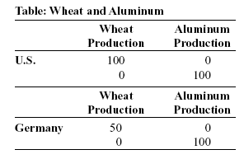

20. | (Table: Wheat and Aluminum) Look at the table Wheat and Aluminum. The United States and Germany can produce both wheat and aluminum. The table shows, in tonnage, the maximum annual output combinations of wheat and aluminum that can be produced. Which of the following choices would represent a possible trade based upon specialization and comparative advantage?
 | A) | The United States would trade 1 ton of wheat to Germany for 1.5 tons of aluminum.
 | B) | Germany would trade 2 tons of wheat to the United States for 1 ton of aluminum.
 | C) | Germany would trade 2 tons of aluminum to the United States for .5 tons of wheat.
 | D) | The United States would trade 1 ton of wheat to Germany for 1 ton of aluminum.

21. | If Brazil gives up 3 automobiles for each ton of coffee it produces, while Peru gives up 7 automobiles for each ton of coffee it produces, then:
 | A) | Brazil has a comparative advantage in coffee production and should specialize in coffee production.
 | B) | Brazil has a comparative advantage in automobile production and should specialize in coffee.
 | C) | Brazil has a comparative advantage in automobile production and should specialize in automobile production.
 | D) | Brazil has a comparative advantage in coffee production and should specialize in the production of automobiles.

22. | French fries and hamburgers are complements. Suppose the cost of the ingredients used to make hamburgers rises, so that the price of a hamburger rises. Then the equilibrium relative price of french fries ________ and the equilibrium quantity ________.
 | A) | falls; increases
 | B) | rises; increases
 | C) | falls; decreases
 | D) | rises; decreases

23. | Which of the following is likely to cause a rightward shift in the demand for home-delivered pizza?
 | A) | a larger population
 | B) | a lower price of pizza
 | C) | a lower price of fast-food hamburgers
 | D) | a higher price of pepperoni

Use the following to answer question 24:

Figure: Four Markets for DVDs

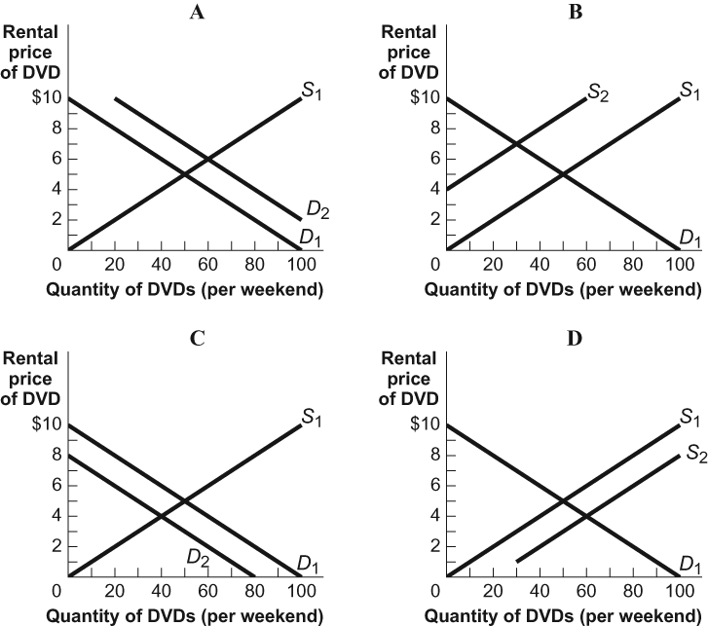

24. | (Figure: Four Markets for DVDs) Look at the figure Four Markets for DVDs. If D₁ or S₁ is the original curve and D₂ or S₂ is the new curve, which of the graphs shows what may happen if some of the stores that rent DVDs close?
 | A) | C
 | B) | A
 | C) | D
 | D) | B

25. | In Kessy's old kitchen, he could bake 10 cookies or mix 15 glasses of lemonade in one day. Now Kessy has a larger oven and refrigerator. How does this affect his production possibility frontier?
 | A) | He will not be able to produce as much as before.
 | B) | He will not be efficient.
 | C) | It shifts out his production possibility frontier.
 | D) | It shifts in his production possibility frontier.

Answer Key

1. | B
2. | C
3. | D
4. | D
5. | D
6. | D
7. | C
8. | D
9. | A
10. | A
11. | A
12. | C
13. | A
14. | A
15. | C
16. | A
17. | D
18. | C
19. | B
20. | A
21. | A
22. | C
23. | A
24. | D
25. | C

