ECON 2105 Exam #2 Chapters 4-5 VERSION A

Exam Format: 25 multiple-choice questions
Resources Allowed: calculator (no cell phones); 4 pages of notes [2 sheets of paper, front and back only]

Extra Credit Paper: Extra credit paper for exam#2 must be turned in at the time to the exam. No email submissions and no late submissions will be accepted.

Take Home Quiz #4: To be turned in with your completed exam#2. No email submissions and no late submissions will be accepted.

Name: __________________________ Date: _____________

Use the following to answer question 1:

Figure: The Market for Loanable Funds III

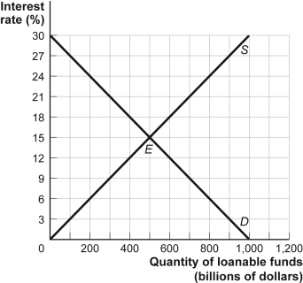

1. | (Figure: The Market for Loanable Funds III) If the government in a closed economy is running a budget balance of zero when it decides to increase defense spending by $200 billion and then finances the spending by selling bonds, the equilibrium interest rate will:
 | A) | rise to 21%.
 | B) | rise to 18%.
 | C) | fall to 12%.
 | D) | rise to 16.5%.

2. | If real GDP grows at an average rate of 3% per year, it will double in approximately _______ years.
 | A) | 20
 | B) | 36
 | C) | less than 10
 | D) | 23

3. | Which of the following will NOT increase the productivity of labor?
 | A) | an increase in the size of the labor force
 | B) | improvements in education
 | C) | technological improvements
 | D) | an increase in the capital stock

4. | Suppose that Mr. Green Jeans sells $5,000 of wheat to Big Ben Bakery. Big Ben uses the wheat to make flour and then hamburger buns, which it sells to Hamburger Heaven for $11,000. Hamburger Heaven also buys $20,000 of beef from a rancher. Hamburger Heaven uses the beef and buns to make 10,000 hamburgers, which are sold for $5 each. How much do these transactions add to GDP?
 | A) | $36,000
 | B) | $31,000
 | C) | $50,000
 | D) | $86,000

5. | Which one of the following transactions is included in a current year's GDP as investment spending?
 | A) | Maggie bought a play-gym set for her day-care business.
 | B) | ABC company purchased 10,000 shares of IBM stock.
 | C) | Ronnie bought a new BMW.
 | D) | Anton purchased his friend's condo.

Use the following to answer questions 6-9:

Scenario: Open Economy S = I
In an open economy the GDP is $12 trillion this year. Consumption is $8 trillion, and government spending is $2 trillion. Taxes are $0.5 trillion. Exports are $1 trillion, and imports are $3 trillion.

6. | (Scenario: Open Economy S = I) How much is private saving?
 | A) | $3.5 trillion
 | B) | $4 trillion
 | C) | $1.5 trillion
 | D) | $2.5 trillion

7. | (Scenario: Open Economy S = I) What is the government budget balance?
 | A) | a deficit of $0.5 trillion
 | B) | a surplus of $1.5 trillion
 | C) | a surplus of $3.5 trillion
 | D) | a deficit of $1.5 trillion

8. | (Scenario: Open Economy S = I) How much is national saving?
 | A) | $2 trillion
 | B) | $5.5 trillion
 | C) | $3.5 trillion
 | D) | $4 trillion

9. | (Scenario: Open Economy S = I) How much is the net capital inflow?
 | A) | $4 trillion
 | B) | $1 trillion
 | C) | $2 trillion
 | D) | $3 trillion

Use the following to answer questions 10-11:

Scenario: Price Index
Suppose that in the base period a college student buys 20 gallons of gasoline at $2 per gallon, 2 CDs for $13 each, and 4 movie tickets for $7 each. In the next month, the price of gasoline is $2.25 per gallon, CDs cost $12.50 each, and the price of a movie ticket is $7.50.

10. | (Scenario: Price Index) The change in prices from the first to the second month is:
 | A) | –6%.
 | B) | 7.6%.
 | C) | 94%.
 | D) | 6.4%.

11. | (Scenario: Price Index) The price index for the second month is:
 | A) | 106.4.
 | B) | impossible to determine without more information.
 | C) | 94.
 | D) | 100.

12. | If there is an increase in the government budget deficit:
 | A) | the supply of loanable funds will decrease, interest rates will increase, and the amount of borrowing will decrease.
 | B) | the demand for loanable funds will increase, interest rates will increase, and the amount of borrowing will increase.
 | C) | the demand for loanable funds will decrease, interest rates will decrease, and the amount of borrowing will decrease.
 | D) | the supply of loanable funds will increase, interest rates will decrease, and the amount of borrowing will increase.

Use the following to answer questions 13-14:

Figure: Technological Progress and Productivity Growth

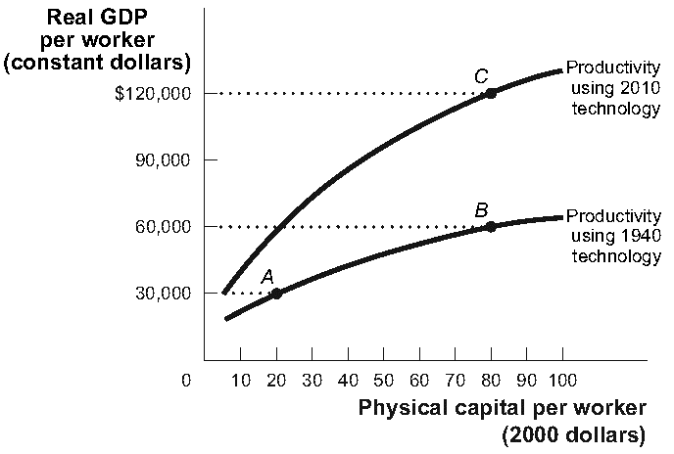

13. | (Figure: Technological Progress and Productivity Growth) If there is an increase in physical capital per worker (all other factors remaining unchanged), it would be best indicated by a move from:
 | A) | B to C.
 | B) | C to B.
 | C) | A to B.
 | D) | B to A.

14. | (Figure: Technological Progress and Productivity Growth) If there is a significant increase in human capital per worker (all other factors remaining unchanged), it would be best indicated by a move from:
 | A) | B to C.
 | B) | A to B.
 | C) | B to A.
 | D) | C to B.

15. | The value added is equal to:
 | A) | the sum of payments to labor and capital.
 | B) | the value of sales by a company.
 | C) | the value of sales minus the value of intermediate goods used by a company.
 | D) | the value of intermediate goods.

16. | In an open economy where government spending was $30 billion, consumption was $70 billion, taxes were $20 billion, and GDP was $100 billion this year, investment spending was $10 billion. As a result, there was:
 | A) | a net capital outflow of $10 billion.
 | B) | a trade surplus of $20 billion and a financial deficit of $20 billion.
 | C) | a net capital inflow of $10 billion.
 | D) | capital inflows of $10 billion and capital outflows of $20 billion.

17. | Crowding out negatively affects the economy by:
 | A) | decreasing consumption.
 | B) | reducing private investment spending on physical capital.
 | C) | decreasing government borrowing.
 | D) | increasing private borrowing.

Use the following to answer question 18:

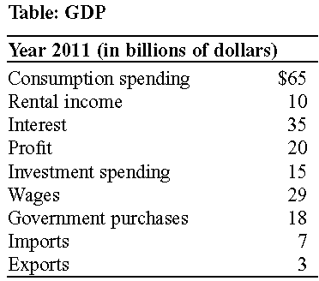

18. | (Table: GDP) GDP in the table is:
 | A) | $139 billion.
 | B) | $94 billion.
 | C) | $188 billion.
 | D) | $168 billion.

Use the following to answer question 19:

Figure: Circular-Flow Model

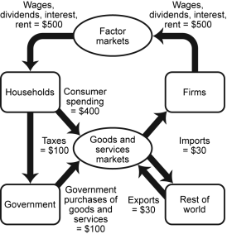

19. | (Figure: Circular-Flow Model) If the circular-flow model is in equilibrium (the sum of money flowing into each box is equal to the sum of the money flowing out of that box), which of the following is likely to happen if there is an increase in consumer spending?
 | A) | an increase in the unemployment rate
 | B) | a decrease in the inflation rate
 | C) | a decrease in the nominal GDP
 | D) | an increase in the nominal GDP

20. | Intermediate goods are not counted in the calculation of GDP because:
 | A) | these goods are not produced for the market.
 | B) | these goods are produced in the underground economy.
 | C) | these goods involve financial transactions.
 | D) | to do so involves double counting.

21. | One difference between a closed and an open economy is that:
 | A) | in the latter, the government is more open to the idea of financing investment spending than in the former.
 | B) | in the former, foreign savings finance more investment spending than in the latter.
 | C) | in the latter, foreign savings complement domestic savings in financing investment spending.
 | D) | in the former, foreign savings complement domestic savings in financing investment spending.

22. | A capital inflow into a country is associated with:
 | A) | a decreased source of funds available for domestic investment.
 | B) | imports equaling exports.
 | C) | imports less than exports
 | D) | imports exceeding exports.

23. | Diminishing returns to physical capital implies that when the human capital per worker and the state of technology remain fixed, each successive increase in physical capital leads to:
 | A) | a decrease in productivity.
 | B) | a smaller increase in productivity.
 | C) | negative productivity.
 | D) | a larger increase in productivity.

Use the following to answer questions 24-25:

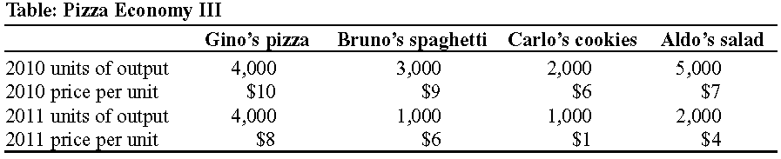

24. | (Table: Pizza Economy III) Considering 2010 as the base year, real GDP between 2010 and 2011 grew at a rate of:
 | A) | –39.47%.
 | B) | 53.19%.
 | C) | –58.67%.
 | D) | 39.47%.

25. | (Table: Pizza Economy III) Considering 2010 as the base year, given that total population was 1,140 in 2010 and 1,380 in 2011, real GDP per capita between 2010 and 2011 grew at a rate of:
 | A) | 50%.
 | B) | –50%.
 | C) | 75%.
 | D) | –25%.

Answer Key

1. | B
2. | D
3. | A
4. | C
5. | A
6. | A
7. | D
8. | A
9. | C
10. | D
11. | A
12. | B
13. | C
14. | A
15. | C
16. | C
17. | B
18. | B
19. | D
20. | D
21. | C
22. | D
23. | B
24. | A
25. | B

