ECON 2105 Quiz #2 Chapter 3 "Supply and Demand"

Name: __________________________ Date: _____________

Use the following to answer question 1:

Figure: Demand and Supply of Gasoline

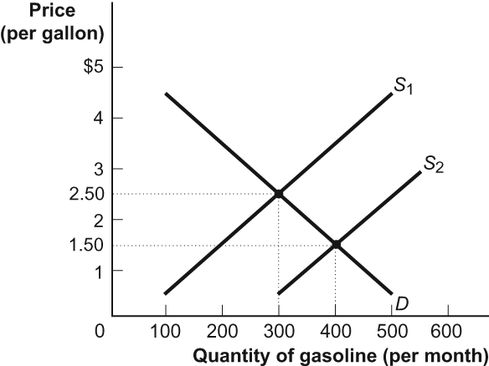

1. | (Figure: Demand and Supply of Gasoline) Look at the figure Demand and Supply of Gasoline. When the supply curve shifted from the initial equilibrium, the new intersection of supply and demand has a price of ________ and quantity of 400. This supply shift could have resulted from ________.
 | A) | $2.00; an increase in consumers' income
 | B) | $2.00; an increase in the number of buyers
 | C) | $1.50; an increase in consumers' income
 | D) | $1.50; an increase in refining technology

2. | Consider the market for iPods. What happens if a fantastic new alternative MP3 player is developed and at the same time a boat carrying a large shipment of iPods is attacked by pirates and sunk?
 | A) | Price increases and the change in quantity is indeterminate.
 | B) | Price decreases and quantity increases.
 | C) | Price increases and quantity increases.
 | D) | The change in price is indeterminate and quantity decreases.

3. | Suppose you manage a corner grocery store. If peanut butter is an inferior good, what do you suppose would happen to the price and quantity sold of peanut butter as incomes fall during an economic recession?
 | A) | The price and quantity would both decrease.
 | B) | The price would increase and the quantity would decrease.
 | C) | The price would decrease and the quantity would increase.
 | D) | The price and quantity would both increase.

4. | Consider the supply curve for cotton shirts. An increase in the price of cotton will:
 | A) | decrease the supply of cotton shirts.
 | B) | increase the quantity supplied of cotton shirts.
 | C) | decrease the demand for cotton shirts.
 | D) | increase the supply of cotton shirts.

Use the following to answer question 5:

Figure: Demand for DVDs

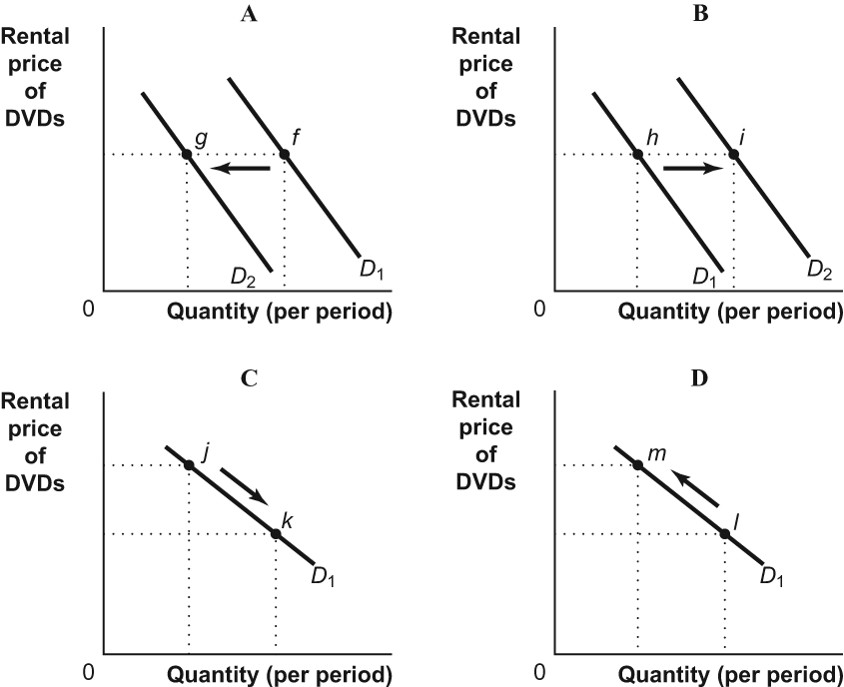

5. | (Figure: Demand for DVDs) Look at the figure Demand for DVDs. A decrease in the price of DVD players (a complement) would result in a change illustrated by:
 | A) | the move from h to i in panel B.
 | B) | the move from j to k in panel C.
 | C) | the move from l to m in panel D.
 | D) | the move from f to g in panel A.

6. | A decrease in supply, with no change in demand, will lead to ________ in equilibrium quantity and ________ in equilibrium price.
 | A) | an increase; a decrease
 | B) | a decrease; a decrease
 | C) | an increase; an increase
 | D) | a decrease; an increase

Use the following to answer question 7:

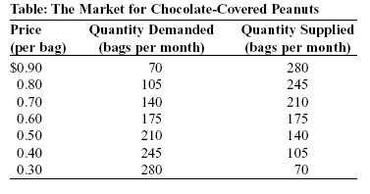

7. | (Table: The Market for Chocolate-Covered Peanuts) Look at the table The Market for Chocolate-Covered Peanuts. A shortage of 210 bags of chocolate-covered peanuts exists if the price is ________ per bag.
 | A) | $0.40
 | B) | $0.30
 | C) | $0.60
 | D) | $0.80

Use the following to answer question 8:

Figure: The Demand and Supply of Wheat

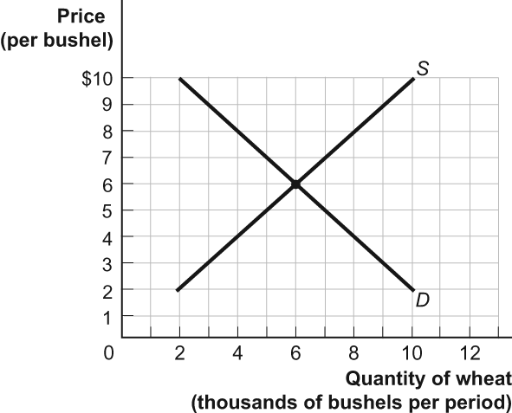

8. | (Figure: The Demand and Supply of Wheat) Look at the figure The Demand and Supply of Wheat. If there were a decrease in supply of 2,000 bushels at each price, the equilibrium price and quantity would be ________ and ________ bushels, respectively.
 | A) | $6; 4,000
 | B) | $8; 6,000
 | C) | $7; 5,000
 | D) | $5; 5,000

9. | Raclette is a popular wintertime dish in Switzerland. It is essentially melted Raclette cheese over boiled new potatoes. If the price of Raclette cheese decreased, we would expect to see:
 | A) | no effect on the demand for either of the Raclette ingredients, since this is a traditional dish and its consumption does not depend on the prices of the ingredients.
 | B) | an increase in demand for Raclette cheese.
 | C) | an increase in demand for Raclette cheese and for new potatoes.
 | D) | an increase in demand for new potatoes.

Use the following to answer question 10:

Figure: Shifts in Demand and Supply II

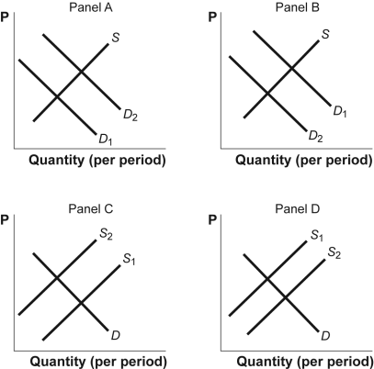

10. | (Figure: Shifts in Demand and Supply II) Look at the figure Shifts in Demand and Supply II. The figure shows how supply and demand might shift in response to specific events. Suppose the birth rate (the number of babies per woman of childbearing age) decreases. Which panel best describes how this will affect the market for diapers?
 | A) | panel D
 | B) | panel A
 | C) | panel B
 | D) | panel C

Answer Key

1. | D
2. | D
3. | D
4. | A
5. | A
6. | D
7. | B
8. | C
9. | D
10. | C

