ECON 2105 Exam #3 Chapters 6-8 VERSION A

Date: April 15, 2015
Format:: 25 Multiple-Choice Questions/Problems

Resources Allowed: calculator (no cell phones allowed); 4 pages of notes (2 sheets of paper, front and back only)

Extra Credit Paper for Exam#3: Must be turned in at the end of the exam with your scantron. Will not be accepted late or by email.

Name: __________________________ Date: _____________

1. | Falling inventories indicate ______ unplanned inventory investment and a ______ economy.
 | A) | negative; slowing
 | B) | positive; growing
 | C) | negative; growing
 | D) | positive; slowing

2. | Suppose that political instability in the Middle East temporarily interrupts the supply of oil to the United States. Which of the following is most likely to occur?
 | A) | The aggregate demand curve shifts left, output decreases, and prices decrease.
 | B) | The short-run aggregate supply curve shifts right, output increases, and prices decrease.
 | C) | The aggregate demand curve shifts right, output increases, and prices increase.
 | D) | The short-run aggregate supply curve shifts left, output decreases, and prices increase.

Use the following to answer question 3:

Figure: Inflationary and Recessionary Gaps

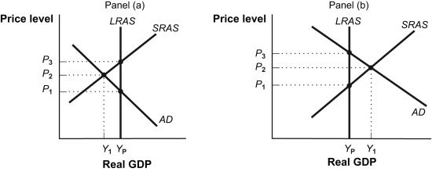

3. | (Figure: Inflationary and Recessionary Gaps) If the economy is in short-run equilibrium at Y₁ in panel (b), a contractionary policy to bring the economy back to potential output at Y_{P} would attempt to
 | A) | shift the LRAS to the left
 | B) | shift the aggregate demand curve to the left by decreasing aggregate demand.
 | C) | shift the aggregate demand curve to the right by increasing aggregate demand.
 | D) | shift the SRAS to the left

4. | Suppose the banking system does NOT hold excess reserves and the reserve ratio is 20%. If Sam deposits $500 cash into his checking account, the banking system can increase the money supply by:
 | A) | $2,500.
 | B) | $400.
 | C) | $2,000.
 | D) | $5,000.

5. | If the currency in circulation is $100 million, checkable bank deposits are $500, savings deposits are $300 million, and travelers' checks are $10 million, then the M1 money supply is:
 | A) | $410 million.
 | B) | $900 million.
 | C) | $100 million.
 | D) | $610 million.

6. | Rising inventories typically indicate _______ unplanned inventory investment and a _________ economy.
 | A) | negative; slowing
 | B) | positive; expanding
 | C) | negative; expanding
 | D) | positive; slowing

7. | If the MPS is 0.1, then the tax multiplier is:
 | A) | more than 10.
 | B) | less than 10.
 | C) | exactly 10.
 | D) | exactly 0.1.

Use the following to answer questions 8-9:

Figure: AD–AS Model I

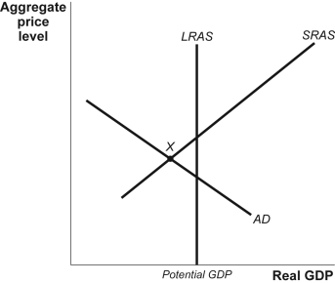

8. | (Figure: AD–AS Model I) If the economy is at point X, the appropriate fiscal policy is to:
 | A) | decrease the money supply and interest rates.
 | B) | increase taxes and decrease government spending.
 | C) | decrease taxes and increase government spending.
 | D) | increase the money supply and interest rates.

9. | (Figure: AD–AS Model I) If the economy is at point X, the appropriate monetary policy is to:
 | A) | increase the money supply and decrease interest rates.
 | B) | decrease the money supply and increase interest rates.
 | C) | decrease taxes and increase government spending.
 | D) | increase taxes and decrease government spending.

Use the following to answer question 10:

Figure: Changes in the Money Supply

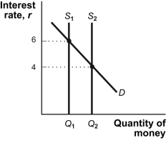

10. | (Figure: Changes in the Money Supply) Refer to the information in the figure Changes in the Money Supply. If the supply of money shifts from S₁ to S₂, the Federal Reserve must have _______ bonds in the open market.
 | A) | issued new
 | B) | sold
 | C) | borrowed
 | D) | bought

11. | According to the wealth effect, when prices decrease, the purchasing power of assets:
 | A) | decreases and consumer spending increases.
 | B) | decreases and consumer spending decreases.
 | C) | increases and consumer spending increases.
 | D) | increases and consumer spending decreases.

Use the following to answer question 12:

Figure: Aggregate Expenditures and Real GDP

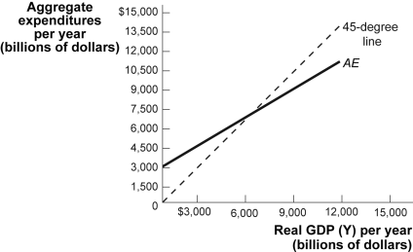

12. | (Figure: Aggregate Expenditures and Real GDP) At a real GDP of $9,000 billion:
 | A) | there will be no unplanned investment.
 | B) | planned investment is less than investment.
 | C) | planned investment equals investment.
 | D) | planned investment is greater than investment.

13. | Which of the following will shift the short-run aggregate supply curve to the right?
 | A) | a decrease in government purchases of goods and services
 | B) | an economy-wide decrease in commodity prices
 | C) | an increase in nominal wages
 | D) | a decrease in productivity

Use the following to answer question 14:

Figure: Policy Alternatives

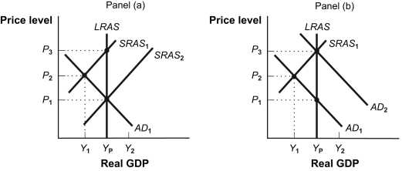

14. | (Figure: Policy Alternatives) If the economy is in equilibrium at Y₁ in panel (a) and the government increases government spending, the result will likely be
 | A) | deflation.
 | B) | inflation.
 | C) | an increase in unemployment.
 | D) | a decrease in interest rates.

15. | If other things are equal, expectations of lower disposable income in the future would ________ and shift the consumption function _________.
 | A) | decrease autonomous consumption; down
 | B) | increase the marginal propensity to consume; up
 | C) | decrease the marginal propensity to consume; down
 | D) | increase autonomous consumption; up

Use the following to answer question 16:

Figure: Fiscal Policy I

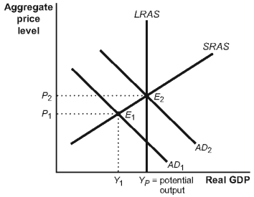

16. | (Figure: Fiscal Policy I) Suppose that this economy is in equilibrium at E₁. If there is a decrease in taxes, then:
 | A) | AD₁ will shift to the right, causing an increase in the price level and an increase in real GDP.
 | B) | AD₁ will shift to the right, causing a decrease in the price level and an increase in real GDP.
 | C) | AD₂ will shift to the left, causing a decrease in the price level and a decrease in the real GDP.
 | D) | AD₂ will shift to the left, causing an increase in the price level and a decrease in real GDP.

17. | In the long run, inflationary and recessionary gaps are self-correcting because, eventually:
 | A) | nominal wages rise in order to close a recessionary gap and fall to close an inflationary gap.
 | B) | nominal wages rise in order to close an inflationary or fall in order to close a recessionary gap.
 | C) | the government applies the right combination of fiscal and monetary policies.
 | D) | the multiplier compensates the negative supply or demand shocks.

Use the following to answer question 18:

Figure: Monetary Policy and the AD–SRAS Model

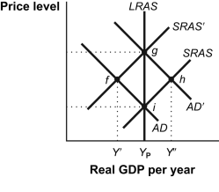

18. | (Figure: Monetary Policy and the AD–SRAS Model) Refer to the information in the figure Monetary Policy and the AD–SRAS Model. If the economy is in a recessionary gap at point f, it could move to point g as a result of:
 | A) | an increase in the money supply.
 | B) | selling government securities in the open market.
 | C) | raising the discount rate.
 | D) | a decrease in the money supply.

19. | Suppose that consumer expectations about the future improve. How will this affect the aggregate demand curve?
 | A) | The aggregate demand curve shifts to the right.
 | B) | There will be a movement downward along the fixed aggregate demand curve.
 | C) | There will be a movement upward along the fixed aggregate demand curve.
 | D) | The aggregate demand curve shifts to the left.

Use the following to answer question 20:

Figure: The Multiplier

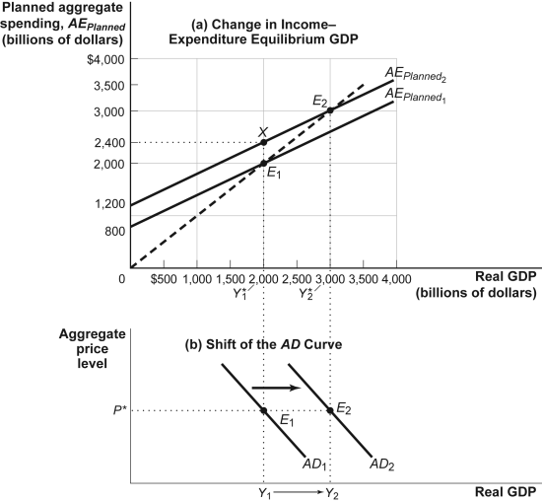

20. | (Figure: The Multiplier) If this economy is currently at Y₁ and investment spending increases, then:
 | A) | an upward movement along the AD₁ will take place, reflecting an increase in the price level.
 | B) | a downward movement along the AD₁ will take place, reflecting a decrease in the price level.
 | C) | AD₁ will shift to the right, reflecting a multiplied increase in the real GDP at every price level.
 | D) | AD₁ will shift to the left, reflecting a multiplied decrease in the real GDP at every price level.

Use the following to answer question 21:

Figure: Consumption Functions

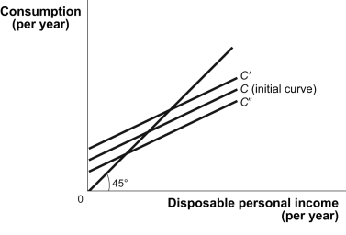

21. | (Figure: Consumption Functions) An economy's consumption function would shift from curve C to curve Cʹ when there is a(n):
 | A) | increase in expected future GDP growth estimates.
 | B) | drop in wealth.
 | C) | increase in the unemployment rate.
 | D) | increase in expected future disposable income.

Use the following to answer question 22:

Scenario: Consumption Spending
Suppose that the consumption function is: C = $500 + 0.8 × YD, where YD is disposable income.

22. | (Scenario: Consumption Spending) If income increases by $2,000, consumption will increase by:
 | A) | $400.
 | B) | $1,600.
 | C) | $500.
 | D) | $2,000.

23. | A recessionary gap can be closed by _______ wages that shift the _______.
 | A) | falling; LRAS curve to the right
 | B) | falling; SRAS curve leftward
 | C) | rising; SRAS curve rightward
 | D) | falling; SRAS curve rightward

Use the following to answer question 24:

Figure: Policy Alternatives

24. | (Figure: Policy Alternatives) Assume that the economy depicted in panel (a) is in short-run equilibrium at a real GDP level of Y₁. Doing nothing and letting the economy correct itself:
 | A) | occurs in the long run when wages fall.
 | B) | occurs in the short run as wages rise.
 | C) | occurs because the aggregate demand curve shifts.
 | D) | is called fiscal policy.

25. | Suppose that a financial crisis decreases investment spending by $100 billion and the marginal propensity to consume is 0.8. Assuming no taxes and no trade, by how much will real GDP change?
 | A) | $800 billion decrease
 | B) | $500 billion decrease
 | C) | $400 billion increase
 | D) | $200 billion decrease

Answer Key

1. | C
2. | D
3. | B
4. | C
5. | D
6. | D
7. | B
8. | C
9. | A
10. | D
11. | C
12. | B
13. | B
14. | B
15. | A
16. | A
17. | B
18. | A
19. | A
20. | C
21. | D
22. | B
23. | D
24. | A
25. | B

