MGT 4058
Database Management
Instructor: Dr. Han Zhang

Sample Exam #1 Answer Key

1. Please circle True or False according to the following statements (4 points each, 32 points total)

Note: if the correct answer is False, and you choose “False”, but your explanation about “False” is wrong, you only get 2 point for this question.

  - A super key must be a candidate key in a table of a relational database.

True False√

If you choose “False”, please explain why it is “False” in the following part.

A super key is not necessarily a candidate key. A candidate key must be a super key.

  - The three-schema architecture for database development is: conceptual schema, external schema and logical schema.
True False √

If you choose “False”, please explain why it is “False” in the following part.

Logical schema should be internal schema.

  - A secondary key is an attribute (or combination of attributes) used strictly for date retrieval purposes. A secondary key does not necessarily yield a unique outcome
True√ False

If you choose “False”, please explain why it is “False” in the following part.

  - In RDBMS terminology, relations and relationships are exactly same. We can use them interchangeably.
True False√

If you choose “False”, please explain why it is “False” in the following part.

In RDBMS terminology, relations are collection of attributes about a single subject such as students, orders, customers, etc. Relationships are linkage or logical way that data in one table is related to data in another table.

  - Entity integrity rule states that no primary key attributes (or component of primary key attributes) can be null.

True√ False

If you choose “False”, please explain why it is “False” in the following part.

  - Can this E-R diagram correctly represent the following case? If yes, select True; if no, select False.
True False√
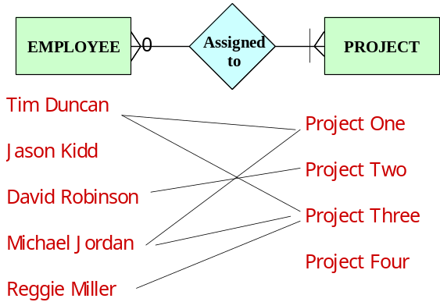
If you choose “False”, please explain why it is “False” in the following part.

According to the ER diagram, each employee must be assigned to at least one project, but Jason Kidd is not assigned to any project in this case.

  - Please examine the following Enhanced E-R diagram. If this diagram is correct, please choose True; if incorrect, choose False.
True False √
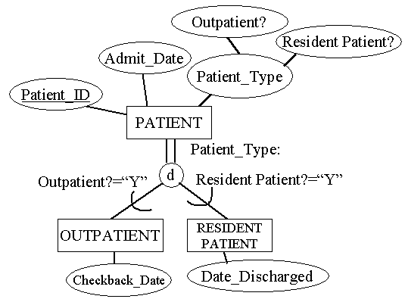
If you choose “False”, please explain why it is “False” in the following part.

This ER diagram uses disjoint rule, but uses overlap subtype discriminator.

  - The degree of a relationship describes the number of instances of one entity associated with another entity.
True False√
If you choose “False”, please explain why it is “False” in the following part.

The cardinality of a relationship describes the number of instances of one entity associated with another entity.

- Multiple choices (5 points each, 10 points total)

The following questions may have more than one right answer. Please mark all the right answers. If you select a wrong answer, each wrong answer will lead to two points deduction.

2.1 The completeness constraint in supertype/subtype relationships has the following possible rules:

__________Overlap Rule
___√_______Partial Specialization Rule
___ √______Total Specialization Rule
__________Disjoint Rule

2.2 Please select the right statement(s) about primary key in a relational database:

____√___ At any time, no two rows of the same table have the same value for the primary key
________ A primary key must be a simple attribute.
___√____ If a primary key is a composite attribute, no component of the composite attribute can be eliminated. Otherwise, the primary key cannot uniquely identify each row in a table.
____√___ A primary key attribute (column) is not allowed to accept null value.
________ A primary key is not necessarily a candidate key.

- Please answer questions according to the following E-R diagram and tables regarding two entities: ADVISER and STUDENT (20 points).

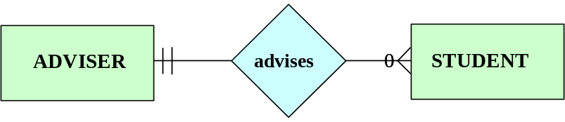

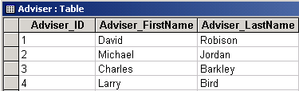

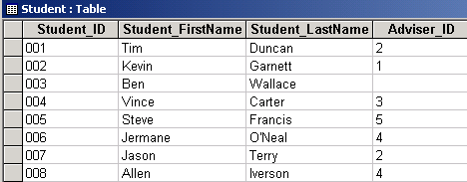

Questions:
  - According to the E-R diagram, can one student be advised by two advisers? (1 points) Can one adviser advise two students? (1 points) Why? (2 points)

No. one student cannot have two advisers. Because according to the E-R diagram, one student can have one and only one adviser.
Yes. One adviser can advise two students. Because according to the E-R diagram, one adviser can advise none student or many students.

  - Please explain the two entities’ participation (mandatory or optional?) in the relationship. (2 points) Why? (2 points)

ADVISER entity is mandatory because the minimum cardinality of ADVISER for a student is 1. In other words, each student must have one and only one adviser, therefore, the participation of ADVISER in this relationship is mandatory

STUDENT entity is optional because the minimum cardinality of STUDENT for an adviser is 0. In other words, not every adviser will have a student, therefore, the participation of STUDENT in this relationship is optional.

3.3 Assume Adviser_ID is the primary key of the ADVISER table and Student_ID is the primary key of the STUDENT table. Also, assume there are only 4 unique advisers in the ADVISER table. Please concentrate on the foreign key of the STUDENT table and find all the problem(s) with that table (6 points), and also answer the reason(s) for the problem(s) (6 points).

Two problems:
First, Student 003 does not have an adviser. According to the E-R diagram, everyone student must have one and only one adviser.

Second, student 005 has an adviser whose Adviser_ID is 5, but this Adviser_ID does not exist in the ADVISER table. This violates referential integrity.

- Please design an E-R diagram according to the following description. (38 points)

In one big business corporation, employee can be separated into exactly two types: Management Employee and Union Employee. Management employee has the following attributes: employee ID, first name, last name, date of birth, skill(s), age, position and language(s) he/she can speak. Union employee has the following attributes: employee ID, first name, last name, date of birth, skill(s), age and working unit.

Management employees supervise union employees.

Union employees work in work centers. Work centers have center ID, and center name. A union employee may have different work schedules in different work centers.

Business rule: an employee cannot be management employee and union employee at the same time. A management employee supervises at least one union employee or many employees, but one union employee is supervised by one and only one management employee. A union employee works in at least one work center or works in many work centers. A work center may not have a single union employee or may have many union employees.

Note: when you draw the E-R diagram, please consider using the subtype discriminator if you consider using supertype/subtype relationship. Please ignore associative entity (if any).

