MGT 4058
Database Management
Instructor: Dr. Han Zhang

Sample Exam #3

Answer Key

Please be aware that this sample exam only covers SQL. However, in your final exam, Data warehousing will be also covered. SQL will be the major part of the final exam.

You will need the following two tables to answer the True/False questions in the exam: NBAPlayer table and TimeSheets table. NBAPlayer table stores data about NBA Players’ basic information such as player ID (PID), name, salary per hour (PerHour), city, state, agent’s code (AgentCode) and job title (JobTitle). TimeSheets table stores players’ working information such as when the player worked (DateWorked), How long the player worked (HoursWorked) and player’s ID (PID).

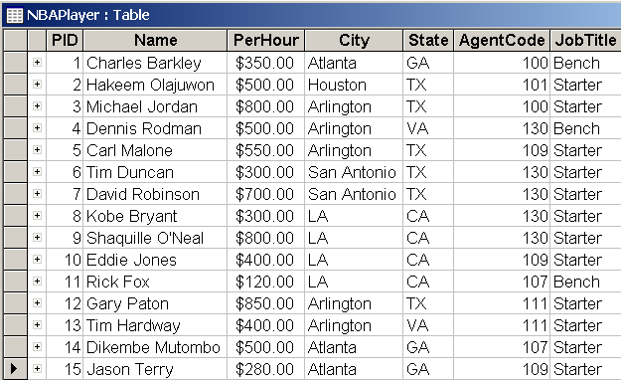

Data type in NBAPlayer table:
PID: Number, Name: Text, PerHour: Currency, City: Text, State: Text, AgentCode: Number, JobTitle: Text

PID is the Primary key for NBAPlayer table.

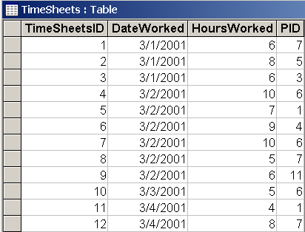

Data Type for TimeSheets table:
TimeSheetsID: Number, DateWorked: Date/Time, HoursWorked: Number, PID: Number

TimeSheetsID is the primary key for the TimeSheets table

Notes: NBAPlayer table and TimeSheets table all have a lot of data. Please don’t think NBAPlayer table only has 15 records, and TimeSheets only has 12 records. They may have hundreds or thousands of record.
1. Please circle True or False according to the following statements (5 points each, 20 points total)

  - In SQL, only the SELECT, FROM and WHERE clauses are mandatory for the basic SELECT statement.
True False √
Correct Answer: In SQL, only the SELECT and FROM clauses are mandatory for the basic SELECT statement.

  - One student is asked to write SQL to solve the following question:
“Please list PID and average HoursWorked for those PIDs whose average HoursWorked is greater than 5 in the TimeSheets table.”
His/her answer is the following. Is this True or False?

SELECT PID, AVG(HoursWorked)
FROM TimeSheets
Where AVG(HoursWorked)>5
GROUP BY PID;

True False√
Correct: SELECT PID, AVG(HoursWorked)
FROM TimeSheets
GROUP BY PID
HAVING AVG(HoursWorked)>5;

  - One student is asked to write SQL to solve the following question:
“How many Sdate (sales date) have been recorded for the Employee whose EID is 5 in the sales table?”
Suppose the following table is the Sales table, and we have exactly 6 records in the table. SID is the primary key, and other three columns are allowed to have null value. Also, EID’s data type is number.
His/her answer is the following. Is it True or False?

SELECT Count(*)
FROM Sales
WHERE EID=5;

True False√
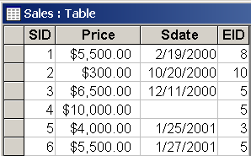

Correct Answer:
SELECT Count(Sdate)
FROM Sales
WHERE EID=5;

1.4 One student is asked to write SQL to solve the following question: What is the average of PerHour for NBA players who are playing for each unique city (unique city means same city and same state). The results do not have to show city name and state name. His/her answer is the following. Is it True or False?

SELECT Avg(PerHour)
FROM NBAPlayer
GROUP BY City, State;
True√ False

2. SQL

The YellowJacket Computing Inc., uses several database systems to conduct its computer hardware and software business operations. The following example is a subset of one of the database systems. Prices in Product table reflect the current prices for products. The Transaction table (relation) keeps track of each customer's purchase and return history by storing product number, quantity, and the grand total he/she paid. (This database is available on the class website. The name of the database is SQL Assignment Database.)

Customer (CustSSN: Text (11), CustName: Text (20), Job: Text (20), Age: Number, Zip: Text (5))
Product (ProductID: Text (9), ProdName: Text (20), Quantity: Number, Price: Currency)
Transaction (TransNumber: AutoNumber, ProductID: Text (9), CustSSN: Text (11), TransDate: Date/Time, TransQty: Number, GrandTotal: Currency)

Sample data of Customer table
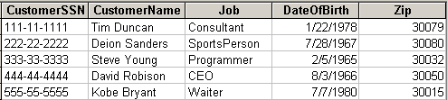

Sample data of Product table
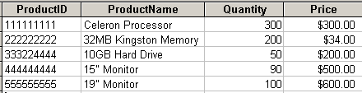
Note: Price means unit price for each product

Sample data of Transaction table
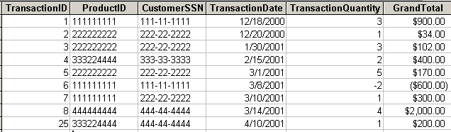

Notes: The above three tables have a lot of data. What you see here is only part of the data.

2. Please write SQL to finish the following questions (80 points):

  - List all the customers’ SSN, name, job, date of birth and zip code for those customers whose jobs are consultant or programmer (5 points).

SELECT * FROM customer
Where job='consultant' or job='programmer';

  - Please modify Tim Duncan’s job title from consultant to NBA Superstar, and zip code from 30079 to 30032 (5 points).

UPDATE customer SET job = 'NBASuperStar', zip=30032 WHERE CustomerSSN='111-11-1111';

  - List TransactionID, CustomerSSN and TransactionDate for transactions with GrandTotal between $500 and $2000 (including $500 and $2000). (5 points).

SELECT TransactionID, CustomerSSN, TransactionDate FROM Transaction WHERE GrandTotal >=500 and GrandTotal <=2000;

  - Please list the total number of transactions for the customer whose customer SSN is 222-22-2222. (6 points).

Select count(*)
From Transaction
Where CustomerSSN='222-22-2222';

Or

Select customerssn, count(*)
From Transaction
Where CustomerSSN='222-22-2222'
group by customerssn;

The following is wrong:

Select customerssn, count(*)
From Transaction
Where CustomerSSN='222-22-2222';

  - David Robinson bought one new 19” monitor (Product ID: 555555555) on 4/20/2003. Please add this new transaction in the database (9 points).

INSERT INTO transaction (productid, customerssn, transactiondate, TransactionQuantity, GrandTotal )
VALUES("555555555", "444-44-4444", "4/20/2003", 1, 600);

  - List the customer name, average product quantity and average purchase amount (grand total) for each customer who has made at least two transactions in year 2001 (not including refunds). (Notes: each unique TransactionID represents one transaction) (10 points).

SELECT CustomerName, Avg(TransactionQuantity) AS AvgOfTransQty, Avg(GrandTotal) AS AvgOfGrandTotal FROM Customer, Transaction WHERE Customer.CustomerSSN=Transaction.CustomerSSN and GrandTotal > 0 and year(TransactionDate)=2001 GROUP BY CustomerName having count(*)>=2;

  - List customer SSN, name, job title, and zip code for the customers who have made no transaction at all in year 2000 (10 points).

SELECT customerSSN, Customername, job, zip FROM customer WHERE CustomerSSN not in (SELECT CustomerSSN FROM Transaction WHERE year(TransactionDate)=2000);

The following code is wrong. For example, if some customers didn’t do any transaction, then the customer will not show up in the query result.

SELECT distinct Customer.customerSSN, Customername, job, zip FROM customer, transaction WHERE customer.CustomerSSN=transaction.customerssn and year(transactiondate)<>2000;

  - List all transaction dates, product names, and prices for all transactions conducted in March 2001 (Please excluding transactions processed refunds) (10 points).

SELECT TransactionDate, ProductName, Price FROM Transaction, Product WHERE Transaction.ProductID=Product.ProductID and GrandTotal > 0 and year(TransactionDate)=2001 and month(TransactionDate)=3;

  - Please list the unique customer name and SSN for the customers who made transactions in either year 2000 or year 2001. The results should be demonstrated according to customer name in a descending order (10 points).

SELECT distinct customername, customerssn
FROM Customer
Where customerssn in (select customerssn from transaction where year(transactiondate)=2000 or year(transactiondate)=2001)
order by customername desc;

or:

SELECT distinct customername, customer.customerssn
FROM Customer, transaction
Where customer.customerssn=transaction.customerssn and (year(transactiondate)=2000 or year(transactiondate)=2001)
order by customername desc;

  - Please write SQL statement to find which customer paid the highest GrandTotal for a single transaction (please note that one TransactionID represents one transaction) (10 points).

SELECT CustomerName
FROM Customer, Transaction
WHERE Customer.CustomerSSN=transaction.customerssn and grandtotal=(SELECT Max(Grandtotal) from Transaction);

OR

SELECT CustomerName
FROM Customer
Where customer.customerssn in (select customerssn from transaction where grandtotal in (SELECT Max(Grandtotal) from Transaction));

