**Chapter 11**

1. Select the equilibrium expression for the reaction:

P4(s) + 3KOH(aq) + 3 H2O(l) <-----> PH3(aq) + 3KH2PO2 (aq)

Ans: E



2. The value of *K* for the reaction N2O4(g) <-----> 2NO2(g) at a given temperature is 0.211. If the equilibrium partial pressure of NO2 at the same temperature is 0.0172 bar, then what is the equilibrium concentration of N2O4?

A) 0.0815

B) 0.00664

C) 0.00140

D) 6.24×10–5

E) 0.0602

3. For which reaction does *K* = *Kc* (at the same temperatures)?

A) C(s) + CO2(g) <-----> 2 CO(g)

B) 2 SO2(g) + O2(g) <-----> 2 SO3(g)

C) 2 BrCl(g) <-----> Br2(g) + Cl2(g)

D) N2(g) + 3H2(g) <-----> 2 NH3(g)

E) N2O4(g) <-----> 2NO2(g)

4. Calculate *K* for the reaction 2 SO2(g) + O2(g) <-----> 2 SO3(g) given the information below.

SO3(g) <-----> ½ O2(g) + SO2(g) *K* = 4.0×10–13

A) 4.0 x 1024

B) 5.0 x 1012

C) 2.5 x 1012

D) 1.6 x 106

E) 6.3 x 1024

5. A mixture of 19.8 bar H2 and 12.8 bar Br2 was placed in a vessel at 700. K. At equilibrium, the vessel is found to contain 8.2 bar H2. What is *K* for the reaction?

H2(g) + Br2(g) <-----> 2 HBr(g)

A) 55

B) 14

C) 12

D) 1.2

E) 0.018

6. If *G*rxn° = 27.1 kJ/mol at 25C for the dissociation of acetic acid (CH3COOH) in aqueous solution, then which statement is *true*?

CH3COO(aq) + H2O(l) <-----> CH3COO–(aq) + H3O+(aq)

A) At equilibrium, the concentration of products and reactants will be the same.

B) At equilibrium, the concentration of products will be greater than that of reactants.

C) At equilibrium, the concentration of products will be less than that of reactants.

D) The reaction can never be in equilibrium.

E) Because acetic acid is a weak acid, it doesn't generate H3O+ in water.

7. What is the equilibrium partial pressure of CO(g) if 4.50 g of C(s) and 0.500 bar of CO2(g) are placed in a reaction vessel and allowed to reach equilibrium at 1.00×103 °C, where *K* = 167.5.

C(s) + CO2(g) <-----> 2 CO(g)

A) 1.01bar

B) 0.998 bar

C) 0.994 bar

D) 0.988 bar

E) 0.494 bar

8. Which changes to the system will cause the following reaction to shift right (toward products as written) to re-attain equilibrium?

N2O4(g) <-----> 2 NO2(g) H° = 58.0 kJ/mol

I) addition of NO2

II) addition of N2O4 gas

III) increase in temperature

A) I only

B) II only

C) III only

D) I and III

E) II and III

9. Which statement is *false*?

A) The rate of the forward reaction is equal to the rate of the reverse reaction when *Q = K* *.*

B) The rate of the forward reaction is greater than that of the reverse reaction when *Q* < *K.*

C) When *Q* = *K*, Grxn° = 0.

D) When *Q* = *K*, no macroscopic change in reaction composition can be observed.

E) All of these statements are true.

10. Which statement is *true*?

A) When the value of *Q* is large, the equilibrium must lie on the product side of the equilibrium reaction.

B) When the value of *K* is large, the equilibrium lies on the reactant side of the equilibrium reaction.

C) A small value of *K* means that the equilibrium concentrations of the reactants are small compared to the equilibrium concentrations of the products.

D) A large value of *K* means that the equilibrium concentrations of products are large compared to the equilibrium concentrations of the reactants.

E) When the value of *K* is small, the value of *Q* for the same reaction will also be small.

11. The equilibrium constant, *K*c for the reaction 2 NOCl(g) <-----> 2 NO(g) + Cl2(g) is 0.51 at a certain temperature. A mixture of the three gases with the following composition was introduced into a container at this temperature. Which statement is *true*?

[NOCl] = 1.3 *M* [NO] = 1.2 *M* [Cl2] = 0.60 *M*

|  |  |
| --- | --- |
| A) | Cl2(g) is produced until equilibrium is reached. |
| B) | [NOCl] = [NO] = [Cl2] at equilibrium. |
| C) | NOCl(g) is produced until equilibrium is reached. |
| D) | [Cl2] = 0.30 *M* at equilibrium. |
| E) | No apparent macroscopic reaction takes place. |

12. For the following reaction, when the volume of the container is reduced:

3 Fe(s) + 4 H2O(g) <-----> 4 H2(g) + Fe3O4(s)

A) the equilibrium constant increases  
 B) more H2(g) is produced  
 C) no change occurs  
 D) more H2O(g) is produced  
 E) more Fe(s) is produced

13. The equilibrium constant *K* for the synthesis of ammonia gas from nitrogen and hydrogen gas is 6.8 x 105 at 298 K. Predict its value at 400. K using any of the pertinent information below.

       Gorxn = - 16.45 kJ/mol  
Horxn = - 92.22 kJ/mol

A) 1.0  
 B) 140  
 C) 7.6 x 10-5  
 D) 6.7 x 105  
 E) 51

14. The equilibrium constant, *Kc* , is unitless because:

A) Solids and pure liquids are not included in the equilibrium expression.

B) At equilibrium, all reagents are at standard state (1M or 1 bar).

C) In equilibrium reactions, the number of reactant atoms/molecules always equals the number of product atom/molecules.  
 D) Equilibrium expression are written in terms of activities, not concentrations.

E) None of these is true.

15. A mixture of N2, H2, and NH3 with partial pressures of 0.22 bar, 0.44 bar, and 0.18 bar, respectively, was prepared and heated to 500. K at which temperature *K* = 0.036. Which statement is true?

N2(g) + 3 H2(g) <-----> 2 NH3(g)

A) NH3 tends to decompose under these conditions.  
 B) NH3 tends to form under these conditions.  
 C) The partial pressure of NH3 remains constant.  
 D) *Q* = 1.86 under these conditions.  
 E) NH3 forms regardless of conditions.

16. Which equation best matches the equilibrium constant expression below?



A) Cu(aq) + 2Ag2+(aq) <-----> Cu2+(aq) + Ag(aq)

B) 2Ag(aq) + Cu2+(aq) <-----> Cu(aq) + 2Ag2+(aq)

C) 2Ag(s) + Cu2+(aq) <-----> Cu(s) + 2Ag2+(aq)

D) Cu(s) + 2Ag+(aq) <-----> 2Ag(s) + Cu2+(aq)

E) 2Cu(s) + Ag+(aq) <-----> Cu2+(aq) + 2Ag(s)

17. What is the value of *K*  for the reaction N2O(g) + ½ O2(g) <-----> 2NO(g) given the information below?

N2(g) + ½ O2(g) <-----> N2O(g) *K* = 2.7x10-18

N2(g) + O2(g) <-----> 2NO(g) *K* = 4.7x10-31

A) 5.9 x 1012

B) 2.7 x 10-18

C) 1.7 x 10-13

D) 1.3 x 10-48

E) 3.7 x 1017

18. The following were placed in a 1.00 L reaction vessel:

1.00 mol CO

1.00 mol H2O

2.00 mol CO2

2.00 mol H2

If *Kc* = 1.00 at 1100 K for the reaction below, then which statement is *true*?

CO(g) + H2O(g) <-----> CO2(g) + H2(g)

A) The concentration of CO at equilibrium is less than the initial concentration.

B) The concentration of CO2 at equilibrium is greater than the initial

concentration.

C) *K*for the reaction is greater than *K*c (at the same temperature).

D) The equilibrium concentration of H2 can be represented as 2.00 – x.

E) All of these statements are true.

19. A 1.00 bar sample of H2S is allowed to decompose at 1405 K until equilibrium is achieved. At equilibrium, the partial pressure of S2 is 0.037 bar. What is the value of *K* for this reaction?

2H2S(g) <-----> S2(g) + 2H2(g)

A) 2.36x10-4

B) 2.96x10-3

C) 1.42x10-3

D) 4.24x103

E) 7.04x102

20. Which statement is *true*?

3Fe(s) + 4H2O(g) <-----> Fe3O4(s) + 4H2(g) Ho = -150 kJ

A) Reducing the volume of the system causes equilibrium to shift to the right

toward products.

B) Decreasing the pressure of the system causes the equilibrium to shift to

the left toward reactants.

C) Decreasing the temperature shifts the reaction right toward products.

D) Increasing the partial pressure of H2O shifts the reaction left toward

reactants.

E) The addition of O2 to the systems shifts the reaction to the right toward products.

21. At a particular temperature, *K*c = 2.5 x 1010 for the reaction

2SO2(g) + O2(g) <-----> 2SO3(g)

What is *K*c for the reaction SO3(g) <-----> SO2(g) + ½ O2(g)

A) 4.0 x 10-11

B) 1.6 x 10-21

C) 6.3 x 10-6

D 6.3 x 1020

E)1.6 x 105

22. The value of *K* at 308 K is 6.5x104 for the reaction of NO(g) with chlorine gas to form NOCl(g). If *P*NO = 0.35 bar and *P*NOCl = 0.10 bar at equilibrium, then what is the equilibrium partial pressure of the chlorine gas?

A) 2.3 x 105

B) 4.3 x 10-6

C) 1.9 x 103

D) 5.4 x 10-4  
 E) 1.3 x 10-6

23. Which statement is *true*?

A) All reaction quotients are equilibrium constants.

B) If K > Q, then the reaction must shift to the reactants (left) to re-attain

equilibrium.

C) If Q < K, then the reaction is nonspontaneous.

D) Not all equilibrium constants are reaction quotients.

E) If Q > K, the reaction must proceed in a direction to reduce the amount of

products present or increase the amount of reactants.

24. What is the expression for the reaction quotient for the reaction:

4NO2(g) + O2(g) <-----> 2N2O5(s)

A) 

B) 

C) 

D) 

E) 

25. At 425oC, *K* = 4.18 x 10-9 for the reaction 2HBr(g) <-----> H2(g) + Br2(g). If 0.20 bar of HBr(g), and 0.010 bar of both H2(g) and Br2(g) are introduced into a container, then which expression best represents the equilibrium pressure of HBr?

A) 0.20 – x

B) 0.20 – 2x

C) 0.20 + x

D) 0.20 + 2x

E) 0.010 + x

26. An evacuated 2.00 L flask was filled with 0.200 mol HI gas which decomposed according to the following equation at 453oC. At equilibrium, the concentration of HI was 0.078 *M*. What is *K*c for this reaction at 453oC?

2HI(g) ⇌ H2(g) + I2(g)

1. 0.020
2. 0.011
3. 0.0016
4. 1.8
5. 0.14

27. Which equation correlates with the equilibrium constant expression:



1. 3D(g) + 2E(g) ⇌ 2C(g)
2. 2C(g) ⇌ D(g) + E(g)
3. A(s) + B(l) + 2C(g) ⇌ 3D(g) + 2E(g)
4. 3D(g) + 2E(g) ⇌ 2C(g) + 2B(s)
5. None of these equations correlate to the equilibrium constant expression given.

28. Molecular iodine decomposes according to the following reaction, for which *K*c = 3.76 x 10-3 at 1000oC. If 0.45 mol of I2 is placed in a 3.0 L container, what is the equilibrium concentration of I(g) at 1000oC?

I2(g) ⇌ 2I(g)

1. 0.011 M
2. 0.023 M
3. 0.00028 M
4. 0.00056 M
5. 0.15 M

29. The value of Go for the reaction below is -141.6 kJ/mol at 298 K. What is the value of *K* for the reaction at 298K?

O2(g) + 2SO2(g) ⇌ 2SO3(g)

1. 0.944
2. 1.51 x 10-25
3. 6.62 x 1024
4. 1.06
5. 1.42 x 1057

30. Which statement is *true*?

1. A reaction with *Q* greater than 1 must be product favored.
2. At equilibrium, the concentration of reactants is equal to the concentration of products.
3. If *K* is less than 1, then the pressure of reactant is greater than that of product and the system is not at equilibrium.
4. *Q* cannot be negative.
5. *K* can have a value anywhere from negative infinity to positive infinity.

31. Which statement is *true*?

1. All Q are *K*.
2. The values of *K* and *Kc* for a given reaction can never be the same.
3. For a reaction to be at equilibrium, *K* must equal 1.
4. If Q = 64 and *K* = 5.7 for a given reaction, then the reaction must proceed to the left to re-attain equilibrium.
5. None of these statements are true.

32. Use the information given below to find *K*c for the reaction

CO2(g) + H2(g) ⇌ H2O(g) + CO(g)

2H2O(g) ⇌ 2 H2(g) + O2(g) *Kc* = 1.6 x 10-11

2CO2(g) ⇌ 2CO(g) + O2(g) *Kc* = 1.3 x 10-10

1. 8.1
2. 0.12
3. 0.35
4. 7.1 x 105
5. 2.9

32. The following graph shows a system composed of compounds A and B in a rigid, constant-volume flask. The system was initially at equilibrium then a change occurred while keeping the temperature, volume and total pressure of the system constant. Which of the following statement(s) are true about the system?

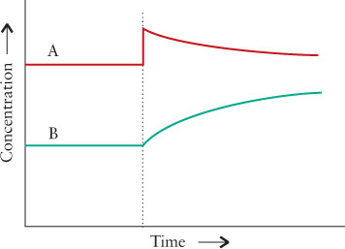

A) [A] was added to the system that was already at equilibrium. The system was immediately stressed and at that moment, Q ≠ *K*c.

B) After a stress is placed on a system, the system relieves that stress until Q = *K*c. The *K*c is equal to the *K*c before the stress was placed on the system.

C) A possible equilibrium expression this system is: 

D) All of the above statements are true.

E) None of the above statements are true.

**Chapter 12**

1. What is the conjugate base of CH3NH3+ in H2O?

A) CH3NH42+  
 B) CH3NH2  
 C) H3O+  
 D) OH–  
 E) None of these

2. Which of these species is most likely to be completely deprotonated in aqueous solution?

A) HNO2  
 B) HF  
 C) CH3COOH  
 D) HCN  
 E) HClO4

3. Which statement(s) correctly pairs the definition with the acid/base theory?

A) Bronsted-Lowry bases are proton donors.  
 B) Arrhenius bases produce hydronium ions in aqueous solution.  
 C) Lewis bases are electron pair donors.  
 D) Bronsted-Lowry acids are proton acceptors.  
 E) All of these are true.

|  |  |  |  |  |
| --- | --- | --- | --- | --- |
| 4. | Which of the following is the weakest acid? | | | |
| A) | HCN (p*K*a = 9.31) |  |  |
| B) | HIO3 (p*K*a = 0.77) |  |  |
| C) | HF (p*K*a = 3.45) |  |  |
| D) | CH3COOH (p*K*a = 4.75) |  |  |
| E) | HNO2 (p*K*a = 3.37) |  |  |

|  |  |
| --- | --- |
| 5. | Which oxoacid is strongest? |
|  | A) HIO  B) HClO3   C) HClO  D) HBrO  E) HClO4 |

|  |  |
| --- | --- |
| 6. | The pH of 0.800 M aqueous benzenesulfonic acid (a monoprotic acid) is 0.51. What is the value of *K*a for benzenesulfonic acid? |
|  | A) 0.19  B) 0.12  C) 0.90  D) 0.44  E) 0.51 |

|  |  |
| --- | --- |
| 7. | What is the pH of a 0.25 M HBrO(aq) solution? (p*K*a = 8.69) |
|  | A) 5.90  B) 0.60  C) 8.10  D) 4.65  E) 9.30 |

|  |  |  |
| --- | --- | --- |
| 8. | The equation that represents *K*a2 for phosphoric acid is | |
| A) | HPO42–(aq) + H2O(l) ↔ PO43–(aq) + H3O+(aq) |
| B) | H2PO4–(aq) + H2O(l) ↔ HPO42–(aq) + H3O+(aq). |
| C) | H3PO4(aq) + 2H2O(l) ↔ HPO42–(aq) + 2H3O+(aq). |
| D) | HPO42–(aq) + H2O(l) ↔ H2PO4–(aq) + OH–(aq). |
| E) | H3PO4(aq) + H2O(l) ↔ H2PO4–(aq) + H3O+(aq). |

|  |  |  |
| --- | --- | --- |
| 9. | What is the pH of a 0.026 *M* solution of NaOH? | |
| A) | 1.59 |
| B) | 0.026 |
| C) | 12.41 |
| D) | 13.97 |
| E) | The pH cannot be calculated without the Kb of NaOH. |

|  |  |  |
| --- | --- | --- |
| 10. | Which of the following salts are acidic in H2O?  I) NaBr  II) NH4Br  III) NaF  IV) FeCl3 | |
| A) | I and III |
| B) | III and IV |
| C) | I and II |
| D) | IV only |
| E) | II and IV |

|  |  |
| --- | --- |
| 11. | All of the following can act as Lewis bases except |
|  | A) OH  B) H2O  C) NH3  D) Br–  All of these may act as Lewis bases |

|  |  |
| --- | --- |
| 12. | All of the following acids have the same strength in water except |
|  | A) HNO3  B) HClO3  C) HBr  D) HF E) They all have the same strength |

13. What is the [OH-] concentration in a cup of coffee with pH = 4.27?

A) 9.7 *M*

B) 2.0x10-5 *M*

C) 1.9x10-10 *M*

D) 5.5x10-5 *M*

E) 5.4x109 *M*

14. What is the pH of a 0.013 *M* solution of HBr?

A) 1.89

B) 1.59

C) 12.41

D) 12.11

E) 3.78

15. The pH of a 0.042 *M* solution of a weak acid, HA, is 2.79. What is the Ka for this acid?

A) 6.3x10-5

B) 5.2x10-5

C) 1.6x10-3

D) 0.040

E) 0.45

16. What is the pH of a 0.167 *M* solution of C6H5NH2? The Kb of C6H5NH2 is 7.4x10-10 and the Ka of C6H5NH3+ is 1.4x10-5.

A) 11.184

B) 13.227

C) 0.777

D) 4.954

E) 9.046

17. Which acid is strongest?

A) HCN, pKa 9.21

B) HN3, pKa = 4.72

C) HNO2, pKa = 3.14

D) HBrO, pKa = 8.60

E) H2O2, pKa = 11.66

18. Identify the two conjugate acid – base pairs in the reaction below. Acids are listed first in each pair, followed by that acid's conjugate base.

HIO2(aq) + (CH3)2NH(aq) <-----> IO2-(aq) + (CH3)2NH2+(aq)

**Pair One Pair Two**

A) HIO2 and (CH3)2NH IO2- and (CH3)2NH2+

B) HIO2 and (CH3)2NH2+ IO2- and (CH3)2NH

C) (CH3)2NH2+ and HIO2 (CH3)2NH and IO2-

D) HIO2 and IO2- (CH3)2NH2+ and (CH3)2NH

E) IO2- and HIO2 (CH3)2NH and (CH3)2NH2+

19. Which statement is *true*?

A) NH3 is a Bronsted-Lowry base because it is a proton donor.

B) The bromide ion is a Lewis base, but not a Bronsted-Lowry base.

C) Water can be a Bronsted-Lowry acid OR a Lewis base.

D) Metal cations tend to be Lewis acids due to their ability to donate electron

pairs.

E) HSO4- is neither an acid nor a base under any theory.

20. Which statement regarding a solution of 0.0100 *M* NaNO2 is *true*?

A) The pH of the solution is acidic because HNO2 is a weak acid that undergoes acid hydrolysis to produce H3O+ in solution.

B) The pH of the solution is neutral because it was made from a strong base and a weak acid.

C) The pH of the solution is basic because NaOH is a strong base that undergoes base hydrolysis to produce OH- in solution.

D) The pH of the solution is acidic because the conjugate acid of NaOH undergoes acid hydrolysis to produce H3O+ in solution.

E) The pH of the solution is basic because the conjugate base of HNO2 undergoes base hydrolysis to produce OH- in solution.

21. At 50.0oC, p*K*w = 13.262. What is the pH of pure water at this temperature?

A) 7.00

B) 7.37

C) 6.63

D)13.30

E) 0.70

22. The hydrogen sulfate or bisulfate ion HSO4– can act as either an acid or a base in water solution. In which of the following equations does HSO4– act as an acid?

A) HSO4– (aq) + H2O(l) → H2SO4 (aq) + OH– (aq)

B) HSO4– (aq) + H3O+ (aq) → SO3 (aq) + 2 H2O (l)

C) HSO4– (aq) + OH– (aq) → H2SO4 (aq) + O2–(aq)

D) HSO4– (aq) + H2O (l) → SO42– (aq) + H3O+ (aq)

E) none of these

23. Which species is *least* likely to be completely deprotonated in aqueous solution?

A) HNO3

B) HF

C) HCl

D) HBr

E) HClO4

24. Which statement is *true*?

A) NH3 is a Bronsted-Lowry base because it is a proton donor.

B) The bromide ion is a Lewis base, but not a Bronsted-Lowry base.

C) Water can be a Bronsted-Lowry acid AND a Lewis base.

D) Metal cations tend to be Lewis acids due to their ability to donate electron

pairs.

E) HSO4- is neither an acid nor a base under any theory.

25. What is the conjugate base of HPO42- ?

A) PO43-

B) H3PO4

C) H2PO4-

D) HPO4

E) H2PO4

26. What is the pH of a 0.0147 *M* solution of KOH at room temperature?

A) 1.83

B) 12.17

C) 13.98

D) 12.47

E) 1.53

27. Which base is *weakest?*

A) BrO4-

B) BrO3-

C) IO4-

D) BrO-

E) IO-

28. Which statement regarding a solution of 0.0100 *M* NaNO2 is *true*?

A) The pH of the solution is acid because HNO2 is a weak acid that undergoes acid hydrolysis to produce H3O+ in solution.

B) The pH of the solution is neutral because it was made from a strong base and a weak acid.

C) The pH of the solution is basic because NaOH is a strong base that undergoes base hydrolysis to produce OH- in solution.

D) The pH of the solution is acidic because the conjugate acid of NaOH undergoes acid hydrolysis to produce H3O+ in solution.

E) The pH of the solution is basic because the conjugate base of HNO2 undergoes base hydrolysis to produce OH- in solution.

29. Which of the following species would be found in a 1.0M aqueous solution of HCl at 298K?

1. H2O
2. H3O+
3. Cl-
4. HCl
5. H+
6. I, II, and III
7. II, III, and IV
8. III, IV, and V
9. All of the species
10. Not enough information is provided

30. If pKa for a known acid HA is 1.39, what is the value of pKw at 25°C?

1. 2.45 x 10-13
2. 14
3. 1.39
4. 12.6
5. 0.041

31. An aqueous solution of which substance could have pH = 5.95?

1. KNO3
2. Ca(CN)2
3. NaF
4. CH3NHCl
5. Li2SO4

32. What is the pH a 0.0237 *M* solution of NaOH?

1. 12.375
2. 1.625
3. 0.00237
4. -1.625
5. There is not enough information.

33. What is the pH of a 0.244 *M* solution of H3BO3?

1. 0.610
2. 13.4
3. 0.914
4. 13.1
5. There is not enough information.

34. Which statement is *true*?

1. NH3 is a Bronsted-Lowry base because it is a proton donor.
2. The fluoride ion is a Lewis base, but not a Bronsted-Lowry base.
3. Water can be a Bronsted-Lowry acid AND a Lewis base.
4. Metal cations tend to be Lewis acids due to their ability to donate electron pairs.
5. HSO4- is neither an acid nor a base under any theory.

35. Which of the following statements is *true*?

1. Ka values are the same for all 3 protons in H3PO4.
2. Ka1 > Ka2 > Ka3 for any triprotic acid.
3. pKa1 + pKa2 + pKa3 = 14 for a triprotic acid.
4. Ka1 < Ka2 < Ka3 for any triprotic acid.
5. Two of these statements are true.

36. Sodium bicarbonate undergoes thermal decomposition according to the reaction below. Which of the following would cause the equilibrium to shift to produce more CO2(g)?

2NaHCO3(s) ⇌ NaCO3(s) + CO2(g) + H2O(g)

I. Addition of 0.20 atm of argon gas

II. Removal of NaHCO3(s)

III. Removal of H2O(g)

1. I only
2. II only
3. III only
4. I and II
5. II and III

37. Which base is *weakest?*

1. BrO4-
2. BrO3-
3. IO4-
4. BrO-
5. IO-

38. What is the conjugate base of H3AsO4?

1. AsO43-
2. H4AsO4
3. HAsO42-
4. H2AsO4-
5. H3AsO3-

39. What concentration of NH3 is required to have the same pH as a 0.010 *M* solution of LiOH? The *Kb* for NH3 is 1.8 x 10-5.

1. 0.010 M
2. 2.4 M
3. 560 M
4. 5.6 M
5. There is not enough information.

40. Which statement properly identifies and labels the conjugate acid-base pairs in the reaction:

HNO2(aq) + HPO42-(aq) <-----> NO2–(aq) + H2PO4-(aq).

Acid 1 Base1 Acid 2 Base 2

A) HNO2 HPO42– NO2– H2PO4–

B) H2PO4– NO2– HPO42– HNO2

C) NO2– HNO2 HPO42– H2PO4–

D) HNO2 NO2– H2PO4– HPO42–

E) HPO42– H2PO4– HNO2 NO2-

41. Acetic acid, CH3COOH, is a known weak acid. Which of the following equations demonstrates the proton transfer equilibrium of the conjugate base of acetic acid in water?

A) CH3COOH(aq) + H2O(l) CH3COO**-**(aq) + H3O**+**(aq)

B) CH3COO**-**(aq) + H2O(l) CH3COOH(aq) + H3O+(l)

C) CH3COO**-**(aq) + H3O**+**(aq) CH3COOH2(aq) + OH**-** (aq)

D) CH3COOH(aq) + H2O(l) → CH3COO**-**(aq) + H3O**+** (aq)

E) CH3COO**-**(aq) + H2O(l) CH3COOH(aq) + OH**-**(aq)

**Chapter 13**

|  |  |  |
| --- | --- | --- |
| 1. | 100 mL of each of the following solutions is mixed. Which one of the mixed solutions is a buffer? | |
| A) | 1.0 M NH3(aq) + 0.6 M KOH(aq) |
| B) | 1.0 M NH4Cl(aq) + 1.0 M KOH(aq) |
| C) | 1.0 M NH3(aq) + 0.4 M HCl(aq) |
| D) | 1.0 M NH4Cl(aq) + 0.4 M HCl(aq) |
| E) | 1.0 M NH3(aq) + 1.0 M HCl(aq) |

|  |  |
| --- | --- |
| 2. | Choose the effective pH range of an aniline/anilinium chloride buffer. The value of the *K*b for aniline is 4.3  10–10. |
|  | A) 3.6–5.6  B) 8.4–10.4  C) 1.1–3.1  D) 5.1–7.1  E) 10.1–12.1 |

|  |  |
| --- | --- |
| 3. | A buffer solution made of NH3 and NH4NO3 (Kb for NH3 = 1.8x10–5). If the pH of the buffer is 9.26 and the concentration of NH4NO3 is 0.175 *M*, then what is the concentration of NH3? |
|  | A) 0.0387 *M* B) 0.175 *M*  C) 0.757 *M* D) 0.831 *M* E) 0.452 *M* |

|  |  |  |
| --- | --- | --- |
| 4. | If a small amount of a strong base is added to buffer made up of a weak acid, HA, and the sodium salt of its conjugate base, NaA, the pH of the buffer solution does not change appreciably because | |
| A) | the *K*a of HA is changed. |
| B) | no reaction occurs. |
| C) | the strong base reacts with A– to give HA, which is a weak acid. |
| D) | the strong base reacts with HA to give AOH and H+. |
| E) | the strong base reacts with HA to give A– which is a weak base. |

|  |  |
| --- | --- |
| 5. | A buffer solution contains 0.0200 M acetic acid and 0.0200 M sodium acetate. What is the pH after 0.0020 mol of NaOH are added to 1.00 L of this buffer? p*K*a = 4.75 for acetic acid. Assume no change in volume. |
|  | A) 4.75  B) 4.70  C) 4.80  D) 4.84  E) 4.66 |

|  |  |
| --- | --- |
| 6. | The curve for the titration of 50.0 mL of 0.0200 M C6H5COOH(aq) with 0.100 M NaOH(aq) is given below. What are the main species in the solution after 7.5 mL of base have been added? |
|  | A) C6H5COOH(aq) and C6H5COO–(aq)  B) C6H5COOH(aq) and NaOH(aq)  C) NaOH and and C6H5COO–(aq)  D) C6H5COOH(aq) only  E) NaOH(aq) only |

|  |  |
| --- | --- |
| 7. | The pH at the half-stoichiometric point for the titration of 0.22 M HNO2(aq) with 0.10 M KOH(aq) is 3.37. Which statement *best* explains why this is true? (For HNO2, *K*a =  4.3  10–4) |
|  | A) There is no NO2- present in solution  B) [HNO2] = [NO2-] at the half-stoichiometric point, so pH = pKa for NO2-  C) All KOH added has been consumed  D) [HNO2] = [NO2-] at the half-stoichiometric point, so pH = pKa for HNO2  E) None of these statements explain the pH. |

|  |  |
| --- | --- |
| 8. | The complete titration curve for the titration of a weak acid with 0.100 M KOH(aq) is given below.    Which acid is being titrated?  A) H2SO3 (pKa1 ~ 2.0 and pKa2 ~ 6.9)  B) HCN (pKa1 ~ 2.9)  C) H3PO4 (pKa1 ~ 2.0, pKa2 ~ 7.2, and pKa3 ~12.3)  D) H2CO3 (pKa1 ~ 6.4 and pKa2 ~ 10.3)  E) H2C2O4 (pKa1 ~ 1.2 and pKa2 ~ 4.2) |

|  |  |  |
| --- | --- | --- |
| 9. | Which statement *best* explains why KCH3COO is a basic salt? | |
| A) | K+ is the weaker ion and undergoes acid hydrolysis to produce OH– in solution. |
| B) | CH3COO– is the stronger ion and undergoes acid hydrolysis to produce H3O+ in solution. |
| C) | K+ is the stronger ion and undergoes base hydrolysis to produce H3O+ in solution. |
| D) | KOH is a strong base and dominates the pH of the solution. |
| E) | CH3COO– is the stronger ion and undergoes base hydrolysis to produce OH- in solution. |

|  |  |
| --- | --- |
| 10. | Which image is correctly labeled and has arrows demonstrating the correct movement of electrons in a Lewis acid-base neutralization reaction?  A)    B)    C)    D)    E) |
|  |  |

|  |  |  |
| --- | --- | --- |
| 11. | The solubility of which of the following will *decrease* with addition of 0.10 M NaNO3?  I. Pb(NO3)2  II. Na2CO3  III. CaCl2  IV. K3PO4 | |
| A) | I only |
| B) | III and IV |
| C) | II only |
| D) | I and II |
| E) | IV only |

12.  An experiment using the bacteria *Bacillus sphearicus* must be kept at a pH near 5.25 in order for the bacteria to survive. Which is the best weak acid to use in the buffer?

A) HC3H3O3, Ka = 4.1x10-3

B) HC2Cl3O2, Ka = 2.2x10-1

C) HC3H5O2, Ka = 1.3x10-5

D) HClO, Ka = 2.9x10-8

E) HIO, Ka = 2.3x1o-11

13. What is the pH when 0.0025 moles of HCl are added to 50.0mL of a solution composed of 0.10 M HCN and 0.10 M NaCN? You may assume there is no change in volume.

Ka(HCN) = 4.9 x 10-10 Ka(HCl) = 108

A) 9.31

B) 8.83  
 C) 9.79

D) 12.40

E) 8.02

14. Identify the analyte and titrant used in the titration whose curve is shown below.

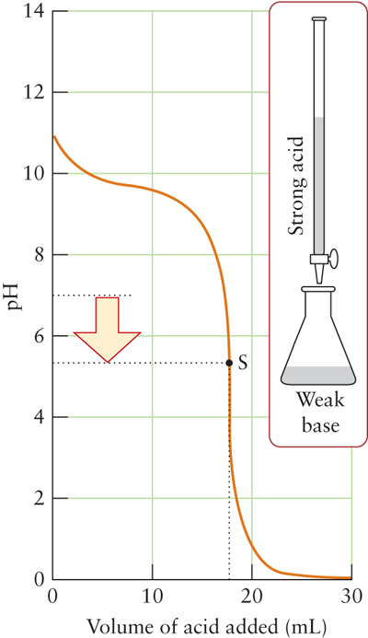

Volume of titrant added (mL)

**Analyte Titrant**

A) HCN NaOH

B) NH3 HClO

C) CH3NH2 HNO3

D) HF NH3

F) HClO CH3NH2

15. A 25.0 mL sample of 0.20 *M* HNO2 was titrated with 0.20 *M* KOH. What is the pH of the system when 12.5 mL of KOH have been added?

Ka HNO2 = 4.3 x 10-4 Kb NaOH = 1 x 1010

A) 4.30

B) 3.37

C) 10.63

D) 7.00

E) 3.50

16. What are the primary species present between points B and D on the titration curve? You may ignore water as a primary species and assume that this curve represents an "ideal" and complete titration curve.

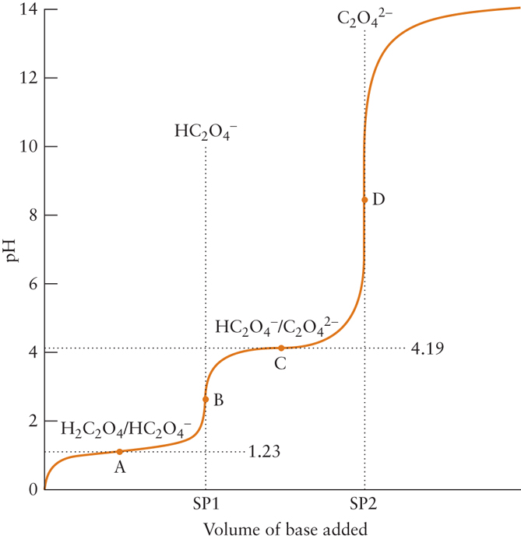

A) H2A and HA-

B) HA- and A2-

C) H2A and A2-

D) A2- and OH-

E) HA- and OH-

17. What volume of 0.35 *M* HCl must be added to 10.0 mL of 0.42 *M* NaOH to reach the stoichiometric point?

A) 10.0 mL

B) 1.47 mL

C) 12.0 mL

D) 14.7 mL

E) 8.33 mL

18. What is the molar solubility of Fe(OH)3 if its Ksp is 2.0x10-39?

A) 1.6 x 10-10

B) 9.3 x 10-11

C) 7.9 x 10-14

D) 2.6 x 10-20

E) 4.5 x 10-20

19. Which statement regarding the titration of NH3 with HBr is *true*?

A) The pH at the equivalence point is acidic because there is HBr present.

B) The pH at the equivalence point is neutral because there is no NH3 or HBr

remaining.

C) The pH at the equivalence point is basic because all HBr has been

neutralized.  
 D) The pH at the equivalence point is acidic because an acidic salt forms.

E) None of these statements is true.

20. In the titration of H3AsO4 with LiOH, it was determined that the first equivalence point occurred when 25.0 mL of LiOH was added. What *total* volume of LiOH must be added to reach the third equivalence point?

A) 25.0 mL

B) 50.0 mL

C) 75.0 mL

D) 100.0 mL

E) This cannot be determined without the Ka values for H3AsO4.21. Which statement regarding the titration curve below is *true*?

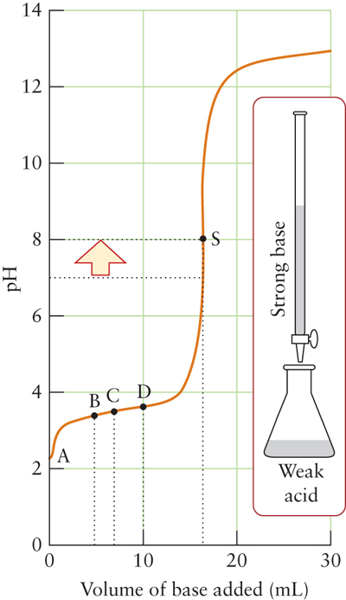

A) The pH at the equivalence point is 7.00

B) At point D, there is excess strong base present.

C) The small increase in pH from point B to D is because a buffer formed.

D) Beyond point S, only excess weak conjugate base is present.

E) More than one of these statements is true.

|  |  |  |
| --- | --- | --- |
| 22. | 100 mL of each of the following solutions is mixed. Which one of the mixed solutions is a buffer? | |
| A) | 1.0 M CH3NH2(aq) + 0.6 M KOH(aq) |
| B) | 1.0 M CH3NH3Cl(aq) + 1.0 M KOH(aq) |
| C) | 1.0 M CH3NH2( (aq) + 0.8 M HNO3(aq) |
| D) | 1.0 M NH4Cl(aq) + 0.8 M HCl(aq) |
| E) | 2.0 M CH3NH2( (aq) + 2.2 M HNO3aq) |

|  |  |
| --- | --- |
| 23. | Which statement regarding the reaction of HCN with NH3 is *true*?  A) NH3 is the proton donor.  B) The N of HCN is the electron pair donor.  C) A coordinate covalent bond is broken.  D) A coordinate covalent bond is formed.  E) None of these statements is true. |

24. What concentration of HNO2 is required to produce a solution whose pH is 1.26? The Ka for HNO2 is 7.2 x 10-4

A) 4.25 *M*

B) 9.75 *M*

C) 1.16 *M*

D) 0.055 *M*

E) 3.96 *M*

25. Identify the most likely analyte and titrant (listed in that order) based on the curve below.

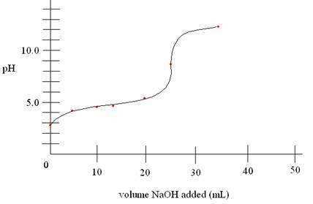

Volume titrant added (mL)

A) NaOH, HCl

B) HBr, LiOH

C) H2SO4, KOH

D) Ba(OH)2, HNO3

E) CH3COOH, NaOH

26. What is the pH of a buffer composed of 0.50 *M* CH3COOH and 0.50 *M* NaCH3COO after 0.020 mol of HCl has been added to 1.0 L of the buffer solution? Assume no change in volume. The Ka of CH3COOH is 1.8 x 10-5 and the Kb of NaOH is 108.

A) 3.56

B) 4.71

C) 4.74

D) 6.44  
 E) 4.78

27. The molar solubility of PbI2 in water at 25oC is 0.0015. What is the Ksp for PbI2?

A) 3.6 x 10-8

B) 3.4 x 10-9

C) 6.8 x 10-9

D)1.4 x 10-8

E)0.29

28. What effect (and why) does the addition of Na2CO3 have on the solubility of ZnCO3?

A) The solubility increases due to complex ion formation.

B) The solubility decreases due to complex ion formation.

C) The solubility decreases due to the common ion effect.

D) The solubility increases due to the common ion effect.

E) The solubility increases as a result of both the common ion effect and

complex ion formation.

29. Which statement regarding the titration of HClO with NaOH is *true*?

1. The pH at the equivalence point is acidic because there is HClO is present.
2. The pH at the equivalence point is neutral because there is no acid or base remaining
3. The pH at the equivalence point is basic because a basic salt forms
4. The pH at the equivalence point is acidic because an acidic salt forms.
5. The pH at the equivalence point is basic because NaOH is present.

30. Which of these *cannot* be used to form a buffer when paired with its conjugate acid or base?

1. CH3COOH (acetic acid)
2. CH3NH2
3. HNO2
4. HClO4
5. NH3

31. A diprotic acid, H2A, has the following acid dissociation constants: *K*a1 = 1.1 x 10-3 and *K*a2 = 2.5 x 10-6. Which combination of species would you use to make a buffer solution whose pH is 5.80?

1. NaHA / H2A
2. Na2A / NaHA
3. H2A / NaHA / Na2A
4. H2A / Na2A
5. H2A and its conjugates cannot be used to form a buffer of pH = 5.80.

32. What are the primary species present at point C on the titration curve? You may ignore water as a primary species and assume that this curve represents an "ideal" and complete titration curve.



1. H2A and HA-
2. HA- and A2-
3. H2A and A2-
4. A2- and OH-
5. HA- and OH-

33. What ratio of [A-] to [HA] is needed to produce a solution with pH = 8.00 if the *K*a of the acid is 3.5 x 10-8?

1. 0.288
2. 3.47
3. 1.00
4. 8.00
5. 7.46

34. The molar solubility of PbI2 in water at 25oC is 0.0015. What is the Ksp for PbI2?

1. 2.0 x 10-6
2. 3.4 x 10-9
3. 6.8 x 10-9
4. 1.4 x 10-8
5. 0.29

35. In the titration of H3AsO4 with LiOH, it was determined that the first equivalence point occurred when 25.0 mL of LiOH was added. What *total* volume of LiOH must be added to reach the second equivalence point?

1. 25.0 mL
2. 50.0 mL
3. 75.0 mL
4. 100.0 mL
5. This cannot be determined without the Ka values for H3AsO4.

36. What is the pH of a buffer composed of 0.50 *M* CH3COOH and 0.50 *M* NaCH3COO after 0.020 mol of HCl has been added to 1.0 L of the buffer solution? Assume no change in volume. The Ka of CH3COOH is 1.8 x 10-5 and the Kb of NaOH is 108.

1. 3.56
2. 4.71
3. 4.74
4. 6.44
5. 4.78

|  |  |
| --- | --- |
| 37. | What is the pH of an aqueous solution that is 0.011 M HF (*K*a = 3.5  10–4) and 0.015 M NaF? |
|  | A) 1.95  B) 3.46  C) 3.59  D) 5.27  E) 3.33 |

38. What is the pH of a solution composed of 0.13 *M* H2PO4- and 0.20 *M* HPO42- if the *K*a for H2PO4- is 6.2 x 10-8 and the *K*a for HPO42- is 4.8 x 10-13.

A) 7.39

B) 12.51

C) 12.13  
 D) 7.02

E) 0.89

39. Which statement best characterizes the pH *after* the equivalence point (stoichiometric point) in the titration of a weak base with a strong acid?

1. The pH equals the pH of the weak base. If you know the molarity and *K*b of the weak base, you can find the pH.
2. The pH is determined by the excess strong acid. You will need to determine the molarity of the strong acid present and then find the pH using –log[H3O+].
3. The pH is determined by the buffer that is formed, so you will need to find the molarity of the weak base and its conjugate acid. You can then use this information and plug into the Henderson-Hasselbalch equation.
4. The pH is determined by the salt that is formed. The pH of the salt is acidic, and so you should use the *K*a for the base with the acid dissociation equilibrium equation.
5. The pH is determined by the salt that is formed. The pH of the salt is basic, and so you should use the *K*b of the weak base with the basicity equilibrium equation.

**Chapter 14**

|  |  |  |  |  |
| --- | --- | --- | --- | --- |
| 1. | What is the proper cell diagram for the reaction   |  |  | | --- | --- | |  | 2AgCl(s) + H2(g)  2Ag(s) + 2H+(aq) + 2Cl(aq) | | |
| A) | PtCl(aq)H+(aq) || H2(g)AgCl(s)Ag(s) |
| B) | PtH2(g)H+(aq) || Cl(aq)AgCl(s)Ag(s) |
| C) | Ag(s)AgCl(s)Cl(aq) || H+(aq)H2(g)Pt |
| D) | PtH2(g)H+(aq) || Cl(aq)Ag(s)Pt |
| E) | Ag(s)AgCl(s)H+(aq) || Cl(aq)H2(g)Pt |

|  |  |  |  |  |  |  |  |  |  |  |
| --- | --- | --- | --- | --- | --- | --- | --- | --- | --- | --- |
| 2. | |  |  |  | | --- | --- | --- | |  | Ag+(aq) + e  Ag(s) | *E*° = +0.80 V | |  | Fe3+(aq) + e  Fe2+(aq) | *E* = +0.77 V | |  | Cu2+(aq) + 2e  Cu(s) | *E* = +0.34 V |   Which is the strongest oxidizing agent? |
|  | A) Ag  B) Cu2+  C) Cu  D) Ag+  E) Fe2+ |

|  |  |  |  |
| --- | --- | --- | --- |
| 3. | Consider the reaction:   |  |  | | --- | --- | |  | 2Ag+(aq) + Cu(s)  Cu2+(aq) + 2Ag(s) |   Calculate the value of *E*cell for the given reaction above given:  Ag+ + e- 🡪 Ag *E*o = +0.80 V  Cu2+ + 2e- 🡪 Cu *E*o = +0.34 V |
|  | A) +1.48 V  B) 1.26 V  C) 0.46 V  D) +1.26 V  E) +0.46 V |

Balance the following reaction in acidic solution to answer questions 4—6.

Cr2O7 **2-**(aq) + C2O4**2-** (aq) 🡪 Cr**3+** (aq) + CO2 (g)

|  |  |
| --- | --- |
| 4. | What is the reducing agent? |
|  | A) Cr2O7 **2-**(aq)  B) C2O4**2-** (aq)  C) Cr**3+** (aq)  D) CO2 (g)  E) Cr(s) |

|  |  |
| --- | --- |
| 5. | How many electrons are transferred in this reaction? |
|  | A) 0  B) 1  C) 3  D) 4  E) 6 |

|  |  |
| --- | --- |
| 6. | What is the coefficient for CO2(g) in the balanced equation? |
|  | A) 1  B) 2  C) 3  D) 6  E) 7 |

|  |  |
| --- | --- |
| 7. | What is the oxidation state of Cl in Al(ClO3)3? |
|  | A) -1  B) +1  C) +6  D) +9  E) +5 |

|  |  |
| --- | --- |
| 8. | Frank’s great-great grandfather buried a bell in his backyard during the Siege of Atlanta in Civil War. The bell was made of a mix of copper and nickel parts. When Frank dug it out recently, he found about a quarter of the bell has gone. Given the cell potentials below, of what is the bell now composed?  Eo (Cu2+/Cu) = + 0.34 V  Eo (Ni2+/Ni) = - 0.26 V |
|  | A) All Cu parts  B) All Ni parts  C) 0% of Cu and 50% of Ni  D) All SiO2  E) All Au |

|  |  |  |  |  |
| --- | --- | --- | --- | --- |
| 9. | What mass of chromium metal can be plated out by passing a total charge of  1.06 x 105 C through an electrolytic cell containing a solution of Cr(NO­3)3? | | | |
| A) | 19.0 g |
| B) | 57.1 g |
| C) | 18.4 g |  |  |
| D) | 1.67 g |  |  |
| E) | 1.10 g |  |  |

10. The galvanic cell shown below uses the half-cells Mg2+/Mg and Zn2+/Zn, and a salt bridge containing KCl(aq). The voltmeter gives a positive voltage reading. Which statement correctly identifies the anode and cathode compartments and the reactions that occur in them?

Mg2+(aq) + 2e- 🡪 Mg(s) Eo = -2.37

Zn2+(aq) + 2e- 🡪 Zn (s) Eo = -0.76 V



A) A and E represent the cathode: Zn2+(aq) + 2e- 🡪 Zn (s)

B) B and F represent the cathode: Mg2+(aq) + 2e- 🡪 Mg(s)

C) A and E represent the anode: Mg2+(aq) + 2e- 🡪 Mg(s)

D) B and F represent the anode: Zn(s) 🡪 Zn2+(aq) + 2e-

E) B and F represent the cathode: Zn2+(aq) + 2e- 🡪 Zn (s)

11. What is the oxidation state of N in Sn(NO3)4?

A) -3

B) +2

C) +3

D) +4

E) +5

Balance the following redox reaction *in acid* and use it to answer questions 12-14.

CH3OH(aq) + Cr2O72-(aq) 🡪 CH2O(l) + Cr3+(aq)

12. What is the sum of the coefficients in the balanced equation?

A) 36

B) 24

C) 22

D) 82

E) 28

13. How many electrons are transferred in this reaction?

A) 2

B) 3

C) 6

D) 9

E) 18

14. If the reaction is balanced *in base* then what is the coefficient for water, and on which side does it appear?

A) 7 on the products side

B) 8 on the reactants side

C) 7 on the reactants side

D) 1 on the reactants side

E) 14 on the reactants side

15. Which reaction corresponds to the cell diagram?

Pt(s) | H2(g) | H+(aq) || Ag+(aq) | Ag(s)

A) H2(g) + 2Ag+(aq) 🡪 2H+(aq) + 2Ag(s)

B) 2H+(aq) + Pt(s) + 2Ag(s) 🡪 H2(g) + 2Ag+(aq)

C) 2H+(aq) + Ag(s) 🡪 H2(g) + Ag+(aq)

D) Pt(s) + H2(g) + 2Ag+(aq) 🡪 2H+(aq) + 2Ag(s)

E) H2(g) + Ag+(aq) 🡪 2H+(aq) + Ag(s)

16. What is the standard cell potential (Eocell) when a galvanic cell is constructed using the following half-reactions?

Au3+ + 3e- 🡪 Au(s) Eo = +1.50 V

Cu+ + e- 🡪 Cu(s) Eo = +0.52 V

A) +0.52V

B) +0.98 V

C) +2.02 V

D) -0.98 V

E) -2.02

Use the table below to answer questions 17 and 18.

**Half-reaction** **E° (Volts)**

Au3+ + 3e- → Au(s) +1.50

Cu+ + e- → Cu(s) +0.52

Pb2+ + 2e- → Pb(s) -0.13

Fe2+ + 2e- → Fe(s) -0.44

Cr3+ + 3e- → Cr(s) -0.74

Al3+ + 3e- → Al(s) -1.66

Mg2+ + 2e- → Mg(s) -2.37

Rb+ + e- → Rb(s) -2.98

17. A galvanic cell is constructed using gold (Au) and magnesium (Mg) half-cells. Which statement is *true*?

A) Electrons flow from the Au half-cell to the Mg half-cell.

B) At the cathode, Mg(s) is produced.

C) Three electrons are transferred in this reaction.

D) Au3+ is produced at the anode.

E) Ions flow into the cathode and the anode from the salt bridge.

18. Which of the following is the *strongest* reducing agent?

A) Cu+

B) Cu(s)

C) Al(s)

D) Al3+

E) Fe2+

19. Which statement is *true* if a galvanic cell using the following overall reaction runs at 25oC?

2Ag+(aq) + Cu(s) 🡪 Cu2+(aq) + Ag(s) Eocell = +0.46

A) Go = +88.8 kJ, and the reaction is non-spontaneous  
 B) Go = -44.4 kJ, and the reaction is spontaneous  
 C) Go = -88.8 kJ, and the reaction is spontaneous  
 D) Go = +44.4 kJ, and the reaction is non-spontaneous  
 E) None of these is true.

20. What is the value of the equilibrium constant, *K*, for the reaction in question 20?

A) 2.78 x 10-16  
 B) 3.63 x 1015  
 C) 6.06 x 107  
 D) 1.65 x 10-8   
 E) 7.77 x 10-1

21. Consider the electrolysis of molten barium chloride. How many grams of barium metal can be produced by supplying 0.50 amperes for 30.0 minutes?

A) 0.13 g

B) 0.64 g

C) 0.36 g

D) 1.6 g

E) 2.8 g

22. The pH for a galvanic cell with the following cell diagram is 2.75, and its cell potential (Ecell) is +0.84 V. If the concentration of Fe2+ is 0.10 *M* and the partial pressure of H2 is 1.00 bar, then what is the concentration of Fe3+ at 298K?

Pt(s) | H2(g) | H+(aq) || Fe3+(aq), Fe2+(aq) | Pt(s)

Fe3+ + e- 🡪 Fe2+ Eo = +0.80 V

2H+ + 2e- 🡪 H2 Eo = 0.00 V

Fe2+ + 2e- 🡪 Fe(s) Eo = -0.44 V

A) 0.42 *M*

B) 3.9 x 10-4 *M*  
 C) 0.21 *M*

D) 1.05 x 10-4 *M*  
 E) 8.5 x 10-4 *M*

23. What is the oxidation state for Mn in Ca(MnO4)2?

A) +8

B) +7

C) +6

D) +2

E) 0

Use the unbalanced oxidation-reduction reaction to answer questions 24-25.

Cr2O72-(aq) + Zn(s) 🡪 Zn2+(aq) + Cr3+(aq)

24. What is the oxidizing agent?

A) Zn(s)

B) Cr2O72-(aq)

C) Zn2+(aq)

D) Cr3+(aq)

E) There is no reducing agent.

25. What is the sum of the coefficients when the reaction is balanced in acid?

A) 4

B) 5

C) 18  
 D) 30

E) 64

26. Which answer option correlates the values of Gibbs free energy, cell potential, and the equilibrium constant for a galvanic cell?

**Gibbs free energy *K* *E*o­cell**

A) + > 1 -

B) + < 1 +

C) - > 1 +

D) - < 1 +

E) - >1 -

27. Calculate the value of the equilibrium constant (T = 298 *K*)

Pb(s) + 2Ag+(aq) 🡪 Pb2+(aq) + Ag(s) *E*ocell = +0.93 V

A) -1.8 x 105

B) 1.3 x 1031

C) 7.7 x 1030

D) 1.5 x 1031

E) 2.9 x 1031

28. Which statement regarding the galvanic cell represented by the line notation below is *true*?

PtH2(g)H+(aq) || Cl(aq)AgCl(s)Ag(s)

A) Anions must flow into the anode to maintain charge balance.

B) Platinum is an inert electrode in both half-cells.

C) Solid silver metal is produced at the anode.

D) Electrons flow from the cathode to the anode.

E) The standard hydrogen electrode (SHE) is the cathode

29. A galvanic cell was constructed using the Zn2+/Zn and H2/H+ (standard hydrogen electrode) half-cells under the following conditions. What is *E*cell at

298 K ?

Zn2+(aq) + 2e- 🡪 Zn(s) *E*o = -0.76 V

2H+ + 2e- 🡪 H2 *E*o = 0.00 V

[Zn2+] = 0.010 *M*

[H+] = 2.5 *M*

*P*H2 = 0.30 atm

A) 0.86 V

B) 0.76 V

C) 0.53 V

D) 0.31 V

E) 1.21

30. How many hours are required to plate 25.00 g of nickel metal from 1.00 *M* NiSO4(aq), using a current of 3.00 C/s?

A) 7.6 h

B) 3.8 h

C) 8.3 h

D) 2.6 h

E) 255 h

31. What is *E*ocell for the reaction 2Ag+(aq) + Ni(s) 🡪 2Ag(s) + Ni2+(aq)?

Ag+ + e- 🡪 Ag *E*o = 0.800 V

Ni2+ + 2e- 🡪 Ni(s) *E*o = -0.257 V

1. 0.543 V
2. 1.057 V
3. 0.286 V
4. -1.057 V
5. This reaction cannot occur.

32. *E*ocell for the reaction 2 Fe3+(aq) + 2 I-(aq) 🡪 2 Fe2+(aq) + I2(aq) is 0.24V. What is ΔGo for this reaction?

1. -11.6 kJ
2. -46.3 kJ
3. -23.2 kJ
4. 23.2 kJ
5. There is not enough information.

33. In an electrochemical cell, *Q* = 0.0010 and *K* = 2.30. What can you conclude about *E*cell and *E*°cell?

A) *E*cell is positive and *E*°cell is negative.

B) *E*cell is negative and *E*°cell is positive.

C) Both *E*cell and *E*°cell are negative.

D) Both *E*cell and *E*°cell are positive.

E) Not enough information is given.

34. A galvanic cell is constructed that uses the following half-cell reactions:

Cu**+**(aq) + e**-** → Cu(s)

I**2**(s) + 2e**-** → 2I**-**(aq)

Which of the following statements would be true if the cell is operating at 298 K with [Cu**+**] = 0.25*M* and [I**-**]= 3.5 *M*?

A) Copper solid is the anode of the cell.

B) Two moles of electrons are transferred during the electrochemical cell reaction.

C) *E*cell for the concentrations given would be greater than *E*°cell.

D) The reaction would be spontaneous.

E) All of the above statements are correct.

**Chapter 15**

|  |  |
| --- | --- |
| 1. | **The rate constant for the second order reaction**  is  2.79 *M*-1min-1 at 48.0ºC. If the initial concentration of NO2 is 1.05 *M*, what is the half-life in minutes? |

A) 0.341 min

B) 0.248 min

C) 0.376 min

D) 5.85 min

E) 8.06 min

|  |  |  |  |  |  |  |  |  |  |  |  |  |  |  |  |  |  |  |  |  |  |  |  |  |  |  |  |  |  |  |  |  |  |  |  |  |  |  |  |  |
| --- | --- | --- | --- | --- | --- | --- | --- | --- | --- | --- | --- | --- | --- | --- | --- | --- | --- | --- | --- | --- | --- | --- | --- | --- | --- | --- | --- | --- | --- | --- | --- | --- | --- | --- | --- | --- | --- | --- | --- | --- |
| 2. | Determine the rate law for the reaction given the following data:  2A + B  products   |  |  | | --- | --- | |  |  |  |  |  |  |  |  | | --- | --- | --- | --- | --- | | Initial concentration, M | | | Initial rate, M s1 | | |  | A | B | | |  | 0.10 | 0.10 | | 2.0  102 | |  | 0.20 | 0.10 | | 8.0  102 | |  | 0.30 | 0.10 | | 1.8  101 | |  | 0.20 | 0.20 | | 8.0  102 | |  | 0.30 | 0.30 | | 1.8  101 | | | | |
| A) | rate = *k*[B]2 |  |  |
| B) | rate = *k*[A][B]0 |  |  |
| C) | rate = *k*[A]2 |  |  |
| D) | rate = *k*[A][B] |  |  |
| E) | rate = *k*[A] |  |  |

|  |  |
| --- | --- |
| 3. | A non-steroidal anti-inflammatory drug is metabolized with a first-order rate constant of 3.25 day1. What percent of the drug remains in the body after 13.0 hr? |
|  | A) 17.2  B) 1.74  C) 82.8  D) 87.3  E) 12.7 |

|  |  |  |
| --- | --- | --- |
| 4. | Which of the following statements is *true*? | |
| A) | When the concentration of a second order reactant is doubled, the rate of the reaction doubles. |
| B) | The rate of a zero order reaction is independent of concentration. |
| C) | All spontaneous reactions occur quickly. |
| D) | Average rate of reaction is the slope of the line tangent to the curve in the plot of concentration vs. time. |
| E) | The half –life of a first order reaction is dependent on initial concentration. |

5. What are the units for the rate constant for a *third* order reaction?

A) M/s

B) s-1

C) M-1s-1

D) M-2s-1

E) M-1s-2

6. Determine the value and units of *k* based on the graph below.

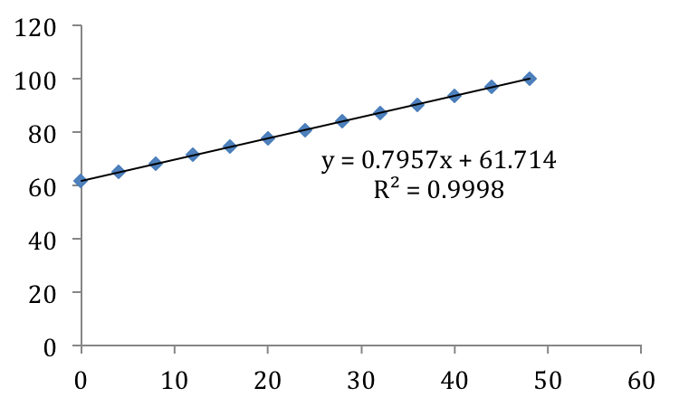

**1 /[A]**

**Time (sec)**

A) *k* = 61.714 s-1

B) *k* = - 61.714 M-1s-1

C) *k* = 0.7957 M-1s-1

D) *k* = - 0.7957 M/s

E) *k* cannot be determined from this graph

7. Which changes result in the greatest rate for a reaction with the rate law:

Rate = *k*[A][B]2 ?

A) doubling the concentration of A and halving the concentration of B

B) doubling the concentration of A and doubling the concentration of B

C) halving the concentration of A and doubling the concentration of B

D) keeping the concentration of A constant and tripling the

concentration of B

E) quadrupling the concentration of A and keeping the concentration of B constant

|  |  |  |  |  |  |
| --- | --- | --- | --- | --- | --- |
| 8. | The rate of formation of oxygen in the reaction given is is 2.28 M/s. What is the rate of formation of NO2?   |  |  | | --- | --- | |  | 2N2O5(g)  4NO2(g) + O2(g) | | | |
| A) | 0.57 M/s |
| B) | 9.12 M/s |
| C) | 1.14 M/s |
| D) | 4.56 M/s |
| E) | 2.28 M/s |

|  |  |  |
| --- | --- | --- |
| 9. | What is the overall rate law expression for the reaction described by this mechanism?  (1) NO2(g) + F2(g) 🡪 NO2F(g) + F(g) (slow)  (2) NO2(g) + F(g) 🡪 NO2F(g) (fast) | |
| A) | Rate = *k*[NO2]2[F2][NO2F]2 |
| B) | Rate = *k*[NO2][F] |
| C) | Rate = *k*[NO2]2[F2] |
| D) | Rate = *k*[NO2][F2] |
| E) | The rate law cannot be determined without experimental data. |

|  |  |  |
| --- | --- | --- |
| 10. | Which of the following statements is *false*? | |
| A) | For a reaction to occur, two molecules must collide *both* with the proper orientation and with a minimum amount of energy (so that they don't just "bounce apart"). |
| B) | The rate constant for a reaction can be determined from the slope of the line resulting from a graph of ln *k* vs. T. |
| C) | Intermediates are produced by one step in a mechanism and consumed by a subsequent reaction step. |
| D) | The transition state is a high-energy complex that exists only at the instant when the reacting system is highest in potential energy. It is neither a reactant nor a product but a transitional species with partial bonds. |
| E) | All of these statements are true. |

|  |  |  |
| --- | --- | --- |
| 11. | Consider the following reaction diagram. Which of the statements below concerning this diagram is ***true***?  **Energy**  **Reaction Progress**  A  B  C | |
| A) | The reaction has two intermediates. |
| B) | The reaction has one transition state. |
| C) | The overall reaction is A  C. |
| D) | The rate law for the reaction is rate = *k*[A]. |
| E) | Step two has the lowest activation energy of all steps in the mechanism. |

|  |  |  |
| --- | --- | --- |
| 12. | The mechanism for the reaction of nitrogen dioxide with carbon monoxide to form nitric oxide and carbon dioxide is thought to be:  NO2 + NO2  NO3 + NO (slow)  NO3 + CO  NO2 + CO2 (fast)  What is the rate law expected for this mechanism? | |
| A) | Rate = k[NO3][CO] |
| B) | Rate = k[NO2]2 |
| C) | Rate = k[NO2]2[CO] |
| D) | Rate = k[NO3][NO] |
| E) | Rate = k[NO2]2[CO][NO3] |

13. Which statement is *true*?

A) Catalysts are produced by one reaction in a mechanism and consumed by a subsequent reaction.  
 B) According to collision theory, all molecules that collide with one another react.  
 C) Two molecules may collide with proper orientation but still not undergo chemical reaction.  
 D) Catalysts and intermediates are the same thing.  
 E) Intermediates and transitions states are the same.

14. Which statement(s) is(are) *true*?

aA(g) + bB(g) <-----> cC(g) + dD(g)

*k*f = 9.52 x 10- 5 M-1s-1

*k*r = 1.10 x 10 -9 M-1s-1

I. The forward reaction proceeds more slowly than the reverse reaction.  
 II. The reaction as written is product favored at equilibrium.  
 III. The reaction as written is spontaneous.

A) I only  
 B) II only  
 C) III only  
 D) II and III  
 E) I and II

|  |  |  |  |  |  |  |  |  |  |  |  |  |  |  |  |  |  |  |  |  |  |  |
| --- | --- | --- | --- | --- | --- | --- | --- | --- | --- | --- | --- | --- | --- | --- | --- | --- | --- | --- | --- | --- | --- | --- |
| 15. | Determine the rate law expression for the reaction CO(g) + Cl2(g)  COCl2(g) given the following experimental data   |  |  |  |  | | --- | --- | --- | --- | | Experiment | Initial [CO]  (M) | Initial [Cl2]  (M) | Initial Rate (M/s) | | 1 | 0.12 | 0.20 | 0.121 | | 2 | 0.24 | 0.20 | 0.241 | | 3 | 0.24 | 0.40 | 0.964 | |  |  |  |  | | |
| A) | Rate = k[CO][Cl2]2 |
| B) | Rate = k[CO][Cl2] |
| C) | Rate = k[CO]2[Cl2]4 |
| D) | Rate = k[CO] |
| E) | Rate = k[Cl2] |

|  |  |  |
| --- | --- | --- |
| 16. | The rate constant for a reaction is 10.5 s-1. If the initial concentration of reactant is 0.100 M, then how long does it take for one half-life to elapse? | |
| A) | 0.0660 s |
| B) | 0.952 s |
| C) | 0.660 s |
| D) | 0.00476 s |
| E) | 0.693 s |

|  |  |  |
| --- | --- | --- |
| 17. | Which diagram best correlates to the mechanism if the reaction is endothermic?  A + B C (slow)  C + D  E (fast) | |
| A) |  |
| B) |  |
| C) |  |
| D) |  |
| E) |  |

|  |  |  |
| --- | --- | --- |
| 18. | Which rate law best matches the data graphed below? | |
| A) | Rate = k |
| B) | Rate = k[A] |
| C) | Rate = k[A]2 |
| D) | Rate = k[A]3 |
| E) | Rate = k[A]1/2 |

|  |  |  |
| --- | --- | --- |
| 19. | The reaction A  B + C is first order in A with *k =* 0.034 s-1 at 25° C. If [A]0 =  2.4 *M*, then what is [A] after 4.2 s? | |
| A) | 1.0 *M* |
| B) | 1.2 *M* |
| C) | 3.65 *M* |
| D) | 2.26 *M* |
| E) | 2.08 *M* |

20. The rate law for a reaction is: Rate = k[A]2[B]. What happens to the rate if both concentrations are doubled?

A) No change  
 B) Rate increases by a factor of 4  
 C) Rate increases by a factor of 2  
 D) Rate increases by a factor of 8.  
 E) Not enough information

21. The rate constant for the decomposition of cyclobutane (C4H8) at 1000oC is

87 *M-1* s-1. If the initial concentration of cyclobutane is 2.00 *M*, what percent of it decomposes in 0.010 seconds?

A) 8.0%

B) 64%

C) 42%

D) 90.%

E) 10.%

22. Determine the rate law from the data given.

|  |  |  |  |
| --- | --- | --- | --- |
| **Experiment** | **Initial [NO]** | **Initial [O2]** | **Initial rate (*M*/s)** |
| 1 | 0.0110 | 0.0130 | 0.00321 |
| 2 | 0.0220 | 0.0130 | 0.00640 |
| 3 | 0.0110 | 0.0260 | 0.0128 |
| 4 | 0.0330 | 0.0130 | 0.00960 |
| 5 | 0.0110 | 0.0360 | 0.0288 |

A) rate = *k*[O2][NO]

B) rate = *k*[O2]2[NO]

C) rate = *k*[O2]

D) rate = *k*[O2][NO]2

E) rate = *k*[NO]

23. Identify the intermediates.

1) ClO- (aq) + H2O(l) <-----> HClO(aq) + OH-(aq) (fast)

2) I-(aq) + HClO(aq) <-----> HIO(aq) + Cl-(aq) (slow)

3) OH-(aq) + HIO(aq) <-----> H2O(l) + IO-(aq) (fast)

A) ClO-, HIO, H2O

B) HClO, H2O ,OH-, HIO

C) ClO-, I-, IO-, Cl-

D) I-, IO-

E) HClO, OH-, HIO

24. Which reaction progress diagram most accurately portrays the mechanism in question 23?

A) D)

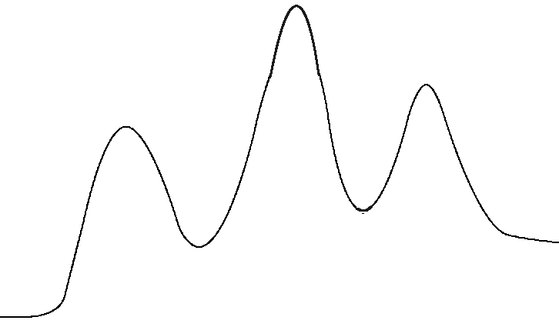

**Reaction Progress 🡪**

**Energy 🡪**

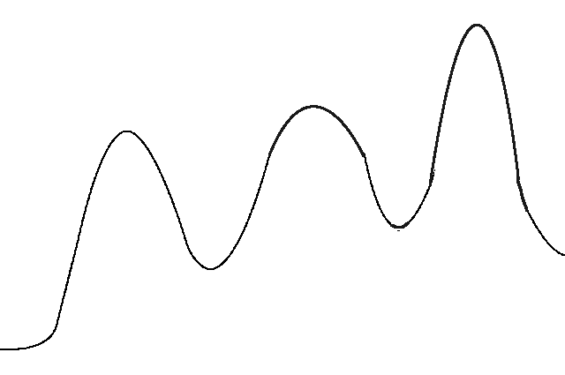

**Reaction Progress 🡪**

**Energy 🡪**

B)

E) None of these

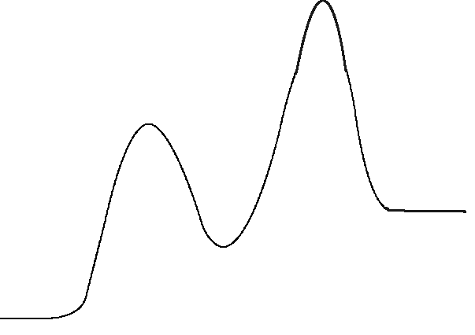

**Reaction Progress 🡪**

**Energy 🡪**

C)

**Reaction Progress 🡪**

**Energy 🡪**

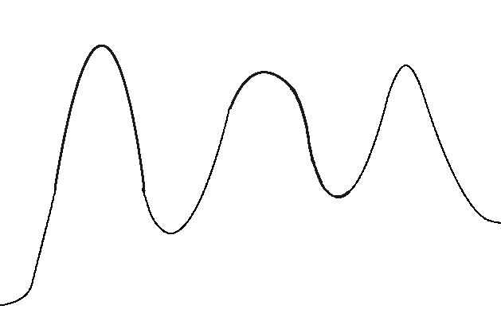

25. Which of the following statements is true regarding reactions with species A as first order?

1. If the concentration of A is doubled, the rate does not change.
2. The rate law with respect to A indicates that at the molecular level, the reaction depends on one molecule of A to proceed.
3. Changing the concentration of A always changes the rate of the reaction.
4. I only
5. II only
6. I and II
7. II and III
8. I, II, and III

26. Use the proposed mechanism to answer questions 26 and 27.

1. NO(g) + O2(g) ⇌ NO3(g) [fast, equilibrium]
2. NO3(g) + NO(g) 🡪 2NO2(g) [slow]

Which statement about the mechanism / overall reaction is true?

1. Step 2 is unimolecular.
2. The overall reaction is 2NO(g) + O2(g) + NO3(g) 🡪 2NO2(g) + NO3(g)
3. The reaction has only one intermediate.
4. The reaction has only one transition state.
5. The overall reaction is termolecular.

27. What is the rate law for the overall reaction?

1. rate = *k*[NO3][NO]
2. rate = *k*[NO][O2]
3. rate = *k*[NO]
4. rate = *k*[NO]2[O2]
5. rate = *k*[NO3]

28. At 25oC, HI breaks down very slowly to hydrogen and iodide:

rate = 2.4x10-21M-1s-1 [HI]2

If 0.0100 mol of HI(g) is placed in a 1.0 L container, then how long will it take for 10.0% of the HI to react?

1. 9.39 x 1020 s
2. 4.17 x 1017 s
3. 4.39 x 1019 s
4. 3.75 x 1023 s
5. 4.63 x 1021 s

29. The half-lives for which of the following elementary steps depend on the concentration of A?

1. A -> B
2. 2A -> C
3. A -> D + E
4. I only
5. II only
6. I and III only
7. I, II, and III
8. None of these

30. Which statement is true regarding the following reaction progress diagram?

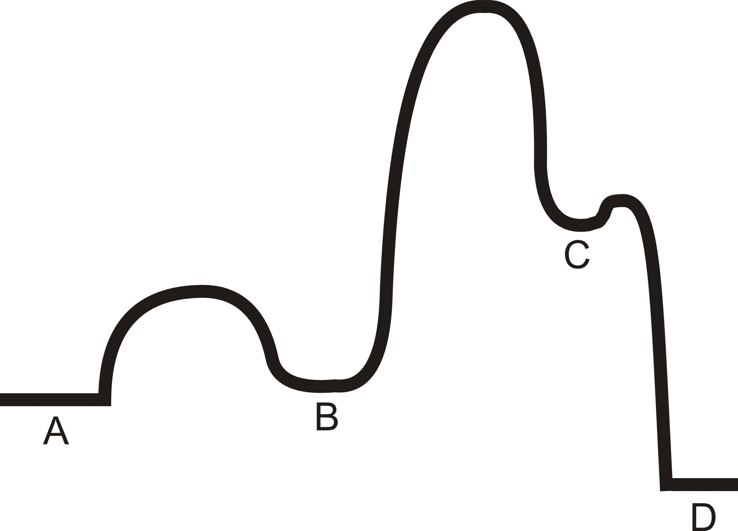

1. The reaction has 2 intermediates.
2. The reaction is exothermic.
3. The second step of the reaction is the slowest step.
4. I only
5. II only
6. I and II only
7. I and III only
8. All of these statements are true.

31. Concentration of reactant A and time data for a kinetics experiment was taken in the laboratory. A plot of 1/[A] vs. time (in seconds) gave a linear plot. What are the units of the rate constant for this reaction?

1. M/s
2. 1/s
3. 1/ M·s
4. 1/M2·s
5. 1/M·s2

32. Which statement below *best* describes the difference between an intermediate and a transition state?

1. An intermediate cannot be isolated while a transition state can.
2. A transition state is always higher energy than the reactants while intermediates are always lower energy than the reactants.
3. A transition state does not persist while an intermediate has a defined lifetime.
4. An intermediate is always higher energy than a transition state.
5. None of these statements are true.

33. Which statement *cannot* be inferred from the diagram below?

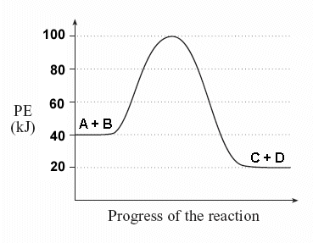

**Energy (kJ)**

1. The reaction is exothermic.
2. The rate constant k1 for the forward reaction is greater than the rate constant k–1 for the reverse reaction.
3. The activation energy for the forward reaction is 60 kJ.
4. The reaction requires a catalyst.
5. A + B -> C + D is an elementary step.

|  |  |  |  |  |  |  |
| --- | --- | --- | --- | --- | --- | --- |
| 34. | For the reaction   |  |  | | --- | --- | |  | HO(g) + H2(g)  H2O(g) + H(g) |   a plot of  versus 1/*T* gives a straight line with a slope equal to 5.1  103 K. What is the activation energy for the reaction? | | | |
| A) | 42 kJmol |  |  |
| B) | 98 kJmol |  |  |
| C) | 0.61 kJmol |  |  |
| D) | 5.1 kJmol |  |  |
| E) | 12 kJmol |  |  |
|  |  | | | |

**Chapter 7**

1. Doping germanium with which element results an n-type semiconductor?

1. arsenic
2. gallium
3. carbon
4. tin
5. oxygen

2. Which statement regarding molecular orbital theory is *false*?

1. Constructive interference leads to a bonding molecular orbital that is always lower in energy than the constituent atomic orbitals.
2. Destructive interference leads to an antibonding molecular orbital that is always higher in energy than the constituent atomic orbitals.
3. A linear combination of *N* atomic orbitals results in *N* molecular orbitals.
4. Degenerate molecular orbitals have different energies.
5. Molecular orbitals are filled according to the Aufbau principle to give the molecular electronic configuration.

3. For molecular orbital theory regarding bulk solids, which of the following statements is true?

1. The molecular orbitals are close enough in energy that a band forms rather than discrete orbitals.
2. The distance between the bands is called the energy gap.
3. The lower energy band is called the conduction band.
4. A small band gap results in a material being an insulator.
5. Conductors do not have a valence band.

4. Which of the following theories of bonding best explains conductivity in metals?

1. Molecular orbital theory
2. Valence bond theory
3. VSEPR
4. Electronegativity
5. Band gap theory

5. Which of the following statements is/are *true*?

1. Graphite and diamond are allotropes.
2. Diamond is a network solid.
3. Graphite and diamond are both sp3hybridized for carbon.
4. I only
5. II only
6. I and II
7. II and III
8. I, II, and III

6. Bronze is an example of a substitutional alloy composed of copper and tin. Which image best depicts bronze?

Ans: B

**A)**

**C)**

**D)**

**B)**

**E)**

7. Which statement is true?

A) Bonding in metals is best described by covalent bonding.

B) The "sea of electrons" model of bonding explains why nonmetals are good insulators.

C) The delocalization of orbitals in molecular orbital theory makes it particularly useful for explaining pi bonding in molecules.

D) In general, alloys are weaker and softer than pure metals.

E) The basic unit of structure in silicates is SiO2, silica.

8. Which statement regarding diamond and graphite is true?

A) Carbon and diamond are allotropes, so they have identical structures.

B) The C atoms in carbon and the C atoms in graphite have the same hybridization.

C) The C atoms in diamond have no unhybridized p orbitals.

D) Graphite is a poor electrical conductor because of hybridization.

E) Diamond is a good electrical conductor due to delocalization of electrons.

9. Which image best represents a * orbital?

Ans: C

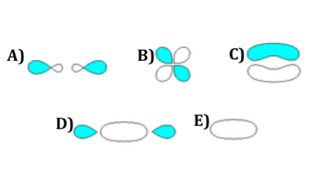

10. Which statement regarding the molecular orbitals below is *true*?

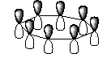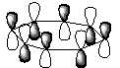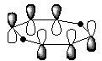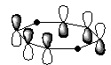

I.

II.

III.

IV.

A) Orbital II is the most bonding orbital.

B) Orbital I is the highest energy orbital.

C) Orbitals III an IV are degenerate (have the same energy).

D) The energy of orbital III is between that of orbitals I and II.

E) More than one of these statements is true.

11. Which statement *best* explains why metals are good conductors?

A) The valence and conduction bands for metals are separated by a large energy gap, so electrons easily flow between the two.

B) There is no energy gap between the valence and conduction bands in

metals, so electrons cannot move between the two.

C) There is a small energy gap between the valence and conduction bands in

metals, so excited electrons can cross the gap.

D) The valence and conduction bands for metals are separated by a large energy gap, so electrons cannot move between the two.

E) There is no energy gap between the valence and conduction bands in

metals, so electrons easily flow between them.

12. A common mineral named anorthite, is in a family of minerals called feldspars, which is a component of granite. It is formed when ½ of the silicon atoms in Si4O8 are replaced with aluminum atoms. The charge is counterbalanced with calcium. What is the formula of this mineral?

A) Ca2AlSi2O8

B) Ca(AlSi3O8)2

C) Ca(Al2Si2O8)

D) Ca(Al2Si4O10)

E) CaAl2Si2O7

13. The π molecular orbitals formed in benzene form from the ___________orbitals of C atoms.

A) unhybridized *p* atomic

B) unhybridized *sp2* molecular

C) hybridized *sp2* atomic

D hybridized *sp* atomic

E) hybridized *sp3* molecular

14. Which of the following statements is (are) true about interference of *N* atomic orbitals?

1. When *N* atomic wave functions have constructive interference, they are out of phase with each other.
2. When *N* atomic wave functions have interference, they form *N* molecular orbitals.
3. C) When *N* atomic wave functions have constructive interference, they form only antibonding molecular orbitals.
4. D) When *N* atomic wave functions have constructive interference, they must have vastly different energies to form bonding molecular orbitals.
5. None of the above statements are correct.

15. When forming a molecular orbital diagram, the energy of the original atomic orbital

A) is higher than the energy of the bonding molecular orbital(s).

B) is the same as the energy of the bonding and antibonding molecular orbital(s).

C) is lower than the energy of the antibonding molecular orbital(s).

D) A and C

E) All of the above are true.

16. Which of the following extrinsic semiconductors would form a p-type semiconductor? (The choices are written as original element: dopant element)

A) Ge: S

B) Ge: P

C) Si: Al

D) Si: N

E) All of the above would form n-type semiconductors

**Chemistry of the main group elements**

1. In which species is hydrogen present as H-, the hydride ion?

A) NaH

B) CH4

C) GeH4

D) HCl

E) NH3

2. Which statement is *true*?

A) The F—F sigma bond is stronger than an C—C sigma bond because the

atomic radius of F is less than that of C.

B) The pi bonds of period three elements are stronger than those of the

period two elements because the period three elements are larger.

C) The P—O sigma bond is weaker than the S—O sigma bond due to the larger difference in electronegativity between the atoms.

D) A silicon pi bond is weaker than a sulfur pi bond because the smaller atomic radius of sulfur allows greater overlap of p orbitals.

E) All of these statements are true.

3. Which statement is *true?*

A) Calcium has a larger atomic radius than potassium.

B) Fluorine has a less positive electron affinity than oxygen.

C) Chlorine has a lower first ionization energy than Br.

D) The sulfide ion (S2-) is smaller than the chloride ion (Cl-).

E) Oxygen is more electronegative than carbon.

4. Which hydrides below are metallic?

I. CrH

II. NaH

III. CaH2

IV. SiH4

A) II and IV

B) I, II, and III

C) I only

D) II and III

E) IV only

5. When the Bronsted base magnesium nitride (Mg3N2) is dissolved in water, a gas is evolved and the pH of the solution increases. Which equation accounts for this reaction?

A) Mg3N2(s) + H2O(l) 🡪 H2(g) + Mg3N2O

B) Mg3N2(s) + 6 H2O(l) 🡪 3 Mg2+(aq) + 6 OH- (aq) + 2NH3(g)

C) Mg3N2(s) + 3H2O(l) 🡪 3Mg2+(aq) + 3OH- (aq) + 2NH2- (g) + H2(g)

D) Mg3N2(s) + 3H2O(l) 🡪 N2(g) + 3H2(g) + 3MgO(s)

E) 5Mg3N2(s) + (9/2)H2O(l) 🡪 3Mg5(NOH2)3 + (7/2)N2(g)

6. What are the products of the reaction:

4NaH + AlBr3 🡪

Note that coefficients of products have note been shown.

A) NaBr and AlH3

B) NaAlBr and H2

C) NaBr and NaAlH4

D) Na3Al and HBr

E) AlBrH2 and Na(s)

7. Which oxides are acidic?

I. Na2O

II. SO3

III. Al2O3

IV. P2O5

A) I and III

B) I only

C) II and IV

D) II and III

E) IV only

8. Identify the reducing agent:

SiH4 + 2O2 🡪 SiO2 + 2H2O

A) SiO2

B) H2O

C) SiH4

D) O2

E) This is not an oxidation – reduction reaction.

9. The reaction HI(aq) + H2O(l) 🡪 H3O+(aq) + I-(aq) is an example of:

A) heterolytic cleavage by proton transfer

B) homolytic cleavage by hydride transfer

C) heterolytic cleavage by hydride transfer

D) homolytic cleavage by proton transfer

10. Which reaction correctly demonstrates the reaction of a basic oxide with water?

A) BaO(s) + 3H2O(l) 🡪 Ba2+(aq) + 2H3O+(aq)

B) Na2O(s) +H2O(l) 🡪 2Na+(aq) + H2O2(l)

C) CaO(s) + H2O(l) 🡪 Ca2+(aq) + O2(g) + H2(g)

D) MgO(s) + 2HNO3(aq) 🡪 Mg(NO3)2(aq) + H2O(l)

E) Li2O(s) + H2O(l) 🡪 2Li+(aq) + 2OH- (aq)

11. Which hydride is least likely to form discrete molecules?

A) CH4  
 B) GeH4  
 C) PH3  
 D) LiH  
 E) None of these

|  |  |
| --- | --- |
| 12. | Which statement best explains why the electron affinity of B is less positive than that of Li? |
|  | A) B has electrons in p orbitals, so it is lower in energy.  B) Li does not want to gain an electron because it already has a half-full s orbital.  C) B is a smaller atom, so its valence electrons are more tightly held.  D) B is farther to the right in the same row as Li.  E) The gain of an electron fills the s orbital for Li while it results in neither a full nor half-full subshell for B. |

13. A main group element should always have:

A) partially filled d orbitals

B) its last valence electron filling an s or p orbital

C) properties of a non-metal

D) a large ionization energy

E) a large electronegativity

14. What characteristic is most influential in characterizing a hydride as saline or metallic?

A) electron affinity

B) ionization energy

C) atomic radius

D) electronegativity

E) ionic radius

15. Which are logical products for the reaction of 4LiH + AlCl3?

A) 3LiCl + LiAlH4

B) LiAlH4 + 3LiCl

C) 3LiClH + AlH

D) LiHCl + AlCl3

E) They do not react

16. Which hydrides below are metallic?

1. CrH
2. NaH
3. CaH2
4. SiH4
5. II and IV
6. I, II, and III
7. I only
8. II and III
9. IV only

17. Which statement regarding driving forces for chemical reactions is *true*?

A) Lewis acid / base interactions do not influence inorganic chemistry reactions.

B) The driving force for many reactions is the combination of the LUMO on

the base with the HOMO of an acid to form a new pair of molecular orbitals.

C) The "attack" of an empty orbital with the lone pair of a nucleophilic species can be the driving force for inorganic chemical reactions.

D) Differences in electronegativity play little role in driving chemical reactions.

E) More than one of these statements is true.

18. Which statement regarding hydrides is *true*?

A) Hydrogen is present as H- in all hydrides.

B) All hydrides exist as crystal lattices.

C) NaH is a metallic hydride.

D) HF is NOT a hydride.

E) In metallic and saline hydrides, H is the MORE electronegative atom present.

19. Which chemical reaction is NOT an example of heterolytic cleavage?

A) KH(s) + H2O(l) 🡪 K+(aq) + H2(g) + OH-(aq)

B) NaH(s) + H+(aq) 🡪 H2(g) + Na+(aq)

C) HCN(aq) + H2O(l) 🡪 H3O+(aq) + CN-(aq)

D) BH 🡪 B• + H•

E) NaH(s) + PH3(g) 🡪 Na+(aq) + H2(g) + PH2-(g)

20. Considering the products of the following reactions, which one does NOT involve a proton transfer process?

A) CO2(g) + H2O(l) 🡪

B) 3LiH(s) + AlCl3(aq) 🡪

C) KH(s) + NH3(aq) 🡪

D) MgH2(s) + H2O(l) 🡪

E) Mg3N2(aq) + 6H2O(l) 🡪

**Chapter 17**

1. What happens to the 5 degenerate d orbitals when the nickel(II) cation forms the complex [Ni(NH3)6]2+?

A) The orbitals split so that there are three orbitals with higher energy than the other two.

B) The orbitals split so that there are two orbitals with higher energy than the other three.

C) The five orbitals remain degenerate but have a higher energy than before complex formation.

D) The five orbitals remain degenerate but have a lower energy than before complex formation.

E) None of the above.

2. What is the coordination number for Pd in the complex Na2[Pd(ox)2)]?

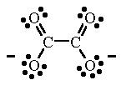

ox

A) 1

B) 2

C) 4

D) 6

E) 8

3. The coordination complexes below exhibit what type of isomerism?

[CrCl(NH3)5]Br and [CrBr(NH3)5]Cl

A) coordination

B) linkage

C) ionization

D) hydration

E) geostereoisomerism

4. Which statement about the coordination complex below is *true.*

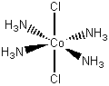

A) The name of the complex is *trans*-tetramminedichlorocobalt  
 B) The name of the complex is *cis*-tetramminedichlorocobalt ion.

C) The complex is chiral.

D) The complex has a geometric isomer.

E) The complex rotates the plane of polarized light.

5. Which statement regarding [Fe(OH2)6]+ is *true*?

A) It is diamagnetic.

B) Its electron configuration is t2g6.

C) It is high-spin.

D) If the ligands were replaced with NH3, the configuration would be t2g4eg2.

E) Both B and D are true.

6. Which ion is least likely to exist?

A) V3+

B) Mn7+

C) Co9+

D) Cu2+

E) Cr6+

7. Which statement about the coordination complex below is *true.*



A) The oxidation state for the Co is 0.  
 B) The coordination number for the complex is six.

C) The complex is chiral.

D) The complex has a geometric isomer.

E) The complex rotates the plane of polarized light.

8. Which statement regarding [Fe(OH)6]4- is *true*?

A) It is diamagnetic.

B) Its electron configuration is t2g6.

C) If the ligands were replaced with NH3, the configuration would be t2g4eg2.

D) Both B and C are true.

E) It is high-spin.

9. The coordination complexes below exhibit what type of isomerism?

[CrCl(NH3)5]Br and [CrBr(NH3)5]Cl

A) coordination

B) linkage

C) ionization

D) hydration

E) geostereoisomerism

10. What is the coordination number for Pd in the complex [Pd(en)2)]Cl2?



en

A) 1

B) 2

C) 4

D) 6

E) 8

11. Which atom would you expect to be largest?

A) Cr

B) Mo

C) Zn

D) Cd

E) They are all the same size.

12. How many *unpaired* electrons would you expect for the central metal to have in the complex [Fe(CN)6]4- ?

A) 4

B) 5

C) 2

D) 1

E) 0

13. Which oxides are (or can be) basic?

I. Na2O

II. SO3

III. Al2O3

IV. P2O5

A) I and III

B) I only

C) II and IV

D) II and III

E) II, III, and IV

14. Which of these molecules is *chiral*?

 I.

II.



III.



A) I only

B) II only

C) III only

D) I and II

E) II and III