1. What is the formula of the ionic compound formed from the most stable monatomic ion of calcium and the chlorite ion?

1. CaCl
2. CaCl2
3. Ca(ClO)2
4. CaClO2
5. Ca(ClO2)2

2. What is the chemical formula of the organic compound shown below?

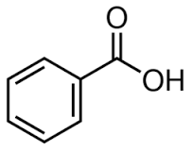

1. C7H12O2
2. C7H6O2
3. C6H5O2
4. C6 H12O2
5. C6H6O2

3. Which answer option ***incorrectly*** correlates the element and description?

1. Na the alkali metal in the third period
2. I the halogen that is a semimetal
3. Te a semimetal in the fifth period
4. Ca an alkaline earth metal
5. Np an actinide element

4. The atomic mass of fluorine is 18.998 amu, and its mass spectrum shows a large peak at this mass. The atomic mass of chlorine is 35.45 amu, yet the mass spectrum of chlorine does *not* show a peak at this mass. Which statement *best* explains this?

1. The only stable isotope of fluorine is 19F, but there is more than one stable isotope of chlorine.
2. The most stable isotope of fluorine is *not* 19F.
3. The isotope 35Cl does not exist.
4. The isotope 19F does not exist.
5. The most abundant isotope of chlorine has a mass greater than 35.45 amu.

5. Which statement regarding chemical nomenclature is true?

1. The names of all ionic compounds require Roman numerals.
2. The name of SO42- is sulfur tetroxide.
3. The name of a compound composed of a metal cation and an anion should contain prefixes, but only if there is more than one metal cation.
4. The name of the compound CO should contain one or more prefixes.
5. The name of FeCO3 is iron carbonate.

6. What is the symbol for an isotope that has 20 protons, 18 electrons, and a mass number that is two more than twice its atomic number?

1. 
2. 
3. 
4. 
5. 

7. The mass of a sample of aluminum (Al) metal is 12.45 g. What mass of copper (Cu) metal is has the same number of atoms as the sample of aluminum?

1. 0.03409 g
2. 5.290 g
3. 29.33 g
4. 137.7 g
5. 176.7 g

8. In the laboratory, a researcher takes 10.0 mL of a 0.247 M aqueous solution of KNO3 and places it in a flask to which she adds enough water to make a total volume of 100.0 mL. Which statement is true about the resulting solution?

1. The concentration of the solution did not change.
2. The volume of solvent did not change.
3. The moles of solute present did not change.
4. The new concentration is greater than 0.247 M
5. The volume of the solution did not change.

9. A 100-g sample of a compound is found to contain 60.00 g C, 4.48 g H, and 35.53 g O. What is the empirical formula for this compound?

1. C5H4O2
2. C10H9O4
3. C20H18O10
4. C2H2O
5. C9H8O4

10. Which statement about a 283.9 g sample of P4O10 is most correct?

1. The sample contains 1 mole of atoms.
2. The sample contains 1 mole of molecules.
3. The sample contains 14 moles of atoms.
4. The sample contains 14 moles of molecules.
5. More than one of these statements is true.

11. Which statement is true given the balanced chemical equation?

Ba(NO3)2(aq) + NaSO4(aq) 🡪 BaSO4(s) + 2NaNO3(aq)

1. Ba2+ and SO42- are spectator ions.
2. The total ionic equation is 2Na+(aq) + 2NO3-(aq) 🡪 2NaNO3(aq)
3. Na+ and SO42- are spectator ions.
4. No reaction occurs.
5. The net ionic equation is Ba2+(aq) + SO42-(aq) 🡪 BaSO4(s)

12. In the laboratory, a student mixes aqueous solutions of sodium carbonate and calcium nitrate. Which image best represents the resulting solution? Note that water molecules have been omitted for clarity

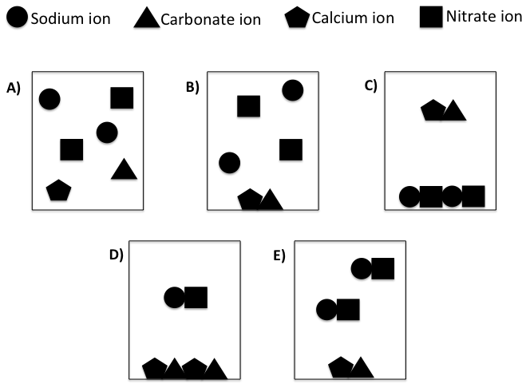

13. How many moles of O2 are required to *completely* react with 4 moles of C4H10?

_____C4H10(g) + _____O2(g) 🡪 ____CO2(g) + ____H2O(g)

1. 1 mole
2. 6.5 moles
3. 13 moles
4. 26 moles
5. 39 moles

14. The reaction of 15.0 kg of Fe2O3(s) with excess CO(g) produced 8.8 kg of Fe(s). What was the percent yield of this reaction?

Fe2O3(s) + 3CO(g) 🡪 2Fe(s) + 3CO2(g)

1. 1.48%
2. 11.9%
3. 58.7%
4. 59.6%
5. 83.8%

15. A reaction vessel initially contains six molecules of N2 and six molecules of H2. Which image best represents the reaction vessel *after* the chemical reaction occurs?

N2(g) + 3H2(g) 🡪 2NH3(g)



16. What is the concentration of a 20.00 mL sample of H2SO4 if it takes 25.00 mL of 0.500 M NaOH to completely react with the H2SO4?

2NaOH(aq) + H2SO4(aq) 🡪 2H2O(l) + Na2SO4(aq)

A) 0.400 *M*

B) 0.157 *M*

C) 0.500 *M*

D) 0.313 *M*

E) 0.625 *M*

17. Which relationship between properties of gases is *incorrectly* stated (you may assume that all other properties are constant)?

1. Pressure and temperature are inversely proportional
2. Temperature and volume are directly proportional
3. Volume and moles of gas are directly proportional
4. Pressure and moles of gas are directly proportional
5. Pressure and volume are inversely proportional

18. A mixture of O2 and Ne gases has a total pressure of 50.0 atm. If the mixture contains 141.2 g O2 and the mole fraction of Ne is 0.79, then what is the partial pressure of the O2?

1. 10.5 atm
2. 17.7 atm
3. 32.5 atm
4. 39.5 atm
5. 221 atm

19. Which sample of gas has the greatest most probable speed?

1. O2 at 473 K
2. N2 at 473 K
3. Cl2 at 473 K
4. O2 at 373 K
5. N2 at 373 K

20. The primary contribution to the pressure of an ideal gas sample results from:

A) Collisions of gas particles with other particles of gas

B) Collisions of gas particles with the walls of the container

C) The molar mass of the gas particles

D) Intermolecular interactions among the gas particles

E) None of the above.

21. Which form of the exam do you have?

1. B)