1. Which statement regarding the diagram is true?

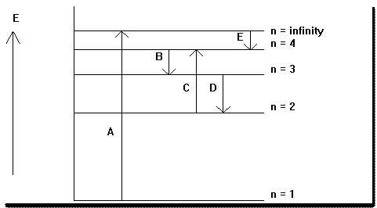

1. Arrow A corresponds to a longer wavelength transition than arrow C.
2. Arrow D depicts absorption with the largest energy.
3. Arrows A and C represent emission lines.
4. Arrow E corresponds to the largest frequency transition depicted.
5. Arrow D represents a transition with shorter wavelength than does arrow E.

2. In a reproduction of the photoelectric effect experiments, a student shines light of three wavelengths—325 nm, 455 nm, and 632 nm—on a metal surface. Observations for each wavelength, labeled I, II, and III, are as follows:

I. No electrons are ejected from the metal surface.

II. Electrons with a kinetic energy of 155 kJ/mol are ejected from the metal

surface.

III. Electrons with a kinetic energy of 51 kJ/mol are ejected from the metal

surface.

Which answer correctly correlates the observations to the appropriate wavelengths?

1. I = 325 nm, II = 455 nm, III = 632 nm
2. I = 632 nm, II = 455 nm, III = 325 nm
3. I = 455 nm, II = 325 nm, III = 632 nm
4. I = 632 nm, II = 325 nm, III = 455 nm
5. I = 325 nm, II = 632 nm, III = 455 nm

3. How much energy (in J) is contained in 2.00 moles of X-ray photons with a frequency of 2.22 x 1018 Hz?

1. 1.47 x 10-15 J
2. 5.64 x 10-10 J
3. 8.87 x 108 J
4. 1.77 x 109 J
5. 6.80 x 1014 J

4. Orbitals A and B are described by the quantum numbers designated below. Given this information, which statement comparing the two orbitals is most correct? (Note: shell = primary determinant of orbital energy)

Orbital A: *n* = 3, *l* = 0, and *ml* = 0

Orbital B: *n* = 3, *l* = 1, and *ml* = -1

1. The two orbitals are in the same shell.
2. The two orbitals have the same shape.
3. Orbital A is lower in energy than orbital B.
4. Both A and B.
5. Both A and C.

5. Which statement regarding electron configurations is true?

1. There are 0 *p* electrons in the ground state electron configuration for vanadium (V).
2. There is only 1 unpaired electron in the ground state electron configuration for phosphorus (P).
3. There are only 2 electrons in *s* orbitals in the ground state electron configuration for sodium (Na)
4. The ground state electron configuration for cobalt (Co) includes 12 *p* electrons.
5. None of these statements is true.

6. For a molecule with three bonding groups and two lone pairs on the central atom, what is the best estimate of the angles between the three bonded groups?

1. 120o
2. 90o and 180o
3. 116o and 90o
4. 86o and 172o

E) 104.5o

7. Which image(s) below depict sigma bond(s)?

I. 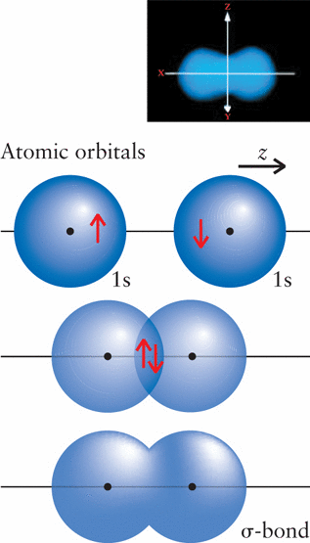

II. 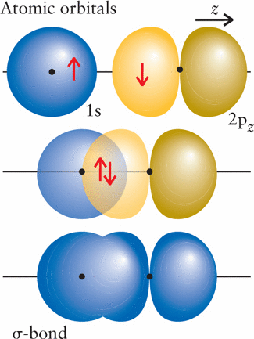

III. 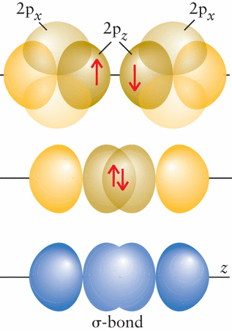

1. I only
2. II only
3. I and II only
4. III only
5. All of I, II, and III

8. Which statement regarding periodic trends is true?

1. The atomic radius of arsenic (As) is less than that of selenium (Se) because selenium has more protons.
2. The atomic radius of potassium (K) is greater than that of sodium (Na) because potassium has more core electrons that effectively shield its valence electrons from protons in the nucleus.
3. The first ionization energy for nitrogen (N) is less that that of oxygen (O) because oxygen has a more stable electron configuration
4. The electron affinity of carbon (C) is less negative than that of nitrogen (N) because carbon has a greater atomic radius.
5. The second ionization energy for calcium (Ca) is less than its first ionization energy because calcium tends to form a 2+ cation.

9. For which of these does electronegativity provide the best description?

1. Atomic radius
2. First ionization energy
3. Electron affinity
4. Ionic radius
5. Bond polarity

10. Which molecule has three lone pairs on the central atom?

A) CO2

B) I3-

C) CH2O

D) NH3

E) Both C and D

11. Which statement is true regarding molecule polarity?

1. CCl4 is a polar molecule because it contains polar bonds.
2. I3-is a polar molecule because it has lone pairs on the central atom.
3. Nonpolar molecules must contain only nonpolar bonds.
4. All diatomic molecules are polar.
5. XeF4 is a nonpolar molecule that contains polar bonds.

12. Which statement is true regarding semi-conductors?

1. Doping Ge with As results in an n-type semi-conductor with a donor band.
2. Doping Ge with As results in a p-type semi-conductor with an acceptor band.
3. Doping Ge with As results in an n-type semi-conductor with an acceptor band.
4. Doping Ge with As results in a p-type semi-conductor with a donor band.
5. Doping Ge with Ga does not yield a semi-conductor.

13. Which statement is true regarding intermolecular forces?

1. The primary intermolecular forces in a sample of C3H8 are greater than those in a sample of NH3.
2. The primary intermolecular force in a sample of CH2Cl2 is hydrogen bonding interactions.
3. A molecule of methyl ethyl ketone (shown below) can participate in hydrogen bonding interactions with a molecule of water.

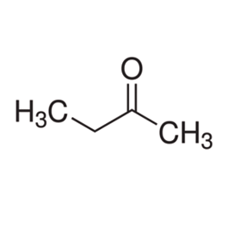

1. The primary intermolecular force between molecules in a sample of SF4 is London dispersion forces.
2. The *only* intermolecular force between molecules in a sample of H2O is hydrogen bonding interactions.

14. Which answer option correctly arranges these molecules in order of *increasing* vapor pressure?

NH3, CH4, C4H10, H2S

1. NH3< H2S < C4H10 < CH4
2. CH4 < C4H10 < H2S < NH3,
3. C4H10 < CH4 < NH3< H2S
4. H2S < C4H10 < NH3 < CH4
5. H2S < NH3 < CH4 < C4H10

15. Which answer option correctly arranges the molecules in order of *increasing* F—central atom—F bond angle?

1. CF4 < XeF4­ < BF3
2. BF3 < CF4 = XeF4
3. XeF4 < CF4 < BF3
4. XeF4 = CF4 < BF3
5. BF3 < CH4 < XeF4

16. The sigma bonds in the SeBr4 molecule are created by overlap of a 2*p* atomic orbital on Br and what type of orbital on Se?

1. An *sp*3 atomic orbital
2. An *sp*3*d* atomic orbital
3. An *sp*3 hybrid orbital
4. An *sp*3*d* hybrid orbital
5. A 4*p* atomic orbital

17. What is the length of the diagonal of the face of the cubic unit cell (labeled “d” in the image) in terms of the radius of the atoms in the cell, *r*?



1. d = *r*
2. d = 2*r­*
3. d = 3*r*
4. d = 4*r*
5. d = 

18. Which statement best explains vapor pressure?

1. The pressure exerted by a gas on the surface of the liquid from which it evaporated.
2. The pressure the atmosphere exerts on all objects.
3. The pressure a gas exerts on the walls of its container.
4. The pressure gas molecules exert on one another when they collide.
5. The pressure a liquid exerts on a vapor.

19. Why does increasing intermolecular attraction directly correlate with decreasing boiling point?

A) It doesn't; stronger intermolecular forces make for higher boiling points because it takes more energy to separate the molecules.

B) Stronger intermolecular forces mean that the molecules are easier to

separate, making for lower boiling points.

C) Molecules with stronger intermolecular forces are lighter, making them

easier to boil.

D) It doesn't; stronger intermolecular forces mean the molecules are smaller because smaller molecules can get closer together, making them harder to

boil.

E) It doesn’t; boiling point is not directly correlated with intermolecular force

strength.

20. Which property of a liquid best explains why some spiders can walk on water?

1. Adhesion
2. Surface tension
3. Vapor pressure
4. Concentration
5. Capillary action

21. Which form of the exam do you have?

A) B)