Practice Exam 2 Questions: Econ 2100

Name: __________________________ Date: _____________

|  |  |  |
| --- | --- | --- |
| 1. | The marginal cost curve intersects the average variable cost curve at: | |
| A) | its lowest point. |
| B) | its maximum. |
| C) | its endpoint. |
| D) | no point; the curves don't intersect. |

|  |  |
| --- | --- |
| 2. | You have rented a one-room apartment, and it is time to pay the bills. You pay the rent, the basic cable bill, the electricity bill, and your grocery bill. Which of these are good examples of fixed costs and which are variable costs? Explain your reasoning. |

Use the following to answer question 3:

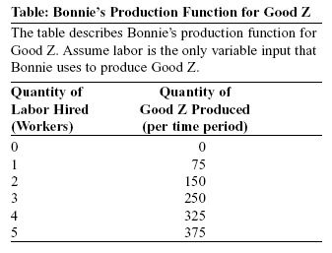

|  |  |  |
| --- | --- | --- |
| 3. | (Table: Bonnie's Production Function for Good Z) Diminishing returns to labor occur when Bonnie hires the ________ worker. | |
| A) | second |
| B) | third |
| C) | fourth |
| D) | fifth |

|  |  |  |
| --- | --- | --- |
| 4. | In the short run, the average total cost curve reaches its minimum point at a smaller level of output than the short-run marginal cost curve reaches its minimum. | |
| A) | True |
| B) | False |

|  |  |
| --- | --- |
| 5. | In the short run, why is it believed that the total product curve increases at a decreasing rate when more labor is added to the production function? |

Use the following to answer question 6:

**Figure: A Perfectly Competitive Firm in the Short Run**

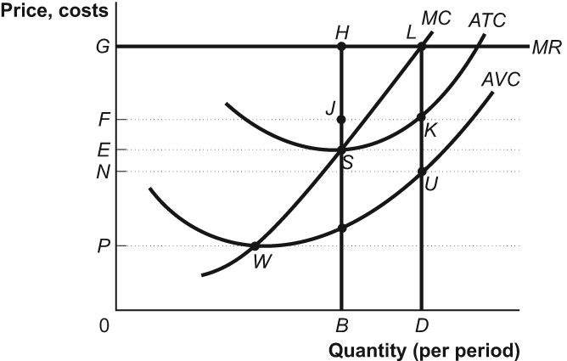

|  |  |  |
| --- | --- | --- |
| 6. | (Figure: A Perfectly Competitive Firm in the Short Run) The firm will shut down in the short run if the price falls below: | |
| A) | *G.* |
| B) | *F.* |
| C) | *E.* |
| D) | *P.* |

|  |  |  |
| --- | --- | --- |
| 7. | If firms are incurring economic losses in the short run, firms will leave the industry, industry output will ________, and economic losses will ________ in the long run. | |
| A) | fall; fall |
| B) | rise; fall |
| C) | rise; rise |
| D) | fall; rise |

Use the following to answer question 8:

**Figure: Revenues, Costs, and Profits III for Tomato Producers**

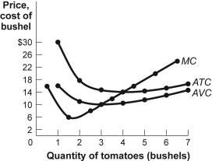

|  |  |  |
| --- | --- | --- |
| 8. | (Figure: Revenues, Costs, and Profits III for Tomato Producers) The market for tomatoes is perfectly competitive, and an individual tomato farmer faces the cost curves shown in the figure. If the market price of a bushel of tomatoes is $8, the farmer's profit-maximizing output is ________ bushels. | |
| A) | 0 |
| B) | 1 |
| C) | 2 |
| D) | 3 |

Use the following to answer question 9:

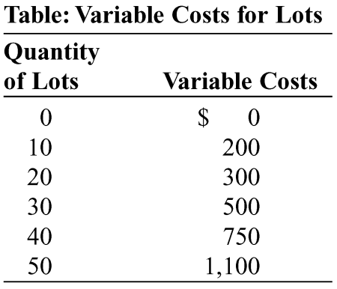

|  |  |  |
| --- | --- | --- |
| 9. | (Table: Variable Costs for Lots) During the winter, Alexa runs a snow-clearing service, and snow clearing is a perfectly competitive industry. The table shows her variable costs for snow clearing and number of lots cleared. Her only fixed cost is $1,000 for a snowplow. Her variable costs include fuel, her time, and hot coffee. If the price per cleared lot is $14, how many lots should Alexa clear? | |
| A) | 0 |
| B) | 40 |
| C) | 50 |
| D) | 20 |

Use the following to answer question 10:

**Figure: Revenues, Costs, and Profits III for Tomato Producers**



|  |  |  |
| --- | --- | --- |
| 10. | (Figure: Revenues, Costs, and Profits III for Tomato Producers) The market for tomatoes is perfectly competitive, and an individual tomato farmer faces the cost curves shown in the figure. The farm's short-run supply curve is the ________ curve above a price of ________. | |
| A) | average total cost; $14 |
| B) | average variable cost; $10 |
| C) | marginal cost; $10 |
| D) | marginal cost; $14 |

|  |  |  |
| --- | --- | --- |
| 11. | A natural monopolist that is price regulated at the marginal cost output level will: | |
| A) | produce the optimal level of output and earn a normal profit. |
| B) | eventually incur losses if marginal cost is less than average total cost. |
| C) | maximize profit. |
| D) | produce the optimal level of output and earn an economic profit greater than zero. |

|  |  |  |
| --- | --- | --- |
| 12. | Because of the existence of a large number of similar but not identical substitutes in most communities, the market for chiropractors is best considered to be: | |
| A) | an oligopoly. |
| B) | a perfect competition. |
| C) | monopolistically competitive. |
| D) | a monopoly. |

|  |  |  |
| --- | --- | --- |
| 13. | Which of the following scenarios best describes an oligopolistic industry? | |
| A) | A single cable company serves customers in a small town. |
| B) | Thousands of soybean farmers sell their output in a global commodities market. |
| C) | Coca-Cola and Pepsi sell most of the soft drinks consumed around the world. |
| D) | A college has one bookstore selling textbooks to students. |

|  |  |  |
| --- | --- | --- |
| 14. | An industry characterized by many firms producing similar but differentiated products in a market with easy entry and exit is called: | |
| A) | perfect competition. |
| B) | monopoly. |
| C) | monopolistic competition. |
| D) | oligopoly. |

Use the following to answer question 15:

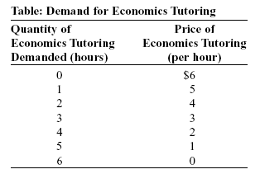

|  |  |
| --- | --- |
| 15. | (Table: Demand for Economics Tutoring) Look at the table Demand for Economics Tutoring. Suppose Eric is the only economics tutor in town and therefore holds a monopoly on the sale of economics tutoring. The table shows the demand schedule for his services. Eric can offer additional hours of tutoring at a constant marginal cost of $2 per hour, and he has no fixed costs.  a. If Eric acts as a monopolist, how many hours will he offer and what price will he charge?  b. Calculate Eric's monopoly profit. |

|  |  |  |
| --- | --- | --- |
| 16. | Which of the following is an example of an environmental standard? | |
| A) | tradable pollution permits |
| B) | taxes on the level of pollution |
| C) | legal limits on sulfur dioxide emissions |
| D) | production subsidies |

|  |  |
| --- | --- |
| 17. | The North Woods is a public area that supports such a large moose population that the government sees no reason to regulate or limit the harvest of the moose.  a. From an economic point of view, how is this situation going to lead to market failure?  b. You are appointed by the governor to regulate the harvest of moose from the North Woods. How could you use the three tools described in the text to maintain the efficient level of moose harvest? |

|  |  |  |
| --- | --- | --- |
| 18. | A common resource is a good that is: | |
| A) | excludable and rival in consumption. |
| B) | nonexcludable and rival in consumption. |
| C) | excludable and nonrival in consumption. |
| D) | nonexcludable and nonrival in consumption. |

|  |  |  |
| --- | --- | --- |
| 19. | If left to the private market, the amount of police protection provided in a city would be ________ than it is now, and free riders would pay ________ for police protection. | |
| A) | more; more |
| B) | more; nothing |
| C) | less; nothing |
| D) | less; a higher price |

|  |  |  |
| --- | --- | --- |
| 20. | An example of a common resource is: | |
| A) | coffee sold in coffee shops. |
| B) | any type of public good. |
| C) | any private good that is monopolized. |
| D) | fishing in the ocean. |

**Answer Key**

|  |  |
| --- | --- |
| 1. | A |
| 2. | Fixed costs are the rent and the basic cable bill, because they are the same payment every month, no matter how much television you watch or how many hours you are actually in the apartment. The electricity and grocery bills are variable costs. These two bills are different every month because your consumption of electricity and of food differs every month. If you are always in the apartment, these payments will be higher. If you are never in the apartment, these two payments will be lower. |
| 3. | C |
| 4. | B |
| 5. | The principle of diminishing marginal returns is at work. In the short run, there is at least one fixed input. When more of a variable input is added to the fixed input, total product rises, but at a slower and slower rate. Each additional worker is working with a smaller and smaller share of the fixed input, so the marginal product of that additional worker falls. |
| 6. | D |
| 7. | A |
| 8. | A |
| 9. | A |
| 10. | C |
| 11. | B |
| 12. | C |
| 13. | C |
| 14. | C |
| 15. | a. Using the demand schedule to calculate marginal revenue, we see that marginal revenue equals $3 for the second hour, but marginal revenue equals $1 for the third hour, so Eric should offer only 2 hours and charge $4 per hour.  b. Eric's total revenue is $2 × 4 equals $8. Because he incurs marginal cost equals $2 for each hour that he tutors, his total cost of tutoring for two hours is $4. So his monopoly profit is $4. |
| 16. | C |
| 17. | a. If hunters can freely harvest the moose, the moose in the North Woods become a common resource. For an individual hunter, the marginal cost of hunting moose is smaller than the marginal social cost. Each individual hunter is unconcerned with the marginal social cost, so the moose will be overharvested.  b. A tax could be levied on the hunting of moose. The tax should be equal to the difference between the individual marginal cost of hunting a moose and the marginal social cost at the efficient harvest quantity. A system of tradable hunting licenses could be used. You would set the number of licenses equal to the efficient harvest quantity. Hunters would then buy and sell licenses among themselves. Those who have a relatively low marginal cost of hunting moose will be the hunters who end up buying the licenses. You could allocate a property right to the North Woods by selling the land to a private landowner. The private landowner would then be able to sell access to the moose, thus making the moose hunting an excludable and a rival private good. Since there is no longer a difference between the private marginal cost and the marginal social cost, the private landowner would have a profit incentive to prevent the moose from being overharvested. |
| 18. | B |
| 19. | C |
| 20. | D |