**Practice Questions Exam 3 Econ 2100 Spring 2015**

Name: __________________________ Date: _____________

Use the following to answer question 1:

**Scenario: Market Basket**

Suppose a market basket consists of the following goods: 50 pens, 25 notepads, and 25 paperclips. Also assume the price per unit of these goods is as follows for the years noted and 2010 is the base year.

|  |  |  |
| --- | --- | --- |
|  | **Price in 2010** | **Price in 2011** |
| Pens | $0.25 | $0.30 |
| Notepads | 0.30 | 0.25 |
| Paperclips | 0.10 | 0.15 |

|  |  |  |
| --- | --- | --- |
| 1. | (Scenario: Market Basket) What is the value of the price index in 2010? | |
| A) | 100 |
| B) | 111 |
| C) | 90 |
| D) | 0 |

|  |  |  |
| --- | --- | --- |
| 2. | Which of the following is *not* true? The consumer price index: | |
| A) | reflects changes in the prices of goods typically purchased by consumers. |
| B) | contains thousands of goods and services. |
| C) | is calculated by the Bureau of Labor Statistics. |
| D) | changes only in the base year, every five to seven years. |

|  |  |  |
| --- | --- | --- |
| 3. | Consider an economy that produces only two goods: DVDs and DVD players. Last year, 10 DVDs were sold at $20 each and 5 DVD players were sold at $100 each, while this year 15 DVDs were sold at $10 each and 10 DVD players were sold at $50 each. Real GDP this year using last year as the base year is: | |
| A) | $100. |
| B) | $700. |
| C) | $1,300. |
| D) | $300 |

|  |  |  |
| --- | --- | --- |
| 4. | The consumer price index is intended to measure the cost of all goods purchased in the economy over time. | |
| A) | True |
| B) | False |

Use the following to answer question 5:

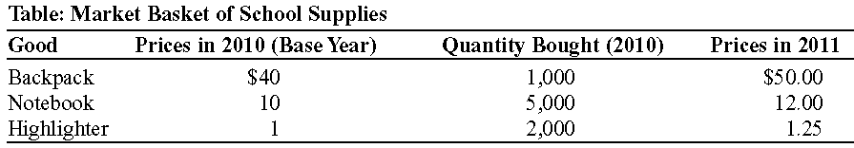

|  |  |  |
| --- | --- | --- |
| 5. | (Table: Market Basket of School Supplies) The accompanying table shows the prices of three common school supplies in 2010 and 2011 and the quantities of each school supply that consumers bought in 2010, the base year. If we were to construct a school supply index in 2011, it would be equal to: | |
| A) | 81.8. |
| B) | 100. |
| C) | 122.3. |
| D) | 112,500. |

Use the following to answer question 6:

**Scenario: Price Index**

Suppose that in the base period a college student buys 20 gallons of gasoline at $2 per gallon, 2 CDs for $13 each, and 4 movie tickets for $7 each. In the next month, the price of gasoline is $2.25 per gallon, CDs cost $12.50 each, and the price of a movie ticket is $7.50.

|  |  |  |
| --- | --- | --- |
| 6. | (Scenario: Price Index) The price index for the second month is: | |
| A) | 94. |
| B) | 106.4. |
| C) | 100. |
| D) | impossible to determine without more information. |

|  |  |  |
| --- | --- | --- |
| 7. | When the actual rate of unemployment is equal to the natural rate of unemployment, we conclude that there is no cyclical unemployment. | |
| A) | True |
| B) | False |

|  |  |  |
| --- | --- | --- |
| 8. | The sum of frictional and structural unemployment is the: | |
| A) | actual unemployment level. |
| B) | cyclical amount of unemployment. |
| C) | natural rate of unemployment. |
| D) | amount of unemployment in an economy during a recession. |

|  |  |
| --- | --- |
| 9. | What do economists mean by the natural rate of unemployment? How would this natural rate of unemployment be affected by a permanent influx of younger, predominantly unskilled immigrant workers? |

|  |  |  |
| --- | --- | --- |
| 10. | An effective minimum wage can lead to: | |
| A) | frictional unemployment. |
| B) | structural unemployment. |
| C) | a decrease in wages. |
| D) | a shortage of workers in that labor market. |

|  |  |  |
| --- | --- | --- |
| 11. | During a recession: | |
| A) | unemployment and the growth rate of real GDP both decrease. |
| B) | unemployment decreases and the growth rate of real GDP increases. |
| C) | unemployment increases and the growth rate of real GDP decreases. |
| D) | There is no relation between unemployment and the growth rate of real GDP. |

|  |  |  |
| --- | --- | --- |
| 12. | The official unemployment rate is a useful but not altogether accurate measure of joblessness. | |
| A) | True |
| B) | False |

|  |  |  |
| --- | --- | --- |
| 13. | In the long run, wages and prices are considered to be: | |
| A) | sticky. |
| B) | constant. |
| C) | flexible. |
| D) | irrelevant. |

|  |  |  |
| --- | --- | --- |
| 14. | The short-run aggregate supply curve is upward-sloping because: | |
| A) | a higher aggregate price level leads to lower output as costs of production increase. |
| B) | a higher aggregate price level leads to higher output, since most production costs are fixed in the short run. |
| C) | a lower aggregate price level leads to higher output, since production costs tend to fall in the short run. |
| D) | a lower aggregate price level leads to higher profit and higher productivity. |

Use the following to answer question 15:

**Figure: *AD–AS***

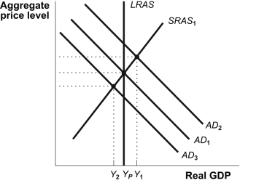

|  |  |  |
| --- | --- | --- |
| 15. | (Figure: *AD–AS*) Suppose that initially the economy is at long-run equilibrium. If the government cuts taxes, the: | |
| A) | short-run aggregate supply curve will shift to the right. |
| B) | short-run aggregate supply curve will shift to the left. |
| C) | aggregate demand curve will shift to the right. |
| D) | aggregate demand curve will shift to the left. |

|  |  |  |
| --- | --- | --- |
| 16. | The short-run aggregate supply curve is positively sloped because: | |
| A) | business people suffer from money illusion. |
| B) | wages are sticky, or don't readily adjust to changes in economic conditions in the short run. |
| C) | workers care about nominal wages, not real wages. |
| D) | of diminishing returns to labor. |

Use the following to answer question 17:

**Figure: Shifts of the *AD–AS* Curves**

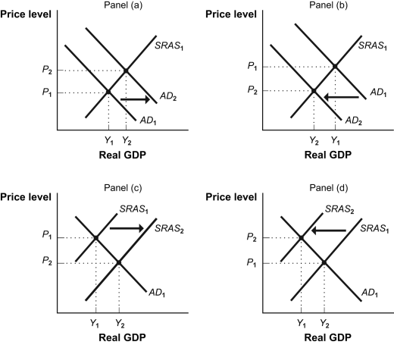

|  |  |  |
| --- | --- | --- |
| 17. | (Figure: Shifts of the *AD–AS* Curves) An increase in wages in the short run is illustrated by: | |
| A) | panel (a). |
| B) | panel (b). |
| C) | panel (c). |
| D) | panel (d). |

|  |  |  |
| --- | --- | --- |
| 18. | The wealth effect suggests: | |
| A) | a positive relationship between the price level and consumption spending. |
| B) | that price level changes do not affect real wealth. |
| C) | a negative relationship between the price level and consumption spending. |
| D) | that when the price level increases, the real value of money increases also. |

|  |  |  |
| --- | --- | --- |
| 19. | The public debt–GDP ratio for the United States in 2011 was: | |
| A) | more or less the same as that of other wealthy countries. |
| B) | the largest ratio in the world. |
| C) | less than 5%. |
| D) | over 200%. |

|  |  |  |
| --- | --- | --- |
| 20. | Medicare covers much of the cost of medical care for Americans with low incomes. | |
| A) | True |
| B) | False |

|  |  |  |
| --- | --- | --- |
| 21. | The government has a budget surplus if: | |
| A) | its total revenues are equal to its total expenditures. |
| B) | its total revenues are less than its total expenditures. |
| C) | its total revenues are greater than its total expenditures. |
| D) | the money supply is less than total expenditures. |

Use the following to answer question 22:

**Figure: Short-Run Equilibrium**

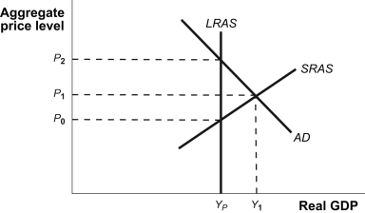

|  |  |  |
| --- | --- | --- |
| 22. | (Figure: Short-Run Equilibrium) The accompanying graph shows the economy in short-run equilibrium. To move the economy to potential GDP, the government should reduce government spending by an amount equal to: | |
| A) | (*Y*1 – *YP*). |
| B) | (*Y*1 – *YP*)/(1 – *MPC*). |
| C) | (*Y*1 – *YP*)*MPC.* |
| D) | (*Y*1 – *YP*)(1 – *MPC*). |

|  |  |  |
| --- | --- | --- |
| 23. | Suppose the economy is in a recessionary gap. To move equilibrium aggregate output closer to the level of potential output, the best fiscal policy option is to: | |
| A) | decrease government purchases. |
| B) | decrease taxes. |
| C) | decrease government transfers. |
| D) | increase real interest rates. |

|  |  |  |
| --- | --- | --- |
| 24. | A change in taxes or a change in government transfers affects consumption through a change in: | |
| A) | autonomous consumption. |
| B) | the marginal propensity to save. |
| C) | disposable income. |
| D) | government spending. |

|  |  |  |
| --- | --- | --- |
| 25. | Money that has value apart from its use as money is: | |
| A) | fiat money. |
| B) | currency. |
| C) | convertible paper money. |
| D) | commodity money. |

|  |  |  |
| --- | --- | --- |
| 26. | If the required reserve ratio rises: | |
| A) | the money multiplier will also rise. |
| B) | the banking system must keep more of a deposit in its reserves. |
| C) | the amount of reserves in the banking system will decrease. |
| D) | excess reserves will also rise. |

|  |  |  |
| --- | --- | --- |
| 27. | Reserve requirements: | |
| A) | set the maximum amount of reserves a bank must hold. |
| B) | set the minimum amount of reserves a bank must hold. |
| C) | are established by Congress. |
| D) | are set by the American Bankers Association. |

Use the following to answer question 28:

**Table: Components of the Money System**

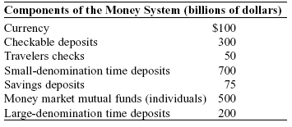

|  |  |  |
| --- | --- | --- |
| 28. | (Table: Components of the Money Supply) The money supply measured by M2 is: | |
| A) | $450 billion. |
| B) | $1,425 billion. |
| C) | $1,725 billion. |
| D) | $2,075 billion. |

|  |  |  |
| --- | --- | --- |
| 29. | Bank reserves are: | |
| A) | the fraction of deposits kept in gold with the Federal Reserve. |
| B) | the deposits lent to finance illiquid investments. |
| C) | the fraction of deposits kept in the form of very liquid assets. |
| D) | gold kept in the bank's vault. |

|  |  |  |
| --- | --- | --- |
| 30. | Suppose that initially a bank has excess reserves of $800 and the reserve ratio is 30%. Then Andy deposits $1,000 of cash into his checking account and the bank lends $600 to Molly. That bank can lend an additional: | |
| A) | $100. |
| B) | $800. |
| C) | $900. |
| D) | $300. |

**Answer Key**

|  |  |
| --- | --- |
| 1. | A |
| 2. | D |
| 3. | C |
| 4. | B |
| 5. | C |
| 6. | B |
| 7. | A |
| 8. | C |
| 9. | The natural rate of unemployment is the normal rate of unemployment around which the actual unemployment rate fluctuates. It is equal to frictional unemployment plus structural unemployment. Because younger workers and unskilled workers are groups that historically have high rates of unemployment, this demographic change would likely increase the natural rate. |
| 10. | B |
| 11. | C |
| 12. | A |
| 13. | C |
| 14. | B |
| 15. | C |
| 16. | B |
| 17. | D |
| 18. | C |
| 19. | A |
| 20. | B |
| 21. | C |
| 22. | D |
| 23. | B |
| 24. | C |
| 25. | D |
| 26. | B |
| 27. | B |
| 28. | C |
| 29. | C |
| 30. | C |