**ECON 2100 Quiz 7 Chapter 13 Fiscal Policy**

Name: __________________________ Date: _____________

|  |  |
| --- | --- |
| 1. | If the marginal propensity to consume is .80, and the federal government decreases spending by $200 billion, the income expenditure model would predict that real GDP will decrease by: |
| A) | $200 billion. |
| B) | $1000 billion. |
| C) | $160 billion. |
| D) | $800 billion. |

Use the following to answer question 2:

**Figure: North-West Government**

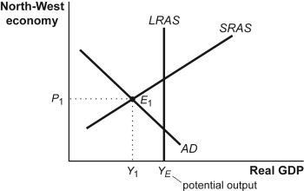

|  |  |
| --- | --- |
| 2. | (Figure: North-West Government) Using the accompanying figure, which of the following would be the appropriate response of the North-West government? |
| A) | Reduce aggregate demand by cutting taxes to close the inflationary gap. |
| B) | Reduce aggregate demand by increasing taxes to close the recessionary gap. |
| C) | Expand aggregate demand by increasing taxes to close the inflationary gap. |
| D) | Expand aggregate demand by decreasing taxes to close the recessionary gap. |

|  |  |
| --- | --- |
| 3. | The presence of an automatic stabilizer in government tax revenue that occurs when GDP rises: |
| A) | decreases the size of the multiplier. |
| B) | has no impact on the size of the multiplier. |
| C) | may either increase or decrease the size of the multiplier. |
| D) | increases the size of the multiplier. |

|  |  |
| --- | --- |
| 4. | Suppose the economy is experiencing an inflationary gap. To move equilibrium aggregate output closer to the level of potential output, the best fiscal policy option is to: |
| A) | decrease the real interest rate. |
| B) | decrease tax rates. |
| C) | decrease government purchases. |
| D) | increase the investment tax credit. |

Use the following to answer question 5:

**Figure: Short-Run Equilibrium**

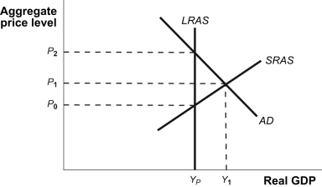

|  |  |
| --- | --- |
| 5. | (Figure: Short-Run Equilibrium) The accompanying graph shows the current short-run equilibrium in the economy. Appropriate fiscal policy action in this situation would be: |
| A) | a decrease in tax rates. |
| B) | a decrease in transfer payments. |
| C) | an increase in the investment tax credit. |
| D) | an increase in government purchases. |

|  |  |
| --- | --- |
| 6. | Government's efforts to stabilize the business cycle through fiscal policy can destabilize the economy due to the presence of: |
| A) | a negative interaction between fiscal and monetary policy due to the multiplier effect. |
| B) | a tendency of prices to change faster than the interest rate. |
| C) | business cycles that are closely synchronized to the political cycle. |
| D) | lags in the process of crafting a budget appropriate to the circumstances. |

|  |  |
| --- | --- |
| 7. | Decreasing funding to explore space: |
| A) | will shift the aggregate demand curve to the left. |
| B) | will shift the aggregate demand curve to the right. |
| C) | will shift the aggregate supply curve to the right. |
| D) | will shift the aggregate supply curve to the left. |

Use the following to answer question 8:

**Figure: Fiscal Policy II**

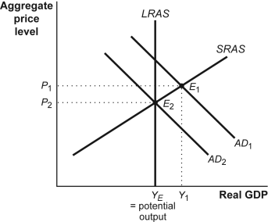

|  |  |
| --- | --- |
| 8. | (Figure: Fiscal Policy II) Suppose that this economy is in equilibrium at *E*1. If there is a decrease in government purchases, then: |
| A) | *AD*1 will shift to the right, causing an increase in the price level and an increase in real GDP. |
| B) | *AD*1 will shift to the left, causing a decrease in the price level and a decrease in real GDP. |
| C) | *AD*2 will shift to the left, causing a decrease in the price level and a decrease in the real GDP. |
| D) | *AD*2 will shift to the left, causing an increase in the price level and a decrease in real GDP. |

|  |  |
| --- | --- |
| 9. | If the *MPC* is 0.8 and the government spending decreases by $50 million, then equilibrium GDP will decrease by: |
| A) | $250 million. |
| B) | $200 million. |
| C) | $40 million. |
| D) | $50 million. |

Use the following to answer question 10:

**Figure: Inflationary and Recessionary Gaps**

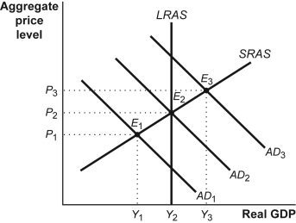

|  |  |
| --- | --- |
| 10. | (Figure: Inflationary and Recessionary Gaps) The movement from *AD*3 to *AD*1 would be caused by: |
| A) | increased government transfers. |
| B) | increased taxes. |
| C) | increased government purchases, increased government transfers, and by increased taxes. |
| D) | increased government purchases. |

**Answer Key**

|  |  |
| --- | --- |
| 1. | B |
| 2. | D |
| 3. | A |
| 4. | C |
| 5. | B |
| 6. | D |
| 7. | A |
| 8. | B |
| 9. | A |
| 10. | B |